**FIRST EDITION**

**2024**

Contents

Preface 4

About the Author 6

Author’s Note 9

Copyright 11

CHAPTER – 1: INTRODUCTION 13

CHAPTER – 2: AI SYSTEMS AND USE of BIG DATA 46

CHAPTER – 3: WHY USE AI? 56

CHAPTER – 4: WHO IS USING AI IN FINANCE 82

CHAPTER – 5: GENERAL NOTIONS IN AI 107

CHAPTER – 6: NEURAL NETWORKS 134

CHAPTER – 7: AI MODEL DEVELOPMENT PROCESS 248

CHAPTER – 8: ISSUES WITH AI 253

GLOSSARY 285

BIBLIOGRAPHY 405

# Preface

Welcome to the intriguing intersection of artificial intelligence and finance, where cutting-edge technology meets the intricate world of monetary systems. In an era defined by unprecedented technological advancements, the financial landscape is undergoing a profound transformation, and at the forefront of this revolution is Artificial Intelligence (AI). This book delves into the captivating journey of where AI is applied in finance, unravelling the symbiotic relationship between algorithms and markets.

As the global economy becomes increasingly digitized, traditional financial models are being redefined by the power of machine learning, data analytics, and intelligent automation. This book aims to be your comprehensive guide to understanding the pivotal role AI plays in reshaping the financial industry. From algorithmic trading and robo-advisors to risk management and fraud detection, each chapter explores a facet of how AI is not merely augmenting but fundamentally altering the landscape of finance.

We embark on this exploration with an emphasis on demystifying complex AI concepts, making them accessible to both seasoned financial professionals and curious newcomers. The journey begins with an overview of the historical context, tracing the evolution of AI in finance and highlighting pivotal milestones. Subsequently, we navigate through the various applications of AI, illustrating how it enhances decision-making processes, optimizes resource allocation, and fosters innovation in financial products and services.

Throughout the chapters, real-world case studies and practical examples illuminate the transformative impact of AI on financial markets, institutions, and regulatory frameworks. However, our discussion extends beyond the opportunities and advantages, addressing the ethical considerations, challenges, and potential risks associated with the integration of AI into the financial realm.

As we delve into this dynamic interplay between artificial intelligence and finance, it becomes evident that the fusion of these domains is not a distant future but an unfolding reality. This book serves as a compass, guiding you through the intricate landscapes of algorithmic finance, deep learning, natural language processing, and the ethical dimensions that underpin this technological revolution.

Whether you are an industry professional seeking to stay abreast of the latest trends or a curious mind eager to comprehend the impact of AI on your financial future, this book invites you to join us on a journey of exploration and discovery. As we navigate the ever-evolving landscape of artificial intelligence in finance, we invite you to critically engage with the material, question assumptions, and envision the possibilities that lie ahead.

Let AI light the path of your journey.

# About the Authors

### Dr. Mayur Doshi

Dr. Mayur Doshi is a veteran in research & development industry including Artificial Intelligence with 35 years of experience. A mathematician by practice and Phd in Organic Chemistry by qualification.

He is a director on the board of directors of Falkonry Software Private Limited, India whose parent Company is in US (www.falkonry.com). Falkonry has created Time Series AI - a GPU-scale breakthrough on real-time operational data (patented). By analyzing terabytes of machine and sensor data, Falkonry AI applications identify developing faults earlier and better than would ever be possible with manual systems.

In the bustling world of finance, where every tick of the clock carries the weight of fortunes and the risk of losses, a new voice has emerged—a first-time author whose ground breaking book is poised to assist the financial markets in redefining themselves. Meet Dr. Mayur Doshi, a visionary mind and the author of the highly anticipated book, "Application of Artificial Intelligence in Finance"

Dr. Mayur, a seasoned expert in artificial intelligence, brings a fresh perspective to the intersection of technology and finance. His journey into the realm of AI applied to finance began with a deep-seated curiosity about the untapped potential of cutting-edge technologies and mathematical curiosity.

This book serves as a roadmap through the uncharted territories of finance, where Dr. Mayur seamlessly weaves together his expertise in AI and his understanding of market dynamics. The book is a testament to his commitment to demystify the intricate world of algorithms, big data, and predictive modelling, making them accessible to both seasoned professionals and curious enthusiasts.

What sets Dr. Mayur's work apart is not just the technical brilliance it showcases but also its unwavering focus on ethical considerations. In a field often criticized for its opacity, he advocates for transparency and accountability in the implementation of AI algorithms. "The future of finance lies not only in its technological advancements but also in its ability to harness these advancements responsibly," he emphasizes.

As a first-time author, Dr. Mayur's journey from research labs to the publishing world has not been without its challenges. However, his passion for democratizing AI in finance and his belief in its potential to create a more inclusive and efficient financial ecosystem have driven her forward. The book is a culmination of years of research, experimentation, and a genuine desire to contribute to the evolution of finance through the lens of artificial intelligence.

### Suketu Sanghvi

Suketu is a veteran in finance industry with 32 years of experience. He is a rank holder Chartered Accountant, rank holder Company Secretary (2nd rank on all India basis) and was ranked first in Computer Systems in Mumbai University upon graduation. He also has a diploma in computer programming.

He started his career in investment banking by managing venture and angel capital investments, executing corporate finance transactions such as mergers and acquisitions, managing ipo’s and rights public issues and then moved on to the banking side doing credit trading, debt underwriting, syndications and derivatives. He executed many innovative and ‘first type’ financial transactions while working in India, Singapore and Hong Kong. He was a co-founder, senior managing director and chief investment officer of an investment advisory and asset management company regulated by the Dubai Financial Services Authority with a hedge fund strategy to invest in special situations/ distressed assets. After liquidation of the fund, he returned back to India in the year 2014 and became a very active investor in global capital markets and ideated, co-founded tech start-ups in India.

During his marquee career he has advised sovereigns such as central bank and ministry of finance and advised sovereign wealth funds, some of the biggest corporate and financial institutions globally and worked on multiple financial products in financial markets in all the domains such as Equity Capital Markets, Debt Capital Markets, Structured Markets such as securitisations, project finance, derivatives and Treasury Markets such as credit trading, equity trading and derivative trading. Suketu has won the most prestigious awards in financial markets such as Euromoney awards, IFR and ISR awards from best deal of the year to best desk of the year multiple times.

Suketu had the experience of working on complex mathematical models with heavy computing requirements in his entire career, resembling complexities in machine learning and Artificial Intelligence. Driven by a desire to contribute to the applications of artificial intelligence in finance, the author combines research, industry insights, and a forward-thinking approach to present a holistic view of the subject. The debut work serves as a testament to the author's commitment to bridging the gap between technological advancements and their practical applications in the financial world.

# Author’s Note

Dear Reader,

As I stand at the intersection of two dynamic realms—artificial intelligence and finance—I am thrilled to share with you the culmination of a journey that has been both challenging and immensely rewarding. This book is a testament to the boundless possibilities that emerge when technology and finance converge.

In the pages that follow, I invite you to join me on a voyage through the intricate landscapes of financial markets transformed by the disruptive force of artificial intelligence. This book is the product of countless hours spent unravelling the mysteries of algorithms, navigating the complexities of quantum computing, and exploring the potential of machine learning in the financial sector.

My motivation for writing this book is rooted in a profound belief that the future of finance is intricately linked with the responsible and ethical integration of advanced technologies. As we usher in an era where AI becomes an indispensable ally in decision-making, it is imperative that we tread carefully, with ethics and transparency as our guiding principles.

Being a first-time author has been a humbling experience. The support and encouragement I've received have fuelled my determination to contribute meaningfully to the ongoing dialogue about the role of technology in shaping our financial future. I hope this book sparks curiosity, foster dialogue, and inspire a new wave of innovation in the ever-evolving world of finance.

As you delve into the chapters that follow, I encourage you to approach the content with an open mind. Whether you're a seasoned finance professional, a tech enthusiast, or someone entirely new to these domains, my aim is to make the material accessible, engaging, and thought-provoking.

Thank you for embarking on this journey with me. May this book be a source of inspiration, knowledge, and, above all, a catalyst for positive change in the world of finance.

# Copyright

No part of this book may be copied, recorded, reproduced or distributed in any form or by any means, electronic, mechanical, photocopying, recording, or otherwise or stored in a database or retrieval system without the prior written permission of the author. The program listing (if any) and cover page may be entered, stored and executed in a computer system, but they may not be reproduced for publication. This edition can only be exported from India by the Author.

**Disclaimer**

This book is proposed to be licensed to Zetheta Algorithms Private Limited (“ZeTheta”), CIN U6201MH2023PTC410415, by the Author for private (internal) and non-public use. However, neither ZeTheta nor its authors guarantee the accuracy or completeness of any information published herein, and neither ZeTheta nor its authors shall be responsible for any errors, omissions, or damages arising out of use of this information. The book is made available with the understanding that ZeTheta and its authors are providing information to arouse intellectual curiosity and research on the subject matter but are not attempting to render any professional services or give recommendations, advice or opinions. If such services are required, the assistance of an appropriate professional should be sought.

ZeTheta is a technology platform and does not act or provide any services of a publisher, broker, sub-broker, investment adviser, financial product distributor, insurance agent, research analyst, portfolio manager, wealth manager, banker, financial adviser in any capacity which is regulated. We are not regulated by any Board/ Authority and we do not carry out any business which requires licensing/ registration from any Board/ Authority. ZeTheta and the author is not a financial influencer and do not make any recommendation to buy or sell any securities or provide any research on any listed security or provide guidance on portfolio allocation.

No representation or guarantee is being made in this book as to the future performance/ outcome or forecasts. Any information, and in particular any forecast, outcome or opinion, contained in this book is not intended to predict actual performance, which will differ, and may differ substantially, from those illustrated in the information in this book. Further, in evaluating any illustrative performance/ outcome/ forecast contained herein or any other information provided in this book, you should understand that not all of the hypothetical assumptions used herein are described in this book. Conditions and events that are not accounted for or discussed in this book may also have a significant effect on the performance/ outcomes. Market projections are subject to much uncertainty because many of the events that shape the markets as well as future developments in technologies, demographics and resources cannot be foreseen.

Nothing in this book should be construed as investment, legal, tax or financial advice; nor any advice to purchase any security, commodities, futures or options. You should carry out your own due diligence and place no reliance on ZeTheta or the author. ZeTheta and the author do not, nor any person connected with it, accept any liability arising from the use of anything in this book. The reader of this book should rely on their own investigations and take their own professional advice.

### CHAPTER – 1:

### INTRODUCTION

We are getting towards an era of man and machine cooperation and making smarter machines. Those smarter machines are making smarter humans. Let us start with a quote from Paul Tudor, one of the hedge fund managers: "no man is better than a machine, and no machine is better than a man with a machine". Artificial Intelligence (AI) in finance is one of the most important direction in which the algorithm developing businesses are moving today since finance is not a science like chemistry or physics and whatever little rules based order finance has keeps evolving and changing, which makes finance the right place for AI.



Finance can be defined as the science and art of managing money. At the personal level, finance is concerned with individuals' decisions about how much of their earnings they spend, how much they save, and how they invest their savings. In a business context, finance involves the same types of decisions: how firms raise money from investors, how firms invest money in an attempt to earn a profit, and how they decide whether to reinvest profits in the business or distribute them back to investors.

The financial markets primarily comprises of: Capital Markets (both primary markets and secondary markets), Money Markets, Commodity Markets, Foreign Exchange Markets, Insurance Markets and Credit Markets.



The constituents of the financial markets include: Corporates, Exchanges, Depositories, Clearing Houses, Banks, Non-Banking Finance Companies, Collective Investment Companies, Insurance companies, Family offices, Private Trusts, REITs, INVITs, Endowments and public charities, Pension and provident funds, Fintechs, Investment advisors, Brokers, Research houses, Financial Media, Portfolio managers, Insurance companies, Agents and distributors of financial products, Central Government, State Governments, Central and state PSUs, Retail investors, High Net worth or Accredited Investors, credit card issuers, merchants, payment processors and gateways.

The main focus of Artificial Intelligence is on Operations research i.e. the use of mathematical and statistical theory for decision making. It originated in the 1930s in the United Kingdom to solve military problems. It soon spread across the Atlantic and played a crucial role in helping the Allies win World War II. After the end of the war, operations research (OR) efforts were directed to peacetime uses, such as stock market investing. In 1952, Harry Markowitz, a graduate student at Chicago, published his landmark paper in which he developed an approach to portfolio selection that optimally balanced risk and return and laid the foundation for a new, quantitative approach to finance. Harry Markowitz developed an approach that helps an investor to achieve his optimal portfolio position. Hence, the portfolio theory, in essence, has a normative character as it prescribes what a rational investor should do. For this seminal work, he received the Nobel prize in economics.

William Sharpe and others asked the follow-up question: If rational investors follow the Markowitzian prescription, what kind of relationship exists between risk and return? Essentially, the capital asset pricing model (CAPM) developed by them is an exercise in positive economics. It is concerned with two key questions:

* What is the relationship between risk and return for an efficient portfolio?
* What is the relationship between risk and return for an individual security?

The CAPM, in essence, predicts the relationship between the risk of an asset and its expected return. This relationship is very useful in two important ways. First, it produces a benchmark for evaluating various investments. For example, when we are analysing a security we are interested in knowing whether the expected return from it is in line with its fair return as per the CAPM. Second, it helps us to make an informed guess about the return that can be expected from an asset that has not yet been traded in the market. For example, how should a firm price its initial public offering of stock?

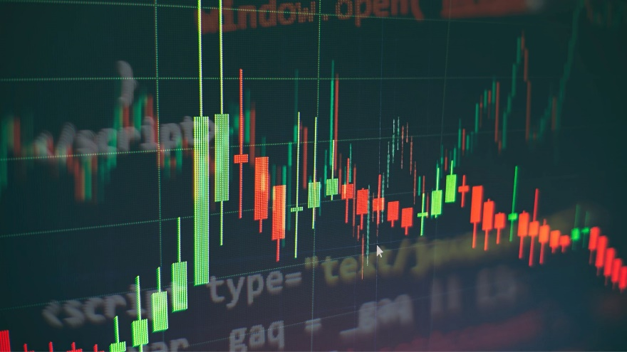

Although the empirical evidence on the CAPM is mixed, it is widely used because of the valuable insight it offers and its accuracy is deemed satisfactory for most practical applications. No wonder, the CAPM is a centrepiece of modern financial economics and William Sharpe, its principal originator, was awarded the Nobel prize in economics.

Incidentally when Sharpe submitted his paper to the Journal of Finance, it received a chilly response and one reviewer pointed out that the assumptions underlying the model were absurdly unrealistic. Undeterred, Sharpe resubmitted the paper citing Milton Friedman’s influential paper ‘Methodology of Positive Economics’ in which he argued persuasively that the value of a model depends not on the realism of its assumptions, but on the validity of its conclusions.

Many of these finance theories led to the implementation of higher load of computational requirements on data and led to the rise of Artificial Intelligence tools.



While media and public attention mostly focus on breakthroughs in areas such as gaming and self-driving cars, Artificial Intelligence (AI) has also become a major technological force in the financial industry. However, it is safe to say that AI in finance is still at a nascent stage—as compared, for example, to industries such as web search, chat-bots or social media.

Artificial Intelligence (AI) techniques are being slowly deployed in finance, in areas such as banking, robo-advisory, asset management, algorithmic trading, credit underwriting or blockchain-based finance, enabled by the abundance of available data and by affordable computing capacity. A sub-set of AI, Machine learning (ML) models use big data to learn and improve predictability and performance automatically through experience and data, without being programmed to do so by humans.

Artificial intelligence (AI) is one of the hottest topics of current times because it has disrupted most industries in recent years, and the finance industry is all set for a disruption. With the advent of Fintech, which is increasing emphasis on AI, the industry is experiencing a revolution in some of its core practices. Probably the most affected area is banking and asset management, which is expected to suffer the largest number of job cuts in the near future. A sizable proportion of banking and asset management companies are increasingly adapting to AI with statistical models running operations, risk management, trading and investment platforms. The increased use of AI across a range of tasks in asset management calls for a more systematic examination of the various techniques and applications involved, as well as the concomitant opportunities and challenges they bring to the industry.

The deployment of AI in finance is expected to increasingly drive competitive advantages for finance industry, by improving their efficiency through cost reduction and productivity enhancement, as well as by enhancing the quality of services and products offered to consumers. In turn, these competitive advantages can benefit financial consumers by providing increased quality and personalised products, unlocking insights from data to inform investment strategies and potentially enhancing financial inclusion by allowing for the analysis of creditworthiness of clients with limited credit history.

According to a study done by PricewaterhouseCoopers (PwC), Artificial Intelligence (AI) could contribute up to $15.7 trillion to the global economy by 2030, which is more than the current output of China and India combined. So, you have definitely made a great choice to study this field. Welcome to the incredible world of Artificial Intelligence in finance!



Ever since artificial intelligence became available to the public, OpenAI’s ChatGPT has been one of the go-to services for many user’s AI needs. By now, millions of people have visited the Chat GPT website, and many more continue to do so. And ChatGPT is not alone – nor is it necessarily the best option out there. There are other sites that offer similar or even better services than ChatGPT. HIX.AI, Chatsonic, Microsoft Bing, YouChat, Claude, Jasper Chat, Perplexity AI, Google Bard, Auto-GPT, Copy.ai etc are all alternatives to ChatGPT and continue to grow in competence and performance as technology progresses.

During the last decade, the pace of automation in the investment management industry has become frenetic because of Artificial Intelligence technologies deployed by large broker-dealers, institutional investment managers and others, much to the disadvantage of retail investor who could not afford such expensive systems. Industry experts estimate that as much as 75% of the daily trading volume in equities in the US is executed algorithmically, that is, by computer programs following a set of predefined rules.

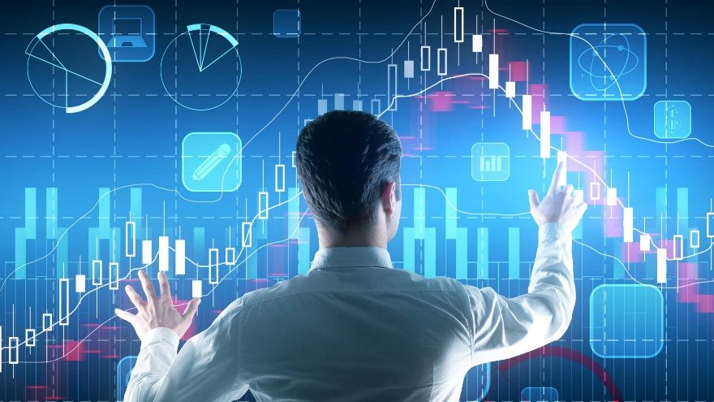In the 20th century, algorithmic trading was used by sell-side brokers to get the best execution of large trades for their clients. In the 21st century, algorithms are used in the entire trading process, from idea generation, to execution, to portfolio management. While all algorithmic trading is executed by computers, the rules for generating the trades may be designed by human beings or by machine learning algorithms using training data. Discipline in the face of gruelling markets is a key success factor in trading and investing. Emotional irrationality, behavioural biases, inability to multitask effectively, and slow execution speeds put manual trading by retail equity investors at a massive disadvantage. Retail investors are aware of these disadvantages. And there is considerable interest in algorithmic trading, especially using Python. Retail investors are now upskilling themselves and preparing for competitions by crowdsourced hedge funds such as Quantopian to fund algorithmic trading strategies developed by them.

The use of AI in trading has gone through different stages of development and corresponding complexity, adding a layer to traditional algorithmic trading at each step of the process. First-generation algorithms consisted of buy or sell orders with simple parameters, followed by algorithms allowing for dynamic pricing. Second-generation algorithms deployed strategies to break up large orders and reduce potential market impact, helping obtain better prices (so-called ‘execution algos’). Current strategies based on deep neural networks are designed to provide the best order placement and execution style that can minimize market impact (JPMorgan, 2019). Deep neural networks mimic the human brain through a set of algorithms designed to recognise patterns, and are less dependent on human intervention to function and learn (IBM, 2020). The use of such techniques can be beneficial for market makers in enhancing the management of their inventory and reduce the cost of their balance sheet. As the development of AI advances, AI algorithms evolve into automated, computer programmed algorithms that learn from the data input used and rely less on human intervention.

In practice, the more advanced forms of AI today are mostly used to identify signals from ‘low informational value’ incidents in flow-based trading, which consist of less obvious events, harder to identify and extract value from. Rather than help with speed of execution, AI is actually used to extract signal from noise in data and converts this information into decision about trades. Less advanced algorithms are mostly used for ‘high informational events’, which consist of news of financial events that are more obvious for all participants to pick up and where execution speed is of the essence.

At this stage of their development, ML-based models are therefore not aiming at front-running trades and profit from speed of action, such as HFT strategies. Instead, they are mostly confined to being used offline, for example for the calibration of algorithm parameters and for improving algorithms’ decision logic, rather than for execution purposes (BIS Markets Committee, 2020). In the future, however, as AI technology advances and is deployed in more use cases, it could amplify the capabilities of traditional algorithmic trading, with implications for financial markets. This is expected to occur when AI techniques start getting deployed more at the execution phase of trades, offering increased capabilities for automated execution of trades and serving the entire chain of action from picking up signal, to devising strategies, and executing them. ML-based algos for execution will allow for the autonomous and dynamic adjustment of their own decision logic while trading. In that case, the requirements already applied for algorithmic trading (e.g. safeguards built in pre-trading risk management systems, automated control mechanisms to switch off the algorithm when it goes beyond the limits embedded in the risk model) should be extended to AI-driven algorithmic trading.

Hedge funds have been on the leading edge of FinTech users, and use big data, AI and ML algorithms in trade execution and back office functions (Kaal, 2019). A class of ‘AI pure play’ hedge funds has emerged in recent years that are based entirely on AI and ML (e.g. Aidiyia Holdings, Cerebellum Capital, Taaffeite Capital Management and Numerai) (BNY Mellon, 2019). To date, there has been no academic or other independent review of the performance of AI-powered funds from a non-industry source, comparing the various funds claiming to be AI-driven. Fund managers use different degrees of AI in their operations and strategies and are naturally reluctant to disclose their methodologies so as to maintain their competitive advantage. While many funds may be marketing their products as ‘AI powered’, the levels at which such technologies are used by funds and the maturity of deployment of AI vary significantly, therefore making it difficult to compare performance between the different self-proclaimed AI products.

Private sector provided indices of AI-powered hedge funds demonstrate outperformance of AI-based funds over conventional hedge fund indices provided by the same source. Indices provided by third parties are prone to a number of biases, such as survivorship and self-selection bias of constituents to the index or back filling, and should be treated with caution.



However, AI applications in finance may create or intensify financial and non-financial risks, and give rise to potential financial consumer and investor protection considerations (e.g. as risks of biased, unfair or discriminatory consumer results, or data management and usage concerns). It may even increase the risk of a black swan event. The lack of explain-ability of AI model processes could give rise to potential pro-cyclicality and systemic risk in the markets, and could create possible incompatibilities with existing financial supervision and internal governance frameworks, possibly challenging the technology-neutral approach to policymaking. While many of the potential risks associated with AI in finance are not unique to this innovation, the use of such techniques could amplify these vulnerabilities given the extent of complexity of the techniques employed, their dynamic adaptability and their level of autonomy.



Emerging risks from the deployment of AI techniques need to be identified and mitigated to support and promote the use of responsible AI. Existing regulatory and supervisory requirements may need to be clarified and sometimes adjusted, as appropriate, to address some of the perceived incompatibilities of existing arrangements with AI applications.

**Typical Learning Skills required for AI**

While Artificial Intelligence is applied in cross sections of multiple industries and knowledge of such industries is essential, the usual learning skillsets the industry will demand includes some of the following, depending upon each project:

1. **Mathematics and Statistics**

Mathematics and Statistics is the foundation upon which Artificial Intelligence algorithms are built. Few concepts that could be used to build AI models are:

* Probability
* Bayes Theorem
* Distributions
* Descriptive Statistics, outlier treatment
* Confidence Interval
* Central Limit Theorem
* Hypothesis Test, AB Testing
* ANOVA
* Correlation
* EDA, Feature Engineering, Missing value treatment
* Experiment Design
* Regex, NLTK, OpenCV
* Classification
* Hyperplane
* Halfspace
* Calculus
* Optimization
* Gradient Descent
* Principal Component Analysis

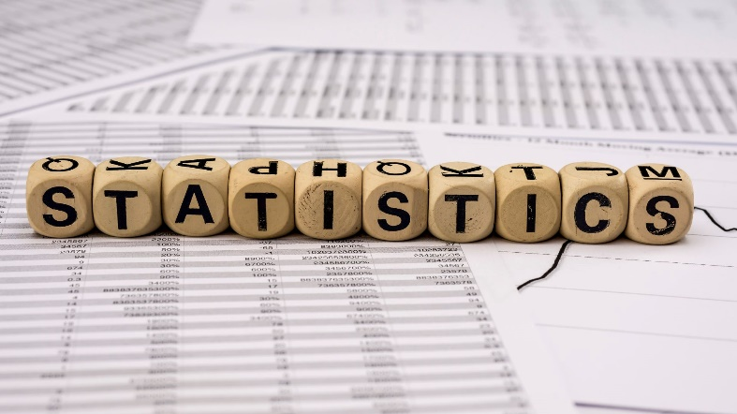

Application of Time Series in AI includes concepts such as:

* Sequential Data & Time Series
* Function Relationship
* Mathematical Representation of Time Series
* ETS Decomposition
* ACF & PACF
* AutoRegression Model
* Moving Average Model
* ARIMA Model
* SariMax of Seasonal Data
* Sequential Models
* Forecasting using Long Short Term Memory

1. **Data Science Tools**

An important step is to learn basic data science skills to get a command over the fundamentals of visualization, dash boarding & reporting of data. Let us look at few popular tools used in Data Science: Few tools that help data scientists are as follows:

**Microsoft Excel or Google Spreadsheets**

Many Statistical functions of Spreadsheets are used in AI models for data mining, data cleaning, data manipulation and data analysis.

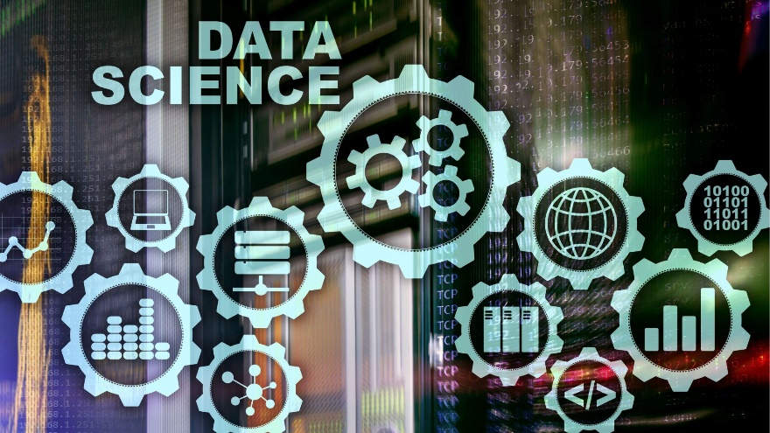

* Formula Referencing
* Basic Functions
* Sorting, Filtering and Subtotalling
* Conditional Formatting
* Pivot Table
* VLOOKUP HLOOKUP
* Macros
* Data Visualization
* Dashboard creation
* Regression

Many of these functions will get simplified after Microsoft 365 Co-Pilot is fully developed.

In the race for AI-powered productivity, Microsoft has announced and released Microsoft 365 Copilot, a tool that promises businesses to transform the way we work by allegedly unleashing creativity, unlocking productivity, and up-levelling skills. This was first set in motion by the emergence of Generative AI, which became a trending innovation topic after OpenAI introduced the now world-famous ChatGPT chatbot in November of 2022. Microsoft and OpenAI have joined forces to advance the underlying AI technology. While Microsoft is responsible for building and offering the supercomputing infrastructure, OpenAI operates its services on this infrastructure.



This Copilot is a highly sophisticated tool that leverages the power of large language models (LLMs) to enhance productivity and streamline workflows in the workplace. Utilizing the state-of-the-art GPT-4, Copilot has the capability to generate professional-grade letters and documents, provide comprehensive summaries of complex data, create visually engaging PowerPoint presentations, and perform in-depth analysis of Excel spreadsheets. Its advanced functionalities 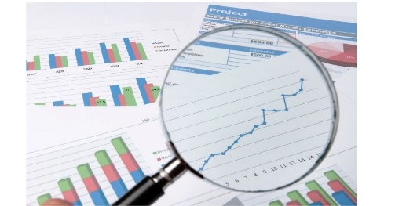include intelligent meeting outlining and summarizing, robust spreadsheet analysis, and the ability to select relevant graphics to complement presentation content. In sum, practically all stakeholders in a company will benefit from this tool in one way or another.

**Tableau/ PowerBI + Spread Sheet**

* Flowcharts, Data Types, Operations
* Conditional Statements & Loops
* Functions
* Strings
* In-build Data Structures - List, Tuples, Dictionary, Set
* Matrix Algebra, Number Systems

**SQL to extract and analyse data**

* Visual Analytics
* Charts, Graphs, Operations on Data & Calculations in Tableau/ PowerBI
* Advanced Visual Analytics & Level of Detail (LOD) Expressions
* Geographic Visualisations, Advanced Charts, and Worksheet & Workbook Formatting
* Introduction to Databases & BigQuery Setup
* Extracting data using SQL
* Functions, Filtering & Subqueries
* Joins
* GROUP BY & Aggregation
* Window Functions
* Date and Time Functions & CTEs
* Indexes & Partitioning
* Sub-Query & Joins

1. **Programming/ Coding Skills**

Multiple programming skills can assist in building Artificial Intelligence Models. There is no singular “best” language for AI. It depends on what kind of AI model you plan to implement. The following are the common programming languages applied:

1. **Python**

Although Python was created before AI became crucial to businesses, it’s one of the most popular languages for Artificial Intelligence. Python is the most used language for AI. One of the main reasons Python is so popular within AI development is that it was created as a powerful data analysis tool and has always been popular within the field of big data.

As for modern technology, the most important reason why Python is always ranked near the top is that there are AI-specific frameworks that were created for the language. One of the most popular is TensorFlow, which is an open-source library created specifically for machine learning and can be used for training and inference of deep neural networks.



Basics of Python coding includes:

* Variables & Data Types
* Operators
* Control Structure
* Looping Controls
* Functions
* Object Oriented Programming
* File Handling
* Exception Handling
* Regular Expression & Web Scraping

Other AI-centric frameworks include:

* scikit-learn – for training machine learning models.
* PyTorch – visual and natural language processing.
* Keras – serves as a code interface for complex mathematical calculations.
* Theano – library for defining, optimizing, and evaluating mathematical expressions.

Python is also one of the easiest languages to learn and use. Python Libraries that is important for AI:

* Python Refresher
* Numpy, Pandas
* Matplotlib
* Seaborn
* Data Acquisition
* Exploratory Data Analysis
* Web API & Web Scrapping
* Beautifulsoup & Tweepy

Advance Python features are good to know such as:

* Basics of Time & Space Complexity
* OOPS
* Functional Programming
* Exception Handling & Modules

1. **Lisp**

Lisp has been around since the 60s and has been widely used for scientific research in the fields of natural languages, theorem proofs, and solving artificial intelligence problems. Lisp was originally created as a practical mathematical notation for programs but eventually became a top choice of developers in the field of AI.

Even though Lisp is the second oldest programming language still in use, it includes several features that are critical to successful AI projects:

* Rapid prototyping.
* Dynamic object creation.
* Mandatory garbage collection.
* Data structures can be executed as programs.
* Programs can be modified as data.
* Uses recursion as a control structure and not iteration.
* Great symbolic information processing capabilities.
* Read-Eval-Print-Loop to ease interactive programming.

More importantly, the man who created Lisp (John McCarthy) was very influential in the field of AI, so much of his work had been implemented for a long time.



1. **Java**

Since many Mobile and Web Apps use AI, Java is indispensable programming language used to apply AI.

Not only can Java work with TensorFlow, but it also has other libraries and frameworks specifically designed for AI:

* Deep Java Library – a library built by Amazon to create deep learning abilities.
* Kubeflow – makes it possible to deploy and manage Machine Learning stacks on Kubernetes.
* OpenNLP – a Machine Learning tool for processing natural language.
* Java Machine Learning Library – provides several Machine Learning algorithms.
* Neuroph – makes it possible to design neural networks.

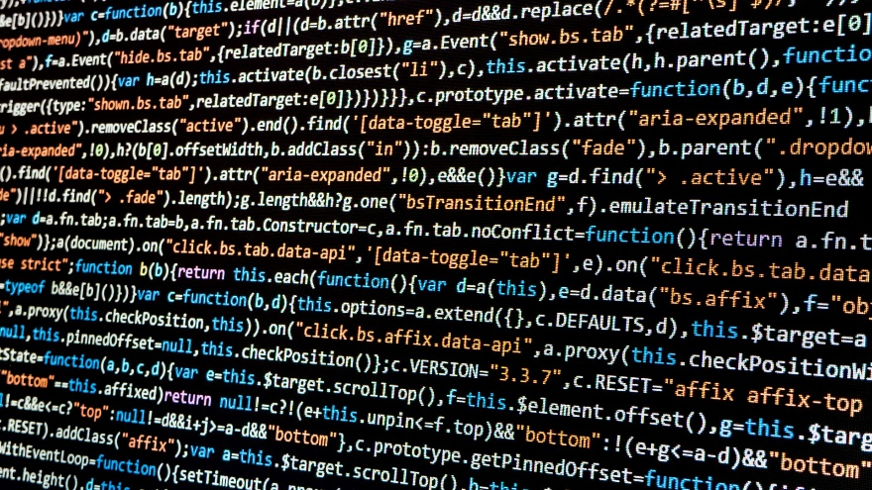Java also makes use of simplified debugging, and its easy-to-use syntax offers graphical data presentation and incorporates both WORA and Object-Oriented patterns.

1. **C++**

C++ is another language that has been around for quite some time, but still is a legitimate contender for AI use. One of the reasons for this is how widely flexible the language is, which makes it perfectly suited for resource-intensive applications. C++ is a low-level language that provides better handling for the AI model in production. And although C++ might not be the first choice for AI engineers, it can’t be ignored that many of the deep and machine learning libraries are written in C++.

And because C++ converts user code to machine-readable code, it’s incredibly efficient and performant.

* AI speech recognition implementation.
* Deep learning libraries – e.g. MapReduce, mlpack, and MongoDB.
* C++ Builder – a rapid application development environment.

1. **R**

R is extremely important for statistical analysis and fantastic at crunching very large numbers, which makes it better than Python at scale. And with R’s built-in functional programming, vectorial computation, and Object-Oriented Nature, it does make for a viable language for Artificial Intelligence.

R also enjoys a few packages that are specifically designed for AI:

* gmodels – provides several tools for the task of model fitting.
* TM – a framework used for text mining applications.
* RODBC – an ODBC interface.
* OneR – makes it possible to implement the One Rule Machine Learning classification algorithm.

1. **Julia**

Julia is one of the newer languages on the list and was created to focus on performance computing in scientific and technical fields. Julia includes several features that directly apply to AI programming:

* Common numeric data types.
* Arbitrary precision values.
* Robust mathematical functions.
* Tuples, dictionaries, and code introspection.
* Built-in package manager.
* Dynamic type system.
* Ability to work for both parallel and distributed computing.
* Macros and metaprogramming capabilities.
* Support for multiple dispatches.
* Support for C functions.

Julia can also be integrated with TensorFlow.jl, MLBase.jl, and MXNet.jl.

1. **Haskell**

A functional, readable, statically-typed language, Haskell offers a number of capabilities that make it a solid choice for AI programming. For one, it allows developers to describe algorithms explicitly and succinctly. It also provides type safety and seamless multicore parallelism. Additional notable features include:

* Lazy evaluation capacities – enable definitions of infinite data structures.
* HLearn library – includes machine learning algorithm implementations.
* Ideal for machine learning.

1. **Prolog**

Easy pattern matching and list handling are notable features of Prolong, which stands for programming in logic. These features make the logic language a good choice for AI. Prolong is especially ideal in cases where developers need to focus on problems because the language can execute the program using its search tools. In particular, facets and tools that make Prolong a dependable AI language are:

* Declarative nature – enables programmers to declare rules and facts when writing AI programs.
* Intelligent database retrieval.
* Natural language processing.
* System that is simple to use.
* Tree-based data structuring.
* Knowledge representation.

1. **Scala**

Scala is a user-friendly, dependable language, but that’s just part of why developers apply it to AI. It’s a good choice for building machine learning algorithms and gleaning insights from large datasets, as well as managing complex content in general. It also has features like:

* Smile – a data science library with algorithms for actions like classification.
* ****An abundance of frameworks and libraries like BigDL and Breeze.

1. **Data Science Skills**

**Big Data Engineering**

* 5 V's of Big Data
* Need of Big Data Analytics
* Type of Big Data Analytics
* Problem with Big Data Analytics
* Hadoop Ecosystem
* Hadoop Architecture
* HDFS Master Slave Architecture
* MapReduce
* Data Analysis with Pig & Hive
* Architecture of Pig
* Components of Pig
* Commands of Pig
* Architecture of Hive
* Data Model of Hive
* Hive Commands

**Advanced Data Structures & Algorithms**

* Arrays
* Linked Lists
* Stacks & Queues
* Trees
* Tries & Heaps
* Searching & Sorting Algorithms
* Recursion
* Hashing & 2 pointers

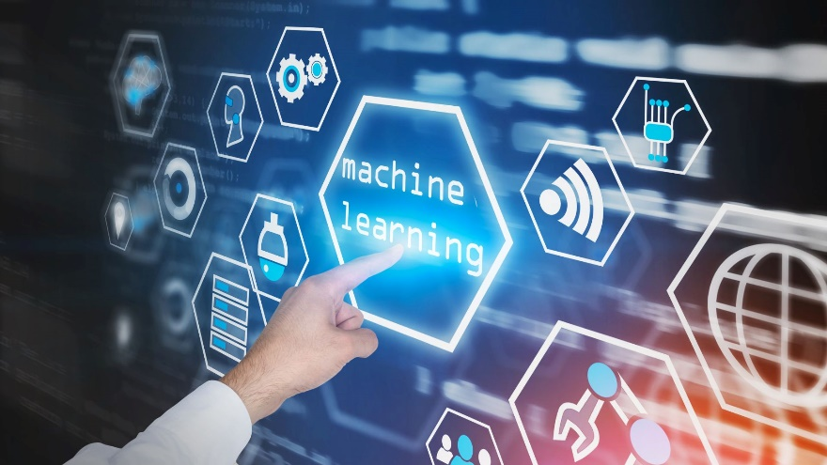

**Machine Learning Data Ops**

* Streamlit
* Flask
* Containerisation, Docker
* Experiment Tracking
* MLFlow
* CI/CD
* Github Actions
* ML System Design
* AWS Segemaker, AWS Data Wrangler, AWS Pipeline
* Apache Spark
* Spark ML lib

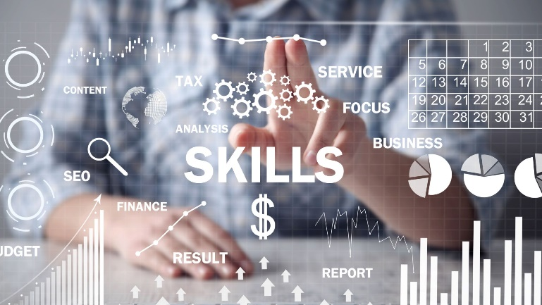

1. **AI Skills**

**Machine Learning – Supervised**

* MLE, MAP, Confidence Interval
* Classification Metrics
* Imbalanced Data Decision Trees
* Bagging & Boosting
* Naive Bayes
* Support Vector Machine

**Machine Learning – unsupervised**

* EDA & Pre-processing
* Time Series Analysis and Logistic Regression
* Support Vector Machine
* Introduction to Clustering, k-Means
* k-Means ++, Hierarchical, K-Nearest Neighbors
* GMM
* Anomaly/ Outlier/ Novelty Detection
* PCA, t-SNE
* Recommender Systems
* Random Forest
* Principle Component Analysis
* Association Rule



**Neural Networks**

* Perceptrons
* Neural Networks
* Hidden Layers
* Tensorflow
* Keras
* Forward & Backward Propagation
* Multilayer Perceptrons (MLP)
* Callbacks
* Tensorboard
* Optimization
* Hyperparameter tuning
* Gradient Descent
* Activation Functions
* Dropout



**Computer Vision**

* Convolutional Neural Nets
* Data Augmentation
* Transfer Learning
* Flatten & Fully Connected Layer
* CNN
* CNN Hyperparameters Tuning & BackPropagation
* CNN Visualization
* Popular CNN Architecture - Alex, VGG, ResNet, Inception, EfficientNet, MobileNet
* Object Segmentation, Localisation, & Detection
* Face Detection
* Object Tracking
* Text Recognition
* YOLO

**Natural Language Processing**

* Text Processing & Representation
* Tokenization, Stemming, Lemmatization
* Vector space modelling, Cosine Similarity, Euclidean Distance
* POS tagging, Dependency Parsing
* Topic Modelling, Language Modelling
* Embeddings
* Recurrent Neural Networks
* Information Extraction
* Long Short Term Memory
* Named Entity Recognition
* Text Classification using ANN
* Sentiment Analysis
* Sequence Model
* Gated Recurrent Unit
* Bi-directional & Multi-directional GRU
* Transformers Based Models
* Attention Mechanism
* Face Hugging Transformers
* RASA Configuration
* Intent Entity Response Story
* Action module

**Generative AI**

* Generative Models, GANs
* Attention Models
* Siamese Networks
* Advanced CV
* Attention
* Transformers
* HuggingFace
* BERT

It is usually impossible for one person to have all the skillsets above at a professional level and thus, AI Solutions are built by a team of experts in their own field coming together for each project. However, academic level knowledge helps computer engineers in understanding AI and be part of a team that can successfully develop the AI solutions.

### CHAPTER – 2:

### AI SYSTEMS AND USE of BIG DATA

AI systems are machine-based systems with varying levels of autonomy that can, for a given set of human-defined objectives, make predictions, recommendations or decisions using massive amounts of alternative data sources and data analytics referred to as ‘big data’. ML models are able to learn from these data sets to ‘self-improve’ without interference from humans.

An AI system, is a machine-based system that can, for a given set of human-defined objectives, make predictions, recommendations or decisions influencing real or virtual environments. It uses machine and/or human-based inputs to perceive real and/or virtual environments; abstract such perceptions into models (in an automated manner e.g. with ML or manually); and use model inference to formulate options for information or action. AI systems are designed to operate with varying levels of autonomy.

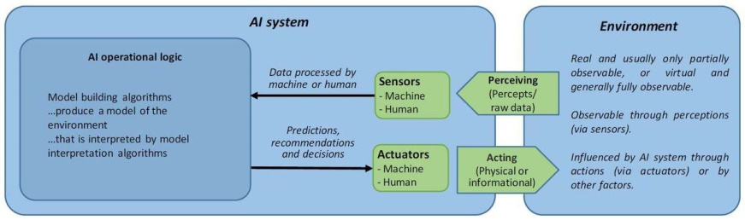

The AI system lifecycle phases are (i) planning and design, data collection and processing, and model building and interpretation; (ii) verification and validation; (iii) deployment; and (iv) operation and monitoring. An AI research taxonomy distinguishes AI applications (e.g. NLP); techniques to teach AI systems (e.g. neural networks); optimisation (e.g. one-shot-learning); and research addressing societal considerations (e.g. transparency).

ML is an AI subset and describes the ability of software to learn from applicable data sets to ‘self-improve’ without being explicitly programmed by human programmers (e.g. image-recognition, prediction of borrower default, fraud and AML detection). The different types of ML include: supervised learning (‘classical’ ML, consisting of advanced regressions and categorization of data used to improve predictions) and unsupervised learning (processing input data to understand the distribution of data to develop, for example, automated customer segments); and deep and reinforcement learning (based on neural networks and may be applied to unstructured data like images or voice). To date, AI applications in finance mostly make use of ML techniques, such as statistical learning, and thus the AI label applies only in a very broad sense (e.g., Gu, Kelly, and Xiu 2020). Moreover, a large part of what is branded as AI (or ML) in finance is not new but has existed in the form of statistical or econometric modelling techniques for a long time.

**Illustration of AI subsets**

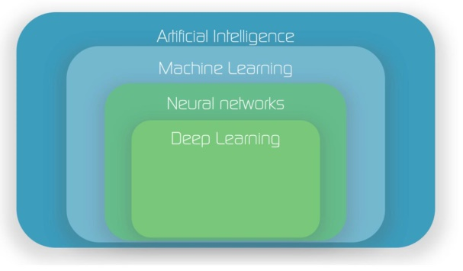

*Source:* (Hackermoon.com, 2020)*.*

Deep learning neural networks are modelling the way neurons interact in the brain with many (‘deep’) layers of simulated interconnectedness. Such models use multi-layer neural networks to learn and recognise complex patterns in data, inspired by the way the human brain works. Deep learning models can recognise and classify input data without having to write specific rules (no need to specify specific detectors), and can identify new patterns that no human being would have anticipated or developed (Krizhevsky, Sutskever and Hinton, 2017). Such networks are thought to have higher tolerance of noise and can operate at multiple layers of generality from sub features.

ML models use massive amounts of alternative data sources and data analytics that is referred to as ‘big data’. The term big data was first coined in the early 2000s when Big Data was used to describe “the explosion in the quantity (and sometimes, quality) of available and potentially relevant data, largely the result of recent and unprecedented advancements in data recording and storage technology”. The ecosystem of big data encompasses data sources, software, analytics, programming and statistics, and data scientists who synthesise the data to signal out the noise and produce intelligible outputs.

**The four Vs of Big Data**

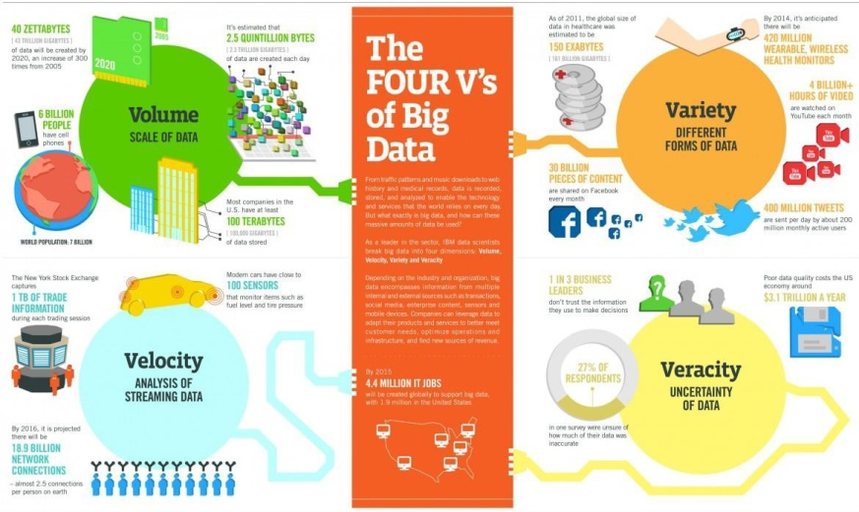Source: (IBM, 2020).

Attributed characteristics of big data include the ‘4Vs’: volume (scale of data); velocity (high-speed processing and analysis of streaming data); variety (heterogeneous data), and veracity (certainty of data, source reliability, truthfulness), as well qualities including exhaustivity, extensionality, and complexity. Veracity is of particular importance as it may prove difficult for users to assess whether the dataset used is complete and can be trusted, and may require assessment on a case- by-case basis.

Big data can include climate information, satellite imagery, digital pictures and videos, transition records or GPS signals, and personal data: a name, a photo, an email address, bank details, posts on social networking websites, medical information, or a computer IP address. Such data challenge existing methods due to size, complexity, or rate of availability and requires advanced digital techniques, such as ML models to analyse them. Increased use of AI in IoT applications are also generating significant sums of data, feeding back into AI applications.

### Big data sources

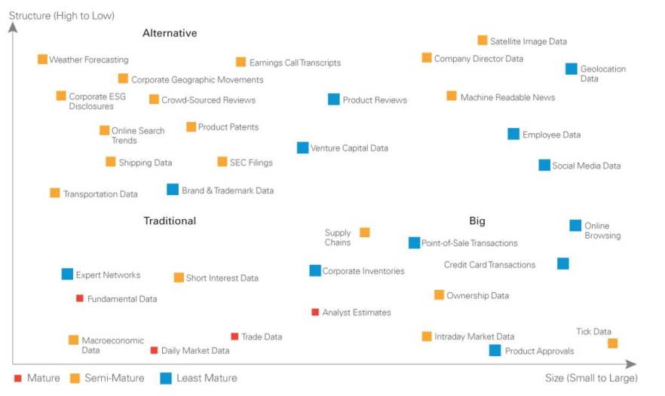Source: Dell Technologies.

Greater data availability allows ML models to perform better because of their ability to learn from the examples fed into the models in an iterative process referred to as training the model (US Treasury, 2018).

#### AI System lifecycle

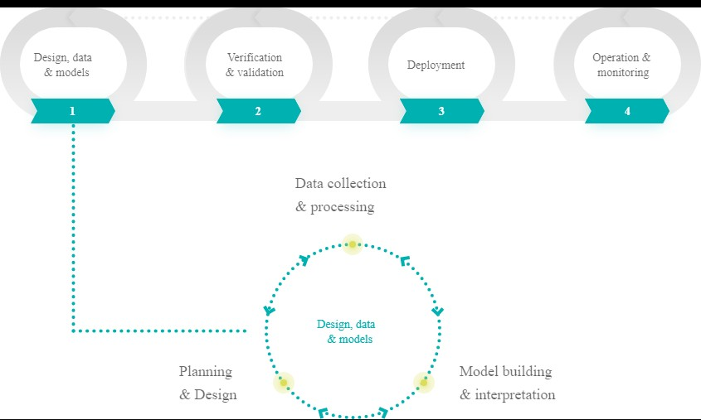

Although an extensive list of techniques can accomplish automation, most ML applications in finance, rely on a number of major (classes of) techniques These include artificial neural networks (ANNs), cluster analysis, decision trees and random forests, evolutionary (genetic) algorithms, least absolute shrinkage and selection operator (LASSO), support vector machines (SVMs), and natural language processing (NLP).

The interest of academic research in specific AI techniques has steadily increased in the past two decades, as illustrated by the number of published papers on the subject. Some of these techniques, such as evolutionary algorithms or neural networks, were established research topics long before ML gained popularity. On the other hand, SVMs and NLP have gained interest more recently. Neural network, random forest, and NLP techniques have experienced the sharpest increase in their mention in published papers during the past five years.

One can really trick oneself with statistical models, even a transparent model like a linear regression. If say you do stepwise regression, it's really easy to convince yourself that the direction of the coefficients make sense. And then all of a sudden, they start flipping when you change some variables. And then you start rationalising again why they're in that direction. So when you move into more nonlinear models that can even get more dangerous to build AI Algorithms in finance. So for a lot of people, the best approach to that is to start with the financial hypothesis and use the data to test that hypothesis and don't just data mine to look for patterns. And then also, instead of trying to use AI to predict prices or to predict returns, you can use it to create new data that could be input into another model. And so there's this misconception that AI means that the robots are just going to take control of the whole process and run amuck and the humans are going to be out of the loop. This cannot occur until the AI tools stabilise. Again there can be no permanent stabilisation as markets change and there can be new data set influencing financial decisions and the AI tolls will keep undergoing constant change over a period of time. Thus there is always going to be collaboration between humans and machines. There is a good analogy of this in generative art, which is becoming popular. It is basically the process of a computer being part of the creative process and generating visual arts, text or music. The question mark here is should be who gets the credit? the machine or the artist who used the generative code? And the idea is that the artist is controlling how much randomness to give the automated process. They're controlling the constraints. They're controlling the direction that the whole process takes in the first place. This is similar to the financial modelling process. Thus, humans don't just let the computer data mine away and find any pattern that they want. One has to have the domain knowledge to make the machines smarter so that these machines can make the humans smarter. The problem of applying AI to finance is not too dissimilar to the problem of applying AI to other fields. Some major breakthroughs in AI in the 2010s were made possible by the application of reinforcement learning (RL) to playing arcade games, such as those from Atari published in the 1980s (see Mnih et al. 2013), and to board games, such as chess or Go (see Silver et al. 2016). Learnings from applying RL in gaming contexts, among other areas, are today applied to such challenging problems as designing and building autonomous vehicles or improving medical diagnostics. The table below compares the application of AI and RL in different domains:

|  |  |  |  |  |  |
| --- | --- | --- | --- | --- | --- |
| **Area** | **Goal** | **Approach** | **Carrot/ Stick Policy** | **Obstacle** | **Risks** |
| Autonomous Driving | Safe driving | RL in virtual learning environment | Punishment for mistakes | Transition from virtual to physical world | Life and property threatening |
| Arcade Games | Max score | RL in virtual gaming environment | Points and scores | Planning and delayed rewards | Addiction |
| Financial Trading | Maximizing long-term performance | RL in virtual trading environment | Financial returns | Efficient markets & competition | Financial losses |

The most interesting part of training the AI software agents in arcade games lies in the availability of a perfect virtual learning environment and the absence of any major risk, except for social evils like addiction. With autonomous vehicles, the major problem arises when transitioning from virtual learning environments—for example, a computer game such as Grand Theft Auto—to the physical world with a self-driving car navigating real streets populated by other cars and people. This leads to serious risks such as a car causing accidents or harming people.

For a trading bot, RL can also be completely virtual, that is, in a simulated financial market environment. The major risks that arise from malfunctioning trading bots are financial losses and, on an aggregated level, potential systematic risks due to herding by trading bots. The systems can put a limit on the financial losses it is ready to assume. Thus, financial markets are an ideal place to train, test, and deploy AI algorithms.

### CHAPTER – 3:

### WHY USE AI?

Artificial Intelligence has an enormous impact and has surpassed humans in many fields, from gaming to computer vision to self-driving cars. Artificial Intelligence can create a competitive edge to extract actionable insights in the complex framework of the financial markets with their ever-changing dynamic nature, hundreds of noisy factors affecting performance, and non-linear interactions. There are no areas in investing, from modelling returns to reducing risk to even reducing costs, where AI does not have a better solution than a human.

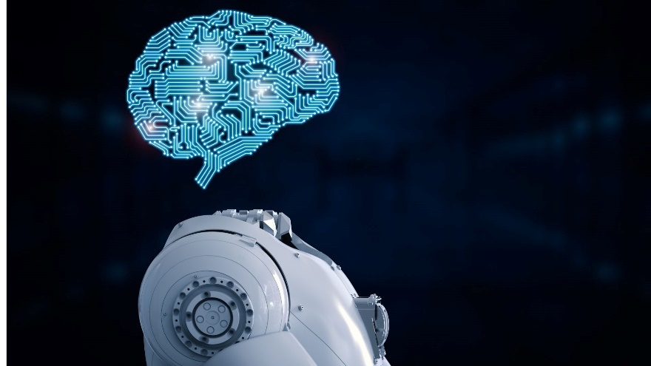

When used in trading, AI adds a layer of complexity to conventional algorithmic trading, as the algorithms learn from data inputs and dynamically evolve into computer-programmed algos, able to identify and execute trades without any human intervention. In highly digitised markets, such as equities and debt, AI algorithms can enhance liquidity management and execution of large orders with minimal market impact, by optimising size, duration and order size in a dynamic fashion, based on market conditions. Traders can also deploy AI for risk management and order flow management purposes to streamline execution and produce efficiencies.

Artificial Intelligence is nascent in India and but booming in investment industry. Artificial intelligence has the edge over traditional investment models and manual investment management. It can process large datasets and extract actionable insights, accounting for the complex non-linear interactions between the hundreds of economic and financial variables. As the new set of investors and the new asset managers are more data-driven and influenced by AI, we anticipate seeing the investing field evolve to be more efficient and rewarding.



The application of AI in the Indian investment industry is still at an early stage – with some traders utilising AI as a partial input into their trading process (retaining their discretionary control over investing and risk management) whilst others, ‘pure AI traders’, have outsourced both the trading and risk management aspect to the machine with minimal input from human intervention. This variability in the application of AI in the investment space mirrors its development in other industries as well; such as transport sector where a fully reliable self-driven car is yet to hit the roads. The challenge will lie in successfully showcasing the ability of the machine in meaningful learning.

A new study has recently found that hedge funds in US with the highest level of automation outperform those that rely more on human involvement. During the period that was studied (2006 to 2021), the AI-based hedge funds generated average returns of about 0.75% per month, vs. about 0.25% per month for the human-guided hedge funds. The study, called “Man Versus Machine: On Artificial Intelligence and Hedge Funds Performance,” was written by researchers from Texas A&M University and Finland’s University of Vaas. The data was sourced from Prequin and funds classified based on automation. The least automated of the four fund categories were the “discretionary funds,” which rely mostly on mechanical trading rules performed by humans. These funds place a greater emphasis on managers in general, specifically their professionalism and skill. The second-least automated type is the “systematic fund,” which typically uses a sophisticated quantitative framework based on statistical methods. This class was followed by “combined funds,” which for example emphasize a systematic trading style, but manually choose when trades are closed. And the most automated of the four hedge fund categories are the “AI-ML funds.” These AI-ML funds “are simply given an input along with a desired output, and the model itself determines the best course of action via a mathematical function.” Of the 826 funds in the researchers’ sample, they identified 36 as AI-ML funds. Curiously, the authors also found that the so-called “combined funds,” with a medium level of both automation and human involvement, performed the worst among the four types of hedge fund strategies.

In a note in June 2023, the global markets team at Capital Economics moved up its year-end forecast for the US S&P 500 from 4,500 to 5,500 in 2024 and from 5,000 to 6,500 in 2025. A key driver behind that surge higher will be artificial intelligence, it said. "We think investors' enthusiasm about AI has room to grow even further over the next couple of years," Capital Economics senior markets economist Thomas Mathews wrote. "New technologies – even those that have turned out to be genuinely transformative – have often manifested in the inflation of 'bubbles' in stock prices in the past. We are increasingly of the view that we're seeing something similar now or, at the very least, that we are in a period in which enthusiasm about AI technology could grow further and provide a strong tailwind for equity indices more broadly." Goldman Sachs strategist Ryan Hammond wrote in a note in June 2023 - "We assume that widespread AI adoption occurs in 10 years and lifts trend real GDP growth by 1.1% for 10 years. In this scenario, earnings per share in 20 years would be 11% greater than our current assumption and the S&P 500 fair value would be 9% higher than today, holding all else equal".

AI is used in diverse set of areas such as:

**Managing large orders and high frequency trading** -In highly digitised markets, AI algorithms can enhance liquidity management, exploit arbitrage opportunities and execute large orders with minimal market impact, by optimising size, duration and order size in a dynamic fashion.

**Alpha Generation** – One of the main aims of an investor is to generate excess returns or beat the index, and an AI-driven investor wants to exceed the returns of a traditional investor to justify the costs of developing AI models. Machine Learning algorithms can better model the non-linear nature of diverse financial datasets and extract more accurate and actionable insights on alpha generation.

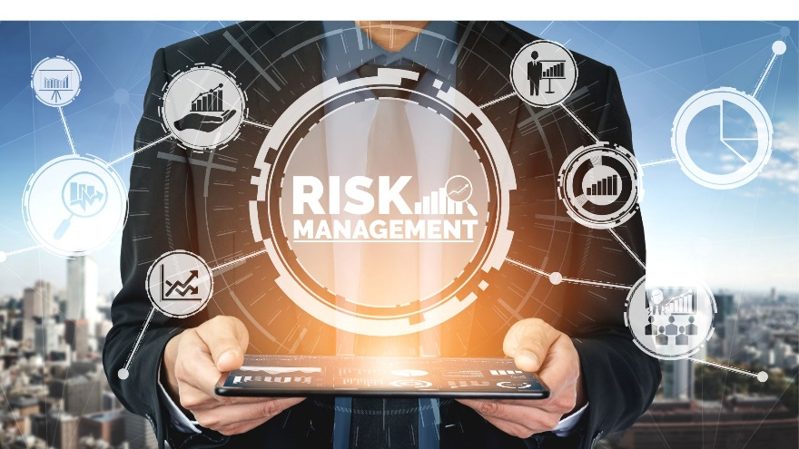

**Managing Risk** – Risk is as unpredictable as returns in the financial markets, and AI has wide applicability in risk management. Traders can deploy AI for risk management and order flow management purposes to streamline execution and produce efficiencies. Artificial intelligence models can predict the changing volatility patterns and market regimes to optimise the portfolio/ asset allocation model to safeguard capital and improve risk adjusted return on capital.

**Extracting Alternative Information** – An exciting new area of investing where AI plays a significant role in extracting information from unstructured data. For example, pulling sentiment out of social media channels, mainframe news channels or technical analyst recommendations or consensus estimates from analyst notes, drawing information about a company based on blogs or geographic activity data.

**Operational Efficiency** – Last but not least, Artificial Intelligence techniques can enhance the user experience by empowering asset managers to understand user requirements better and get better insights using big-data analytics.

**Speech and Image recognition -** Convert speech to text to improve your service with insights from customer interactions, such as contact center sales calls, and drive better customer service experiences. Derive insights from images and videos to accelerate insurance claims processing by assessing damage to property such as real estate or vehicles, or expedite customer onboarding with KYC-compliant identity document verification.



**Sentiment analysis -** Identify sentiment in a given text with prevailing emotional opinion using natural language AI, such as investment research, chat data sentiment, and more.

**Anomaly detection -** Detect anomalies, such as fraudulent transactions, financial crime, spoofing in trading, and cyber threats.

**Recommendations -** Deliver highly personalized recommendations for financial products and services, such as investment advice or banking offers, based on customer journeys, peer interactions, risk preferences, and financial goals.

**Translation -** Make your content, such as financial news, and apps multilingual with fast, dynamic machine translation at scale to enhance customer interactions and reach more audiences wherever they are.



**Conversations -** Delight your customers with human-like AI-powered contact center experiences, such as banking concierge or customer center, to lower costs, and free up your human agents' time. Transform personal finance and give customers more ways to manage their money by bringing smart, intuitive experiences to your apps, websites, digital platforms, and virtual tools.

**Data science and analytics -** Access a complete suite of data management, analytics, and machine learning tools to generate insights and unlock value from data for business intelligence and decision making.

**Predictive modelling -** Use data customer, risk, transaction, trading or other data insights to predict specific future outcomes with high degree of precision. These capabilities can be helpful in fraud detection, risk reduction, and customer future needs’ prediction.



**Cybersecurity -** Automate aspects of cybersecurity by continuously monitoring and analyzing network traffic to detect, prevent, and respond to cyberattacks and threats.

**Generative AI -** Build new AI-powered search and conversational experiences by creating, recommending, synthesizing, analyzing, and engaging in a natural and responsible way. Watch this demo to see how a financial services firm is transforming the search experience for employees.

The use of AI and ML in asset management has the potential to increase the efficiency and accuracy of operational workflows, enhance performance, strengthen risk management, and improve the customer experience (Blackrock, 2019) (Deloitte, 2019). Natural Language Generation (NLG), a subset of AI, can be used by financial advisors to ‘humanise’ and simplify data analysis and reporting to clients (Gould, 2016). As ML models can monitor thousands of risk factors on a daily basis and test portfolio performance under thousands of market/economic scenarios, the technology can enhance risk management for asset managers and other large institutional investors. In terms of operational benefits, the use of AI can reduce back-office costs of investment managers, replace manually intensive reconciliations with automated ones, and potentially reduce costs and increase speed.



Feeding ML models with big data can provide asset managers with recommendations that influence decision-making around portfolio allocation and/or stock selection, depending on the type of AI technique used. Big data has replaced traditional datasets, which are now considered a commodity easily available to all investors, and is being used by asset managers to gain insights in their investment process. For the investment community, information has always been key and data has been the cornerstone of many investment strategies, from fundamental analysis to systematic trading and quantitative strategies alike. While structured data was at the core of such ‘traditional’ strategies, vast amounts of raw or unstructured/semi-structured data are now promising to provide a new informational edge to investors deploying AI in the implementation of their strategies. AI allows asset managers to digest vast amounts of data from multiple sources and unlock insights from the data to inform their strategies at very short timeframes.

The use of AI/ML and big data used to be reserved to larger asset managers or institutional investors who have the capacity and resources to invest in AI technologies, possibly introducing a barrier for the adoption of such techniques by smaller actors. Investment in technology and in talent is required to transform and explore vast amounts of unstructured new datasets of big data and build ML models. To the extent that the deployment of AI and proprietary models provides a performance edge against competition, this may, in turn, result in restricted participation by smaller players who cannot adopt in-house AI/ML techniques or use big data information sources. This could potentially reinforce the trend of concentration in a small number of larger players that is being observed in the hedge fund industry, as bigger groups outpace some of their more nimble rivals (Financial Times, 2020).

Restricted participation by smaller players would persevere at least until the industry reaches a point where such tools become ubiquitous/provided as a service by third party vendors. At the same time, third party datasets may not be held at the same standard across the industry, and users of third party tools will have to build confidence as to the accuracy and trustworthiness of data used (‘veracity’ of big data) so as to reach a level of comfort sufficient for them to adopt them.

The use of the same AI models by a large number of asset managers could lead to herding behaviour and one-way markets, which may raise potential risks for liquidity and the stability of the system particularly in times of stress. Market volatility could increase through large sales or purchases executed simultaneously, giving rise to new sources of vulnerabilities.



It could be argued that the deployment of AI/ML and big data in investing could somehow reverse the trend towards passive investing. If the use of such innovative technologies proves to be alpha generating in a consistent manner that suggests some level of cause-and-effect relationship between the use of AI and the superior performance (Blackrock, 2019) (Deloitte, 2019), the active investment community could leverage this opportunity to reinvigorate active investing and provide alpha-adding opportunities to their clients.

Given the rapid developments in the AI tools and big data being made available by the media coupled with learnings from popular programmes like Python or R language, young and ambitious students, equipped with a notebook and internet access, can successfully develop and apply AI in a financial trading context.

Hitherto, the biggest complication for spending in AI systems to be deployed for the investment industry in India had been lack of adequate regulations like developed markets for ‘market abuse’. Investors and developers do not want to take a risk on developing expensive technology stacks and then get stonewalled by new regulations that may come in near future in India.



In February 2023, Securities and Exchange Board of India (SEBI) issued a consultation paper to propose an institutional mechanism that will require stock brokers to put in place systems for detection and prevention of market abuse. India does not have any regulatory provisions that cast responsibility on brokers to have a system to prevent market abuse.

SEBI also listed out probable instances of fraud or market abuse which a broker's system should be equipped to monitor. The probable instances can include creation of misleading appearance of trading, price manipulation, front running, and insider trading and mis-selling.

In May, 2023, SEBI proposed that asset management companies (AMCs) should establish measures to prevent market abuse and fraudulent transactions and also suggested that senior management of AMCs should be responsible for detecting and reporting any misconduct by employees, dealers, stock brokers, or related entities.

A stable regulatory mechanism being promulgated in the current year in India will increase AI tools for trading and investments as clarity for ethical and legit business helps traders to make long term investments in developing the hardware and software for the business.

Most often, data used in AI Models belongs to time series data. A time series is a series of data points indexed in time. Usually, a time series is a sequence taken at successive, equally spaced points in time: a sequence of discrete-time data. Examples of time series are heights of ocean tides, counts of sunspots, and the daily closing value of the Nifty 50. Historical data in this context is time series data from the past. It is one of the most important and the most valuable parts for forecasting about future prices. There are some publicly available datasets online, but usually, that data doesn’t contain a lot of features—it’s usually 1-day interval data, 1-hour interval data, or 1-minute interval data.

Smaller intervals mean more time series data in a fixed period—in one year there are 365 (or 366) days, so there are a maximum of 365 (or 366) data points available. Each day has 24 hours, so in one year there are 8,760 (or 8,784) hourly data points available, and each day has 86,400 minutes, so in one year there are 525,600 (or 527,040) minute data points available.

With more data, more information is available, and with more information, it is possible to make better conclusions about what will happen in the next time period—assuming, of course, that the data consists of a good enough feature to generalize well. The stock price data of say 2007-09 or Covid period in 2020, at the height of a crisis, is biased and probably not relevant for making price predictions. Other variables and data points are necessary to predict such black swan events. With a smaller time interval, it is easier to predict what will happen next because of a lot of data points in a fixed interval. Mathematically, it is easier to predict what will happen in the next nanosecond if we have all the data points for every nanosecond in a fixed n-year interval than what will happen on the stock market next year if we have all n data points for every year in a fixed n-year interval.

However, that doesn’t mean that, assuming a rapid series of short-term predictions is right, the long-term prediction should also be right. Each prediction introduces error and, by chaining multiple predictions, the long-term prediction will contain a significant amount of error in the end and will be useless.

There is a special type of deep learning architecture that is suitable for time series analysis: recurrent neural networks (RNNs), or even more specifically, a special type of recurrent neural network: long short-term memory (LSTM) networks. LSTMs are capable of capturing the most important features from time series data and modelling its dependencies. PyTorch framework, written in Python, is usually used to train the model, design experiments, and draw the results.

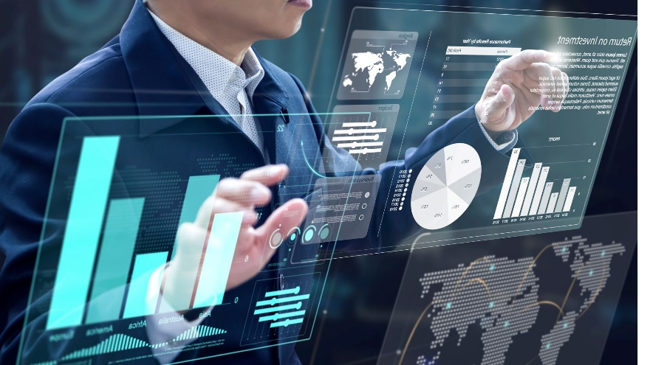

Investment industry related data is highly nonlinear and sometimes securities price data can even seem completely random. Traditional time series methods such as ARIMA and GARCH models are effective only when the series is stationary, which is a restricting assumption that requires the series to be pre-processed by taking log returns (or other transforms). However, the main issue arises in implementing these models in a live trading system, as there is no guarantee of stationarity as new data is added. This is combated by using neural networks, which do not require any stationarity to be used. Furthermore, neural networks by nature are effective in finding the relationships between data and using it to predict (or classify) new data.

As a concept, the artificial neural network has been around for a long time, but the hardware wasn’t good enough to allow fast experiments in deep learning. NVIDIA helped revolutionize deep learning networks a decade ago, as it started offering very fast graphics processing units (GPUs) for general purpose computing in Tesla-series products. Instead of shading polygons in games and professional design applications, highly parallelized GPUs can compute other data as well and, in many cases, they’re vastly superior to CPUs.

NLP approaches are capable of extracting economically meaningful informa- tion from various sources of text, such as corporate annual reports (Azimi and Agrawal 2019), news articles (Schumaker and Chen 2006; Ke, Kelly, and Xiu 2019), and Twitter posts (Sprenger, Sandner, Tumasjan, and Welpe 2014). Unlike more traditional textual analysis techniques, such as dictionary-based approaches that extract information only from individual words in the text, AI approaches can also interpret context and sentence structure.

LASSO regression can automatically select the factors with the highest explanatory power for future returns from a large set of return-predictive sig- nals documented in the literature (Feng, Giglio, and Xiu 2017; Freyberger, Neuhierl, and Weber 2018). The LASSO framework can also be used to find lead–lag relationships between asset groups or markets. For example, one can investigate which domestic industry or market returns are the most significant predictors of returns among all other markets or industries (Rapach, Strauss, and Zhou 2013; Rapach, Strauss, Tu, and Zhou 2019). More-generalized versions of LASSO regression, known as “elastic nets,” complement LASSO’s variable selection feature by also ensuring that estimated coefficients are not disproportionately large (e.g., Gu et al. 2020). In addition, AI models can be used to identify stocks expected to outperform or underperform, using a range of economic or firm-level variables. The results of these analyses can then be incorporated into the portfolio optimization process by allocating more (less) weight to assets with high (low) alpha. Beyond using historical data, training AI using actual experts’ stock buy or sell recommendations (Bew, Harvey, Ledford, Radnor, and Sinclair 2019; Papaioannou and Giamouridis, forthcoming) has also been successful.

Across AI techniques available for return prediction, ANNs have been found to perform best compared with ordinary least squares regression, elastic nets, LASSO regressions, random forests, and gradient boosted regression trees (Gu et al. 2020). In fact, the out of sample predictions of an ANN with three hidden layers were almost 30% more accurate than those generated by a gradient boosted regression tree, which was the second best performing technique among the six. Note that these results might be highly task and dataspecific. Nevertheless, the success of neural networks in this case is largely attributed to their ability to capture complex nonlinear relationships. In addition, these models stand apart because they are highly versatile and because a large number of functional forms and structures are available that allow neural networks to learn from data more effectively than other techniques. Recent studies have also introduced methods of interpreting neural networks statistically using confidence intervals and by ranking the importance of input variables and interaction effects (Dixon and Polson 2019).



Not surprisingly, neural networks are therefore one of the most popular AI techniques for predicting stock returns (Vui, Sim, Soon, On, Alfred, and Anthony 2013; Abe and Nakayama 2018), company fundamentals (Alberg and Lipton 2017), and returns of other asset classes such as bonds (Bianchi, Büchner, and Tamoni 2019). However, evidence is also available that indicates vector machines can be better at predicting the first two moments of asset returns than ANNs can, provided they are tuned appropriately (Huang, Nakamori, and Wang 2005; Chen, Shih, and Wu 2006; Arrieta-ibarra and Lobato 2015). Consequently, a popular implementation consists of using the average prediction across various AI techniques. This “ensemble” approach has been shown to produce better predictions than any individual AI technique (Rasekhschaffe, Christian, and Jones 2019; Borghi and De Rossi, forthcoming). Recent findings indicate that AI signals generate significant profits in both short and long positions (0.78% abnormal returns per month for a long only, value-weighted portfolio) and that these profits remain statistically and economically significant even in the post-2001 period, during which a global decay is seen in abnormal returns (Avramov, Cheng, and Metzker 2019).

Modelling and predicting asset prices becomes a particularly challenging exercise when derivatives are involved. As a result, constructing optimal portfolios that include derivatives is difficult, because their prices and payoffs are not well defined and are contingent on other assets. Most conventional derivative pricing approaches rely heavily on theoretical models, such as Black– Scholes, that are based on somewhat restrictive assumptions. This is, again, a realm where AI can play a role. For example, ANNs can be used for pricing and hedging using nonparametric option pricing frameworks that perform better than the Black–Scholes model in terms of delta hedging (Hutchinson, Lo, and Poggio 1994) and forecasting future option prices (Yao, Li, and Tan 2000). Recent studies also extend the deep learning framework to price exotic (Becker, Cheridito, and Jentzen 2019a) and American-style (Becker, Cheridito, and Jentzen 2019b) options.

Lastly, AI can be used for improving estimates of variance–covariance matrices in the Markowitz framework. To illustrate, hierarchical cluster analysis can replace the covariance structure of asset returns with a tree structure (de Prado 2016). This approach uses all the information contained in the covariance matrix but requires fewer estimates and thus leads to more stable and robust portfolio weights. Empirical evidence using simulated return observations suggests that a minimum variance portfolio under this approach has a 31.3% higher Sharpe ratio than that under the classical Markowitz (1952) framework.

Ultimately, the jury is still out as to whether AI implementations are generally superior to more traditional implementations in stock selection, factor investing, or asset allocation. More evidence would be desirable to confirm that the benefits of AI models, including their ability to capture nonlinear ties, outweigh the costs and potential data issues, such as collinear variables. The additional evidence will only grow more important because many asset managers have recently started using AI, potentially leading to the superior performance of AI-based investment strategies being arbitraged away in the near future. Moreover, other reasons to be cautious also exist. For example, some research advocating the use of AI in portfolio management has examined only small samples of assets or emerging markets that lack liquidity and efficiency. Another challenging aspect of using AI is selecting relevant variables from the raw data and transforming them into appropriate formats for AI models to function properly, also known as “feature engineering.” This constitutes an essential and time-consuming part of alpha research (Rasekhschaffe et al. 2019).

**Benefits of AI in Finance**

The biggest impact of AI that is seen in the financial world globally is not as much in building predictive models or in creating rule-based systems for investing but instead to use it to help create more relevant data. Finance is an information game. If one has an information edge over other competitors, then that's where the corporate can get an edge. Thus AI is being used to help with the big data problem. And part of that data problem is encapsulated in alternative data, which means data that does not come from traditional financial sources like market data from exchanges, financial statements, and other sources of fundamental data since these has been mined for ages and there is a good repository of information and data processing software’s in existence. The first source of alternative data that AI is helping to mine is textual data that needs machine learning in order to make it usable – thus structuring this unstructured data, trying to figure out what is being talked about companies or how these talks are linked into the financial security that can be traded etc is an important source for investors globally. The second part is co-relations and regressions and analysis of the financial data which could be mixed with textual behavioural data where AI tools are being aimed to be deployed or tested.

Thanks to artificial intelligence and the prevalence of virtual assistants and chatbots, customers can ask questions at all hours of the day (and night!) and don’t have to wait to speak with a person. “It is always about making the human interaction more efficient, because in many of these cases, there’s still a customer service rep,” says Rob Thomas, senior vice president of IBM’s Cloud and Data Platform, in a recent Yahoo! Finance video. “But AI is making them more productive, making them better at solving the problem.” This means “virtual assistants can respond to customer needs with minimal employee input,” according to AI News. “A straightforward means of increasing productivity, the time and effort spent on generic customer queries is reduced, freeing up teams to focus on longer-term projects that drive innovation across the business.”

The use of AI in finance brings following benefits:

**Reducing the need for repetitive work/process automation**

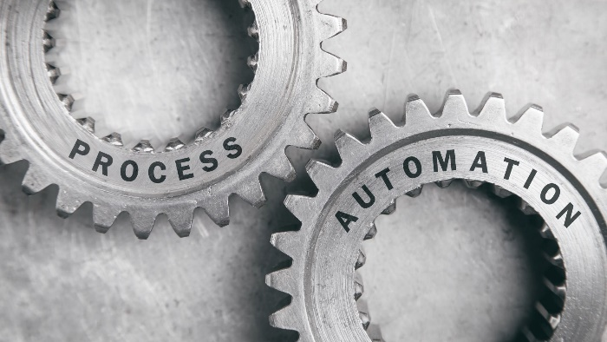

AI can automate repetitive mundane, time-consuming tasks, such as reviewing documents or pulling information from applications, which will free up employees to tackle other projects.

**Reducing false positives and human error**



People make mistakes, and human error is an unfortunate reality. In the financial services industry, 94% of surveyed IT professionals said they aren’t confident that their employees, consultants and partners can safely protect customer data. Thankfully, artificial intelligence can help reduce false positives and human error.

**Ability to execute tasks of any length**

Artificial intelligence has the ability to scale, meaning that you can use this type of advanced technology for shortor long-term projects.

**Making smart underwriting decisions**

AI solutions are helping banks and lenders “make smarter underwriting decisions” when it comes to the approval process for loans and credit cards. This is done by using a variety of factors that paint a more accurate picture of those who may be traditionally underserved.

**Save money**



Every item previously mentioned on this list can contribute to increased revenue. By automating tasks, you free up employees to take on additional responsibilities instead of hiring more personnel. Virtual assistants and 24/7 chatbots create a more positive customer service experience and using AI to help determine whether someone qualifies for a loan typically means finding those with good credit who won’t default.

**Automation –**

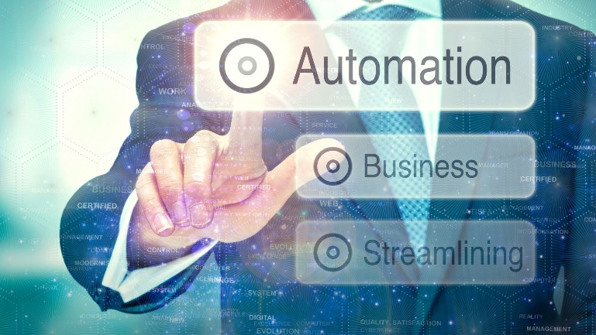

8AI can help automate workflows and processes, work autonomously and responsibly, and empower decision making and service delivery. For example, AI can help a payments provider automate aspects of cybersecurity by continuously monitoring and analysing network traffic. Or, it may enhance a bank’s client-first approach with more flexible, personalized digital banking experiences that meet client needs faster and more securely.

**Accuracy -** AI can help financial services organizations control manual errors in data processing, analytics, document processing and on-boarding, customer interactions, and other tasks through automation and algorithms that follow the same processes every single time.

**Efficiency -** When AI is used to perform repetitive tasks, people are free to focus on more strategic activities. AI can be used to automate processes like verifying or summarizing documents, transcribing phone calls, or answering customer questions like “what time do you close?” AI bots are often used to perform routine or low-touch tasks in the place of a human.

**Speed -** AI can process more information more quickly than a human, and find patterns and discover relationships in data that a human may miss. That means faster insights to drive decision making, trading communications, risk modelling, compliance management, and more.

**Availability -** With AI, you can help your customers’ complete financial tasks, find solutions to meet their goals, and manage and control their finances whenever and where they are. When running in the cloud, AI and ML can continuously work on its assigned activities.

**Innovation -** The ability to analyze vast amounts of data quickly can lead to unique and innovative product and service offerings that leapfrog the competition. For instance, AI has been used in predictive analytics to modernize insurance customer experiences without losing the human touch.

### CHAPTER – 4:

### WHO IS USING AI IN FINANCE

Most of us might have used AI in finance, not realising the same. Artificial Intelligence has been in development for a long time by Microsoft prior to arrival of ChatGPT and some of these features are already incorporated in Excel by Microsoft and not frequently used and plus now ChatGPT has made it even simpler. AI in data analysis in Excel is part of the Data menu item in top menu bar and also part of the free Add-in of Analysis ToolPak and Analysis ToolPak VBA. One has to load the Analysis ToolPak add-in program in Microsoft Excel 2010, Microsoft Excel 2013 and Microsoft Excel 2016 from options. Go to File > Options > Add-ins (wait for a while, takes time to load sometimes). It will show active and inactive add-ins. Go to Manage button in the end and select ‘Excel Add-ins’ then click Go in the next window select Analysis ToolPak and click on OK. In the Excel versions from year 2016 and 2019 one can now see in Add-ins (top right side of the Home Bar) and one can select Analysis ToolPak.

Let us look at few examples (ideally good to have Excel version 2016/ 2019 or above):

**Recognition of Pattern with Flash Fill**

Let us assume you got a download of prices of equity shares in text form which is not tabulated and you want to tabulate them.

|  |  |
| --- | --- |
| **Company Name** | **Market Price** |
| Reliance Industries, 2436 | 2436 |
| HDFC Bank Limited, 1629 |  |
| TCS, 3606 |  |
| Colgate Palmolive, 1996 |  |
| State Bank of India, 604 |  |

If you go to the top menu bar of Excel and click on ‘Data’, you will see ‘flash fill’ but you can flash fill cells. That were the old school Excel and prior to that one had to create a complicated Excel formula to convert the text to tables.

Now let us see how AI got embedded in Excel. Instead of the process from old school Excel, just start by typing the market price 2436 in first cell of the market price column and click “Ctrl + E” and all the cells of market price will get populated or as you start typing the second cell of market price you will get suggestions for all the remaining cells of column market price and you can press enter button to accept them all. That was quick and simplest of all!!

But then tables can be more complicated and performing smaller tasks of doing different things with different cells makes it difficult to have one AI solution fits all.

That’s where ChatGPT comes to rescue. Now how to we do the same task with ChapGPT? Just type in ChatGPT “create an excel formula to extract the text separated by commas from the cells …” and it will give the formula. Just copy this code/ formula and paste in excel and you will get the text tabulated. If you wanted different outcomes for different rows or columns then you could have asked ChatGPT a more detailed query to get the formula.

**Charting Data and other Analysis**

Let us assume you have downloaded daily price of a stock from one of the stock exchanges, say Hindalco and want to co-relate this price with daily price chart of Aluminium prices over many years. In the old school Excel we had to select the data and then go to top menu bar to select chart and then multiple options to select after that to create our Chart.

With AI based Analysis ToolPak from version 2016/ 2019 of Excel, you can simply go to the top home bar right side end icon ‘Analysis ToolPak’ and just click it. You will see entire analysis of the data with AI driven charts ready. You can also ask questions on your data to Excel. For example, you can ask what the average price is in the year 2022. You can also go to the insert menu item in top bar and select recommended charts and Excel will use AI tools to analyse the data and recommend you different charts that you can select.

Now it can happen that it is difficult to remember all this. In which case, you can just write on ChatGPT – create an excel formula to calculate correlation between two sets of numerical data in cells or you can type in ChatGPT create an excel formula to calculate average values in cells. Copy and paste the code/ formulae in excel. Similarly you can take help of ChatGPT to create charts.

**Forecasting**

Now let us continue, with the same sample of Hindalco daily share prices over number of years in history.

The old school way to forecast in Excel was to insert a chart and then add then next to the chart click the + button to add a trend line. Then click on any part of the trend line drawn on the chart and select format it and you can see the option of forecast forward with number of periods you can insert. One could also select trend line options e.g. exponential, linear, logarithmic etc. To keep it simple one can select linear. The result will be the trend line extending to the forecasted periods, but it still does not show the pattern of price changes experienced in history being forecasted around the forecasted trend line.

Excel has embedded AI based solutions now. One can simply select the data and then click data on the top bar and then click on forecast sheet option (right end). You will get the forecasted pattern of the share prices. You can even change the period for which you want the forecast and the confidence intervals for the forecast. It detects seasonality of the share prices automatically from the past history. It also populates the forecasted data in Excel Sheet.

Again, you may not remember this, ask ChatGPT in simple words for forecasting formulae’s or create forecast charts from the cells and you will be able to complete the task without remembering or advanced knowledge of Excel.

**Extracting data**

Let us look at data on email Ids of Companies and their registrars for investor related matters and you want to extract say domain names from the date:

|  |  |  |  |  |
| --- | --- | --- | --- | --- |
| **Company Name** | **Registrar Name** | **Email Id** | **Email Id** | **Domain Name** |
| Reliance Industries | KFintech | einward.ris@karvy.com | investor.relations@ril.com | ril.com |
| HDFC Bank Limited | Datamatics | investorsqry@dfssl.com | shareholder.grievances@hdfcbank.com |  |
| TCS | TCPL India | csg-unit@tcplindia.co.in | investor.relations@tcs.com |  |
| Colgate Palmolive | Linktime | rnt.helpdesk@linkintime.co.in | investors_grievance@colpal.com |  |
| State Bank of India | Alankit | rta@alankit.com | investor.complaints@sbi.co.in |  |

In old school Microsoft Excel, to extract the data one had to make a complicated formulae in a formulae type syntax command.

However, with AI embedded in Microsoft Excel it is very simple to extract the domain names from the email id’s above. In the column of Domain Name just type the first domain name and then continue in next cell as well. As you try to type next row domain name of hdfcbank.com, Excel will highlight all the domain names extracted from the Email Id and you can just press enter to populate all the rows of domain name extracted by the AI engine of Microsoft Excel. You can also click “Ctrl + E” to populate all domain names.



Sometimes data extraction tasks are more complicated and OpenAI’s ChatGPT can come to the rescue. One can ask ChatGPT to create a formulae in excel to extract text that appears after @ from cells and then copy and paste the formulae in Microsoft Excel. Using AI will become easier and more efficient when it’s embedded directly into Microsoft Office with Microsoft’s upcoming Copilot features. The features of Copilot may include automatically generating standardised computer programmes for each service or act or work action in HTML, CSS, Java etc to avoid boiler plate programmes being written or plugged in from other developers by corporates. As more number of users take advantage of the service, it will allow Microsoft to collect more data to further train the model and improve it with time.

As the AI market expands, it’s important to know some of the key players who are applying AI globally. Let us take a look at the areas where artificial intelligence in finance is gaining momentum and highlight the companies that are leading the way.

**AI Companies in Financial Credit Decisions**

Credit is king. One report found that 27 percent of all payments made in 2020 were done with credit cards. But easier payment isn’t the only reason credit is important to consumers. Having good credit makes it easier to access favorable financing options, land jobs and rent apartments. So many of life’s necessities hinge on credit history, which makes the approval process for loans and cards important. Artificial intelligence solutions help banks and credit lenders make smarter underwriting decisions by using various factors that more accurately assess traditionally underserved borrowers in the credit decision making process. These companies help the financial industry rethink the underwriting process.

1. **Enova** uses AI and machine learning in its lending platform to provide advanced financial analytics and credit assessment. The company aims to serve non-prime consumers and small businesses and help solve real-life problems, like emergency costs and bank loans for small businesses, without putting either the lender or recipient in an unmanageable situation.
2. **Ocrolus** offers document processing software that combines machine learning with human verification. The software allows business, organizations and individuals to increase speed and accuracy when analyzing financial documents. Ocrolus’ software analyzes bank statements, pay stubs, tax documents, mortgage forms, invoices and more to determine loan eligibility, with areas of focus including mortgage lending, business lending, consumer lending, credit scoring and KYC.
3. **DataRobot** provides machine learning software for data scientists, business analysts, software engineers, executives and IT professionals. DataRobot helps financial institutions and businesses quickly build accurate predictive models that inform decision making around issues like fraudulent credit card transactions, digital wealth management, direct marketing, blockchain, lending and more. Alternative lending firms use DataRobot’s software to make more accurate underwriting decisions by predicting which customers have a higher likelihood of default.
4. **Scienaptic AI** provides several financial-based services, including a credit underwriting platform that gives banks and credit institutions more transparency while cutting losses. Its underwriting platform uses non-tradeline data, adaptive AI models and records that are refreshed every three months to create predictive intelligence for credit decisions.
5. **Zest AI** is an AI-powered underwriting platform that helps companies assess borrowers with little to no credit information or history. The platform uses thousands of data points and provides transparency that helps lenders better assess populations traditionally considered “at risk.” The company reported that auto lenders using machine-learning underwriting cut losses by 23 percent annually, more accurately predicted risk and reduced losses by more than 25 percent.
6. **Underwrite.ai** uses AI models to analyze thousands of financial attributes from credit bureau sources to assess credit risk for consumer and small business loan applicants. The platform acquires portfolio data and applies machine learning to find patterns and determine the outcome of applications.
7. **Socure** created ID+ Platform, an identity verification system that uses machine learning and AI to analyze an applicant’s online, offline and social data, which helps clients meet strict KYC conditions. The system runs predictive data science on information such as email addresses, phone numbers, IP addresses and proxies to investigate whether an applicant’s information is being used legitimately. Socure is used by institutions like Capital One, Chime and Wells Fargo, according to its website.

**AI Companies Managing Financial Risk**



Time is money in the finance world, but risk can be deadly if not given the proper attention. Accurate forecasts are crucial to the speed and protection of many businesses. Financial markets are turning to machine learning to create more exacting, nimble models. These predictions help financial experts utilize existing data to pinpoint trends, identify risks, conserve manpower and ensure better information for future planning.The following companies are just a few examples of how artificial intelligence in finance is helping banking institutions improve predictions and manage risk.

1. **Kensho,** a Standard & Poor’s Global Company, created machine learning training and data analytics software that can assess thousands of datasets and documents. Its data training software uses a combination of machine learning, cloud computing and natural language processing and it can provide easily understandable answers to complex financial questions, as well as extract insights from tables and documents quickly. Traders with access to Kensho’s AI-powered database in the days following Brexit used the information to quickly predict an extended drop in the British pound, Forbes reported. Kensho builds analytical products used by some of the world’s leading financial institutions, including Goldman Sachs, Bank of America, Merrill Lynch and JPMorgan Chase.
2. **Derivative Path’**s platform helps financial organizations control their derivative portfolios. The company’s cloud-based platform, Derivative Edge, features automated tasks and processes, customizable workflows and sales opportunity management. There are also specific features based on portfolio specifics — for example, organizations using the platform for loan management can expect lender reporting, lender approvals and configurable dashboards.
3. **Simudyne’s** platform allows financial institutions to run stress test analyses and test the waters for market contagion on large scales. The company offers simulation solutions for risk management as well as environmental, social and governance settings. Simudyne’s secure simulation software uses agent-based modelling to provide a library of code for frequently used and specialized functions.
4. **Ayasdi** creates cloud-based machine intelligence solutions for fintech businesses and organizations to understand and manage risk, anticipate the needs of customers and even aid in anti-money laundering processes. Its Sensa AML and fraud detection software runs continuous integration and deployment and analyzes its own as well as third-party data to identify and weed out false positives and detect new fraud activity.
5. **Range** is a membership-based fintech company that markets its money management services specifically to millennials. Part old school and part new, it offers everything you’d expect from a traditional wealth management service: investment, retirement, education and estate planning delivered via consults with certified financial planners. These services are bundled with DIY wealth management tools powered by machine learning.

**Companies Using AI in Quantitative Trading**

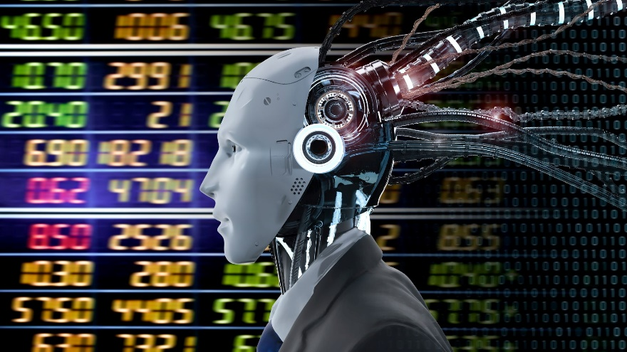

Quantitative trading is the process of using large data sets to identify patterns that can be used to make strategic trades. Artificial intelligence is especially useful in this type of trading. AI-powered computers can analyze large, complex data sets faster and more efficiently than humans. The resulting algorithmic trading processes automate trades and save valuable time. The following companies are just a few examples of how AI-infused technology is helping financial institutions make better trades.

1. **Canoe** ensures that alternate investments data, like documents on venture capital, art and antiques, hedge funds and commodities, can be collected and extracted efficiently. The company’s platform uses natural language processing, machine learning and meta-data analysis to verify and categorize a customer’s alternate investment documentation.
2. **Entera** is an AI-powered investment platform for real estate investors. The platform lets investors buy, sell and operate single-family homes through its SaaS and expert services. Investors can access homes from on and off-market sources. Additionally, Entera can discover market trends, match properties with an investor’s home and complete transactions.
3. **AlphaSense** is an AI-powered search engine for the finance industry, AlphaSense serves clients like banks, investment firms and Fortune 500 companies. The platform utilizes natural language processing to analyze keyword searches within filings, transcripts, research and news to discover changes and trends in financial markets. AlphaSense is valuable to a variety of financial professionals, organizations and companies — and is especially helpful for brokers. The search engine provides brokers and traders with access to SEC and global filings, earning call transcripts, press releases and information on both private and public companies.
4. **Kavout** uses machine learning and quantitative analysis to process huge sets of unstructured data and identify real-time patterns in financial markets. One of Kavout’s solutions is the K Score, an AI-powered stock ranker. The K Score analyzes massive amounts of data, such as SEC filings and price patterns, then condenses the information into a numerical rank for stocks. The higher the K Score, the more likely the stock will outperform the market.
5. **Alpaca** uses proprietary deep learning technology and high-speed data storage to support its yield farming platform. (Yield farming is when cryptocurrency investors pool their funds to carry out smart contracts that gain interest.) Alpaca is compatible with dozens of cryptocurrencies and allows users to lend assets to other investors in exchange for lending fees and protocol rewards.

**Companies Using AI in Personalized Banking**



Traditional banking doesn’t always cut it with today’s consumers. A 2021 survey from J.P. Morgan Chase found that 89 percent of respondents use mobile apps for banking. Additionally, 41 percent said they wanted more personalized banking experiences and information. AI assistants, such as chatbots, use AI to generate personalized financial advice and natural language processing to provide instant, self-help customer service. Here are a few examples of companies using AI to learn from customers and create a better banking experience.

1. **Kasisto** is the creator of KAI, a conversational AI platform used to improve customer experiences in the finance industry. KAI helps banks reduce call center volume by providing customers with self-service options and solutions. Additionally, the AI-powered chatbots also give users calculated recommendations and help with other daily financial decisions.
2. **Abe AI** is a virtual financial assistant that integrates with Google Home, SMS, Facebook, Amazon’s Alexa, web and mobile to provide customers with more convenient banking. The assistant provides services ranging from simple knowledge and support requests to personal financial management to spending overviews and budgeting. In 2016 Abe released its smart financial chatbot for Slack. The app helps users with budgeting, savings goals and expense tracking.
3. **Trim** is a money-saving assistant that connects to user accounts and analyses spending. The smart app can cancel money-wasting subscriptions, find better options for services like insurance, and even negotiate bills. Trim has saved more than $20 million for its users, according to a 2021 Finance Buzz article.

**Companies Using AI in Cybersecurity and Fraud Detection for Banking**



Every day, huge quantities of digital transactions take place as users move money, pay bills, deposit checks and trade stocks online. The need to ramp up cybersecurity and fraud detection efforts is now a necessity for any bank or financial institution, and AI plays a key role in improving the security of online finance. Here are a few examples of companies providing AI-based cybersecurity solutions for major financial institutions.

1. **Vectra** offers an AI-powered cyber-threat detection platform, which automates threat detection, reveals hidden attackers specifically targeting financial institutions, accelerates investigations after incidents and even identifies compromised information. A Vectra case study provides an overview of its work to help a prominent healthcare group prevent security attacks. Vectra’s platform identified behaviour resembling an attacker probing the footprint for weaknesses and disabled the attack.
2. **Jumio’s KYX** platform helps businesses establish trust with online customers. The platform validates customer identity with facial recognition, screens customers to ensure they are compliant with financial regulations and continuously assesses risk. Additionally, the platform analyzes the identity of existing customers through biometric authentication and monitoring transactions. Jumio is commonly used in education, healthcare, retail and gaming industries.
3. **F5:** Utilized by top banks in the United States, F5 provides security solutions that help financial services mitigate a variety of issues. The company offers solutions for safeguarding data, digital transformation, GRC and fraud management as well as open banking. An F5 case study provides an overview of how one bank used its solutions to enhance security and resilience, while mitigating key cybersecurity threats. The company’s applications also helped increase automation, accelerate private clouds and secure critical data at scale while lowering TCO and futureproofing its application infrastructure.
4. **Darktrace’s AI**, machine learning platform analyzes network data and creates probability-based calculations, detecting suspicious activity before it can cause damage for some of the world’s largest financial firms. Bank One implemented Darktace’s Antigena Email solution to stop impersonation and malware attacks, according to a case study. The bank saw a rapid decrease in email attacks and has since used additional Darktrace solutions across its business.
5. **FIS** provides a host of banking and financial solutions. One way it uses AI is through a compliance hub that uses C3 AI to help capital markets firms fight financial crime. Announced in 2021, the machine learning-based platform aggregates and analyzes client data across disparate systems to enhance AML and KYC processes. FIS also hosts FIS Credit Intelligence, a credit analysis solution that uses C3 AI and machine learning technology to capture and digitize financials as well as delivers near-real-time compliance data and deal-specific characteristics.

**Companies Using AI in Blockchain Banking**



AI and blockchain are both used across nearly all industries — but they work especially well together. AI’s ability to rapidly and comprehensively read and correlate data combined with blockchain’s digital recording capabilities allows for more transparency and enhanced security in finance. AI models executed on a blockchain can be used to execute payments or stock trades, resolve disputes or organize large datasets. Here are a few examples of companies using AI and blockchain to raise capital, manage crypto and more.

1. **TQ Tezos** leverages blockchain technology to create new tools on Tezos blockchain, working with global partners to launch organizations and software designed for public use. TQ Tezos aims to ensure that organizations have the tools they need to bring ideas to life across industries like fintech, healthcare and more.
2. **Wealthblock.AI** is a SaaS platform that streamlines the process of finding investors. It helps businesses raise capital and handle automated marketing and messaging and uses blockchain to check investor referral and suitability. Additionally, Wealthblock’s AI automates content and keeps investors continuously engaged throughout the process.
3. **Shapeshift** is a decentralized digital crypto wallet and marketplace that supports more than 750 cryptocurrencies. The platform provides users access to nine different blockchains and eight different wallet types. ShapeShift has also introduced the FOX Token, a new cryptocurrency that features several variable rewards for users.
4. **Figure** uses blockchain and AI to streamline the home loan process. Its platform finds new access points for consumer credit products like home equity lines of credit, home improvement loans and even home buy-lease offerings for retirement. Figure Marketplace uses blockchain to host a platform for investors, startups and private companies to raise capital, manage equity and trade shares.

Artificial intelligence has streamlined programs and procedures, automated routine tasks, improved the customer service experience and helped businesses with their bottom line. In fact, Business Insider predicts that artificial intelligence applications will save banks and financial institutions $447 billion by 2023. The majority of banks (80%) understand the potential benefits of AI, but now it’s more important than ever with the widespread impact of COVID-19, which has affected the finance industry and pushed more people to embrace the digital experience. In a recent AI News article, Mani Nagasundaram, senior vice president and head of solutions of global financial services at HCL Technologies, explained that COVID-19 has forced banks and financial institutions to respond to customers at an even faster pace — and around the clock. Artificial intelligence can free up personnel, improve security measures and ensure that the business is moving in the right technology-advanced, innovative direction. According to Forbes, 70% of financial firms are using machine learning to predict cash flow events, adjust credit scores and detect fraud.

According to Forbes, 54% of financial service organizations with 5,000+ employees are now using artificial intelligence. Here are some examples:

**Capital One**: “Eno” was the first natural language SMS text-based assistant offered by a bank in the United States.

**Bank of America**: The chatbot “Erica” debuted in 2018 and has served more than 10 million users. As of mid-2019, Erica was able to understand almost 500,000 question variations.

**JPMorgan Chase**: The bank uses key fraud detecting applications, including implementing an algorithm to detect fraud patterns, according to Business Insider. Details of credit card transactions are sent to data centers, which decide whether the transactions are fraudulent.

One of the biggest newswire/ media group like **Thompson Reuters** have created AI labs and their Star Mine Models are used by institutional investors. They have five labs in San Francisco, New York, London, Singapore and Cape Town, all with the goal of doing these iterative experiments with customers with their data and applying novel emerging technologies. Their finance and risk business got separated into a new entity Refinitiv which went private and acquired by Blackstone, GIC and Canada Pension Plan Investment Board in the year 2018 and in the next year sold to the London Stock Exchange Group Plc (LSE) with a stock swap of LSE shares.

In the year 2023, **Bloomberg**, the most important platform for financial data sourcing globally, launched BloombergGPT, a 50-billion parameter large language model, purpose-built from scratch for finance. Their large language model (LLM) has been specifically trained on a wide range of financial data to support a diverse set of natural language processing (NLP) tasks within the financial industry. This model will assist Bloomberg in improving existing financial NLP tasks, such as sentiment analysis, named entity recognition, news classification, and question answering, among others. As a financial data company, Bloomberg’s data analysts have collected and maintained financial language documents over the span of forty years. Their AI-ML team pulled from this extensive archive of financial data to create a comprehensive 363 billion token dataset consisting of English financial documents. This data was augmented with a 345 billion token public dataset to create a large training corpus with over 700 billion tokens. Using a portion of this training corpus, the team trained a 50-billion parameter decoder-only causal language model. The resulting model was validated on existing finance-specific NLP benchmarks, a suite of Bloomberg internal benchmarks, and broad categories of general-purpose NLP tasks from popular benchmarks (e.g., BIG-bench Hard, Knowledge Assessments, Reading Comprehension, and Linguistic Tasks). This is a trail blazer change, far bigger than ChatGPT for the financial world.

While the Indian technology companies are assisting the world in digital transformation, the Indian financial sector was quite slow in adopting artificial intelligence and has recently changed the gear for faster adoption of AI technologies. Several large financial services companies and FinTechs have collaborated to conduct proof of concepts (POCs) and implement some of these emergent technologies into their operations, according to a report by PriceWaterhouse Coopers. AI is viewed as one of the most exciting and profitable ventures in the FinTech space in India. “The applications of AI and ML in data analytics and customer service create the opportunity for exponentially more personalized and faster customer experiences, significantly better insights, and, automation of back-end workflows,” the report stated. More than 36 percent of large financial institutions are already investing in these technologies, and almost 70 percent report that they are planning to in the near future.

**State Bank of India (SBI)**, which is India’s largest public-sector bank with 420 million customers, has already embarked on its AI journey. From a customer chatbot perspective, SBI has launched SIA, an AI-powered chat assistant that addresses customer enquiries instantly and helps them with everyday banking tasks in 2017. SIA was developed by Payjo, a startup based in Silicon Valley and Bengaluru. To fuel its AI mission, SBI also launched a national hackathon in FY 2019-2020, “Code For Bank”, for developers, startups and students to come up with innovative ideas and solutions for the banking sector, focusing on technologies such as predictive analytics, fintech/ blockchain, digital payments, IoT, AI, machine learning, BOTS and robotic process automation. SBI is currently using an AI-based solution developed by Chapdex, the winning team from its first hackathon.

**HDFC Bank**, India’s largest private sector bank, has developed in 2020 an AI-based chatbot, “Eva”, built by Bengaluru-based Senseforth AI Research. Eva can assimilate knowledge from thousands of sources and provide simple answers in less than 0.4 seconds. HDFC Bank is also experimenting with in-store robotic applications.

**ICICI Bank**, India’s second-largest private sector bank has deployed software robotics in over 200 business processes across various functions of the company. ICIC seems to be referring to what is often referred to as “robotic software” – a kind of software generally focused on automating office work. The software robots at ICICI Bank are configured to capture and interpret information from systems, recognize patterns and run business processes across multiple applications to execute activities, including data entry and validation, automated formatting, multi-format message creation, text mining, workflow acceleration, reconciliations and currency exchange rate processing among others. In the year 2020, ICICI Bank launched its AI-based chatbot, named iPal.

**Axis Bank**, India’s third-largest private sector bank, launched an innovation lab called “Thought Factory” in 2019 to accelerate the development of innovative AI technology solutions for the banking sector. Their innovation hub is in house and located in Bengaluru and they also have an accelerator program through which the bank engages with startups in a 3-month program. Shortlisted startups are then put in a structured mentorship program for fine-tuning, validating and scaling their business. Axis Bank has also launched an AI & NLP (Natural Language Processing) enabled app, Conversational Banking, to help consumers with financial and non-financial transactions, answer FAQs and get in touch with the bank for loan other products. To help reduce the turnaround time (TAT), the bank has implemented AI across 125+ processes and cognitive automation across 90 processes, which needed repetitive manual labour. Currently, robotic process automation (RPA) is complete for most processes, including account maintenance and servicing, loan disbursements, bulk transaction processes and ATM support. With RPA there’s visible reduction in TAT – savings account opening has reduced by 90 percent, on current accounts by 92 percent, and on other processes by 50 percent-80 percent.

### CHAPTER – 5:

### GENERAL NOTIONS IN AI

AI systems are designed to learn from experience, adapt to new situations, and improve performance over time. The ultimate goal of AI is to create machines that can simulate human intelligence, including reasoning, problem-solving, and creativity. To understand AI, it is essential to be familiar with key concepts and terminology commonly used in the field. This includes understanding different types of AI, such as machine learning and deep learning, as well as the algorithms and techniques used to develop AI systems, e.g., neural networks and reinforcement learning. Other important concepts include natural language processing, computer vision, ethics, and bias in AI.



AI starts with data. The data generally comprises two components:

1. **Features**

Features data is usually the input data that is given as input to an algorithm. In a financial context, this might be, for example, the salary or expenditure of a person.

1. **Label**

Label data is usually the output data that is given as the relevant output to be learned. In a financial context, this might be the creditworthiness of an obligor.

Depending on the type of data and the problem at hand, two types of tasks are to be learned which are important:

1. **Estimation**



Estimation (or approximation, regression) refers to the cases in which the labels data is real-valued (continuous); that is, it is technically represented as floating point numbers.

1. **Classification**

Classification refers to the cases in which the labels data consists of a finite number of classes or categories that are typically represented by discrete values (positive natural numbers), which in turn are represented technically as integers.

Thereafter, we need to be clear about our approaches, which may be classified into:

1. **Artificial intelligence (AI)**

AI encompasses multiple types of learning (algorithms) and may include those below.

1. **Machine learning (ML)**

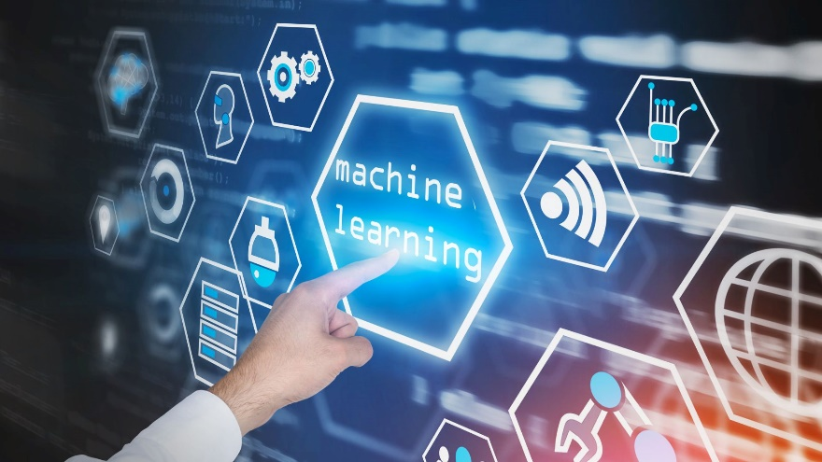

Machine learning (ML) is a subset of artificial intelligence (AI). ML involves training algorithms to make predictions or decisions based on input data. Unlike traditional programming, where rules and logic are explicitly defined, ML algorithms are trained using large datasets to learn patterns and make decisions. ML is the discipline of learning relationships and other information about given data sets based on an algorithm and a measure of success; a measure of success might, for example, be the mean-squared error (MSE) given labels values and output values to be estimated and the predicted values from the algorithm.

There are several types of machine learning algorithms, including supervised learning, unsupervised learning, and reinforcement learning.

**Supervised learning (SL)**

These are algorithms that learn from a given sample data set of features (input) and labels (output) values. For example, algorithms like ordinary least-squares (OLS) regression and neural networks. The purpose of supervised learning is to learn the relationship between the input and output values. In finance, such algorithms might be trained to predict whether an obligor is creditworthy or not. ZeTheta’s vrtual portfolio analyser is a type of SL Algorithm.

**Unsupervised learning (UL)**

These are algorithms that learn from a given sample data set of features (input) values only, often with the goal of finding structure in the data. They are supposed to learn about the input data set, given, for example, some guiding parameters. Clustering algorithms fall into that category. In a financial context, such algorithms might cluster equities into certain groups of data.

**Reinforcement learning (RL)**

These are algorithms that learn from trial and error by receiving a reward for taking an action. They update an optimal action policy according to what rewards and punishments they receive. Such algorithms are, for example, used for environments where actions need to be taken continuously and rewards are received immediately, such as in a computer game. ZeTheta’s virtual risk analyser is a type of RL Algorithm.

1. **Deep learning (DL)**



DL encompasses all algorithms based on neural networks. The term deep is usually only used when the neural network has more than one hidden layer. DL is a sub-set of machine learning and so is therefore also a sub-set of AI. DL has proven useful for a number of broad problem areas. Traditional machine learning methods require human input for the machine learning software to work sufficiently well. A data scientist manually determines the set of relevant features that the software must analyze. This limits the software’s ability, which makes it tedious to create and manage.

On the other hand, in deep learning, the data scientist gives only raw data to the software. The deep learning network derives the features by itself and learns more independently. It can analyze unstructured datasets like text documents, identify which data attributes to prioritize, and solve more complex problems.

For example, if you were training a machine learning software to identify an image of a pet correctly, you would need to take these steps:

* Find and label thousands of pet images, like cats, dogs, horses, hamsters, parrots, and so on, manually.
* Tell the machine learning software what features to look for so it can identify the image using elimination. For instance, it might count the number of legs, then check for eye shape, ear shape, tail, fur, and so on.
* Manually assess and change the labelled datasets to improve the software’s accuracy. For example, if your training set has too many pictures of black cats, the software will correctly identify a black cat but not a white one.
* In deep learning, however, the neural networks would process all the images and automatically determine that they need to analyze the number of legs and the face shape first, then look at the tails last to correctly identify the animal in the image.

DL is suited for estimation and classification tasks, as well as for RL. In many cases, DL-based approaches perform better than alternative algorithms, such as logistic regression or kernel-based ones, like support vector machines. DL approaches used include dense neural networks (DNNs), recurrent neural networks (RNNs), and convolutional neural networks (CNNs).

Some of the Deep Learning applications in finance are in the diagram below.

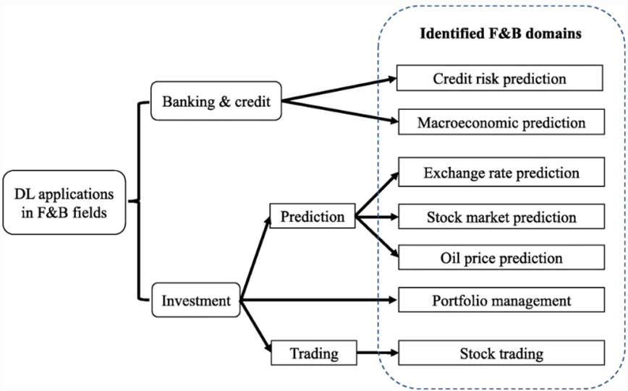

The Artificial Neural Networks history began perhaps since 1940’s when McCulloch and Pitts first proposed the idea of simulating neuronal activity using mathematical logic. But it was until early 1960’s that the idea that machines can learn was first explored by Rosenblatt with the creation of the Perceptron Algorithm. For the first time the possibilities of Artificial Intelligence were recognized when this algorithm was tested on an IBM 704 computer. Although there was great expectation about artificial intelligence at that time, the computer technology was not well advanced at that time to make Artificial Neural Networks to work in their full potential. A big leap forward in ANN research was PJ Werbos’s 1974 unpublished PhD Dissertation "Beyond regression: new tools for prediction and analysis in the behavioural sciences", where he first proposed backpropagation to train Neural Networks. A detailed explanation on Backpropagation can be found also in Werbos. Backpropagation algorithm was indeed a break-through that allowed the effective use of gradient descent method in the training of ANN.

The development of the Neocognitron by Fukushima and Miyake inspired the creation of Convolutional Neural Networks (CNN) which are indeed Deep Neural Networks (DNN) with multi layers but where some hidden layers are called convolutional layers as they perform a convolution that connects to the next hidden layers of neurons. This type of neural networks are often used in pattern recognition problems. In 1982 John Hopfield, with his paper Hopfield, invented the Hopfield Network with the purpose of modelling human memory. This later was known as Recurrent Neural Network, in which time lapses between hidden layers and neurons were important to model human learning process and memory. Several other types of DNN with different variations and architectures have been created in recent years. Deep learning is currently a field very dynamic with great possibilities.

**CLASSIFICATION METHODS**

Let us review the classification methods used in practice.

SUPERVISED: CLASSIFICATION

**Classification: Decision Trees**

A decision tree is a structure that looks like an upside-down tree, where the top is known as the root and the bottom nodes are known as leaf nodes. You start at the root node, ask a question about a feature, and, depending on the answer, you split the data set into branches. It is followed by another question about the next feature, and the data set is split again. These questions and answers continue till a point is reached where the data is segmented such that all members of the node carry the same label or no more features are left for classification. The beginning point of the decision tree is a labelled data set of features.



For example, if we are predicting whether citizens of a certain area will vote with party A or party B, and we are using features such as education, age, income, and so forth, we can start building a decision tree by asking questions about the data—for example, “College Educated? Age above 40? Makes above $100,000?” could be some of the questions—and based on the answers to a series of questions, we get to the bottom of the tree. The split at each question establishes a different path. At the bottom of the tree, we get information about how many people for each path voted for party A vs. party B. If at the leaf node we are left with a mix (impure), where some voted for party A and some for party B, we can calculate the probability.

Notice that each path gives us some rule paths also—for example:

Notice that sometimes full paths may not exist. If the answer to our second question was that all college educated and age above 40 voted for party A, then there is no need to further explore that path. The path has become pure.

Which questions get asked first is important. Sequence matters. Some questions may carry more prediction-worthy information (i.e., information that contributes most to the prediction)—they are more informative. Different features will provide different prediction-worthy information. Some features are more informative. Can we find out which ones? There are processes that are employed (e.g., entropy) that can help us identify the most prediction-worthy participant features in the data set. Thus, a better way to build decision trees is by segmenting the data in a manner that increases the accuracy of the prediction, and that means to identify the features that carry the most information and then structuring the order of questions in accordance with that knowledge.

**CLASSIFICATION: RANDOM FOREST**

Decision trees sometimes overfit the data. That means that they do not generalize to new situations. They can fit the examples well but lack the ability to predict new examples. It happens because they pick up both noise (due to outliers and randomness) of the data and the signal (the insights obtained from the sample data).

A random forest is an ensemble method that takes the average or weighted average of more than one decision tree where each tree represents a subsample of features. At training time, the random forest creates multiple decision trees and then calculates the mode for classification or the median for regression. The averaging of multiple trees increases the quality of the result and addresses the overfitting problem by generalizing the model so that the model can recognize new situations.

**CLASSIFICATION: USING MATHEMATICAL FUNCTIONS**

In the decision trees, we discovered models that predict the target output based on other descriptive attributes (inputs). The trees enabled that by subdividing the set of all instances into series of successive, more informative subsets (purer), which enabled our ability to predict. They contained more information (a better, cleaner, stronger relationship) between the output and the inputs. The decision tree gave us the structure and the parameters of the model. The structure was the specific tree model, and the parameters were the probability estimates that we discovered once we got to the bottom of the tree at the leaf nodes.

Another way to develop a predictive model is to specify a mathematical function such that the structure of the model and the parameters represent the data set. The model is set up by choosing the parameters. The initial model is developed with the modeller knowing something about the data set from domain expertise or by using some mathematical concepts (such as entropy) to develop some insights into the data. Then the parameters are tuned for learning. This process, known as parameter learning, searches for the best parameters from the space of all parameters that describe the data set.

The general idea of the classification via mathematical functions is to split the data in a manner that it can predict the output better. In a two-dimensional system, this can be viewed as a partitioning straight line that can separate the data into two classes (e.g., voting for party A or party B). This is known as a linear classifier.

Many problems require us to think in terms of binary answers. For example, is there a fraud or not; should a person get the credit or not; should an investment be made or not. We can have more than 2 dimensions—implying we have more than 2 features (dozens, hundreds, or more)—and that can be viewed as a plane (for three dimensions) and a hyperplane (four or more dimensions) that splits the data into different classes.

**CLASSIFICATION: SIMPLE LINEAR CLASSIFIER**

Let us return to our previously used example of classifying (predicting) citizens as voting for party A or party B based on two variables of education and income. A linear classifier can be viewed as a line that attempts to split the data into two parts. The reason I used the words “attempts to” is because in many cases it is not possible to get the data cleanly split between sets. Some values can appear on the wrong side of the divider line.

Like any line in the two-dimensional system, the best divider line has a certain slope and a y-intercept. This means we can represent this line as an equation. Let us say we discover that the equation is as follows:

Here –1.75 represents the slope and 50 represents the y-intercept—linear discriminant. In fact, we can move the income to the other side of the equation and set a simple rule that says if the value of the function is above zero, this means the point resides above the line, and if it is below zero (or equal to it), then it is below the line:

Note: the assignment is based on how the line separated the data. Recall our target variables (output variables) are party A or party B. Let's review what the above equations are trying to accomplish.

Our goal is to predict party A and party B voters by studying two features of income and education. To make numerical values, we have converted education from 0 to 20 (years of education) and income from zero to $200,000. Our plotted data therefore gives us points where each point is a mixture of education and income, or (x1, x2). Based on our known information, each of those combinations produced a party A or a party B classification. By dividing the data set into two regions, hopefully our data can be nicely split between party B and party A. To split the data, we calculated the weighted sum of the values of the two attributes and based on that determined a line that split the data into two regions (party A and party B).

The line was represented by an equation, and the equation when viewed as a function helped us split our data by calculating the value of the function and figuring out whether the value is above zero. A general function is:

Here the weights of the function are the parameters, and the classification is based on negative or positive values of the function. The higher the discovered weight, we can generally assume that attribute (input) is better for predicting the output. We now have both the structure and the estimates embedded in a mathematical function. We have successfully fit our model to the data by representing it mathematically. This is what we call our parametrized model.

The function shows that in addition to income and education we can use other attributes such as age and number of times previously voted for classification.

Also, the data we used (income and education) in the example was numerical. What about other types of data? If the data is text or image, it is changed to numerical values. As part of getting the data ready for ingestion, we also normalize the data. This is done to make the parameter values closer to each other. The parameter values can turn out to be widely different if there is wide difference between the numeric values of the variables. For example, in the above example, while the education scale runs between 0 and 20, the income scale runs between 0 and $200,000. To eliminate that problem, we can normalize the data before using it in the classification algorithm.

**Classification: Picking the Right Line**

Picking the right linear classifier is not trivial. Notice the space in between the two types of features. Many lines appear to qualify as the partitioning line. Which line then represents the best line that partitions the data sets better than any other line? Of all the lines that can part our data into regions, which line is the best line?

One way to think about it is that based on the features, we are hoping that the data will split into some natural partitions. We hope that based on the feature vector provided (i.e., X1, X2), the data points will clearly occupy separate areas in the two-dimensional space. Hence, the problem of classification can be defined as finding the line (2-dimensional), plane (3-dimensional), or hyperplane (more than three-dimensional) that can separate the data into segments of the output variable (target). The word hyperplane is generally used for the separation plane. A hyperplane in a two-dimensional system is a line. A hyperplane in a three-dimensional system is a plane.

Notice that in the above function, while we considered several inputs, we were only doing binary classification (i.e., two outputs—party A or party B). A more advanced system (multi-classifier) will be able to classify among several classes (e.g., party B, party A, party C, independents). Those problems are known as multi-class classification problems. In a multi-class classification problem, feature vectors are classified in three or more classes.

As previously mentioned, there is another type of problem in classification, and it is known as multi-label classification. Notice that in both binary and multi-class classification, each feature vector was classified as only one class. If a feature vector belonged to party A, it did not belong to party B. In multi-labelled you can classify in two or more classes.

While simple classifiers can address some trivial problems, some more complex problems can be solved with more advanced and powerful methods explained below. These methods display different levels of effectiveness for different types of problems.

**SUPERVISED: SUPPORT VECTOR MACHINE**

In our example, when provided the input values for education and income, the classifier classified as party A voter or party B voter. How can we make this classification more reliable?

One way to increase the reliability is to consider a band or a bar between the data, instead of a line. This band will have two boundaries, one on one side and the other on the other side. Each can be viewed as the best boundary drawn closest to the data. Now we can draw a line that runs right in between the two boundaries and that becomes our separation line. The distance between the two boundaries of the corridor (stripe, band) is known as the margin.

A support vector machine (SVM) is a classifier that separates data into classes by establishing a boundary space between the data (Boser et al., 2010). The boundary space looks like a street with a line in the centre. The street is laid out in the middle of the data such that the distance between the closest points and the central line of the street is maximized. Maximizing that achieves the goal of finding the optimal hyperplane that separates data. Margin is the perpendicular distance between the hyperplane (i.e., the middle line) and the lines on the side. The lines of the side are defined by the class that contains support vectors. Support vectors are the vectors (points) that are closest to the hyperplane on all sides of the plane.

If we drop a test vector and it falls on either side of the plane, away from the middle, we can be reasonably confident that it belongs in those categories. What if the test vector falls extremely close to the middle line or on it? That can go either way. Assuming you have a reasonable divider line in between the data, the further away a point is from the margin, the more likely the point belongs to that class.

What about cases in which points end up on the wrong side of the line? For example, we may have a party A voter whose attribute values indicate that she should be a party B. She is on the wrong side of the partition (misclassified). Her misclassification raises an important issue: how to handle misclassifications? A related question is: do misclassifications decrease the predictive ability of our function? To measure that, we can define something known as the loss function. The loss function is measured by calculating the distance between the misclassified values and the margin. In fact, we can have simple rules that can alleviate our problem:

There will be no loss if the values fall where they belong (party A or party B), that is, the predictor gets it right; If the values fall inside the boundary but have not crossed the margin, we will not penalize it; However, if the values end up on the other side of the margin, we can penalize it by calculating the distance between the values and the boundary of the margin. Now we are in a better position to handle those values that end up on the wrong side.

Even though we used only two features (X1 and X2), real problems will involve more than two dimensions (i.e., N dimensions). In those problems, the feature vectors are mapped to an N-dimensional space and a hyperplane is discovered that separates the vectors into two classifications.

What if our training data is hopelessly mixed? Try putting a partitioning line through that. In fact, if we drop a test feature vector (represented by the triangle) in the middle of the data, it will be tough to determine if it belongs to party A or party B.

You cannot get a line (hyperplane) to divide the data precisely into two camps. They are known as non-separable (linear) cases since the data is not easily separable with a straight line. The triangle is the test vector, and clearly it is difficult to determine whether it belongs with the circles or the plus signs. In that case advanced versions of SVM give us some creative ways to handle those situations. One simple solution is to simply tolerate a few mis-assignments. The dissenters or rebels are tolerated as a necessary evil. The misclassified element can be in the margin area, even if they are on the wrong side of the decision boundary or they are deep inside the wrong territory. The algorithm attempts to make sure that it is optimizing the trade-off between maximizing the margin and minimizing misclassification.

Another way to achieve better classification for tough cases is to transform the existing features by using mathematical transformations. For example, you can square, multiply, or create a mathematical transformation that alters the state of features in a manner where they become more separable.

It seems impossible to separate the data since it is right in the middle surrounded in a manner where you cannot easily separate party A voters from party B voters. A mathematical transformation can help split the data. A new dimension (Z) can be introduced by squaring x and y and adding them to form a new feature. When plotted, the transformation makes the data clearly separable, so we can now easily part the data into two segments.

**CLASSIFICATION: NAIVE BAYES**

The Naive Bayes algorithm classifies by calculating the probability of different classes or outcomes. The probabilities are measured based on previously known examples presented in the training data. This algorithm is based on the Bayesian theorem, and it assumes that each feature is independent of the other features. The core strategy of the algorithm is to assume that the features are independent and then estimate the probability (think of it as the relative participation) of the feature in a class. The probabilities are then multiplied to determine the influence of features in a class.

**CLASSIFICATION: BAYESIAN BELIEF NETWORKS**

Bayesian belief networks (BBN) are also based on the Bayesian theorem, except unlike naive Bayes model, which assumes that features are independent of each other, BBN considers the probabilities and dependencies among features.

**CLASSIFICATION: K-NEAREST NEIGHBOUR**

Just as the name states, this algorithm looks at the nearest neighbours of the instances being classified and classifies based on that. For example, let us say you are trying to classify a family by its income. One way you can estimate the income is to find out the income of the, say, ten neighbours and based on that you can estimate a family's income. Here we assumed that the family lives in a neighbourhood and it is likely that their income will be not too different than its neighbours' (the surrounding points in the decision space).

Had we picked only one neighbour to estimate the family income, we may have gotten it wrong. But just by looking at the ten nearest neighbours, we are more likely to get a more reasonable estimate. The k in the k-nearest allows us to specify how many nearest data points we want the algorithm to look at.

We can represent our test data as a triangle. We are trying to see whether the triangle belongs in the plus class or in the circle class. When we use k = 4 (the inner circle), it picks up the 4 nearest neighbours and determines that there are more plus signs (i.e., 3 out of 4) than circles (1 out of 4) and therefore classifies the triangle as a plus. However, if we increase the size of k to 7, the 7 nearest neighbours of the triangle give a different output: 4 out of 7 are circles, and 3 out of 7 are plus signs, so we classify the triangle as a circle.

**REGRESSION**

Before we go into details of AI algorithm settings, we will just glance through some simple statistical concepts.

**Linear regression**

Linear regression analysis is used to predict the value of a variable based on the value of another variable. The variable you want to predict is called the dependent variable. The variable you are using to predict the other variable's value is called the independent variable. This form of analysis estimates the coefficients of the linear equation, involving one or more independent variables that best predict the value of the dependent variable. Linear regression fits a straight line or surface that minimizes the discrepancies between predicted and actual output values. There are simple linear regression calculators that use a “least squares” method to discover the best-fit line for a set of paired data. You then estimate the value of X (dependent variable) from Y (independent variable).

You can perform the linear regression method in a variety of programs and environments, including (a) R linear regression (b) MATLAB linear regression (c) Sklearn linear regression (d) Linear regression Python (e) Microsoft Excel linear regression and other places.

Linear-regression models are relatively simple and provide an easy-to-interpret mathematical formula that can generate predictions. Linear regression can be applied to various areas in business and academic study. You’ll find that linear regression is used in everything from biological, behavioural, environmental and social sciences to business. Linear-regression models have become a proven way to scientifically and reliably predict the future. Because linear regression is a long-established statistical procedure, the properties of linear-regression models are well understood and can be trained very quickly.

**Multivariate regression**

In the reality, there is ample number of situations where many independent variables get influenced by other variables for that we have to look for other options rather than a single regression model that can only work with one independent variable. This issue is solved by Multivariate Regression methods. Multivariate regression is a supervised machine learning algorithm involving multiple data variables for analysis. Multivariate regression is an extension of multiple regressions with one dependent variable and multiple independent variables. Based on the number of independent variables, we try to predict the output. Multivariate regression tries to find out a formula that can explain how factors in variables respond simultaneously to changes in others.

There are numerous areas where multivariate regression can be used. Let’s look at some examples below:

* Mavjibhai wants to evaluate the price of a house. He will collect details such as the location of the house, number of bedrooms, size in square feet, amenities available, or not available. Based on these details price of the house can be evaluated after determining how each variable is interrelated.
* An agronomist wants to predict the total crop yield expected after monsoon. He/ she collected details of the expected amount of rainfall, fertilizers to be used, and soil conditions. By building a Multivariate regression model the agronomist can predict his crop yield. With the crop yield, the agronomist also tries to understand the relationship among the variables.
* If a company wants to know how much it has to pay to a new hire, they will take into account many details such as education, number of years of experience, job location, skills etc. Basis this information salary of an employee can be evaluated and how these variables help in estimating the salary is determined.
* Investors can use Multivariate regression to predict the GDP growth of a state or a country based on parameters like total amount spent by consumers, import expenditure, total gains from exports, total savings, etc.

The above example uses Multivariate regression, where we have many independent variables and a single dependent variable.

The simple regression linear model represents a straight line meaning y is a function of x. When we have an extra dimension (z), the straight line becomes a plane.

Here, the plane is the function that expresses y as a function of x and z. The linear regression equation can now be expressed as:

y = m1.x + m2.z+ c

y is the dependent variable, that is, the variable that needs to be predicted.

x is the first independent variable. It is the first input.

m1 is the slope of x1. It lets us know the angle of the line (x).

z is the second independent variable. It is the second input.

m2 is the slope of z. It helps us to know the angle of the line (z).

c is the intercept. A constant that finds the value of y when x and z are 0.

The equation for a model with two input variables can be written as:

y = β0 + β1.x1 + β2.x2

The equation for a model with three input variables can be written as:

y = β0 + β1.x1 + β2.x2 + β3.x3

Below is the generalized equation for the multivariate regression model-

y = β0 + β1.x1 + β2.x2 +….. + βn.xn

Where n represents the number of independent variables, β0~ βn represents the coefficients, and x1~xn is the independent variable.

The multivariate model helps us in understanding and comparing coefficients across the output.

**LEARNING TYPES**

Now we proceed with unsupervised learning.

**UNSUPERVISED LEARNING**

Unsupervised learning is learning by finding patterns; it is when machines find patterns from the data given to them as input, but they are not given any examples. There is no expert or supervisor telling you how to label the data. There is no y-data—it is all x-data (features or input). In unsupervised learning, we have the inputs but no outputs. Since our supervised learning algorithms are unable to learn without examples, we must do things differently in unsupervised learning. The underlying assumption here is that class membership is defined by commonly shared feature input patterns. Even without any external guidance, the patterns should just stand out and point us to some classes.

Unsupervised learning is an answer to many business problems in which we have lots of data, and we expect to discover new patterns in the data that can create new knowledge for us. For example, customer segmentation. Since we do not know what those segments are when we start the inquiry, all we have is the data on our customers. We want our algorithm to identify those segments for us— even though we do not know what the algorithm will find. Notice that we are not giving the learning machine the answers or output—and therefore our data sets are not labelled. Another example will be trying to group documents but not knowing which groups we may end up discovering. Detecting fraud by discovering anomalies also uses unsupervised learning.

Some of the methods used in unsupervised learning are known as association rules, clustering, and self-organizing maps.

One way to get intuition about unsupervised learning is to think about data convergence due to proximity (how close) of features. For example, if we were teaching a machine to learn to classify fruits and we were using supervised learning, we would train it by giving it examples of oranges, apples, bananas, and grapes from features shape and size. In unsupervised learning, we will only have input data and no labels (outputs). Think for a second, if all we have is the size and shape data about the four fruits, it is highly likely that you will be able to tell the distinction between bananas, grapes, oranges, and apples. I only gave you the size and shape information, and you were able to tell what the fruits are. If the same problem was given to the machine, the unsupervised learning methods will aggregate the data into groups or clusters that are close to each other. Thus, apples will cluster around apples, oranges around oranges, bananas around bananas, and grapes around grapes. Here we did not tell the algorithm the right answers but simply based on the features, the algorithm found the clusters. If our unsupervised algorithm placed oranges and apples close to each other, perhaps by adding colour as a feature, we would be able to get better clusters.

**Unsupervised: Clustering**

In unsupervised learning you sometimes find what you did not know you were looking for. You allow data to form natural groupings. It is as if data accumulates around other data with which it has some type of affinity. Once the data groups together, you can then start looking at the groups and determine if you found something interesting.

One of the clustering algorithms, known as k-mean clustering (MacQueen, 1967; Lloyd, 1982), works by randomly placing a certain number (k) of data points (known as centroids) in the middle of the feature (inputs) data points and then calculating the distance between feature data points and the centroids. Each feature vector is considered a data point, and the centroids are dropped at random locations between the data points. You then calculate the (Euclidean) squared distance from the points to the centroids, and those points that are closer to each of the centroids are grouped together. Then the process is iteratively repeated till the position of the centroids is optimized.

Let us say we have two features, X1 and X2, about customers, and we want to find out how to group customers based on those features. We start by dropping two centroids at random locations. Based on Euclidean squared distance, we start by identifying points closest to them and then establishing two groups. Now we have split our data into two groups—notice the line parting the two groups. But we must not stop there. Let us calculate the average of the data points in each group and force our centroids to again move to those new average positions.

The new positions are now identified for the centroids. They left their original positions (white triangles) and moved to the centre of their respective clusters. But their moving does something unexpected. The Euclidian distance between the original points and the centroids has now changed. This means we can now re-divide the clusters—shifting members based on the new division.

We now have them re-divided into new clusters. We can calculate the new average for the points and once again force our centroids to move. We keep on iterating till our average position of the centre of the cluster does not result in changing the memberships of the data. This means that we now have our final clusters—we have achieved success (at least in terms of splitting). We can no longer split the data into any more clusters.

Now we can look into these clusters and see whether our clusters represent meaningful information. Perhaps we can start naming them. In real life, you will have many features. Take the example of fraudulent transactions. Let us say we have accumulated data on fraudsters and fraudulent transactions. We can cluster the population with the goal of discovering some unique patterns of the fraudsters that we did not know before. For example, we may realize that the group of younger fraudsters committed fraud in high-frequency, low-size transaction vs. older ones, who did low-frequency, large-sized transaction frauds.

### CHAPTER – 6:

### NEURAL NETWORKS

**Neural Networks**

Neural Networks (NN) are used in financial predictions by processing historical data of financial instruments. NN is a method in artificial intelligence that teaches computers to process data in a way that is inspired by the human brain. It is a type of machine learning process, called deep learning that uses interconnected nodes or neurons in a layered structure that resembles the human brain. NN is made of artificial neurons that work together to solve a problem. Neurons are software modules, called nodes, and artificial neural networks are software programs or algorithms that, at their core, use computing systems to solve mathematical calculations.

NNs can help computers make intelligent decisions with limited human assistance. This is because they can learn and model the relationships between input and output data that are nonlinear and complex. Neural networks can comprehend unstructured data and make general observations without explicit training. For instance, they can recognize that two different input sentences have a similar meaning: e.g. Can you tell me how to make the payment? And How do I transfer money? NN would know that both sentences mean the same thing. Or it would be able to broadly recognize that Mahatma Gandhi Road is a place, but Mahatma Gandhi is a person’s name.

A basic NN has interconnected artificial neurons in three layers:

**Input Layer**

Information from the outside world enters the artificial neural network from the input layer. Input nodes process the data, analyze or categorize it, and pass it on to the next layer.



**Hidden Layer**

Hidden layers take their input from the input layer or other hidden layers. Artificial neural networks can have a large number of hidden layers. Each hidden layer analyzes the output from the previous layer, processes it further, and passes it on to the next layer.

**Output Layer**

The output layer gives the final result of all the data processing by the artificial neural network. It can have single or multiple nodes. For instance, if we have a binary (yes/no) classification problem, the output layer will have one output node, which will give the result as 1 or 0. However, if we have a multi-class classification problem, the output layer might consist of more than one output node.

The basic structure of a NN can be illustrated as Y = F(XTw + c) regarding the independent (input) variables X, the weight terms w, and the constant terms c. Y is the dependent variable and X is formed as an n × m matrix for the number of training sample n and the number of input variables m. To apply this structure in finance, Y can be considered as the price of next term, the credit risk level of clients, or the return rate of a portfolio. F is an activation function that is unique and different from regression models. F is usually formulated as sigmoid functions and tanh functions. Other functions can also be used, including ReLU functions, identity functions, binary step functions, ArcTan functions, ArcSinh functions, ISRU functions, ISRLU functions, and SQNL functions. If we combine several perceptrons in each layer and add a hidden layer from Z1 to Z4 in the middle, we term a single layer as a neural network, where the input layers are the Xs, and the output layers are the Ys. In finance, Y can be considered as the stock price. Moreover, multiple Ys are also applicable; for instance, fund managers often care about future prices and fluctuations. Using these models can ignore the order 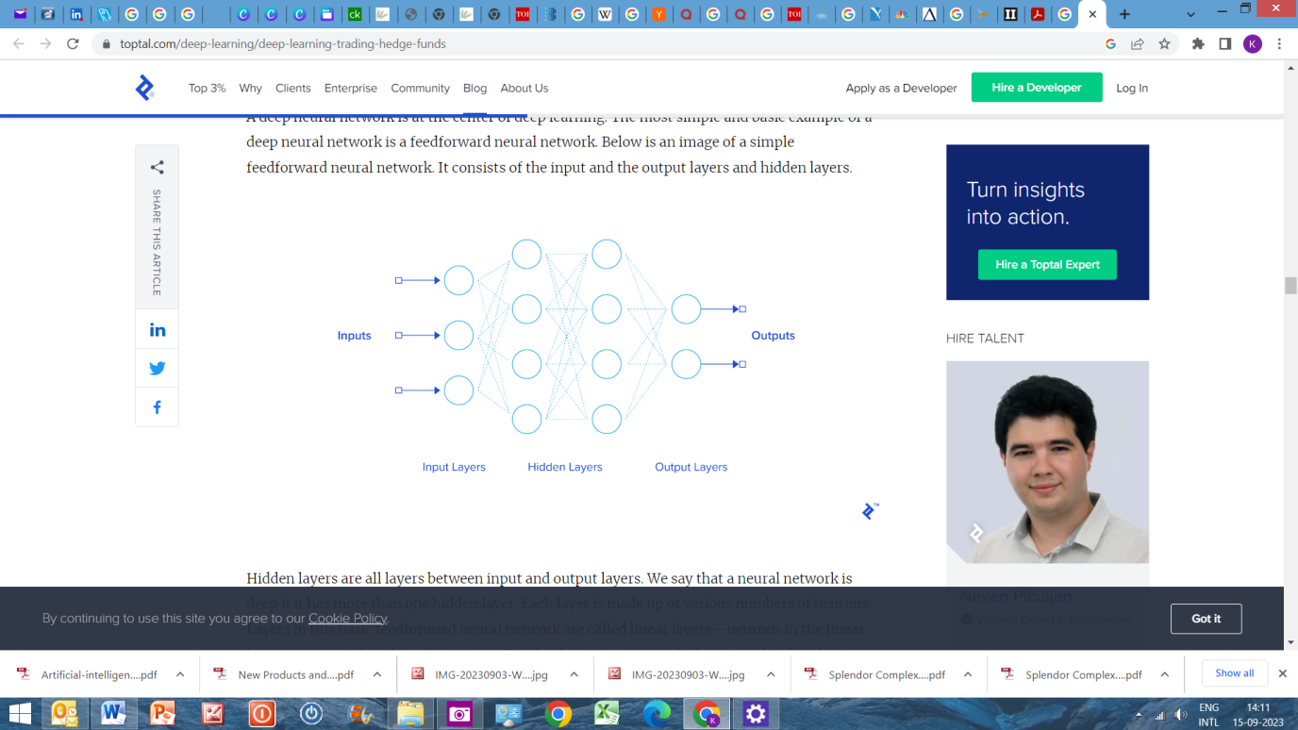of data and the significance of time.

The image above may look complicated, but it is nothing much to worry as we can simply it mathematically. Equation of a neural network looks like this.

ai = σ (wiai−1+bi)

wi is called weights. It is like the equation of regression. Weights are nothing but a little bit modified form of regression coefficients.

Neural networks tries to minimize something called cost function which is again very simple and looks like this:

C = 1/2n ∑ (y(x) − ai(x))2

The cost function minimization is similar to least square minimization.

So in a very simplistic way, neural networks are the advanced form of regression technique. Most of the machine learning techniques follows the same principle and has no rocket science.

**A simple example:**

Let us detect sarcasm from social media review comments and its ratings. Intuitively, if a review has a positive sentiment but a low rating, then it’s probably sarcastic. Examples:

"I have heard AI can solve problems and drive cars, design home interiors, and even recognise images. But can it keep my spouse happy? That's the real test!" (Rating: 0.5/5)

"Do you know why robots are so great at dancing? Because they have algorithm moves!" (Rating: 1/5)

You may have noticed that the sentiment of the reviews are positive (“solve problem”, “great”), but the ratings are low. That seems like a sign of sarcasm.

Now that we suspect there is some relationship between {sentiment, rating} and {sarcasm}, we list down some data points: Sentiment (+1 for positive, 0 for neutral, -1 for negative), Rating (0 to 5), Sarcasm (1 for Yes, 0 for No)

(Sentiment, Rating, Sarcasm)

(1, 0.5, 1)

(1, 1, 1)

(1, 5, 0)

(-1, 4, 1)

(-1, 1, 0)

... and a few thousand more.

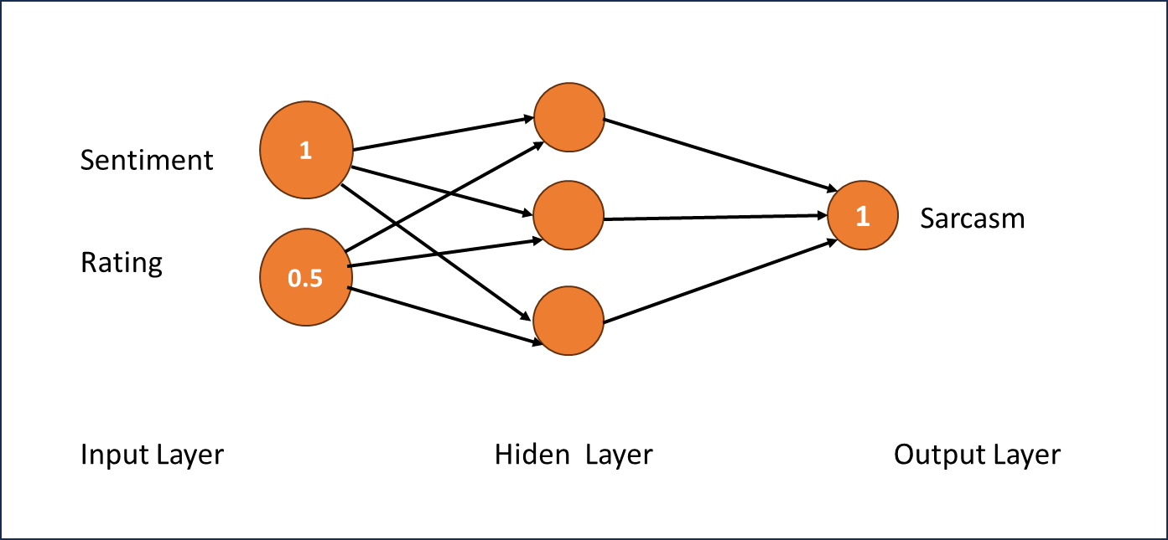So, to find out the actual relationship, we want to work on sentiment and rating values to somehow get the value of sarcasm. We will use layers as steps to move from inputs to output. Let’s look at the first example (1, 0.5, 1):

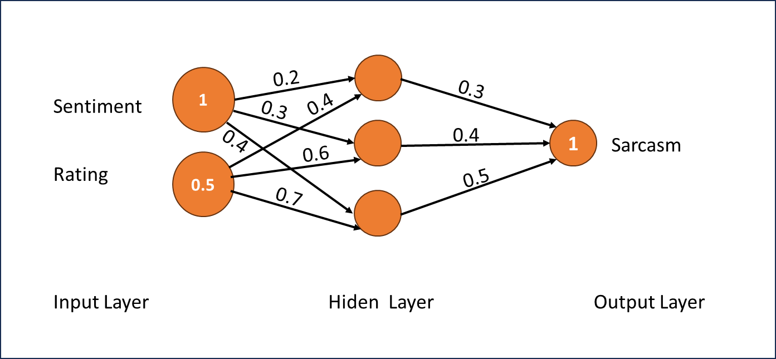Each line in that network has a weight. We will use those weights to calculate the values in the circles in the hidden layer and the output layer (which we hope will be ‘1’). Initially we assign weights randomly:

Now we have our initial thumb rule type neural network. Let’s see what the output will be. At each circle (aka “neuron”) in the hidden and output layer, we multiply their inputs with the corresponding weights and sum up the results.

Hidden Layer 1st Neuron = (1∗0.2) + (0.5∗0.4) = 0.4

Hidden Layer 2nd Neuron = (1∗0.3) + (0.5∗0.6) = 0.6

Hidden Layer 3rd Neuron = (1∗0.4) + (0.5∗0.7) = 0.75

Also, we want the output (Sarcasm) to be a number between 0 and 1 (because nothing else makes sense). We do this by using a magic function on the output layer, which reduces any given number to a number between 0 and 1. Any function we use at any neuron is called the activation function and in this case, we use the sigmoid function on the output layer.

Final Layer = (0.4∗0.3) + (0.6∗0.4) + (0.75∗0.5) = 0.735

Output = sigmoid(0.735) = 0.324

So, we have an output 0.324. But we were expecting 1! So, what do we do? We change the weights slightly to nudge the output towards the correct value. We do this using a method called Back propagation, which is explained later.

We repeat this thousands of times covering all the training data, changing the weights slightly every time. Eventually, we’ll get the ‘right’ weights which will best predict sarcasm, given sentiment and rating.

That’s it! Most applications of neural networks that you see, are variations of the above neural network with changes in:

* The structure of inputs and outputs.
* The number of hidden layers/neurons.
* How the neurons are connected.
* The training process.
* The activation function.

… and some other hyper parameters.

Logistic regression is just a one-layer neural network.

While the high level and conceptual thinking of NNs (neural networks) in AI is inspired by neurons and neural networks in the brain, the AI implementation of these concepts has diverged significantly from how the brain works. Moreover, as the field of AI has progressed over the years, and new complex ideas and techniques have been developed (RNNs, GANs, etc which we will talk about later) that link has further weakened.

**Key Similarities between AI NNs and Brain Networks**

**The high-level architecture and general principles** - at a high level, a brain neuron has three components:

1. 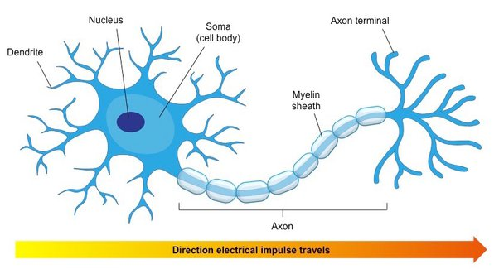**The dendrites** (the input mechanism) - tree like structure that receives input through synaptic connections. The input could be sensory input from sensory nerve calls, or "computational" input from other neural cells. A single cell can have as many as 100K inputs (each from a different cell)
2. **The Soma** (the calculation mechanism) - this is the cell body where inputs from all the dendrites come together, and based on all these signals a decision is made whether to fire an output (a "spike"). This is a bit of a generalisation, as some of the calculation already happens before the Soma, and is encoded in the dendritic structure of the cell.
3. **The axon** (the output mechanism) - once a decision was made to fire an output signal (thus making the cell active), the axon is the mechanism that carries the signal, and through a tree like structure as its terminal, it delivers this signal to the dendrites of the next layer of neurons via a synaptic connection.

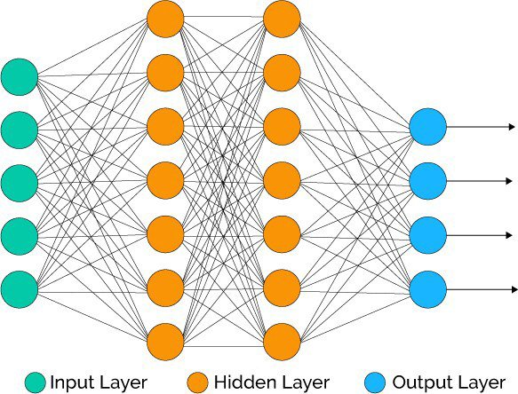Similarly, there is an equivalent structure in AI NNs:

1. **Incoming connections** - every neuron receives a set of inputs, either from the input layer (the equivalent of the sensory input) or from other neurons in previous layers in the network.
2. **The linear calculation and the activation functions**- these "sum up" the inputs and make a non linear decision whether to activate the neuron and fire.
3. **The output connections** - these deliver the activation signal of the neuron to the next layer in the network.

Similarly, **convolutional NNs** have been inspired by the visual pathway. The cool thing is that the original inspiration was about the architecture (small kernels/filters that are responding to specific shapes or patterns, and are applied on a small region at a time). However, years later, when ML researchers developed new techniques to visualise the hidden layers of a CNN, it was discovered that the representation of the images in the CNN, are very similar to what happens in the visual cortex. I.e hierarchical representation - starting from simple patterns at the first layer, which are then composed into complex shapes and objects in the deeper layers.

**Plasticity** - one of the unique characteristics of the brain, and the key feature that enables learning and memory is its plasticity, ability to morph and change. New synaptic connections are made, old ones go away, and existing connections become stronger or weaker, based on experience. Plasticity even plays a role in the single neuron impacting its electromagnetic behaviour, and its tendency to trigger a spike in reaction to certain inputs.

This idea of plasticity is the key principle in the training of AI NNs iteratively modifying the weights of the networks parameters, based on the batches of inputs. Recently, the field of meta learning expanded the use of plasticity in AI NNs beyond parameters, and apply it to modifying hyper parameters or even a whole model that is optimized at solving a given problem.

**Key** **Differences**

**The complexity and robustness of brain neurons** is much more advanced and powerful than that of artificial neurons. This is not just about the number of neurons, and the number of dendritic connections per neuron which are orders of magnitude of what we have in current AI NNs. But it's also about the internal complexity of the single neuron: as detailed below, the chemical and electric mechanisms of the neurons are much more nuanced and robust compared to the artificial neurons. For example, a neuron is not isoelectric meaning that different regions in the cell may hold different voltage potential, and different current running through it. This allows a single neuron to do nonlinear calculations, identify changes over time (e.g moving object), or map parallel different tasks to different dendritic regions such that the cell as a whole can complete complex composite tasks. These are all much more advanced structures and capabilities compared to the very simple artificial 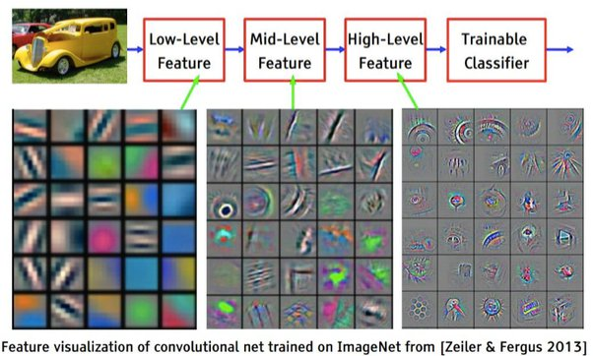neuron.

**Implementation** - the neurons in the brain are implemented using very complex and nuanced mechanisms that allow very complex nonlinear computations:

* chemical transmission of signals between neurons in the synaptic gap, through the use of neurotransmitters and receptors, amplified by various excitatory and inhibitory elements.
* Excitatory / inhibitory Post synaptic potentialthat builds up to action potential, based on complex temporal and spatial electromagnetic waves interference logic
* Ion channels and minute voltage difference a governing the triggering of spikes in the Soma and along the axon
* A lot that we don't yet understand…

Compared to these, the parameters, weights, and the linear and activation functions that are used in AI NNs are very basic and crude.

On top of that, the **overall network architecture** of neurons in the brain is much more complex than most AI NNs. Especially, your common next door feed forward network, where each layer is connected only to the previous and next layers. But even compared to multi layered RNNs, or residual networks, the network of neurons in the brain are ridiculously complex, with tens of thousands of dendrites crossing "layers" and regions in numerous directions.

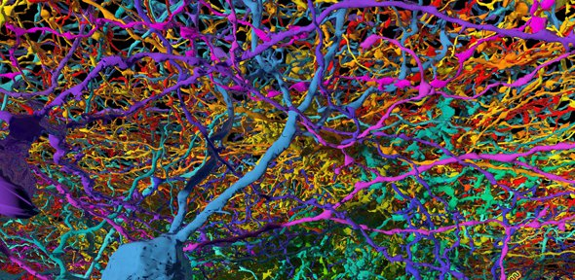On the other hand, it's very unlikely that the brain uses methods like **Back propagation** - leveraging the chain rule over partial derivatives of an error function**.**

**Power consumption** - the brain is an extremely efficient computing machine, consuming on the order of 10 Watts. This is about one third the power consumption of a single CPU…

**New developments - GAN, RL, RNN, …** - there is a constant stream of new ideas and innovations in both theoretical and applied ML. These aren't rooted in the brain anymore. They might be inspired by it, or by human behaviour, but in many ways, ML research and work has a life of its own now pursuing its own challenges and opportunities.

**The brain as continuous inspiration**

Despite all the differences listed above, ML research still keeps referencing to the brain as an inspirational source, since it's so much more robust and effective than anything we have. So identifying these gaps, and researching how they work in the brain, have sparked and inspired some of the most exciting and challenging recentML research. For example:

* **Power efficiency** - as noted, the brain has orders of magnitude more neurons and connections than any ANN we have built, yet it consumes orders of magnitude less power. There are active areas of research trying to achieve that. From biological networks using DNA and other molecules, to "neuromorphic" electronic switches that try to mimic how neurons and synapses work.
* **Learning from a very small set of training examples** - most probably through some built-in models that allow "intuitive" understanding of physical laws, psychology, causality, and other rules that govern decision making and acting on Earth. These accelerate learning and guide prediction/action compared to the current generic tabula-rasa NN architectures.
* **Unleashing the power of unsupervised and reinforcement learning** -unsupervised and reinforcement learning are the "black energy" of AI. Just like in physics, where black energy makes the vast majority of our universe, yet we know very little about it, it's clear that our brain mostly learns through unsupervised and reinforcement learning. Yet, most of the current applications of ML uses supervised learning. Unlocking this puzzle is critical for building machines that can learn like humans.
* **New approaches and architectures -**For example, see article in Quanta Magazine on how the neurological systems behind the smell sense, may inspire a new ML approach to a set of problems we don’t handle well using the current approaches.

Based on the basic structure of NN shown above, traditional networks include deep neural network (DNN), Recurrent Neural Network (RNN), Convolutional neural networks (CNN), Convolutional neural networks (DCNN), Back propagation (BP), Modular Neural Network (MNN), Multilayer Perceptron (MLP), Generative Adversarial Network (GAN) and Feedforward Neural Network (FNN).

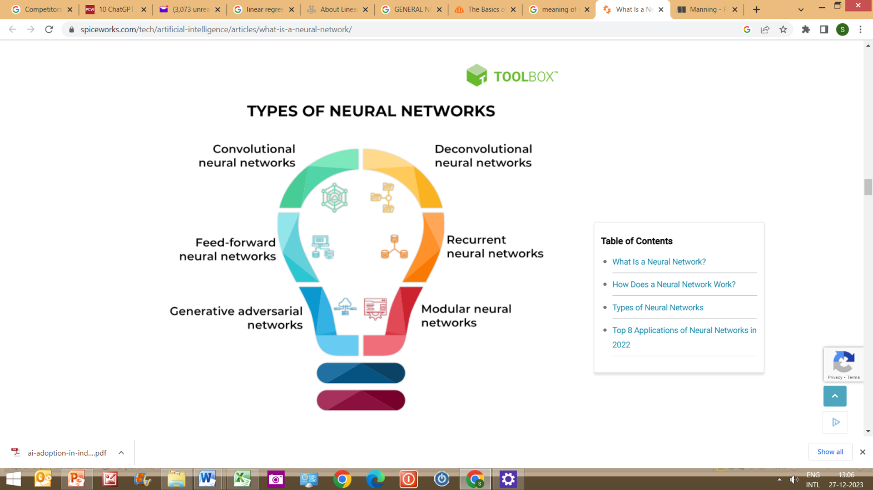

The application domains can be divided into two major areas: (1) Banking and credit risk and (2) Financial market investments. The former contains two domains: credit risk prediction and macroeconomic prediction. The latter contains financial prediction, trading, and portfolio management. Prediction tasks are crucial, as emphasized by Cavalcante et al. (2016).

Stock marketing prediction and trading dominate the listed domains, followed by exchange rate prediction. Price prediction and macroeconomic prediction are two potential topics that deserve more studies especially from the perspective of long term asset allocation in portfolio management.

ZeTheta is working on Proof of Concept (POC) on AI in long term asset allocation in portfolio management and portfolio rebalancing. ZeTheta’s virtual portfolio analyser is a step in this direction.

**Recurrent Neural Networks**

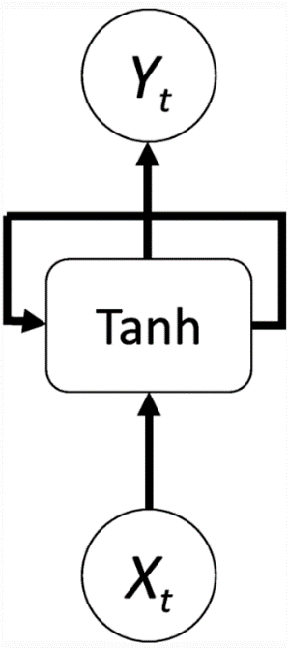As seen in below diagram, RNN has a new NN structure that can address the issues of long-term dependence and the order between input variables. As financial data in time series are very common, uncovering hidden correlations is critical in the real world. RNN can be better at solving this problem, as compared to other moving average (MA) methods that have been frequently adopted before.

Although RNN can resolve the issue of time-series order, the issue of long-term dependencies remains. It is difficult to find the optimal weight for long-term data. Long short-term memory (LSTM) network, a type of RNN, added a gated cell to overcome long-term dependencies by combining different activation functions (e.g., sigmoid or tanh). Given that LSTM is frequently used for forecasting in the finance literature, we can extract LSTM from RNN models and name other structures of standard RNN as RNN(O). LSTM is a recurrent neural network (RNN), aimed to deal with the vanishing gradient problem present in traditional RNNs. Its relative insensitivity to gap length is its advantage over other RNNs, hidden Markov models and other sequence learning methods.

LSTMs are capable of capturing the most important features from time series data and modelling its dependencies. PyTorch framework, written in Python, is usually used to train the model, design experiments, and draw the results.

Investment industry related data is highly nonlinear and sometimes securities price data can even seem completely random. Traditional time series methods such as ARIMA and GARCH models are effective only when the series is stationary, which is a restricting assumption that requires the series to be pre-processed by taking log returns (or other transforms). However, the main issue arises in implementing these models in a live trading system, as there is no guarantee of stationarity as new data is added. This is combated by using neural networks, which do not require any stationarity to be used. Furthermore, neural networks by nature are effective in finding the relationships between data and using it to predict (or classify) new data.

As a concept, the artificial neural network has been around for a long time, but the hardware wasn’t good enough to allow fast experiments in deep learning. NVIDIA helped revolutionize deep learning networks a decade ago, as it started offering very fast graphics processing units (GPUs) for general purpose computing in Tesla-series products. Instead of shading polygons in games and professional design applications, highly parallelized GPUs can compute other data as well and, in many cases, they’re vastly superior to CPUs.

**Deep neural network architecture**

Deep neural networks, or deep learning networks, have several hidden layers with millions of artificial neurons linked together. A number, called weight, represents the connections between one node and another. The weight is a positive number if one node excites another and negative if one node suppresses the other. Nodes with higher weight values have more influence on the other nodes. Theoretically, deep neural networks can map any input type to any output type. However, they also need much more training as compared to other machine learning methods. They need millions of examples of training data rather than perhaps the hundreds or thousands that a simpler network might need.

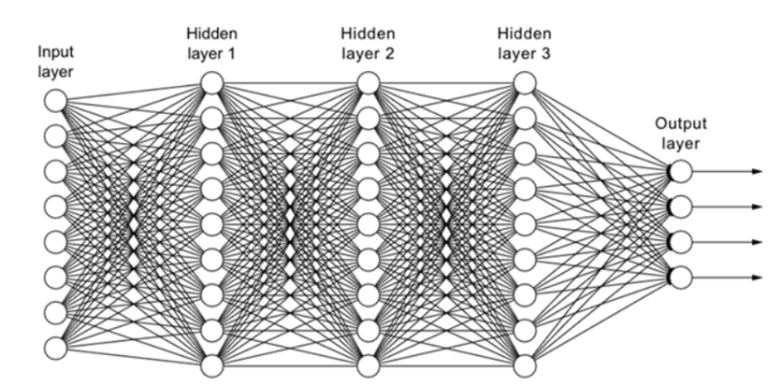Unlike traditional codes, which process data sequentially, neural networks can learn and multitask. In other words, while traditional codes only follow the instructions of their programming, neural networks continuously evolve through advanced algorithms. It can be said that neural computers ‘program themselves’ to derive solutions to previously unseen problems. While traditional codes are ready to go out of the box, neural networks must be ‘trained’ over time to increase their accuracy and efficiency.

**Convolutional neural networks**



The hidden layers in convolutional neural networks (CNNs) perform specific mathematical functions, like summarizing or filtering, called convolutions. They are very useful for image classification because they can extract relevant features from images that are useful for image recognition and classification. The new form is easier to process without losing features that are critical for making a good prediction. Each hidden layer extracts and processes different image features, like edges, color, and depth.

CNNs find applications in many areas, and the financial markets represent a promising domain for these powerful algorithms. In financial equity markets, where vast amounts of data get generated every second, CNNs provide a robust tool for analysis and prediction. Market trend identification serves as a primary application of CNNs. Traders and investors need to keep a pulse on market trends to make informed decisions. CNNs can analyse time-series data of stock prices, identify patterns and trends, and provide insights that can guide trading decisions. High-frequency trading represents another area where CNNs shine. Decisions must be made in fractions of a second in high-frequency trading. CNNs, with their ability to quickly process large volumes of data and make predictions, provide a significant advantage in this domain. Furthermore, CNNs contribute to enhancing financial security. Financial fraud poses a severe risk in the financial markets. CNNs can learn to identify patterns associated with fraudulent transactions, thereby assisting in fraud detection.

For example, suppose we have a dataset of stock prices for a particular equity over a certain period. This dataset forms a time series – a type of data that CNNs handle exceptionally well. A CNN can scan through this time-series data, much like scanning an image, and learn the underlying patterns. For instance, it might learn that a sharp price increase often follows a particular combination of volume and volatility. With this knowledge, CNN can then predict future stock prices. However, this example also highlights the complexity of CNNs which can pose difficulties in understanding and interpreting the results, also called as 'black box' challenge. This lack of interpretability means that while a CNN might make accurate predictions, understanding 'why' and 'how' it made those predictions might not be straightforward. This lack of transparency can be a significant issue in financial markets, where accountability and interpretability are crucial. Thus, CNN may predict that a stock's price will rise, it does not provide an explicit reason for this prediction. The prediction is based on the patterns it has learned, and these patterns, encoded as weights in the network, are not readily interpretable by humans.

Another example at a high level is say we will train a CNN to take in an image of a graph of time series data for past prices of a given asset (say, HDFC S&P BSE Sensex ETF – INF179KC1973 contracts traded on the BSE). Then, we predict the movement of the price by constructing a CNN algorithm. If the CNN correctly predicts price movements, we can make money by buying when the CNN says the price will go up in the future, and then selling it at the higher price in a few minutes’ time. We evaluate the trained network both using traditional statistical performance measures (viz.,R2) and also with a “paper trade” simulator like ZeTheta’s virtual portfolio analyser that enables us to see what would have happened if we had bought and sold contracts according to the CNNs predictions; in particular, we can see how profitable the strategy of following the trained CNN would be. Naturally, this methodology is subject to the vulnerability that it is impossible to tell how other participants in the market would have reacted to the presence of the CNN’s buying and selling, but it does give us atleast some measure of confidence as to the CNN stabilities as a trader.

**Deconvolutional neural networks**

Deconvolutional neural networks (DCNNs) are similar in nature to CNNs but work in a reversed process and are thus a distinct application of AI. DCNNs strive to find lost features or signals that may have previously not been deemed important to a CNN's task. A signal may be lost due to having been convoluted with other signals. The deconvolution of signals can be used in both image synthesis and analysis. A CNN emulates the workings of a biological brain's frontal lobe function in image processing. A DCNN constructs upwards from processed data. This backwards function can be seen as a reverse engineering of CNNs, constructing layers captured as part of the entire image from the machine vision field of view and separating what has been convoluted. DCNNs are related to other deep learning methods used for the extraction of features from hierarchical data, such as those found in deep belief networks and hierarchy-sparse automatic encoders. DCNNs are primarily used in scientific and engineering fields of study. DNNs were initially proposed as a way of performing unsupervised learning and usually as a probe of an already trained CNN.

**Feedforward neural networks (FNNs)**



Feedforward neural networks process data in one direction, from the input node to the output node. Every node in one layer is connected to every node in the next layer. A feedforward network uses a feedback process to improve predictions over time.

This simple neural network variant passes data in a single direction through various processing nodes until the data reaches the output node. Feed-forward neural networks are designed to process large volumes of ‘noisy’ data and create ‘clean’ outputs. This type of neural network is also known as the multi-layer perceptrons (MLPs) model.

A FNN architecture includes the input layer, one or more hidden layers, and the output layer. Despite their alternate name, these models leverage sigmoid neurons rather than perceptrons, thus allowing them to address nonlinear, real-world problems.

Feed-forward neural networks are the foundation for facial recognition, natural language processing, computer vision, and other neural network models.

Due to its capacity to understand intricate correlations between input and output variables, FFNs have been successfully used to solve portfolio optimization issues. Experimental results from studies have shown that the cuckoo search algorithm in a FNN model could be considered for predicting potential financial distress and black swan events. FFN can have applications in market risk management as well. Studies have shown how a deep feed-forward neural network trained for pricing derivative instruments can be efficiently used to calculate the market risk sensitivities as well. The proposed method used is a fast and easily implementable alternative approach to automatic differentiation, and it simultaneously calculates all the first and second order derivatives of a multilayer feed-forward neural network with respect to its input features.

Financial research has given rise to numerous studies in which, on the basis of the information provided by financial statements, companies are classified into different groups. An example is that of the classification of companies into those that are solvent and those that are insolvent. Linear discriminant analysis (LDA) and logistic regression have been the most commonly used statistical models in this type of work. One feedforward neural network, known as the multilayer perceptron (MLP), performs the same task as LDA and logistic regression which, a priori, makes it appropriate for the treatment of financial information.

**Modular neural networks**



Modular neural networks feature a series of independent neural networks whose operations are overseen by an intermediary. Each independent network is a ‘module’ that uses distinct inputs to complete a particular part of the larger network’s overall objective.

The modules do not communicate with one another or interfere with each other’s processes while computation occurs. This makes performing extensive and complex computational processes more efficient and quick.

Numerous studies concluded the weaknesses of Black-Scholes model use as a pricing tool in the derivative options market. For the last two decades, various studies were done analysing the alternate tools to price derivative options. Among the alternates is the use of modular neural networks. While Gradojevic, Gençay, and Kukolj (2009) use Modular back-propagation neural networks (BPNN) without any volatility related inputs, others like Y.H. Wang (2009a, 2009b), Lin and Yeh (2009), Wang, Lin, Huang, Wu (2012), and Chang, Wang and Yeh (2013) test different options of a volatility input and compare the final artificial neural network (ANN) outcome.

Artificial neural network models have a few notable advantages when compared to traditional parametric models. One of them is related to the exclusion of characteristics learned based on historical behaviour of asset returns, such as an assumption of its lognormal distribution. Another advantage is that, as opposed to parametric methods, the ANN can easily adapt and react to structural changes in data-generating processes. Finally, they easily encompass the dynamics of the variable of interest, such as that of asymmetry in the price dynamics, requiring no modifications as opposed to parametric methods. The only requirement of the ANN is a reasonably large set of data for efficient training and testing process in order to adequately learn the relationship between the provided inputs and targeted outputs.

ANN is one of the more modern and preferable tools used in nonlinear modelling. If it were possible to define all the dynamics of the asset price, and consequently set a parametric formula, it would unquestionably outperform the ANN. On the other hand, option-pricing literature shows the opposite, and all the parametric methods are developed to minimize error. Such experience is a reasonable motivator to employ learning networks in the field.

**Generative adversarial networks (GANs)**



GANs are a generative modelling solution that leverages convolutional neural networks and other deep learning offerings to automate the discovery of patterns in data. Generative modelling uses unsupervised learning to generate plausible conclusions from an original dataset.

GANs train generative models by creating a ‘supervised learning problem’ containing a generator model and a discriminator model. The former is prepared to develop new conclusions from the input. At the same time, the latter strives to label generated conclusions as either ‘real’ (from within the dataset) or ‘fake’ (generated by the algorithm). Once the discriminator model labels the generated conclusions wrongly about half the time, the generator model produces plausible conclusions.

There have been several GAN variants proposed in the literature to improve performance; these can mainly be divided into two types: Architecture and Loss variants. In the Architecture variants, structural changes were made to adapt the GAN to a certain purpose, or to improve overall performance. In Loss variants, different approaches to Loss functions try to improve stability and performance while training, often trying to solve the issue of non-convergence. Modifications have been made to tailor each network to its specific goal and used data type. Overall, the main topic of GAN research is and remains centred on image generation and computer vision. Even so, based on the continuing output of time series and finance applied models it is clear that GANs are helping to expand the field of research. There have been some milestone papers which will be discussed in the next segment.

GANs are a hot topic, especially in finance, when it comes to preventing or detecting fraudulent behaviour, or when conducting research in collaboration with universities. In finance, it is hard to publish any internal information as they contain too much confidential data. Hence, you will not easily find any real transactions or customer data online which are not totally faked. GANs are opening here a new door of possibilities by generating synthetic data based on real data, which can be published.

In the studies of financial time-series, there are two major approaches, namely stochastic processes and agent-based models, for modelling the financial time-series data. Stochastic processes such as the ARCH and the GARCH describe a financial time-series data as a series of random variable with temporally dependent parameters. However, it is difficult to recover all the major stylised facts with such explicit mathematical formulations. In contrast, agent-based models describe agents’ behaviour and interaction with other agents and the environment based on reasonable assumptions. The interaction leads to a complex collective behaviour and the emergence of stylised facts. However, it is also difficult to design such agents’ behaviour and to calibrate a large number of model parameters based on real data.

Considering the difficulties of these modelling approaches, it is desirable to develop an alternative approach that has a high reproducibility of stylized facts and can be built without a number of assumptions. Deep learning, especially deep generative models may provide such a solution. Among deep generative models, generative adversarial networks (GANs) have shown spectacular ability in the generation of data including realistic image, audio, and natural language text. The applications of GANs have expanded to a wider range of fields such as physics, complex networks, music, medical time-series, DNA sequences in addition to finance.

**Applications of GANs in Fintech:**

**1. Fraud Detection:**

GANs can generate synthetic fraudulent transactions, which can be used to train a fraud detection model. This helps the model become more adept at identifying new types of fraud, ultimately reducing risk for financial institutions and their customers.

For example, let's say a bank's fraud detection system previously identified transactions over Rs. 5,000 as potentially fraudulent. With the help of GANs, the bank can now train its system to identify new types of fraud, such as transactions that occur at unusual times of day or involve specific merchants or categories. Even if the bank hasn't encountered any fraudulent transactions fitting these criteria, GANs can generate synthetic data that the fraud detection system can use to learn and detect these new types of fraud. This way, GANs can help banks stay ahead of potential fraud and reduce risk for both the institution and its customers.



Financial services multinational American Express Co. has its AI lab looking for solutions to this issue by generating synthetic data to improve their fraud detection models. Amex researchers published a paper where a hybrid of Conditional and Deep Regret Analytic GANs was proposed to generate synthetic datasets. Three tabular datasets with internal company data were used to recreate statistically similar samples. The generated data was evaluated by comparing characteristics of the real and generated data distributions, and also by the internally developed tool DataQC, which uses well known methods to look for anomalies in datasets and outputs a unified score of attribute anomaly levels. The generated data showed satisfactory results, but it was found that models trained on synthetic data still performed worse than those trained on real data. The research team states that further research into generating synthetic data is being done, the capacity on which the generated data is being used internally was not disclosed.

**2. Credit Scoring:**

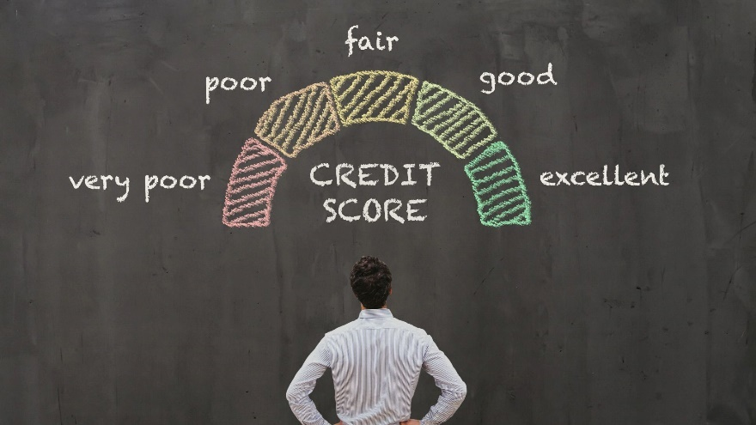

By generating synthetic credit profiles, GANs can help train credit scoring models, leading to more accurate credit decisions and reduced risk for lenders. To understand how this works, let's consider a sample scenario: Suppose a bank wants to improve its credit scoring model to better assess the creditworthiness of potential borrowers. However, the bank has limited data on certain borrower segments, such as young professionals or individuals with thin credit files. This lack of data can lead to less accurate credit decisions and increased risk for the bank.

To address this issue, the bank can use GANs to generate synthetic credit profiles for these underrepresented borrower segments. These synthetic profiles can include various credit-related attributes, such as credit history, income, debt-to-income ratio, and payment behaviour. By incorporating this synthetic data into the training process, the bank's credit scoring model can learn from a more diverse and representative dataset.

As a result, the credit scoring model becomes better equipped to evaluate the creditworthiness of borrowers from different segments, including those with limited credit history or unique financial situations. This leads to more accurate credit decisions, as the model can now better differentiate between high-risk and low-risk borrowers. Consequently, the bank can approve loans for creditworthy individuals who might have been previously overlooked, while also avoiding lending to high-risk borrowers. This ultimately reduces the risk for lenders and helps them make more informed lending decisions.

**3. Investment Management:**

Suppose an investment management firm wants to develop a model that predicts stock price movements. However, they have limited historical data for certain stocks or market conditions. GANs can generate synthetic financial market data, such as stock prices under various market conditions, to supplement the existing data. By training the model on this enriched dataset, the firm can develop more accurate investment strategies, ultimately reducing risk and improving returns for investors.

**4. Personalized Financial Planning:**



Imagine a financial planning app that aims to provide personalized budgeting and saving recommendations for its users. However, the app has limited data on certain user segments, such as recent college graduates or retirees. GANs can generate synthetic financial data, like spending patterns and investment portfolios, for these underrepresented user segments. By incorporating this synthetic data into the app's algorithms, the app can provide more accurate and tailored financial planning advice to a wider range of users.

**5. Risk Management:**

Consider a bank that wants to assess the risk of investing in a new asset class, such as cryptocurrencies. However, the bank has limited historical data on the performance of these assets under various market conditions. GANs can generate synthetic risk profiles for these assets, simulating their performance under different scenarios. By analysing these synthetic risk profiles, the bank can better evaluate the potential risks and rewards of investing in the new asset class, ultimately making more informed investment decisions.

**6. Anti-Money Laundering (AML) Detection:**



Suppose a financial institution wants to improve its AML detection system to identify new and emerging money laundering patterns. However, the institution has limited data on these new patterns, making it difficult to train the detection model effectively. GANs can generate synthetic AML scenarios that mimic these new money laundering patterns. By training the AML detection model on this synthetic data, the institution can improve its ability to detect and prevent money laundering activities, ultimately reducing the risk of financial crime and ensuring regulatory compliance.

With the goal of advancing AI research and development in financial services, JP Morgan’s AI Research department has a branch dedicated to generating synthetic datasets. These datasets can be requested by other research groups and comprise of:

1. Customer related datasets for Anti Money Laundering models,
2. Customer journey events, lower level client-bank interaction dataset,
3. Market execution data: limit order book data describing matches of buy and sell orders of financial instruments at a public stock exchange,
4. Payment data for fraud detection: several transaction types with legitimate and abnormal activities to improve detection.

The research department proposes a framework for ideal representation and transference of synthetic data. The framework suggests:

1. Privacy preserving, the specific data and context where privacy needs to be enforced.
2. Human readability, the data and its associated generative models must be readily interpretable by regulators and other agents for the sake of transparency.
3. Compactness, the representation of synthetic data should be compact and re-constructible; it should require little technical know-how as to improve synthesizing it in different environments.

All the specified data is produced in-house, there is no specific information on the generating process, but there is a paper under review by JP Morgan researchers where the MAS-GAN is proposed for multi-agent simulation, where the Generator is used to calibrate an agent based model.

The Financial Conduct Authority, a financial regulatory body from the United Kingdom created an environment for testing of financial models, products, and services. The Digital Sandbox provides an integrated, collaborative development environment for testing and scaling projects, aiming to reproduce real scenarios and perform stress tests. The initiative is in pilot stage and has already had a test run with 28 groups presenting solutions on the topics of: access to finance for SMEs, improving the financial resilience of vulnerable consumers and fraud/scam detection. The whole Digital Sandbox heavily relies on synthetic data, as real is under strict obligations in the UK. Synthetic financial data was commissioned to leading data scientists from industry and academia. There was a two-group effort, where one group would create the synthetic data and another who could define typologies and behaviours these data was expected to have. The main approaches to this task used GANs and ABMs and the whole process was benchmarked by the Alan Turing Institute. Access to synthetic data was ranked as the most important feature of the sandbox, however, not all data was considered useful, showing that there is demand for high quality synthetic data. The main takeaways from the first pilot were: A digital testing environment is in high demand, particularly by startups. It accelerated product development for the participating firms. The access to good synthetic data was considered extremely valuable by all participants. A second digital sandbox is planned with an expanded testing system. This promising new platform has shown potential and could be implemented in other countries if it further succeeds in the United Kingdom.

GANs hold immense potential for the fintech industry, with applications spanning across various domains. As the technology continues to evolve, we can expect even more innovative uses in the future. By harnessing the power of GANs, fintech companies can make better decisions, reduce risk, and provide more accurate financial services to their customers, ultimately revolutionizing the industry.

**Backpropagation algorithm**



Backpropagation is a widely used algorithm for training feedforward neural networks. Artificial neural networks learn continuously by using corrective feedback loops to improve their predictive analytics. In simple terms, you can think of the data flowing from the input node to the output node through many different paths in the neural network. Only one path is the correct one that maps the input node to the correct output node. To find this path, the neural network uses a feedback loop, which works as follows:

1. Each node makes a guess about the next node in the path.
2. It checks if the guess was correct. Nodes assign higher weight values to paths that lead to more correct guesses and lower weight values to node paths that lead to incorrect guesses.
3. For the next data point, the nodes make a new prediction using the higher weight paths and then repeat Step 1.

In the context of a neural network, learning equates to the fine-tuning of internal parameters or weights. The backpropagation algorithm computes the gradient of the error function with respect to these weights. The weights then adjust in the direction that minimizes the error, which corresponds to the difference between the actual and predicted outputs.

In algorithmic trading, financial institutions use backpropagation to design predictive models. These models are powered by past trading data that guide future trading decisions. The end goal remains clear maximize profits and minimize losses.

In credit risk assessment, another critical area in finance, backpropagation is leveraged to understand the patterns of credit defaulters. With these insights, banks and financial institutions can make informed decisions about credit approvals, thus reducing the risk of defaults.

Portfolio management utilises backpropagation to optimize the allocation of assets. By learning from past market trends and patterns, it helps design efficient investment strategies that maximize returns and minimize risks.

To comprehend the essence of backpropagation, envision a fruit seller anticipating the next day's fruit sales. Suppose the owner predicts selling 100 mangoes, but only 80 sell. This error in prediction becomes a valuable lesson for the owner. The owner adjusts the next day's prediction based on this error. In the context of backpropagation, this mirrors the adjustment of weights in response to the error computed. The iterative process of learning from errors and refining predictions underscores the fundamental principle of backpropagation.

There are two types of backpropagation networks:

Static backpropagation: Static backpropagation is a network designed to map static inputs for static outputs. These types of networks are capable of solving static classification problems such as OCR (Optical Character Recognition).

Recurrent backpropagation: Recursive backpropagation is another network used for fixed-point learning. Activation in recurrent backpropagation is feed-forward until a fixed value is reached. Static backpropagation provides an instant mapping, while recurrent backpropagation does not provide an instant mapping.

A back propagation neural network is widely used well known multi-layer supervised feed forward neural network algorithm since its simplicity and high problem-solving ability. In the traditional back propagation neural network, weight updating done by gradient decent based learning algorithm which is falling into local minima and learning rate is slow. Hence, keep away from above mentioned drawbacks; the opposition based learning (OBL) algorithm is used for weight adjustment in a back propagation neural network. This prediction model demonstrates a superior performance in financial time series forecasting stock market indices.

**The types of artificial intelligence**

There are primarily four types of artificial intelligence:

**Reactive Machines**

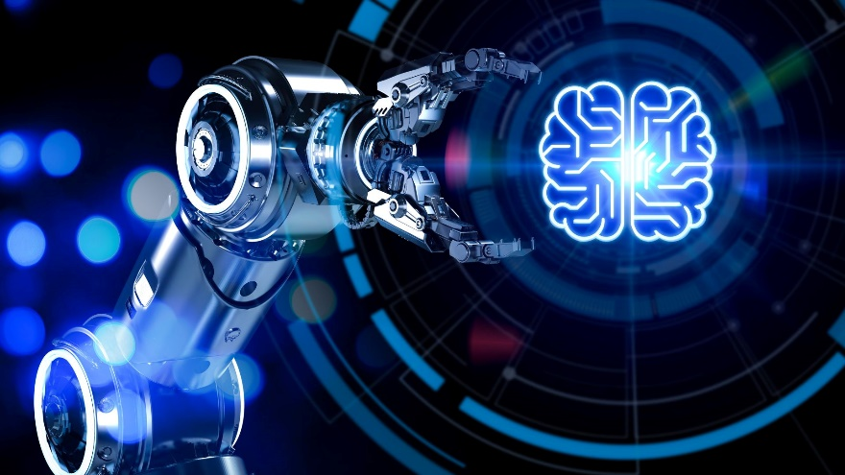

These machines can only react to the current situation based on pre-programmed rules without the ability to store past experiences. They are not capable of using historical data to make future decisions. Examples of reactive machines include Deep Blue, which IBM used to beat a world chess champion, and AlphaGo, which Google developed to defeat human Go champions.

**Limited Memory**

Limited memory AI systems can store past experiences and use them to make informed decisions in the future. These systems can analyze and interpret historical data to improve their performance. Examples of limited memory AI include self-driving cars, which use data from sensors and cameras to make driving decisions.

**Theory of Mind**

This type of AI can understand human emotions, beliefs, intentions, and desires. It can interact with humans in a way that is similar to how humans interact with each other. Theory of Mind AI is still in its early stages of development, and no commercial applications exist yet.

**Self-aware AI**

This is the most advanced type of AI that can understand its existence and capabilities and reason about its thoughts and actions. Self-aware AI does not exist, but some researchers speculate it could be developed.

The different types of AI are categorized based on their level of complexity and sophistication. As technology advances, we may see new categories emerge, and existing categories may become more refined.

**Liquid Neural Networks in Financial Services - the next revolution?**

Artificial Neural Networks (ANN) have been around in the AI world for a while. They have two main major drawbacks:

1. Complexity: they often get super complicated with billions of settings, requiring heavy infrastructures and leading to lack of transparency.
2. Slow Learning: They take a long time to get the hang of things and can't handle surprises well.

Having to deal with these downsides can quickly become a showstopper for financial institutions, which are highly apprehensive about data protection and traceability of information. That’s where Liquid Neural Networks (LNN), a cool but little-known alternative, come into play. Researchers at MIT recently discovered this by studying a tiny worm (C. elegans) with only 302 neurons. Surprisingly, this tiny 1 mm long invertebrate can achieve pretty complex tasks that usually need a much bigger neural network infrastructure. And they succeeded in replicating it!

A liquid neural network (LNN) is a time-continuous recurrent neural network built with a dynamic architecture of neurons. These neurons are able to process time-series data while making predictions based on observations and continuously adapting to new inputs. One of the key differences between LNNs and neural networks is that the former uses dynamic connections between neurons, whereas traditional neural networks have fixed connections and weights between each neuron. These flexible connections mean that liquid neural networks can continuously adapt to and learn from new data inputs in a way that traditional neural networks can’t, as they are dependent on their training data. This makes LNNs better at processing time-series data but is also less effective at processing static or fixed data than other neural networks. It’s important to note that the dynamic architecture of liquid neural networks also requires fewer overall neurons than a neural network and consumes less overall computing power. Their low computational needs mean they can be used to run on lightweight computers and hardware such as microcontrollers. LNNs are more interpretable than more complex black-box neural networks because it’s easier to see how data inputs are influencing outputs.

In April 2023, MIT researchers unveiled research demonstrating how liquid neural networks could be used to help teach aerial drones to navigate to a given object and to respond correctly in complex environments like forests and urban landscapes. Another test conducted by MIT examined how liquid neural networks could be used to help autonomous vehicles navigate. In this test, researchers equipped a car with a camera and computing units and then got human participants to drive the car. The onboard cameras recorded the angle the humans held the steering wheel and passed them to a training platform, which taught the liquid neural network to map the steering wheel to the angle shown in the image. The network then used these camera inputs to autonomously steer the vehicle. At a high level, this exercise demonstrated how liquid neural networks can be used to design neural controllers to help power an autonomous vehicle control system.

LNN offer several standout advantages over traditional networks, all of which open up very interesting prospects for financial institutions

1. Simplicity and Portability: Liquid Neural Networks thrive on simplicity. Unlike their more complex counterparts, they do not require an exorbitant number of parameters. This translates to reduce computational demands and cost-effectiveness, a crucial consideration for financial institutions aiming to maximize resource efficiency. This compact design also makes Liquid Neural Networks highly portable, enabling their use in resource-constrained environments and edge devices. Up to now, most financial organizations have had no other choice than relying on cloud-based solutions for their AI and machine learning needs, making it hard to ring fence their internal data. The rise of Liquid Neural Networks introduces the option to shift towards on-premises computing, offering direct benefits in terms of latency, resiliency and data security.
2. Explainability: Liquid Neural Networks provide a clearer window into decision-making processes, enhancing transparency and interpretability in applications. Compared to the opaqueness often associated with deep neural networks, they offer a much more interpretable model and the ability to easily extract the underlying decision tree. This heightened explainability clearly facilitates regulatory compliance.
3. Adaptability: These networks exhibit remarkable adaptability. By the way, that’s what “Liquid” stands for in the LNN acronym. Like water in its environment, they swiftly adjust to new data and changing conditions, a crucial trait for addressing evolving challenges. In the ever-changing landscape of financial markets, where unforeseen events can have profound impacts (such as the COVID era for instance), the capacity to adjust quickly is invaluable.

In conclusion, Liquid Neural Networks may be like a breath of fresh air in the AI world. In finance, where things move fast and understanding what's happening is key, they could bring efficiency, adaptability, and safety. As financial companies tackle complex challenges in our data-driven world, Liquid Neural Networks could offer a valuable tool to provide top-notch services to customers and partners.

**Application of Deep Learning models in Finance and Banking domains**

**Exchange rate prediction**



Shen et al. (2015) construct an improved DBN model by including RBM and find that their model outperforms the random walk algorithm, auto-regressive-moving-average (ARMA), and FNN with fewer errors. Zheng et al. (2017) examine the performance of DBN and find that the DBN model estimates the exchange rate better than FNN model does. They find that a small number of layer nodes engender a more significant effect on DBN.

Several scholars believe that a hybrid model should have better performance. Ravi et al. (2017) contribute a hybrid model by using MLP (FNN), chaos theory, and multi-objective evolutionary algorithms. Their Chaos+MLP + NSGA-II modelFootnote1 has a mean squared error (MSE) with 2.16E-08 that is very low. Several articles point out that only a complicated neural network like CNN can gain higher accuracy. For example, Galeshchuk and Mukherjee (2017) conduct experiments and claim that a single hidden layer NN or SVM performs worse than a simple model like moving average (MA). However, they find that CNN could achieve higher classification accuracy in predicting the direction of the change of exchange rate because of successive layers of DNN.

**Stock market prediction**

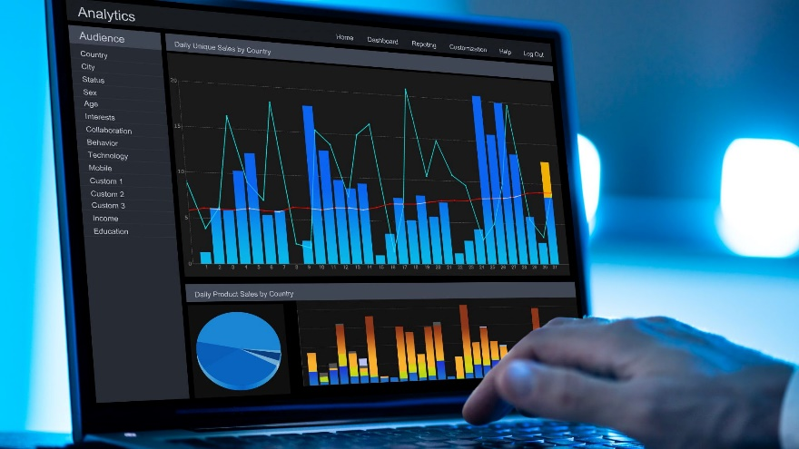

In stock market prediction, some studies suggest that market news may influence the stock price and DL model, such as using a magic filter to extract useful information for price prediction. Matsubara et al. (2018) extract information from the news and propose a deep neural generative model to predict the movement of the stock price. This model combines DNN and a generative model. It suggests that this hybrid approach outperforms SVM and MLP.

Minh et al. (2017) develop a novel framework with two streams combining the gated recurrent unit network and the Stock2vec. It employs a word embedding and sentiment training system on financial news and the Harvard IV-4 dataset. They use the historical price and news-based signals from the model to predict the S&P500 and VN-index price directions. Their model shows that the two-stream gated recurrent unit is better than the gated recurrent unit or the LSTM. Jiang et al. (2018) establish a recurrent NN that extracts the interaction between the inner-domain and cross-domain of financial information. They prove that their model outperforms the simple RNN and MLP in the currency and stock market. Krausa and Feuerriegel (2017) propose that they can transform financial disclosure into a decision through the DL model. After training and testing, they point out that LSTM works better than the RNN and conventional ML methods such as ridge regression, Lasso, elastic net, random forest, SVR, AdaBoost, and gradient boosting. They further pre-train words embeddings with transfer learning (Krausa and Feuerriegel 2017). They conclude that better performance comes from LSTM with word embeddings. In the sentiment analysis, Sohangir et al. (2018) compares LSTM, doc2vec, and CNN to evaluate the stock opinions on the StockTwits. They conclude that CNN is the optimal model to predict the sentiment of authors. This result may be further applied to predict the stock market trend.

Data preprocessing is conducted to input data into the NN. Researchers may apply numeric unsupervised methods of feature extraction, including principal component analysis, autoencoder, RBM, and kNN. These methods can reduce the computational complexity and prevent overfitting. After the input of high-frequency transaction data, Chen et al. (2018b) establish a DL model with an autoencoder and an RBM. They compare their model with backpropagation FNN, extreme learning machine, and radial basis FNN. They claim that their model can better predict the Chinese stock market. Chong et al. (2017) apply the principal component analysis (PCA) and RBM with high-frequency data of the South Korean market. They find that their model can explain the residual of the autoregressive model. The DL model can thus extract additional information and improve prediction performance. More so, Singh and Srivastava (2017) describe a model involving 2-directional and 2-dimensional (2D2) PCA and DNN. Their model outperforms 2D2 with radial basis FNN and RNN.

For time-series data, sometimes it is difficult to judge the weight of long-term and short-term data. The LSTM model is just for resolving this problem in financial prediction. The literature has attempted to prove that LSTM models are applicable and outperform conventional FNN models. Yan and Ouyang (2017) apply LSTM to challenge the MLP, SVM, and kNN in predicting a static and dynamic trend. After a wavelet decomposition and a reconstruction of the financial time series, their model can be used to predict a long-term dynamic trend. Baek and Kim (2018) apply LSTM not only in predicting the price of S&P500 and KOSPI200 but also in preventing overfitting. Kim and Won (2018) apply LSTM in the prediction of stock price volatility. They propose a hybrid model that combines LSTM with three generalized autoregressive conditional heteroscedasticity (GARCH)-type models. Hernandez and Abad (2018) argue that RBM is inappropriate for dynamic data modelling in the time-series analysis because it cannot retain memory. They apply a modified RBM model called p-RBM that can retain the memory of p past states. This model is used in predicting market directions of the NASDAQ-100 index. Compared with vector autoregression (VAR) and LSTM, notwithstanding, they find that LSTM is better because it can uncover the hidden structure within the non-linear data while VAR and p-RBM cannot capture the non-linearity in data.

CNN was established to predict the price with a complicated structure. Making the best use of historical price, Dingli and Fournier (2017) develop a new CNN model. This model can predict next month’s price. Their results cannot surpass other comparable models, such as logistic regression (LR) and SVM. Tadaaki (2018) applies the financial ratio and converts them into a “grayscale image” in the CNN model. The results reveal that CNN is more efficient than decision trees (DT), SVM, linear discriminant analysis, MLP, and AdaBoost. To predict the stock direction, Gunduz et al. (2017) establish a CNN model with a so-called specially ordered feature set whose classifier outperforms either CNN or LR.

**Stock trading**

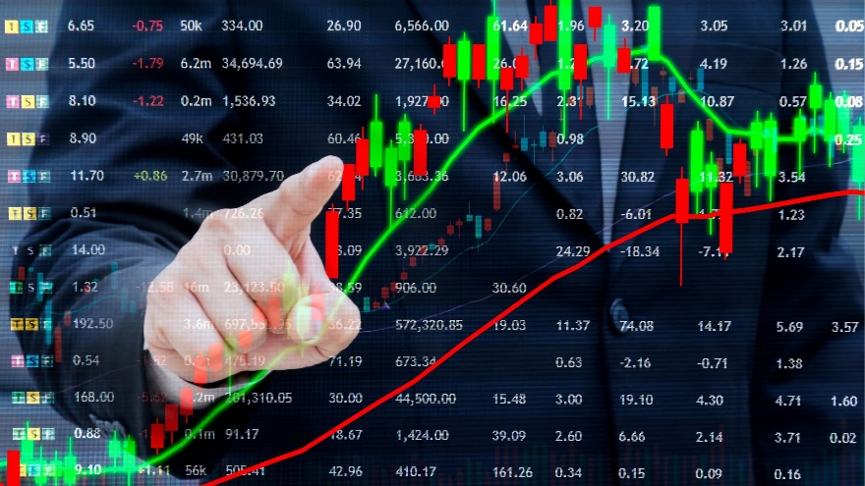

Many studies adopt the conventional FNN model and try to set up a profitable trading system. Sezer et al. (2017) combine GA with MLP. Chen et al. (2017) adopt a double-layer NN and discover that its accuracy is better than ARMA-GARCH and single-layer NN. Hsu et al. (2018) equip the Black-Scholes model and a three-layer fully-connected feedforward network to estimate the bid-ask spread of option price. They argue that this novel model is better than the conventional Black-Scholes model with lower RMSE. Krauss et al. (2017) apply DNN, gradient-boosted-trees, and random forests in statistical arbitrage. They argue that their returns outperform the market index S&P500.

Several studies report that RNN and its derivate models are potential. Deng et al. (2017) extend the fuzzy learning into the RNN model. After comparing their model to different DL models like CNN, RNN, and LSTM, they claim that their model is the optimal one. Fischer and Krauss (2017) and Bao et al. (2017) argue that LSTM can create an optimal trading system. Fischer and Krauss (2017) claim that their model has a daily return of 0.46 and a sharp ratio of 5.8 prior to the transaction cost. Given the transaction cost, however, LSTM’s profitability fluctuated around zero after 2010. Bao et al. (2017) advance Fischer and Krauss’s (2017) work and propose a novel DL model (i.e., WSAEs-LSTM model). It uses wavelet transforms to eliminate noise, stacked autoencoders (SAEs) to predict stock price, and LSTM to predict the close price. The result shows that their model outperforms other models such as WLSTM,Footnote2 LSTM, and RNN in predictive accuracy and profitability.

RL is popular recently despite its complexity. We find that five studies apply this model. Chen et al. (2018a) propose an agent-based RL system to mimic 80% professional trading strategies. Feuerriegel and Prendinger (2016) convert the news sentiment into the signal in the trading system, although their daily returns and abnormal returns are nearly zero. Chakraborty (2019) cast the general financial market fluctuation into a stochastic control problem and explore the power of two RL models, including Q-learningFootnote3 and state-action-reward-state-action (SARSA) algorithm. Both models can enhance profitability (e.g., 9.76% for Q-learning and 8.52% for SARSA). They outperform the buy-and-hold strategy.Footnote4 Zhang and Maringer (2015) conduct a hybrid model called GA, with recurrent RL. GA is used to select an optimal combination of technical indicators, fundamental indicators, and volatility indicators. The out-of-sample trading performance is improved due to a significantly positive Sharpe ratio. Martinez-Miranda et al. (2016) create a new topic of trading. It uses a market manipulation scanner model rather than a trading system. They use RL to model spoofing-and-pinging trading. This study reveals that their model just works on the bull market. Jeong and Kim (2018) propose a model called deep Q-network that is constructed by RL, DNN, and transfer learning. They use transfer learning to solve the overfitting issue incurred as a result of insufficient data. They argue that the profit yields in this system increase by four times the amount in S&P500, five times in KOSPI, six times in EuroStoxx50, and 12 times in HIS.

**Banking default risk and credit**

Most articles in this domain focus on FNN applications. Rönnqvist and Sarlin (2017) propose a model for detecting relevant discussions in texting and extracting natural language descriptions of events. They convert the news into a signal of the bank-distress report. In their back-test, their model reflects the distressing financial event of the 2007–2008 period.

Zhu et al. (2018) propose a hybrid CNN model with a feature selection algorithm. Their model outperforms LR and random forest in consumer credit scoring. Wang et al. (2019) consider that online operation data can be used to predict consumer credit scores. They thus convert each kind of event into a word and apply the Event2vec model to transform the word into a vector in the LSTM network. The probability of default yields higher accuracy than other models. Jurgovsky et al. (2018) employs the LSTM to detect credit card fraud and find that LSTM can enhance detection accuracy.

Han et al. (2018) report a method that adopts RL to assess the credit risk. They claim that high-dimensional partial differential equations (PDEs) can be reformulated by using backward stochastic differential equations. NN approximates the gradient of the unknown solution. This model can be applied to F&B risk evaluation after considering all elements such as participating agents, assets, and resources, simultaneously.

**Portfolio management**



Song et al. (2017) establish a model after combining ListNet and RankNet to make a portfolio. They take a long position for the top 25% stocks and hold the short position for the bottom 25% stocks weekly. The ListNetlong-short model is the optimal one, which can achieve a return of 9.56%. Almahdi and Yang (2017) establish a better portfolio with a combination of RNN and RL. The result shows that the proposed trading system respond to transaction cost effects efficiently and outperform hedge fund benchmarks consistently.

**Macroeconomic prediction**



Sevim et al. (2014) develops a model with a back-propagation learning algorithm to predict the financial crises up to a year before it happened. This model contains three-layer perceptrons (i.e., MLP) and can achieve an accuracy rate of approximately 95%, which is superior to DT and LR. Chatzis et al. (2018) examine multiple models such as classification tree, SVM, random forests, DNN, and extreme gradient boosting to predict the market crisis. The results show that crises encourage persistence. Furthermore, using DNN increases the classification accuracy that makes global warning systems more efficient.

**Price prediction**

For price prediction, Sehgal and Pandey (2015) review ANN, SVM, wavelet, GA, and hybrid systems. They separate the time-series models into stochastic models, AI-based models, and regression models to predict oil prices. They reveal that researchers prevalently use MLP for price prediction.

Zetheta has done few projects on price prediction on prices of REITs, Gold Prices and using sentiment analysis to predict prices of stocks which its users can understand in details by subscribing to Artificial Intelligence course and live project work experience internship on [www.fincomics.com](http://www.fincomics.com) or [www.zetheta.com](http://www.zetheta.com)

**Data preprocessing and data input**

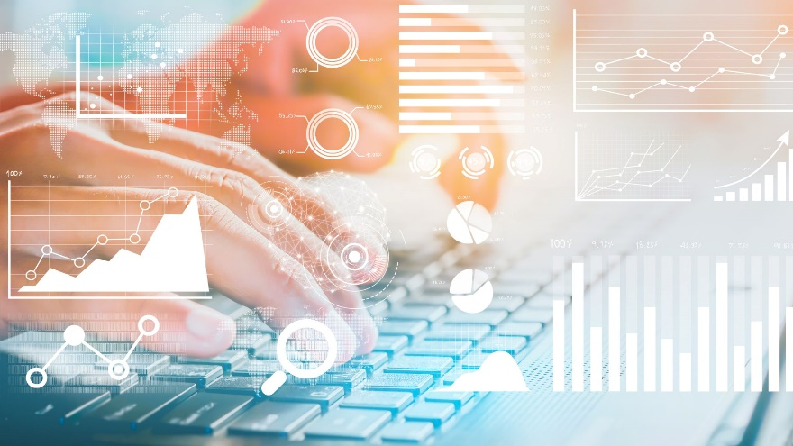

Data preprocessing is conducted to denoise before data training of DL. There are several additional techniques of feature selection as follows.

Relief: The relief algorithm (Zhu et al. 2018) is a simple approach to weigh the importance of the feature. Based on NN algorithms, relief repeats the process for n times and divides each final weight vector by n. Thus, the weight vectors are the relevance vectors, and features are selected if their relevance is larger than the threshold τ.

Wavelet transforms: Wavelet transforms are used to fix the noise feature of the financial time series before feeding into a DL network. It is a widely used technique for filtering and mining single-dimensional signals (Bao et al. 2017).

Chi-square: Chi-square selection is commonly used in ML to measure the dependence between a feature and a class label. The representative usage is by Gunduz et al. (2017).

Random forest: Random forest algorithm is a two-stage process that contains random feature selection and bagging. The representative usage is by Fischer and Krauss (2017).

Data inputs

Data inputs are an important criterion for judging whether a DL model is feasible for particular F&B domains. Based on our review, five types of input data in the F&B domain can be presented.

History price: The daily exchange rate can be considered as history price. The price can be the high, low, open, and close price of the stock. Related articles include Bao et al. (2017), Chen et al. (2017), Singh and Srivastava (2017), and Yan and Ouyang (2017).

Technical index: Technical indexes include MA, exponential MA, MA convergence divergence, and relative strength index. Related articles include Bao et al. (2017), Chen et al. (2017), Gunduz et al. (2017), Sezer et al. (2017), Singh and Srivastava (2017), and Yan and Ouyang (2017).

Financial news: Financial news covers financial message, sentiment shock score, and sentiment trend score. Related articles include Feuerriegel and Prendinger (2016), Krausa and Feuerriegel (2017), Minh et al. (2017), and Song et al. (2017).

Financial report data: Financial report data can account for items in the financial balance sheet or the financial report data (e.g., return on equity, return on assets, price to earnings ratio, and debt to equity ratio). Zhang and Maringer (2015) is a representative study on the subject.

Macroeconomic data: This kind of data includes macroeconomic variables. It may affect elements of the financial market, such as exchange rate, interest rate, overnight interest rate, and gross foreign exchange reserves of the central bank. Representative articles include Bao et al. (2017), Kim and Won (2018), and Sevim et al. (2014).

Stochastic data: Chakraborty (2019) provides a representative implementation.

**How Does a Neural Network Work?**

The ability of a neural network to ‘think’ has revolutionized computing as we know it. These smart solutions are capable of interpreting data and accounting for context.

Four critical steps that neural networks take to operate effectively are:

1. Associating or training enables neural networks to ‘remember’ patterns. If the computer is shown an unfamiliar pattern, it will associate the pattern with the closest match present in its memory.
2. Classification or organizing data or patterns into predefined classes.
3. Clustering or the identification of a unique aspect of each data instance to classify it even without any other context present.
4. Prediction, or the production of expected results using a relevant input, even when all context is not provided upfront.
5. Neural networks require high throughput to carry out these functions accurately in near real-time. This is achieved by deploying numerous processors to operate parallel to each other, which are arranged in tiers.



The neural networking process begins with the first tier receiving the raw input data. You can compare this to the optic nerves of a human being receiving visual inputs. After that, each consecutive tier gets the results from the preceding one. This goes on until the final tier has processed the information and produced the output.

Every individual processing node contains its database, including all its past learnings and the rules that it was either programmed with originally or developed over time. These nodes and tiers are all highly interconnected.

The learning process (also known as training) begins once a neural network is structured for a specific application. Training can take either a supervised approach or an unsupervised approach. In the former, the network is provided with correct outputs either through the delivery of the desired input and output combination or the manual assessment of network performance. On the other hand, unsupervised training occurs when the network interprets inputs and generates results without external instruction or support.

Adaptability is one of the essential qualities of a neural network. This characteristic allows machine learning algorithms to be modified as they learn from their training and subsequent operations. Learning models are fundamentally cantered around the weightage of input streams, wherein, each node assigns a weight to the input data it receives from its preceding nodes. Inputs that prove instrumental to deriving the correct answers are given higher weightage in subsequent processes.

Apart from adaptability, neural networks leverage numerous principles to define their operating rules and make determinations. Fuzzy logic, gradient-based training, Bayesian methods, and genetic algorithms all play a role in the decision-making process at the node level. This helps individual nodes decide what should be sent ahead to the next tier based on the inputs received from the preceding tier.

Basic rules on object relationships can also help ensure higher quality data modelling. For instance, a facial recognition neural network can be instructed ‘teeth are always below the nose’ or ‘ears are on each side of a face’. Adding such rules manually can help decrease training time and aid in the creation of a more efficient neural network model.

However, the addition of rules is not always a good thing. Doing so can also lead to incorrect assumptions when the algorithm tries to solve problems unrelated to the rules. Preloading the wrong ruleset can lead to the creation of neural networks that provide irrelevant, incorrect, unhelpful, or counterproductive results. This makes it essential to choose the rules that are added to the system carefully.

While neural networking, and especially unsupervised learning, still have a long way to go before attaining perfection, we might be closer to achieving a defining breakthrough than we think. It is a fact that the connections within a neural network are nowhere as numerous or efficient as those in the human brain. However, Moore’s Law, which states that the average processing power of computers is expected to double every two years, is still flourishing. This trend gives our expectations from AI and neural networks a definitive direction.

**Vector Database**

A vector database is designed to store, manage and index massive quantities of high-dimensional vector data efficiently. These databases are rapidly growing in interest to create additional value for generative artificial intelligence (AI) use cases and applications. According to Gartner, by 2026, more than 30 percent of enterprises will have adopted vector databases to ground their foundation models with relevant business data.1

Unlike traditional relational databases with rows and columns, data points in a vector database are represented by vectors with a fixed number of dimensions, clustered based on similarity. This design enables low latency queries, making them ideal for AI-driven applications.

**Vector databases vs. traditional databases**

The nature of data has undergone a profound transformation. It's no longer confined to structured information easily stored in traditional databases. Unstructured data is growing 30 to 60 percent year over year, comprising social media posts, images, videos, audio clips and more.2 Typically, if you wanted to load unstructured data sources into a traditional relational database to store, manage and prepare for AI, the process is labor-intensive and far from efficient, especially when it comes to new generative use cases such as similarity search. Relational databases are great for managing structured and semi-structured datasets in specific formats, while vector databases are best suited for unstructured datasets through high-dimensional vector embeddings.

**What are vectors?**

Enter vectors. Vectors are arrays of numbers that can represent complex objects like words, images, videos and audio, generated by a machine learning (ML) model. High-dimensional vector data is essential to machine learning, natural language processing (NLP) and other AI tasks. Some examples of vector data include:

* Text: Think about the last time you interacted with a chatbot. How do they understand natural language? They rely on vectors which can represent words, paragraphs and entire documents, that are converted via machine learning algorithms.
* Images: Image pixels can be described by numerical data and combined to make up a high-dimensional vector for that image.
* Speech/Audio: Like images, sound waves can also be broken down into numerical data and represented as vectors, enabling AI applications such as voice recognition.

**What are vector embeddings?**

The volume of unstructured datasets your organization needs for AI will only continue to grow, so how do you handle millions of vectors? This is where vector embeddings and vector databases come into play. These vectors are represented in a continuous, multi-dimensional space known as an embedding, which are generated by embedding models, specialized to convert your vector data into an embedding. Vector databases serve to store and index the output of an embedding model. Vector embeddings are a numerical representation of data, grouping sets of data based on semantic meaning or similar features across virtually any data type.

For example, take the words “car” and “vehicle.” They both have similar meanings even though they are spelled differently. For an AI application to enable effective semantic search, vector representations of “car” and “vehicle” must capture their semantic similarity. When it comes to machine learning, embeddings represent high-dimensional vectors that encode this semantic information. These vector embeddings are the backbone of recommendations, chatbots and generative apps like ChatGPT.

**Vector database vs graph database**



Knowledge graphs represent a network of entities such as objects or events and depicts the relationship between them. A graph database is a fit-for-purpose database for storing knowledge graph information and visualizing it as a graph structure. Graph databases are built on nodes and edges that represent the known entities and complex relationships between them, while vector databases are built on high-dimensional vectors. As a result, graph databases are preferred for processing complex relationships between data points while vector databases are better for handling different forms of data such as images or videos.

**How vector embeddings and vector databases work**

Enterprise vector data can be fed into an embedding model such as IBM’s watsonx.ai models or Hugging Face (link resides outside ibm.com), which are specialized to convert your data into an embedding by transforming complex, high-dimensional vector data into numerical forms that computers can understand. These embeddings represent the attributes of your data used in AI tasks such as classification and anomaly detection.

**Vector storage**

Vector databases store the output of an embedding model algorithm, the vector embeddings. They also store each vector’s metadata, which can be queried using metadata filters. By ingesting and storing these embeddings, the database can then facilitate fast retrieval of a similarity search, matching the user’s prompt with a similar vector embedding.

**Vector indexing**

Storing data as embeddings isn't enough. The vectors need to be indexed to accelerate the search process. Vector databases create indexes on vector embeddings for search functionality. The vector database indexes vectors using a machine learning algorithm. Indexing maps vectors to new data structures that enable faster similarity or distance searches, such as nearest neighbour search between vectors.

**Similarity search based on querying or prompting**

Querying vectors can be done via calculations measuring the distance between vectors using algorithms, such as nearest neighbour search. This measuring can be based on various similarity metrics such as cosine similarity, used by that index to measure how close or distant those vectors are. When a user queries or prompts an AI model, an embedding is computed using the same embedding model algorithm. The database calculates distances and performs similarity calculations between query vectors and vectors stored in the index. They return the most similar vectors or nearest neighbours according to the similarity ranking. These calculations support various machine learning tasks such as recommendation systems, semantic search, image recognition and other natural language processing tasks.

**Vector databases and retrieval augmented generation (RAG)**

Enterprises are increasingly favoring retrieval augmented generation (RAG) approach in generative AI workflows for its faster time-to-market, efficient inference and reliable output, particularly in key use cases such as customer care and HR/Talent. RAG ensures that the model is linked to the most current, reliable facts and that users have access to the model’s sources, so that its claims can be checked for accuracy. RAG is core to our ability to anchor large language models in trusted data to reduce model hallucinations. This approach relies on leveraging high-dimensional vector data to enrich prompts with semantically relevant information for in-context learning by foundation models. It requires effective storage and retrieval during the inference stage, which handles the highest volume of data. Vector databases excel at efficiently indexing, storing and retrieving these high-dimensional vectors, providing the speed, precision and scale needed for applications like recommendation engines and chatbots.

**Advantages of vector databases**

While it’s clear that vector database functionality is rapidly growing in interest and adoption to enhance enterprise AI-based applications, the following benefits have also demonstrated business value for adopters:

1. Speed and performance: Vector databases use various indexing techniques to enable faster searching. Vector indexing along with distance-calculating algorithms such as nearest neighbour search, are particularly helpful with searching for relevant results across millions if not billions of data points, with optimized performance.
2. Scalability: Vector databases can store and manage massive amounts of unstructured data by scaling horizontally, maintaining performance as query demands and data volumes increase.
3. Cost of ownership: Vector databases are a valuable alternative to training foundation models from scratch or fine-tuning them. This reduces the cost and speed of inferencing of foundation models.
4. Flexibility: Whether you have images, videos or other multi-dimensional data, vector databases are built to handle complexity. Given the multiple use cases ranging from semantic search to conversational AI applications, the use of vector databases can be customized to meet your business and AI requirements.
5. Long term memory of LLMs: Organizations can start with a general-purpose models like IBM watsonx.ai’s Granite series models, Meta's Llama-2 or Google's Flan models, and then provide their own data in a vector database to enhance the output of the models and AI applications critical to retrieval augmented generation.
6. Data management components: Vector databases also typically provide built-in features to easily update and insert new unstructured data.

**Types of vector databases**

There are a few alternatives to choose from:

1. Standalone, proprietary vector databases such as Pinecone
2. Open-source solutions such as weaviate or milvus, which provide built-in RESTful APIs and support for Python and Java programming languages
3. Platforms with vector database capabilities integrated, coming soon to IBM watsonx.data
4. Vector database/search extensions such as PostgreSQL’s open source pgvector extension, providing vector similarity search capabilities

**Integration with your data ecosystem**

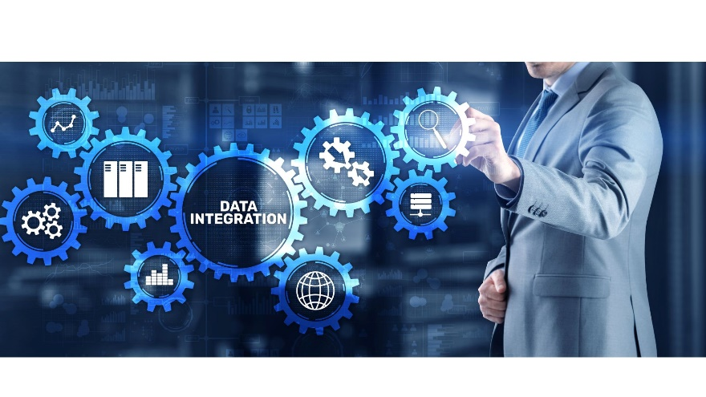

Vector databases should not be considered as standalone capabilities, but rather a part of your broader data and AI ecosystem. Many offer APIs, native extensions or can be integrated with your databases. Since they are built to leverage your own enterprise data to enhance your models, you must also have proper data governance and security in place to ensure the data with which you are grounding these LLMs can be trusted.

This is where a trusted data foundation plays an important role in AI, and that starts with your data and how it’s stored, managed and governed before being used for AI. Central to this is a data lakehouse, one that is open, hybrid and governed, such IBM watsonx.data, part of the watsonx AI data platform that fits seamlessly into a data fabric architecture. For example, IBM watsonx.data, is built to access, catalog, govern and transform all of your structured, semi-structured and unstructured data and metadata. You can then leverage this governed data and watsonx.data’s integrated vector database capabilities (tech preview Q4, 2023) for machine learning and generative AI use cases.

**When vector indexing is not optimal**

Using a vector store and index is well suited for applications that are based on facts or fact-based querying. For example, asking about a company’s legal terms last year or extracting specific information from complex documents. The set of retrieval context you would get would be those that are most semantically similar to your query through embedding distance. However, if you want to get a summary of topics, this doesn’t lend itself well to a vector index. In this case you would want the LLM to go through all of the different possible contexts on that topic within your data. Instead, you may use a different kind of index, such as a list index rather than a vector index, since a vector index would only fetch the most relevant data.

**Use Cases of Vector Databases**



The applications of vector databases are vast and growing. Some key use cases include:

1. Semantic search: Perform searches based on the meaning or context of a query, enabling more precise and relevant results. As not only words but phrases can be represented as vectors, semantic vector search functionality understands user intent better than general keywords.
2. Similarity search and applications: Find similar images, text, audio or video data with ease, for content retrieval including advanced image and speech recognition, natural language processing and more.
3. Recommendation engines: E-commerce sites, for instance, can use vector databases and vectors to represent customer preferences and product attributes. This enables them to suggest items similar to past purchases based on vector similarity, enhancing user experience and increasing retention.
4. Conversational AI: Improving virtual agent interactions by enhancing the ability to parse through relevant knowledge bases efficiently and accurately to provide real-time contextual answers to user queries, along with the source documents and page numbers for reference.

**Examples**

1. In Healthcare Industry the NLP and NLU component of Konfuzio enables deep analysis of medical reports. By using transformer-based algorithms such as BERT, clinical texts can be better understood and relevant information for diagnosis and therapy planning can be extracted.
2. At Financial sector, especially in the area of fraud detection, deep learning methods such as LSTM (Long Short Term Memory) can be used for sequence detection and anomaly detection. They help identify unusual patterns in unstructured text and transaction data to detect potential fraud.
3. In the areas Broker pools, insurers and reinsurers Konfuzio's AI offers significant advantages through the use of NLP and NLU algorithms as well as advanced machine learning techniques. Transformer-based models such as BERT and GPT allow in-depth analysis and interpretation of complex insurance documents, claims reports and policy-related texts. They help broker pools extract and process information quickly and efficiently. Insurance companies benefit from automated and accurate risk assessment by applying classification algorithms such as support vector machines (SVMs) or decision trees. In reinsurance, Deep Learning algorithms, especially LSTM, enable the analysis of large, sequential data sets, supporting the identification of loss patterns and risk profiles. Konfuzio represents a key solution in these contexts to increase efficiency and optimize the handling of unstructured data.
4. For the Retail Konfuzio uses NLP and Deep Learning algorithms for text classification and sentiment analysis. By analyzing customer feedback and product reviews, Konfuzio can develop a deep understanding of customer preferences and generate personalized product recommendations.
5. In Transport and logistics computer vision is used together with NLP to extract and process information from different document types. By using Convolutional Neural Networks (CNNs) for document classification and Transformer models for text extraction, relevant information can be efficiently extracted from waybills or delivery instructions.
6. At Energy sector the combination of NLP for text report analysis and time-series forecasting algorithms such as LSTM or ARIMA (AutoRegressive Integrated Moving Average) is particularly relevant. With these methods, Konfuzio can produce forecasts for energy consumption and production and help optimize the operation of the power grid.
7. In all these scenarios, Konfuzio relies on the combination of NLP, NLU, computer vision and generative AI algorithms to transform unstructured data into valuable information and solve industry-specific challenges.

**CHAT GPT AND ALTERNATIVES**



ChatGPT (Chat Generative Pre-trained Transformer) is a chatbot developed by OpenAI and launched on November 30, 2022. Based on a large language model, it enables users to refine and steer a conversation towards a desired length, format, style, level of detail, and language. Successive prompts and replies, known as prompt engineering, are considered at each conversation stage as a context. By January 2023, it had become what was then the fastest-growing consumer software application in history, gaining over 100 million users and contributing to the growth of OpenAI's valuation to $29 billion. ChatGPT's release spurred the development of competing products, including Bard, Ernie Bot, LLaMA, Claude, and Grok. Microsoft launched its Bing Chat based on OpenAI's GPT-4. Some observers raised concern about the potential of ChatGPT and similar programs to displace or atrophy human intelligence, enable plagiarism, or fuel misinformation.

Although a chatbot's core function is to mimic a human conversationalist, ChatGPT is versatile. Among countless examples, it can write and debug computer programs; compose music, teleplays, fairy tales, and student essays; answer test questions (sometimes, depending on the test, at a level above the average human test-taker); generate business ideas; write poetry and song lyrics; translate and summarize text; emulate a Linux system; simulate entire chat rooms; play games like tic-tac-toe; or simulate an ATM.

Let us review few alternatives of ChatGPT.

**HIX.AI**

Rather than a single service, HIX.AI is an all-in-one AI writing copilot that offers an entire suite of AI solutions. Its services are available without a subscription, albeit the free plan comes with certain limitations. Still, HIX.AI is a good ChatGPT free alternative both due to its processing power and the range of functions it can perform.

The first service to mention is HIX Chat – a chatbot that functions much like ChatGPT. Unlike ChatGPT, which is only available through the OpenAI webpage, this service is accessible through both the web app and HIX.AI’s Chrome extension. With web access, HIX Chat can cover practically any topic imaginable, answering even complex queries with up-to-date information in mere seconds.

Better yet, HIX Chat can even answer your questions based on uploaded PDF documents. The chatbot service can also summarize web pages and YouTube videos on demand, making it incredibly useful for ease of access and web content comprehension. This feature allows HIX.AI to become a leading ChatGPT alternative for free.

As we mentioned earlier, HIX.AI also offers an all-in-one Chrome extension for a variety of purposes. For instance, it can automatically draft emails and replies in Gmail, generate AI content or improve your text in Google Docs, craft engaging posts and replies on popular social platforms, and more. All of these functionalities are available with one simple command – type //.

Even all of what we’ve mentioned doesn’t exhaust the capabilities of HIX.AI. It comes with a reliable ArticleGPT that can produce fact-based, SEO-friendly, long-form content, including product reviews and roundups, how-tos, news articles, and practically any other type of article. It also offers a comprehensive suite of 120+ useful writing tools, a powerful text editor, and even an email generator to assist users in every writing step.

Pros

* Impressive AI capabilities
* Comprehensive suite of AI solutions
* Covers a broad range of topics
* Free plan comes with advanced features

Cons

* May produce generic responses on occasion

**Chatsonic**

Although it has a free basic option, Chatsonic can’t be listed among completely free Chat GPT alternatives. To leverage all of the possibilities of this service, users would need to purchase a monthly subscription. But in exchange, Chatsonic offers numerous AI possibilities.

Of course, the service can produce written content on demand. For this purpose, Chatsonic uses Google Knowledge integration to maximize its chances of producing factual copies. The service can also write in 13 tones (called “personas”) and will even read its responses aloud upon request.

Additional features of Chatsonic include AI-produced images, saving conversation settings, a Chrome extension, and an Android app. All these facets make Chatsonic rank among the top websites like ChatGPT.

Pros

* Powerful AI tool
* Integrated Google Knowledge
* Available in different “personas” (tones)

Cons

* Subscription-based

**Microsoft Bing**



Microsoft Bing has gone through significant revisions in the latest version. The former search tool second only to Google now integrates artificial intelligence and is starting to count among the alternatives to ChatGPT worth considering.

Powered by GPT-4, Bing can provide advanced answers to user queries. Furthermore, it can do so in three different styles: Creative (which focuses more on storytelling), Precision (which tries to provide the most accurate information), and Balanced (which finds the middle ground between the other two).

As one of the leading Chat GPT competitors, Microsoft Bing can conduct advanced online searches based on specific keywords and produce accurate results while citing relevant references. As a downside, Bing might not be as fast as some other alternatives.

Pros

* AI integrated in online searches
* Three styles of response
* Keyword-responsive

Cons

* Relatively slow

**YouChat**

YouChat represents an AI chatbot within the You search engine. It’s been active since 2022, receiving a significant upgrade in early 2023 – YouChat 2.0. This chatbot has been flying under the radar compared to some other options, but has proven to perform exceptionally well.

The advantage that YouChat offers compared to ChatGPT is its so-called multimodal functionality. This effectively means that the chatbot can receive and produce information in forms other than pure text. In particular, YouChat boasts an advanced language learning model that incorporates textual, app, and link input and output. In contrast, the publicly available version of ChatGPT can only process text.

Pros

* Entirely free to use
* Advanced LLM
* Multimodal input/output

Cons

* Limited app integration
* No AI image generation

**Claude**



Starting with the obvious, if you’re looking for a Chat GPT free alternative, you won’t find it in Claude. Purchasing the paid plan is practically necessary for any significant results. However, this companion software boasts powerful AI that may justify the expense.

Claude is available as a chat or in API form. It’s best used in a supportive role, where it can look up information and provide text summaries quickly and efficiently. Although it can be quite creative and handy, Claude doesn’t precisely function like other websites like Chat GPT.

The latest update to the chatbot, Claude 2, is of particular note. Although the update launched relatively recently, it has shown even more potential than the latest version of ChatGPT.

Pros

* State-of-the-art AI
* Available in API form
* Creative responses

Cons

* No significant results with the free plan
* Not a one-to-one alternative to ChatGPT

**Jasper Chat**



As a content creation tool, Jasper is hardly a new addition to the market. In fact, the service has become relatively well-known for generating decent content. Today, Jasper has the Jasper Chat service, an interesting alternative for users looking for other AI like Chat GPT.

The chatbot can be used for free, albeit with numerous limitations. The reason? Jasper Chat is intended primarily for business users, which is why its full features are locked behind a costly subscription plan. The price might be worth it for some because Jasper Chat can be a very proficient conversationalist.

However, it’s worth noting that the dataset used to train the AI is a bit outdated. The information that forms the basis of Jasper Chat is from early 2021 and thus less competitive with other ChatGPT alternatives.

Pros

* Satisfactory content generation
* Good AI conversationalist

Cons

* Not intended for private users
* Relatively costly
* Outdated dataset

**Perplexity AI**

Although the functionality of Perplexity AI may be questionable, one thing makes it a very interesting alternative to ChatGPT. Namely, Perplexity AI is completely free. It’s also very user-friendly and may produce straightforward answers to queries.

Additionally, this chatbot has received some recent upgrades. It can now produce source citations and follow up the initial query with additional questions for clarification’s sake. Yet, it still has some drawbacks that can’t be ignored.

Perplexity AI isn’t capable of retrieving previous responses, which is a major downside when compared with ChatGPT. The data that the chatbot produces can have issues with plagiarism. On top of these problems, Perplexity AI also has a limited suite of features, preventing it from becoming one of the leading alternatives to Chat GPT.

Pros

* Provides source citations
* Query follow-ups
* User-friendly

Cons

* No previous response retrieval
* Possible plagiarism issues
* Limited features

**Google Bard**



Although the artificial intelligence provided by Google may sound like a formidable alternative to all other services, Google Bard actually falls behind some other options on several accounts.

Google Bard is currently in an experimental phase. While its LaMDA model could power an AI like Chat GPT, the service hasn’t reached quite that level yet. As a result, Google Bard is exceptionally fast and reasonably creative, but with considerable downsides. The service is often guilty of plagiarism and inaccuracy, and it won’t give a list of resources for its responses.

However, Google Bard might still have some promise, due to the tech powerhouse behind the service. In its current state, it’s still not the best alternative to ChatGPT.

Pros

* Created by Google
* Exceptional speed

Cons

* Still in experimental phase
* Low accuracy and originality
* No listed resources

**Auto-GPT**

As a ChatGPT alternative, Auto-GPT requires the user to have a certain understanding of Python code, but may be a superior app for those with the right know-how. The secret? Auto-GPT has something that many chatbots lack: semi-autonomous functionality.

For example, when working with ChatGPT, a user will need to provide the initial prompt as well as any follow-ups. On the other hand, Auto-GPT allows you to set the desired goal and let the chatbot do the rest of the work. The chatbot will then provide additional prompts and relevant responses.

* Pros
* Semi-autonomous
* Uses GPT-4
* Upcoming AgentGPT app will make the chatbot easier to use

Cons

* Requires coding knowledge

**Copy.ai**



While it might not seem like a fully fledged chatbot, Copy.ai has plenty to recommend it as an alternative to ChatGPT, for at least some of its functions. For example, it can summarize any text when given only the URL address.

The primary use for Copy.ai, though, is tied to content creation. The app can write content in any tone, making it highly customizable. Also, users can organize their projects into folders and store them all in the online database.

Copy.ai has a limited free version. The paid mode’s pricing will depend on how useful you find the additional functionality – no word count or project limit, additional writer’s tools, automated processes, and access to state-of-art GPT-4.

Pros

* Fast article summarization
* Advanced writing tools (with paid plan)

Cons

* Lesser functionality compared to ChatGPT or other competitors

Alternatives to ChatGPT will certainly continue to grow in competence and performance as technology progresses.

**Credit intermediation and assessment of creditworthiness**

AI-based models and big data are increasingly being used by banks and fintech lenders to assess the creditworthiness of prospective borrowers and make underwriting decisions, both functions at the core of finance. In the context of credit scoring, ML models are used to predict borrowers’ defaults with superior forecasting accuracy compared to standard statistical models (e.g. logic regressions) especially when limited information is available (Bank of Italy, 2019) (Albanesi and Vamossy, 2019). Moreover, financial intermediaries use AI-based systems for fraud detection, as well as in order to analyse the degree of interconnectedness between borrowers, which in turn allows them to better manage their lending portfolio.

AI and big data are being used in fraud detection by financial institutions and FinTech lenders, for client on boarding and KYC checks, anti-money laundering and terrorist financing screening on a shared platform at on boarding and ongoing customer due diligence stage (AML/CFT) and detection of suspicious activities during ongoing monitoring.

In particular, AI can help institutions recognise abnormal transactions and identify suspicious and potentially fraudulent activity through the use of image recognition software, risk models, and other AIbased techniques (e.g. fraudulent use of customer’s personal information, misrepresenting products/services, other scams). AI can also reduce the incidence of false positives, in other words the rejection of otherwise valid transactions (e.g. credit card payment falsely declined), resulting in higher client satisfaction.

A Proof of Concept project to assess the feasibility and effectiveness of the use of AI in AML/CFT on a shared platform has been conducted in Japan. The AI based system for transaction screening and monitoring, using previously filed suspicious transactions from various financial institutions as ML data as objective function, successfully assisted compliance personals in triaging the results of transaction screening against sanctions lists and identifying suspicious transactions (New Energy and Industrial Technology Development Organization, 2021).

At the same time, other applications of AI could be used to circumvent fraud detection capabilities of financial institutions. For example, AI-based fraudulent pictures can become indistinguishable from actual pictures, raising important challenges to authentication and verification functions within financial services (US Treasury, 2018).

The availability of big data and advanced AI-based analytics models using such datasets have transformed the way credit risk is assessed. Credit scoring models powered by AI combine the use of conventional credit information, where available, with big data not intuitively related to creditworthiness (e.g. social media data, digital footprints, and transactional data accessible through Open Banking initiatives).

The use of AI models in credit scoring can reduce the cost of underwriting, while allowing for the analysis of creditworthiness of clients with limited credit history (‘thin files’). It can therefore enable the extension of credit to viable companies that cannot prove their viability through historical performance data or tangible collateral assets, potentially enhancing access to credit and supporting the growth of the real economy by alleviating constraints to SME financing. Recent empirical analysis could even reduce the need for collateral by reducing information asymmetries prevailing in credit markets (BIS, 2020). Credit approval rates for parts of the population that has historically been left behind, such as near-prime clients or underbanked parts of the population, could be better served through alternative scoring methods, potentially promoting financial inclusion. Notwithstanding the above, AI-based credit scoring models remain untested over longer credit cycles or in case of a market downturn, and there is limited conclusive empirical support as to the benefits of ML-driven techniques for financial inclusion. For example, while some analysis suggests that the use of ML models for credit risk assessment results in cheaper access to credit only for majority ethnic groups (Fuster et al., 2017), others find that lending-decision rules based on ML predictions help reduce racial bias in the consumer loan market (Dobbie et al., 2018).

**AI/ML-based credit scoring, transparency and fairness in lending**

Despite their vast potential for speed, efficiency and risk scoring of the ‘unscored’, AI/ML-based models raise risks of disparate impact in credit outcomes and the potential for discriminatory or unfair lending (US Treasury, 2015).13 Similar to other applications of AI in finance, such models also raise important challenges related to the quality of data used and the lack of transparency/explainability around the model.

Well-intentioned ML models may inadvertently generate biased conclusions, discriminated against certain classes of people (e.g. based on race, gender, ethnicity, religion) (White & Case, 2017). Inadequately designed and controlled AI/ML models carry a risk of exacerbating or reinforcing existing biases while making discrimination in credit allocation even harder to find (Brookings, 2020).

As with any model used in financial services, the risk of ‘garbage in, garbage out’ exists in AI/ML-based models for risk scoring and beyond. Inadequate data may include poorly labelled or inaccurate data, data that reflects underlying human prejudices, or incomplete data (S&P, 2019). A neutral ML model that is trained with inadequate data, risks producing inaccurate results even when fed with ‘good’ data. Alternately, a neural network trained on high-quality data, which is then fed inadequate data, will produce a questionable output, despite the well-trained underlying algorithm. This, combined with the lack of explainability in ML models, makes it harder to detect inappropriate use of data or use of unsuitable data in AI-based applications.

As such, the use of poor quality or inadequate/unsuitable data may result in wrong or biased decision making. Biased or discriminatory scoring may not be intentional from the perspective of the firm using the model; instead, algorithms may combine facially neutral data points and treat them as proxies for immutable characteristics such as race or gender, thereby circumventing existing non-discrimination laws (Hurley, 2017). For example, while a credit officer may be diligent not to include gender-based variants as input to the model, the model can infer the gender based on transaction activity, and use such knowledge in the assessment of creditworthiness, circumventing the law. Biases may also be inherent in the data used as variables and, given that the model trains itself on data from external sources that may have already incorporated certain biases, perpetuates historical biases.

Similar to other applications of AI in finance, ML-based models raise issues of transparency given their lack of explainability, i.e., the difficulty in comprehending, following or replicating the decision-making process. Issues related to explainability are particularly pertinent in lending decisions, as lenders are accountable for their decisions and must be able to explain the basis for denials of credit extension. This also means that consumers have limited ability to identify and contest unfair credit decisions, and little chance to understand what steps they should take to improve their credit rating.

Regulations in developed economies ensure that specific data points are not taken into account in the credit risk analysis (e.g. US regulation around race data or zip code data, UK regulation around protected category data). Regulation promoting anti-discrimination principles, such as the US fair lending laws, exists in many jurisdictions, and regulators are globally considering the risk of potential bias and discrimination risk that AI/ML and algorithms can pose (White & Case, 2017).

In some jurisdictions, comparative evidence of disparate treatment, such as lower average credit limits for members of protected groups than for members of other groups, is considered discrimination regardless of whether there was intent to discriminate. Potential mitigants against such risks are the existence of auditing mechanisms that sense check the results of the model against baseline datasets; testing of such scoring systems to ensure their fairness and accuracy (Citron and Pasquale, 2014); and governance frameworks for AI-enabled products and services and assignment of accountability to the human parameter of the project, to name a few.

**BigTech and financial services**

As BigTech increasingly leverage their free access to vast amounts of customer data that feed into AIdriven models to provide financial services, their deployment of AI raises issues around data privacy and concerns over ways in which the collection, storage and use of personal data may be exploited for commercial gain (DAF/CMF(2019)). These practices could disadvantage customers, such as through discriminatory practices related to credit availability and pricing.

****Access to customer data by BigTech give them a clear competitive advantage over conventional financial services providers. This advantage is likely to be further reinforced with their use of AI, which offers possibilities for novel, customised and more efficient service provision by these players. The dominance of BigTech in certain areas of the market could lead to excessive market concentration and increase the dependence of the market to few large BigTech players, with possible systemic implications depending on their scale and scope (DAF/CMF(2019), (FSB, 2020). This, in turn, could give rise to concerns over potential risks to financial consumers, who may not be receiving the same range of product options, pricing or advice that would be provided through traditional financial services providers. It also could lead to difficulties for supervisors in accessing and auditing the financial activities provided by such firms.

Another related risk has to do with anti-competitive behaviours and market concentration in the technology aspect of the service provision. The possible emergence of a small number of key players in markets for AI solutions and/or services incorporating AI technologies (e.g. cloud computing service providers who also provide AI services), evidence of which is already observed in some parts of the world (ACPR, 2018). Challenges for the competitive environment are also present given the privileged position Big Tech players have with regards to customer data. In particular, such firms can use their data advantage to build monopolistic positions, both in relation to client acquisition (for example through effective price discrimination) and through the introduction of high barriers to entry for smaller players.

At the end of 2020, the European Union and the UK published regulatory proposals, the Digital Markets Act, that seek to establish an ex ante framework to govern ‘Gatekeeper’ digital platforms such as Big Tech, aiming to mitigate some of the above risks and ensure fair and open digital markets (European Commission, 2020). Some of the obligations proposed include the requirement for such Gatekeepers to provide business users with access to the data generated by their activities and provide data portability, while prohibiting them from using data obtained from business users to compete with these business users (to address dual role risks). The proposal also provides for solutions addressing self-referencing, parity and ranking requirements to ensure no favourable treatment to the services offered by the Gatekeeper itself against those of third parties.

**Integration of AI in Blockchain-based financial products**



Applications of distributed ledger technologies (DLT), such as the blockchain, have proliferated in recent years across industries and primarily in finance. The rapid growth of blockchain-based applications is supported by the purported benefits of speed, efficiency and transparency that such innovative technologies may offer, driven by automation and disintermediation (OECD, 2020). Widespread adoption of DLTs in finance may be driven by efforts to increase efficiencies from disintermediation, including in securities markets (issuance and post-trade/ clearing and settlement); payments (central bank digital currencies and fiat-backed stablecoins); and tokenisation of assets more broadly, and may drive the re-shaping of roles and business models of financial operators (e.g. custodians).

A convergence of AI and DLTs in blockchain-based finance is being promoted by the industry as a way to yield better results in such systems, as increased automation may amplify efficiencies promised by blockchain-based systems. However, the actual level of AI implementation in blockchain-based projects does not appear to be sufficiently large at this stage to justify claims of convergence between the two technologies.

Instead of a convergence, what is actually being observed in practice is the implementation of AI applications in certain blockchain systems, for specific use-cases (e.g. for risk management, see below), and similarly, the implementation of DLT solutions in certain AI mechanisms (e.g. for data management). The latter involves the use of DLTs to feed information to a ML model, making use of the immutable and disintermediated characteristics of the blockchain, while also allowing for the sharing of confidential information on a zero-knowledge basis without breaching confidentiality and privacy requirements. The use of DLTs in AI mechanisms is hypothetically expected to allow users of such systems to monetise data they own and which is being used by ML models and other AI-driven systems (e.g. IoT). Implementation of such AI use-cases is driven by the potential of the technology to further increase efficiency gains of automation and disintermediation in DLT-based systems and networks.

The largest contribution of AI in DLT-based finance may be in augmenting the automating capacity of smart contracts. Several applications of AI can be identified in specific use-cases applied within DLT networks, such as compliance and risk management (e.g. anti-fraud, introduction of automated restrictions to a network); and data inference and management (e.g. enhancing the function of Oracles). Most of these applications are still in the development phase.

In particular, AI can be used in blockchain networks to reduce (but not eliminate) security susceptibilities and help protect against compromising of the network, for example in payment applications. Leveraging the power of AI can assist users of blockchain networks to identify irregular activities that could be associated with theft or scams, as such events do occur despite the need of both private and public keys in order to compromise security of a user. Similarly, AI applications can improve on-boarding processes on a network (e.g. biometrics for AI identification), as well as AML/CFT checks in the provision of any kind of DLT-based financial services. The integration of AI in DLT-based systems can also assist in compliance processes and risk management in such networks. For example, AI applications can provide a wallet address analysis results that can be used for regulatory compliance purposes or for an internal risk-based assessment of transaction parties (Ziqi Chen et al., 2020). However, when financial intermediaries are

eliminated from financial transactions, the effectiveness of the current financial regulatory approaches focusing on regulated entities may be eroded (Endo, 2019).

The integration of AI-based solutions in DLT-based systems at the protocol level could help authorities achieve their regulatory objectives in an efficient manner. This could be achieved inter alia through the automatic sharing of regulated entities’ data with the authorities in a seamless and real time manner, as well as through the programming of regulatory requirements in the code of the programmes, promoting compliance in an automatic way. Participation of regulators as nodes in decentralised networks has been discussed by the market as one of the ways to resolve the challenges of supervision of such platforms that lack a single central authority.

When it comes to data, in theory, AI could be used in DLT-based systems to potentially improve the quality of the data inputs into the chain, as the responsibility of data curation shifts from third party nodes to independent, automated AI-powered systems, enhancing the robustness of information recording and sharing as such systems are more difficult to manipulate. In particular, the use of AI could improve the functioning of third party off-chain nodes, such as so-called ‘Oracles’, nodes feeding external data into the network. The use of Oracles in DLT networks carries the risk of erroneous or inadequate data feeds into the network by underperforming or even malicious third-party off-chain nodes (OECD, 2020). In theory, the use of AI could further increase disintermediation by bringing AI inference directly on-chain, which would render third party providers of information to the chain, such as Oracles, redundant. In practice, it could act as a safeguard by testing the veracity and truthfulness of the data provided by the Oracles and prevent cyber-attacks or manipulation of such third-party data provision into the network.

The use of such AI applications could theoretically somehow increase participants’ trust in the network as participants can test the information provided by the Oracle and check for any compromise in the system. It reality, however, the introduction of AI does not necessarily resolve the ‘garbage in, garbage out’ conundrum as the problem of poor quality or inadequate data inputs is a challenge that is also observed in AI-based mechanisms and applications.

**AI augmenting the capabilities of smart contracts**



The most significant impact from the integration of AI techniques in blockchain-based systems may come from their application in smart contracts, with a practical impact on the governance and risk management of such contracts and with numerous hypothetical (and yet untested) effects on roles and processes of DLT-based networks. In theory, the use of AI can allow for self-regulated DLT chains that will be operating on a fully autonomous basis.

Smart contracts have existed long before the advent of AI applications and rely on simple software code. Even today, most smart contracts used in a material way do not have ties to AI techniques. As such, many of the suggested benefits from the use of AI in DLT systems remains theoretical, and industry claims around convergence of AI and DLTs functionalities in marketed products should be treated with caution.

That said, AI use cases are extremely helpful in augmenting smart contract capabilities, particularly when it comes to risk management and the identification of flaws in the code of the smart contract. AI techniques such as NLP can be used to analyse the patterns of the smart contract execution and detect fraudulent activity and enhance the security of the system. More importantly, AI can perform testing of the code in a way that a human code reviewer cannot, in terms of both speed and level of detail/scenario analysis. Given that such code is the underlying basis for the automation of smart contracts, flawless coding is at the heart of the robustness of such contracts.

Smart contracts are distributed applications created and run over the blockchain, which consist of self executing contracts written as code on Blockchain ledgers, automatically executed upon reaching predefined trigger events written in the code (OECD, 2019).

Smart contracts are in essence programmes that run on the Ethereum blockchain. The coding of these programmes defines how they will operate and when. They define rules, like regular contracts, and automatically enforce them via the code once the conditions specified in the code are triggered.

Smart contracts are not controlled by a user but are deployed to the network and run as programmed. User accounts can then interact with a smart contract by submitting transactions that execute a function defined on the smart contract.

Smart contracts facilitate the disintermediation from which DLT-based networks can benefit, and are one of the major source of efficiencies that such networks promise to offer. They allow for the full automation of actions such as payments or transfer of assets upon triggering of certain conditions, which are pre-defined and registered in the code, without any human intervention. The legal status of smart contracts remains to be defined, as these are still not considered to be legal contracts in most jurisdictions (OECD, 2020). Until it is clarified whether contract law applies to smart contracts, enforceability and financial protection issues will persist. The auditability of the code of such smart contracts also requires additional resources from market participants who will wish to confirm the basis on which such smart contracts are executed.

In theory, the deployment of AI in smart contracts could further enhance the automation capacity of smart contracts, by increasing their autonomy and allowing the underlying code to be dynamically adjusted according to market/environment conditions. The use of NLP, a subset of AI, could improve the analytical reach of smart contracts that are linked to traditional contracts, legislation and court decisions, going even further in analysing the intent of the parties involved (The Technolawgist, 2020). It should be noted, however, that such applications of AI for smart contracts are purely theoretical at this stage and remain to be tested in real-life examples.

Challenges around operational risks as well as compatibility and interoperability of conventional infrastructure with DLT-based one and AI technologies remain to be examined. AI techniques such as deep learning require significant amounts of computational resources, which may pose an obstacle to performing well on the Blockchain (Hackernoon, 2020). It has been argued that at this stage of development of the infrastructure, storing data off chain would be a better option for real time recommendation engines to prevent latency and reduce costs (Almasoud et al., 2020). Operational risks associated with DLTs remain to be resolved as the technology and the applications facilitated by such technology matures.

**Self-learning smart contracts and governance of DLTs: self-regulated chains and Decentralised Finance (DeFi)**

In theory, AI-powered smart contracts can constitute the basis for the establishment of self-regulated chains. Researchers suggest that, in the future, AI could also be integrated for forecasting and automating in ‘self-learned’ smart contracts, similar to models applying reinforcement learning AI techniques (Almasoud et al., 2020). In other words, AI can be used to extract and process information of real-time systems and feed such information into smart contracts. This means that code of smart contracts would be adjusted automatically, and the governance of the chain would not require any human intervention, resulting in fully autonomous self-regulated decentralised chains.

Decentralised autonomous organisations (DAOs) are organisations that exist as autonomous code on the chain, have already existed, but could be further facilitated by AI-based techniques. For example, AI could provide real-time data feeds as inputs to the code, which in turn would calculate a desired action to take (Buterin, 2013). AI-powered self-learning smart contracts would play a key role in adding new features in the logic of the chain, learn from the experience of the chain and adjust or introduce new rules, in essence defining the overall governance of the chain. Current DeFi projects are typically managed by DAOs, which governance has a variety of centralized aspects such as on-chain voting by governance token holders and off-chain consensus, and such human intervention could be a control point for regulators (Ushida and Angel, 2021). However, the integration of AI into DAOs could facilitate further decentralization and reduce the enforceability of conventional regulatory approaches.

The use of AI to build fully autonomous chains raises important challenges and risks to its users and the wider ecosystem. In such environments, AI smart contracts, rather than humans, would execute decisions and operate systems without human intervention in the decision-making or operation of the system, with important ethical considerations arising from that. In addition, the introduction of automated mechanisms that switch off the model instantaneously (so-called ‘kill switches’) is very difficult in such networks, not least because of the decentralised nature of the network. This is one of the major issues that is also encountered in the DeFi space.

AI integration in blockchains could support decentralised applications in DeFi through use cases that increase automation and efficiencies in the provision of certain financial services. Indicatively, the introduction of AI models could support the provision of personalised/customised recommendations across products and services; credit scoring based on users’ online data; investment advisory services and trading based on financial data; as well as other reinforcement learning applications on blockchain-based processes (Ziqi Chen et al., 2020). As in other blockchain-based financial applications, the deployment of AI in DeFi may augment the capabilities of the DLT use-case by providing additional functionalities, however, it may not radically affect any of the business models involved in DeFi applications.

**Portfolio Optimization**

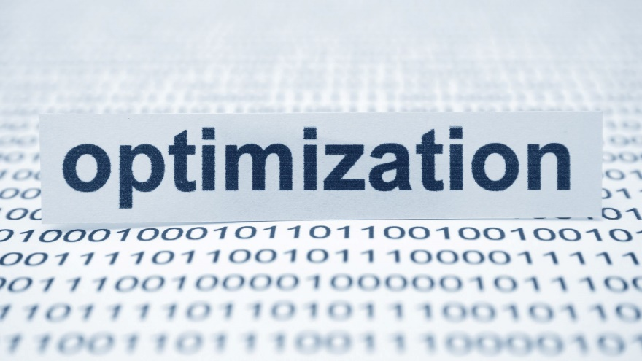

A portfolio manager’s decision entails allocating funds among a (large) set of assets such that the target portfolio satisfies an objective (e.g., mimicking an index, maximizing the Sharpe ratio), given certain constraints. The mean– variance framework of Markowitz typically offers the theoretical foundation. However, two main challenges arise in practice (Michaud and Michaud 2008; Kolm, Tütüncü, and Fabozzi 2014). First, the optimal asset weights are highly sensitive to estimates of expected returns. Considering that estimates of future expected returns are often uncertain, the optimization exercise can yield unstable weights that perform poorly out of sample. In fact, the noise in return estimates can erode any diversification benefits. For example, DeMiguel, Garlappi, and Uppal (2009) show that an equally weighted portfolio has a higher out-of-sample Sharpe ratio than the optimal Markowitz portfolio and a range of other optimal portfolios.

Second, estimating the variance covariance matrix, which is at the heart of Markowitz’s theory, requires a large time series of data and the assumption of stable correlations between asset returns. Moreover, the matrix becomes unstable when asset correlations increase, which happens at times when diversification is most important and yet more difficult to achieve (de Prado 2016). AI addresses these challenges in two ways. First, it can produce return and risk estimates that are more accurate than those produced by other methods and that can be used within traditional portfolio construction frameworks. Second, AI techniques can provide alternative portfolio construction approaches to generate more accurate portfolio weights and produce optimized portfolios with better out-of-sample performance than those generated by traditional linear techniques. Although empirical evidence is limited, interest seems to be growing among both academics and practitioners.

In particular, ANNs can be trained to make asset allocation decisions subject to complex constraints that are often not straightforward to integrate into the mean–variance framework. For example, a neural network can select portfolios according to a learning criterion that maximizes returns subject to value-at-risk constraints (Chapados and Bengio 2001). ANNs can also solve complex multi-objective optimization problems. To illustrate, a neural network–based methodology can construct a mean–variance-skewness optimal portfolio in a fast and efficient manner (Yu, Wang, and Lai 2008). Furthermore, ANNs can incorporate views about the future asset performance into the portfolio optimization using a Black and Litterman (1992) framework, generating higher out-of-sample Sharpe ratios than the market portfolio (Zimmermann, Neuneier, and Grothmann 2002).

Another popular AI technique in portfolio construction is evolutionary algorithms that have the flexibility to accommodate more complex asset allocation problems. For example, evolutionary algorithms solve optimization problems under cardinality constraints (restricting the number of assets in the portfolio) and maximum or minimum holding thresholds (Branke, Scheckenbach, Stein, Deb, and Schmeck 2009). Evolutionary algorithms are also able to incorporate additional objectives. For example, one can incorporate model risk (i.e., the risk of failing to produce accurate estimates of asset returns and volatilities as a result of model mis-specifications) into the optimization problem to reduce forecasting error (Skolpadungket, Dahal, and Harnpornchai 2016). Optimal portfolios using this approach have betterrealized Sharpe ratios by approximately 10% than those that consider only return and volatility in their objective functions.

The ability of ANNs to capture nonlinear relationships between assets without any prior knowledge about the underlying structure of the data can be useful in synthetic replication—that is, replicating a benchmark portfolio such as an index by holding a fraction of the constituents while minimizing tracking error by matching some of the benchmark’s risk factors. For example, ANNs can approximate the Financial Times Stock Exchange (FTSE) 100 Index with only seven stocks (Lowe 1994), resulting in lower transaction costs from portfolio rebalancing as well as reduced portfolio management and monitoring costs. This framework has promising out-of-sample performance and is flexible enough to generate target portfolios with other specified characteristics. For example, one can find the best strategy (i.e., the strategy with the lowest risk or cost) to construct a portfolio that outperforms a specific index by 1% on an annual basis (Heaton, Polson, and Witte 2017).

**Transaction Cost Analysis**



Analyzing transaction costs is an essential part of pre-trade analysis that indicates whether the costs of trading are small enough for a trading signal to generate profits net of implementation costs. Transaction costs have three main components: bid–ask spreads, market impact costs, and trading commissions. Among these three, market impact costs—defined as the adverse effect of a trade on market prices—are the only costs that are not observable before the trade is initiated. Nevertheless, having an estimate of market impact costs is crucial because they represent a significant portion of transaction costs: Market impact absorbs as much as two-thirds of trading gains made by systematic funds (Financial Stability Board 2017).

AI approaches complement traditional market impact models by providing additional insights. The nonparametric structure of AI techniques, together with their ability to capture nonlinear dynamics, are particularly useful for predicting market impact, and various AI techniques have been tested for this purpose. Performance-weighted random forests are found to outperform linear regression, ANNs, and SVMs in predicting the market impact of a market order by 20% out of sample (Booth, Gerding, and McGroarty 2015). On the other hand, SVMs do not seem to perform particularly well when forecasting market impact, whereas ANNs do well if they are properly defined and estimated (Park, Lee, and Son 2016).

Although these nonparametric techniques perform well in estimating market impact, they have two major shortcomings. First, the majority of approaches have no economic intuition for the drivers of price impact. As a result, they are prone to capturing noise rather than relevant information. Second, these techniques cannot distinguish between permanent and temporary market impact, which would require additional variables, including trade direction and liquidity (Farmer, Gerig, Lillo, and Mike 2006). To address these two issues, a parametric approach such as LASSO regression can be used alongside nonparametric techniques. With LASSO regression, the most informative variables capturing information related to the order book and other sources are selected to predict price impact. Empirical evidence indicates that trade sign, market order size, and liquidity based on best limit order prices are the most important variables for forecasting market impact (Zheng, Moulines, and Abergel 2013). A Bayesian network model is another approach for estimating market impact while providing intuition on the main drivers. Unlike most other ML techniques, this approach can also account for variables with data availability issues and model them as latent variables using Bayesian inference. Thanks to this feature, other important variables can be identified (e.g., net order flow imbalance) and added to the model to improve the forecast (Briere, Lehalle, Nefedova, and Raboun 2019).

Another useful application of AI consists of estimating the market impact of trades in assets that lack sufficient (or any) historical trading data, given that using traditional approaches to estimate the market impact costs is almost impossible in this case. A cluster analysis approach can tackle this problem by identifying comparable assets with similar behaviour and using their historical data instead. For example, cluster analysis can allocate bonds into clusters based on their duration, maturity, or value outstanding and measure their similarity according to these variables. Within each cluster, the information of other bonds is used for bonds without sufficient data. Bloomberg’s liquidity assessment tool notably uses this technique to provide liquidity information for various assets.

**Trade Execution**

Executing large trades often involves significant market impact costs. Therefore, such trades are typically broken up into a sequence of smaller orders, which are easier and cheaper to execute. This approach is known as the execution strategy that requires determining the timing and size of smaller orders using some form of execution model. The objective of such models is to minimize transaction costs while completing the transaction within a specified period. Classical modelling approaches for this problem use stochastic control techniques to determine optimal execution strategies (a methodology that goes back to Bertsimas and Lo 1998). Classical models, however, often rely on restrictive assumptions regarding asset price dynamics and the functional form of market impact (Kearns and Nevmyvaka 2013).



In contrast, AI approaches facilitate trade execution modelling by actively learning from real market microstructure data when determining optimal execution strategies. Recent studies advocate reinforcement learning techniques (i.e., algorithms that receive vectors of microstructure and order book variables, such as bid–ask spread, volume imbalances between the buy and sell sides of limit order book, and signed transaction volume) as input and return optimal execution strategies as output (e.g., Nevmyvaka, Feng, and Kearns 2006; Kearns and Nevmyvaka 2013; Hendricks and Wilcox 2014; Kolm and Ritter, forthcoming). The algorithms essentially learn to map each combination of input variables, known as a “state,” to trading actions such that transaction costs are minimized (Kearns and Nevmyvaka 2013).

The advantage of AI-based approaches is that they rely on data rather than normative assumptions to determine market impact costs, price movements, and liquidity. They therefore have the flexibility to adapt as market conditions change and new data become available. These models are often difficult to train and understand, however, especially for large portfolios that benefit the most from a reduction in transaction costs. In addition, systematic execution strategies run the risk of cascading into a systemic event affecting the whole market. A famous precedent for this phenomenon is the so-called flash crash of 2010 (Kirilenko, Kyle, Samadi, and Tuzun 2017).

**Portfolio Risk Management**

AI also has applications in risk management, with regard to both market risk and credit risk (Financial Stability Board 2017; Aziz and Dowling 2019). Market risk refers to the likelihood of loss resulting from aggregate market fluctuation, and credit (or counterparty) risk is the risk of a counterparty not fulfilling its contractual obligations, which results in a loss in value. Although AI has broader uses in risk management, these two categories are the most important in asset management.

**Market Risk**

Market risk analysis involves modelling, assessing, and forecasting risk factors that affect the investment portfolio. AI can play a role in this area in three ways:

* 1. making use of qualitative data for risk modelling,
  2. validating and backtesting risk models, and
  3. producing more accurate forecasts of aggregate financial or economic variables.



One area of application for AI in market risk management relates to extracting information from textual or image data sources. Textual data sources, including news articles, online posts, financial contracts, central bank minutes and statements, and social media, can contain valuable information for managing market risk (Groth and Muntermann 2011). Satellite images are analyzed to predict sales at supermarkets or future crop harvests (Katona, Painter, Patatoukas, and Zeng 2018). The information provided by these sources is, in many cases, not captured by other quantitative variables. For example, AI approaches that use textual information have been shown to generate better predictions of market crashes (Manela and Moreira 2017), interest rates (Hong and Han 2002), and other major macroeconomic outcomes (Cong, Liang, and Zhang 2019) than those using information captured by other data sources. These approaches can also extract information from corporate disclosures with the aim of determining firms’ systematic risk profiles (e.g., Groth and Muntermann 2011; Bao and Datta 2014; Cong et al. 2019). All these applications have triggered an interest among central banks in incorporating methods of AI-based text mining in macroprudential analyses (Bholat, Hansen, Santos, and Schonhardt-Bailey 2015). To date, empirical implementations and evidence in this area are scarce.

AI can also help risk managers validate and backtest risk models (Financial Stability Board 2017). Regulators and financial supervisory institutions emphasize this important part of model risk management (Board of Governors of the Federal Reserve System 2011). Unsupervised AI approaches can detect anomalies in risk model output by evaluating all projections generated by the model and automatically identifying any irregularities. Risk managers can also use supervised AI techniques to generate benchmark forecasts as part of model validation practice. Comparing model results and benchmark forecasts will indicate whether the risk model is producing predictions that differ significantly from those generated by AI. A significant disagreement between AI forecasts and standard risk model outputs can highlight potential problems and trigger a more thorough investigation.

Depending on the exposure of the assets in a portfolio to the underlying risk factors, various financial or economic variables can affect its performance. Therefore, modelling future trends in these factors, especially macroeconomic variables, is important (Elliott and Timmermann 2008; Ahmed, Atiya, El Gayar, and El-Shishiny 2010), and ANNs are particularly popular in this context. For example, empirical evidence suggests that variants of ANNs perform significantly better than linear autoregressive approaches in forecasting 47 monthly macroeconomic variables of the G7 economies (Teräsvirta, van Dijk, and Medeiros 2005). Using ANNs entails the risk of producing implausible forecasts at long horizons, however. Nonetheless, ANNs have been particularly successful in forecasting interest rates (e.g., Kim and Noh 1997; Oh and Han 2000) and exchange rates (e.g., Kaashoek and van Dijk 2002; Majhi, Panda, and Sahoo 2009).

ANNs can also be used to devise systematic risk factors. These models can capture nonlinearities and interactions of covariates, including firm characteristics and macroeconomic variables (e.g., Bryzgalova et al. 2019, Chen, Pelger, and Zhu 2020; Gu, Kelly, and Xiu 2019; Feng, Polson, and Xu 2020). Such factors can better account for risk premia and distinguish between nondiversifiable and diversifiable (idiosyncratic) risk than conventional linear factors can. LASSO regressions can also be useful in determining systematic factor structures. These models are able to select the most relevant systematic risk factors from a subset of factors or market indices (Giamouridis and Paterlini 2010).

AI techniques can also predict market volatility and financial crises, especially ANNs and SVMs, whose ability to capture nonlinear dynamics gives them an advantage over traditional generalized autoregressive conditional heteroskedasticity (GARCH) models. ANNs can predict market volatility either directly (Hamid and Iqbal 2004) or in combination with a variant of GARCH (Donaldson and Kamstra 1997; Fernandes, Medeiros, and Scharth 2014). Some researchers, however, found SVMs to be superior to ANNs in this context (Chen, Hardle, and Jeong 2009). In addition to volatility modelling, ANNs and SVMs are used to predict financial crises. Models performing this forecasting task are often referred to as early warning systems. Almost all major financial institutions use a form of early warning system to monitor systemic risk. ANNs and SVMs have been shown to predict currency crises (e.g., Lin, Khan, Chang, and Wang 2008; Sevim, Oztekin, Bali, Gumus, and Guresen 2014), banking crises (e.g., Celik and Karatepe 2007; Ristolainen 2018), and recessions generally (e.g., Yu, Wang, Lai, and Wen 2010; Ahn, Oh, T.Y. Kim, and D.H. Kim 2011; Gogas, Papadimitriou, Matthaiou, and Chrysanthidou 2015) with reasonable accuracy. Nevertheless, crises are rare financial events, so in the absence of a sufficient number of such events in the sample, one could question the ability of AI models to accurately predict future crises.

**Credit Risk**

The objective of credit risk management is to ensure that the failure of any counterparty to meet its obligations does not have a negative effect on the portfolio beyond specific limits. Asset managers need to monitor the credit risk of the entire portfolio as well as of individual positions and transactions. This practice involves modelling the solvency risk associated with institutions issuing financial products, including equities, bonds, swaps, and options. An extensive range of approaches exists for modelling solvency or bankruptcy risk. Multivariate discriminant analysis, logit, and prohibit models are among the most common traditional methods used (Bellovary, Giacomino, and Akers 2007).

Credit risk modelling is one of the first areas of finance to consider the application of AI techniques. The two most widely used techniques are ANNs and SVMs. In fact, ANNs have become mainstream bankruptcy modelling techniques since the early 1990s (Tam 1991). The popularity of ANNs stems largely from their higher success in forecasting bankruptcy and determining credit ratings compared with traditional techniques (e.g., Zhang, Hu, Patuwo, and Indro 1999; Tsai and Wu 2008). More-recent studies, however, advocate the use of SVMs (e.g., Auria and Moro 2008; Ribeiro, Silva, Chen, Vieira, and das Neves 2012) because they yield slightly more accurate bankruptcy forecasts than ANNs do (Huang, H. Chen, Hsu, W.-H. Chen, and Wu 2004). Moreover, SVMs are less likely to face some of the issues common with ANNs, such as overfitting. ANNs and SVMs also perform particularly well when estimating loss given default (defined as the economic loss when default occurs), which the Basel II Accord requires financial institutions to model in addition to the default probability for regulatory capital monitoring purposes (Loterman, Brown, Martens, Mues, and Baesens 2012).



Beyond SVMs and ANNs, a wide range of other AI approaches— including genetic algorithms (Varetto 1998)—can be used for credit risk modelling (Kumar and Ravi 2007; Peña, Martinez, and Abudu 2011). Because each of the modelling techniques has its own specific advantages and disadvantages, an ensemble technique that uses various approaches separately and then combines the resulting predictions should be considered for achieving the best performance (Verikas, Kalsyte, Bacauskiene, and Gelzinis 2010).

**Robo-Advisors**

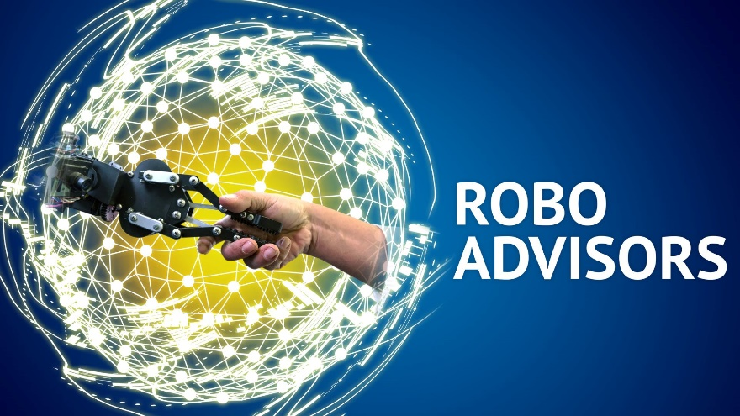

Robo-advisors are computer programs that provide customized advice to assist individual investors in investment activities. These programs have gained significant attention recently because of their success in reducing barriers to entry for retail investors. Academic interest in researching how to enhance robo-advisors using AI is growing. The primary focus is on devising algorithms known as recommender systems that produce optimal portfolios catered to investors’ risk appetites (e.g., Xue, Q. Liu, Li, X. Liu, Ye, Wang, and Yin 2018). However, robo-advising can integrate all types of AI Investor Information

* + Attitude toward risk
  + Behavioural questionnaire
  + Financial goals
  + Wide range of ML techniques to analyze market data
  + NLP to incorporate textual data and provide chatbots
  + Access to large volumes of financial and nonfinancial data sources

Disadvantages

* + Limited view of risk tolerance
  + Ignores taxes and inflation
  + Ineffective advice during crises
  + Shifting responsibility from institutions to retail investors

Advantages

* + Efficient delivery of financial advice and investment recommendations
  + Supports less educated or affluent investors
  + Ability to perform complex analyses on large datasets
  + Not prone to human biases and mistakes

Financial and Investment Advice

* + Financial advice (e.g., banking products, insurance policies)
  + Investment advice (e.g., portfolio of assets calibrated to investor goals and risk tolerance)

Robo-Advisors applications are found in portfolio management, trading, and portfolio risk management. By building on the success of AI in these fields, robo-advisors can not only produce portfolios with better out-of-sample performance for investors but also rebalance portfolios, automatically managing the portfolio’s risks and minimizing transaction costs. Because robo-advising is less expensive than working with a human advisor and can be performed through a simplified interface, investing via a robo-advisor is ultimately both more beneficial and more accessible for retail investors.

Robo-advisors are also less prone to behavioural biases, mistakes, and illegal practices. In fact, robo-advising has been shown to appeal most to investors who fear being victims of investment fraud (Brenner and Meyll 2019). More sophisticated institutional investors can benefit from robo-advisors’ ability to efficiently process a wide range of financial data. Although reducing behavioural biases when making investment decisions is beneficial to all types of investors (D’Acunto, Prabhala, and Rossi 2017), less sophisticated investors particularly benefit from robo-advice in terms of enhancing portfolio performance, increasing diversification, and reducing volatility. At the same time, because robo-advisors have trade execution services integrated into them, they often encourage investors to trade more. This increased trading can be both a benefit, in terms of encouraging investors to rebalance positions more often, and a pitfall, because it can lead to excessive trading that benefits robo-advising systems through commissions at the expense of investors. To be able to use robo-advisors and benefit from their advantages, an investor needs a certain minimum level of technological understanding and financial sophistication.

Not all robo-advisors necessarily use new, sophisticated methods. An analysis of 219 international robo-advisors shows that Markowitz’s portfolio theory is the most prevalent approach, although some systems do not disclose their techniques (Beketov, Lehmann, and Wittke 2018). More-sophisticated robo-advisors rely on proprietary algorithms and do not divulge the details of their approach to analyzing portfolios and making recommendations. Nevertheless, an examination of the industry indicates that the most successful robo-advisors rely heavily on AI to conduct investment and trading analyses (Sabharwal 2018). After all, robo-advising and fintech in general derive most of their success from collecting and analyzing data, and AI is an integral part of this process (Dhar and Stein 2017).

### CHAPTER – 7:

### AI MODEL DEVELOPMENT PROCESS

Usually AI model development process involves:

* Data acquisition — this provides us the features.
* Data preprocessing — an often dreaded but necessary step to make the data usable.
* Develop and implement model — where we choose the type of AI to be adopted.
* Backtest model — a very crucial step in any AI strategy.
* Optimization — finding suitable parameters to optimise the product.

The key aspects are detailed below:

1. **Ensure the backtest is long enough**

The downside of many artificial intelligence models, especially for investment industry, is not enough data. Capital markets data can be very noisy and India is in the midst of a prolonged period of growth (with some black swan events like Covid-19 causing disruption to AI Models).

A one year backtest might hide weakness the model has in other years (i.e. outperformance in a 2015 environment but not in 2016). A longer backtest gives opportunity to see how it does across more regimes and understand how it will perform in adverse conditions (i.e. 2008, 2011, 2019, 2020-2021). For example, Long Term Capital Management, once one of the most successful hedge funds in the world, collapsed in part because of models that only went back 5 years.

1. **Quality of Data**

****Like the point above about having enough backtest years, a model with corrupted data will learn false lessons. For example, if a dataset only includes existing companies within a small universe (like the Nifty 50 or the Sensex), the machine might learn that all of those companies are stronger than they are. By not including the companies that fell out of the Nifty 50 or Sensex the machine cannot learn what failure looks like – so it will be biased to think that any downturn in a stock is a buying opportunity.

1. **Variables**

A natural inclination of some AI models may have is “why don’t I just use every single variable possible and let the machine decide?” It makes sense theoretically – throw as much data at the machine as possible and you will get the best result. In practice, however, it doesn’t always work that way.

At the highest level, our machine learning algorithms will focus on using data to dynamically change asset allocations. Giving the machine access to too many variables can create overfitting and find spurious correlations (i.e. it was Wednesday and it rains heavily on this day of the week and the market goes up in monsoon on Wednesday, therefore buy the market when it rains on Wednesday).

Using targeted data points that make intuitive sense to the user (i.e. interest rates, liquidity, credit ratings, GDP growth rates PCR Ratio, P/E ratios or earnings growth) is more likely to result in a robust, generalized model.

1. **Clear objective**

Each AI Model will have its own objective. Every investor would like to better everything – return, alpha, Sharpe ratio, etc. – but our focus with the clients will be with clear objective of optimising asset allocation.



1. **Clarity and transparency**

Many AI Models can be “black box” in nature, meaning that why the machine made any decisions is not understood by the end user. In order to gain trust, one should have a clear, transparent and explainable AI model. The Model should be more of a “glass box”, less black box artificial intelligence. Explainable AI models are now termed as XAI. The concept of XAI is not a concern if the AI is being used to help choose the next film you want to watch on Netflix. However, if AI is being applied to trade large pension fund investments then clearly XAI is essential. The immediate challenge is to give humans a way to make sense of what computers are doing and be capable of explaining exactly how alpha is being generated.

### CHAPTER – 8:

### ISSUES WITH AI

Many Artificial Intelligence model developers are selling/ licensing their models, bots and APIs to investors globally. Many of these models function on somewhat similar algorithm parameters. Similar to non-AI models and algo-trading models, the use of the same machine learning models by a large number of investors/ traders could potentially prompt of herding behaviour and one-way markets, which in turn may raise risks for liquidity and stability of the economy, particularly in times of stress.

Although AI used in algo-trading can increase liquidity during normal times, it can also lead to convergence and by consequence to bouts of illiquidity during times of stress and to flash crashes. Market volatility could increase through large sales or purchases executed simultaneously, giving rise to new sources of vulnerabilities. Convergence of trading strategies creates the risk of self-reinforcing feedback loops that can, in turn, trigger sharp price moves. Such convergence also increases the risk of cyber-attacks, as it becomes easier for cybercriminals to influence agents acting in the same way.

The abovementioned risks exist in all kinds of algorithmic trading, however, the use of AI amplifies associated risks given their ability to learn and dynamically adjust to evolving conditions in a fully autonomous way. For example, AI models can identify signals and learn the impact of herding, adjusting their behaviour and learning to front run, based on the earliest of signals. The scale of complexity and difficulty in explaining and reproducing the decision mechanism of AI algos and models makes it challenging to mitigate these risks.

AI techniques could also exacerbate illegal practices in trading aiming to abuse or manipulate the markets, and make it more difficult for supervisors to identify such practices if collusion among machines is in place. This is enabled due to the dynamic adaptive capacity of self-learning and deep learning AI models, as they can recognise mutual interdependencies and adapt to the behaviour and actions of other market participants or other AI models, possibly reaching a collusive outcome without any human intervention and perhaps without the user even being aware of it.

If we go back to basics, for each trade to occur, at the same price, there is always a buyer and there is a seller – i.e. exact opposite views. Thus, prices of securities are determined based on propensity to buy and propensity to sell. The propensity to buy or sell a security is determined by:

* 1. Fundamental reasons – macro economic factors, industry or company specific factors or events with the peers or alternative investment opportunities etc.
  2. Investor behaviour – heuristics and biases usually associated with retail investors.
  3. Algorithmic and high frequency traders/ market makers coupled with technical chartists leading to sharper short term movement in prices of securities.
  4. Investor type – different type of investors have different strategies from speculative to long term, from diversification to concentration, from value investing to contrarian investing etc.
  5. Investor needs – liquidity, spending/ savings, events etc.

The new-age millennial investors recognize the power of data and its impact on propensity to sell or buy a security. For example, it is alleged that in US, Robinhood Markets Inc – a broker dealer started facilitating commission free execution of trades which gave them a massive order flow from young millennials and it started selling the order information to market makerswho are high frequency traders equipped with Artificial Intelligence based trading tools from whom Robinhood gets a commission. Robinhood has been fined multiple times by the Securities and Exchange Commission in the US. It is rumoured that the acquirers of such data enter into securities swaps outside the publicly traded market so that they do not get tangled into prohibitions of front running or market abuse/ manipulation and since most of these data points coming from retail investors are good quality reliable data as compared to data that comes from other broker dealers whose clients need not be direct retail clients.

Most often data is used for High Frequency Trading (HFT) arbitrage, which is usually a game of latency (tick-to-trade), which basically means how fast your strategy responds to the incoming market data. HFT entity actually talks of single digit microsecond or even sub-microsecond level latency (Ultra-HFT) with sophisticated customized hardware and software developed for it. For example HFT traders want to take advantage of market arbitrage or a mismatch in securities pricing listed on two different exchanges in the same country or two different countries. When there is a pricing inefficiency (whether it is currency related or not), the fastest traders are the ones that benefit and they’re also the ones that correct the inefficiency. You not only want to buy in stock exchange #1 the fastest but you also need to sell it in stock exchange #2 the fastest. The connectivity through a very expensive transatlantic subsea Hibernia Express Cable provides a small latency advantage over alternative cables to these traders.

In most developed countries front running or tailgating (which is the practice of entering into a trade in any security to capitalize on advance, non-public knowledge of incoming/ pending transactions that will influence the price of the underlying security) and market abuse is not permitted and these rules are strictly implemented. Another practice of ‘Spoofing’ which is an illegal market manipulation practice that involves placing bids to buy or offers to sell securities or commodities with the intent of cancelling the bids or offers prior to the deal’s execution. It is designed to create a false sense of investor demand in the market, thereby manipulating the behaviour and actions of other market participants and allowing the spoofer to profit from these changes by reacting to the fluctuations. Spoofing has been possible in trading before the advent of algorithmic trading, but became prominent with the rise of high frequency trading. Market manipulation using spoofing schemes was determined as one of the primary triggers of the 2010 Flash Crash in the US.

Market players have started taking the Wall Street business models of algo-trading to India due, which is one of the several reasons SEBI has tightened its regulations associated with market manipulation and market abuse.

The use of AI/ML and big data may be reserved to larger asset managers or institutional investors who have the capacity and resources to invest in AI technologies, possibly introducing a barrier for the adoption of such techniques by smaller actors. Investment in technology and in talent is required to transform and explore vast amounts of unstructured new datasets of big data and build ML models. To the extent that the deployment of AI and proprietary models provides a performance edge against competition, this may, in turn, result in restricted participation by smaller players who cannot adopt in-house AI/ML techniques or use big data information sources. This could potentially reinforce the trend of concentration in a small number of larger players that is being observed in the hedge fund industry, as bigger groups outpace some of their more nimble rivals (Financial Times, 2020).

Restricted participation by smaller players would persevere at least until the industry reaches a point where such tools become ubiquitous/provided as a service by third party vendors. At the same time, third party datasets may not be held at the same standard across the industry, and users of third party tools will have to build confidence as to the accuracy and trustworthiness of data used (‘veracity’ of big data) so as to reach a level of comfort sufficient for them to adopt them.

The use of the same AI models by a large number of asset managers could lead to herding behaviour and one-way markets, which may raise potential risks for liquidity and the stability of the system particularly in times of stress. Market volatility could increase through large sales or purchases executed simultaneously, giving rise to new sources of vulnerabilities.

It could be argued that the deployment of AI/ML and big data in investing could somehow reverse the trend towards passive investing. If the use of such innovative technologies proves to be alpha generating in a consistent manner that suggests some level of cause-and-effect relationship between the use of AI and the superior performance (Blackrock, 2019) (Deloitte, 2019), the active investment community could leverage this opportunity to reinvigorate active investing and provide alpha-adding opportunities to their clients.

The use of the same or similar models by a large number of traders could have unintended consequences for competition, and could also contribute to the amplification of stress in markets. For traders, the emergence of widely-used models would naturally reduce the arbitrage opportunities available, driving down margins. This would ultimately benefit consumers by reducing bid-ask spreads. At the same time, it could potentially result in convergence, herding behaviour and one-way markets, with possible implications for the stability of the market and for liquidity conditions particularly during periods of acute stress. As with any algorithm, wide use of similar AI algorithms creates the risk of self-reinforcing feedback loops that can, in turn, trigger sharp price moves (BIS Markets Committee, 2020).

Such convergence could also increase the risk of cyber-attacks, as it becomes easier for cyber-criminals to influence agents acting in the same way rather than autonomous agents with distinct behaviour (ACPR, 2018). When it comes to cyber risk, when AI is used in a nefarious manner, it has the potential to offensively conduct autonomous attacks (without human intervention) on vulnerable systems in trading but also broadly in financial market systems and participants (Ching TM, 2020).

The use of proprietary models that cannot be copied is key for traders to retain any advantage, and may drive intentional lack of transparency, adding to the lack of explainability of ML models. Such unwillingness by users of ML techniques to reveal their model workings for fear of losing their competitive edge raises also issues related to the supervision of algorithms and ML models

The use of algorithms in trading can also make collusive outcomes easier to sustain and more likely to be observed in digital markets (OECD, 2017). Related to that is the risk that AI-driven systems may exacerbate illegal practices aiming to manipulate the markets, such as ‘spoofing’, by making it more difficult for supervisors to identify such practices if collusion among machines is in place. The lack of explainability of ML models used to back trading could make the adjustment of the strategy difficult in times of poor trading performance. Trading algorithms are no longer model-based linear processes (input A caused trading strategy B to be executed) that can be traced and interpreted and where there can be a clear understanding of which parameters drove the outcomes. In times of poor performance, it is crucial for traders to be able to decompose the output into the underlying drivers of the trading decision, so as to adjust and/or correct according to the circumstances. However, even in times of over performance, users are unable to understand why the successful trading decision was made, and therefore cannot identify whether the performance is due to the model’s superiority and ability to capture underlying relationships in the data or to pure luck.

In terms of potential unintended effects in the market, it could be argued that the application of AI technologies in trading and HFT could increase market volatility through large sales or purchases executed simultaneously, giving rise to new sources of vulnerabilities (Financial Stability Board, 2017). In particular, some algo-HFT strategies appear to have contributed to extreme market volatility, reduced liquidity and exacerbated flash crashes that have occurred with growing frequency over the past several years (OECD, 2019). As HFT are a major source of liquidity provision under normal market conditions, improving market efficiency, any disruption in the operation of their models in times of crisis results in liquidity being pulled out of the market, with potential impact on market resilience.

Spoofing is an illegal market manipulation practice that involves placing bids to buy or offers to sell securities or commodities with the intent of cancelling the bids or offers prior to the deal’s execution. It is designed to create a false sense of investor demand in the market, thereby manipulating the behaviour and actions of other market participants and allowing the spoofer to profit from these changes by reacting to the fluctuations. Spoofing has been possible in trading before the advent of algorithmic trading, but became prominent with the rise of high frequency trading. Market manipulation using spoofing schemes was determined as one of the primary triggers of the 2010 Flash Crash (US Department of Justice, 2015).

In a hypothetical scenario, deep learning ML models that learn from the behaviour of other models and adapt to the circumstances could begin to collude with other ML models to take advantage of such practices. In such cases, a trading entity using ML models may become involved in spoofing and rather than benefit for itself, may implicitly pass on the benefit to another model of the firm or even another trading entity using similar models, potentially making it more difficult for supervisors to identify and prove intent. This can be achieved as ML models can coordinate parallel behaviour without actually engaging in explicit communication, and self-learning and reinforcement learning models learn and dynamically re-adapt their behaviour to the actions of other players.

Similar to the considerations discussed in investing, the possible massive use of ‘off-the-shelf’ AI models by market participants could have potential effects for liquidity and market stability, by prompting herding and one-way markets. Such behaviour would also amplify volatility risks, pro-cyclicality and unexpected changes in the market both in terms of scale and in terms of direction. Herding behaviour may lead to illiquid markets in the absence of ‘shock-absorbers’ or market makers available and able to take on the opposite side of transactions.

The deployment of AI in trading may also increase the interconnectedness of financial markets and institutions in unexpected ways, and potentially increase correlations and dependencies of previously unrelated variables (Financial Stability Board, 2017). The scaling up of the use of algorithms that generate uncorrelated profits or returns may generate correlation in unrelated variables if their use reaches a sufficiently important scale. It can also amplify network effects, such as unexpected changes in the scale and direction of market moves.

In order to mitigate risks from the deployment of AI in trading, defences may need to be put in place for AIdriven algorithmic trading. Safeguards built in pre-trading risk management systems aim to prevent and stop potential misuse of such systems. Interestingly, AI is also being used to build better pre-trade risk systems, which include, inter alia, mandatory testing of every release of an algo, and which would apply equally to AI-based algorithms. Automated control mechanisms that instantly switch off the model are the ultimate lines of defence of market practitioners, when the algorithm goes beyond the risk system, and consist of ‘pulling the plug’ and replacing any technology with human handling. Such mechanisms could be considered suboptimal from a policy perspective, as they switch off the operation of the systems when it is most needed in times of stress, and give rise to operational vulnerabilities.

Defences may also need to be applied at the level of the exchanges where the trading is taking place. These could include automatic cancellation of orders when the AI system is switched off for some reason and methods that provide resistance to sophisticated manipulation methods enabled by technology. Circuit breakers, currently triggered by massive drops between trades, could perhaps be adjusted to also identify and be triggered by large numbers of smaller trades performed by AI-driven systems, with the same effect.

The widespread deployment of AI-based models could also raise competition issues by making tacit collusion easier without any formal agreement or human interaction (OECD, 2017). In a tacitly collusive context, the non-competitive outcome is achieved by each participant deciding its own profit-maximising strategy independently of its competitors (OECD, 2017). In other words, the use of algorithms makes it easier for market participants to sustain profits above the competitive level without having entered into an agreement, effectively replacing explicit collusion with tacit co-ordination.

Even though tacit collusion typically occurs in transparent markets with few market participants, there is evidence that collusion might become easier to sustain and more likely to be observed when algorithms are involved in digital markets characterised by high transparency and frequent interaction (OECD, 2017).

The dynamic adaptive capacity of self-learning and deep learning AI models can therefore raise the risk that the model recognises the mutual interdependencies and adapts to their behaviour and actions of other market participants or other AI models, possibly reaching a collusive outcome without any human intervention and perhaps without even being aware of it (OECD, 2017). Although such collusions are not necessarily illegal from a competition law standpoint, questions are raised on whether and how enforcement action could be applied to the model and its users in case that is the case.

Cyber security risks, risk of hacking and other operational risks witnessed across the board of digital financial products/services have direct implications on data privacy and confidentiality. While the deployment of AI does not open up possibilities of new cyber breaches, it could exacerbate pre-existing ones by, inter alia, linking falsified data and cyber breaches, creating new attacks which can alter the functioning of the algorithm through the introduction of falsified data into models or the alteration of existing ones (ACPR, 2018).

Consumers’ financial and non-financial data are increasingly being shared and used, sometimes without their understanding and informed consent (US Treasury, 2018). While informed consent is the legal basis for any use of data, consumers are not necessarily educated on how their data is handled and where it is being used, and consent may not be well informed. Increased tracking of online activity with advanced modes of tracking increases such risks, and so does data sharing by third party providers. Observed data not provided by the customer, such as geolocation data or credit card transaction data are prime examples of datasets at risk of possible violations of privacy policy and data protection laws.

New approaches are being suggested by the industry to secure non-disclosure computation, which protects consumer privacy, including through the generation and use of tailor-made, synthetic datasets, which are put together for the purposes of ML modelling, or the use of Privacy Enhancing Technologies (PETs). PETs try to preserve the overall properties and characteristics of the original data without revealing information about actual individual data samples. PETs include differential privacy, federated analysis, homomorphic encryption and secure multi-party computation. Particularly, differential privacy provides mathematical guarantees on the desired level of privacy and allows better accuracy compared to synthetic datasets. The purported advantage of such techniques is that models trained on synthetic data instead of real data do not show a significant loss of performance. In terms of ensuring the privacy data handling in models, data anonymization approaches do not provide rigorous privacy guarantees, especially given inferences made by AI-based models.

The use of big data by AI-powered models could expand the universe of data that is considered sensitive, as such models can become highly proficient in identifying users individually (US Treasury, 2018). Facial recognition technology and other inferred data such as customer profile can be used by the model to identify users or infer other characteristics, such as gender, when joined up with other information. AI models could achieve the re-identification of anonymised databases by cross-referencing publicly available databases and narrowing down matches to ultimately attribute sensitive information to individuals (Luminovo.ai, 2020). What is more, the higher dimensionality in ML data sets, i.e. the possibility to take into account an unlimited number of variables compared to conventional statistical techniques, increases the likelihood of sensitive information being included in the analysis.

Regulators have renewed their focus on data privacy and protection driven by increased digitalisation of the economy (e.g. EU GDPR) and aiming to reinforce consumer protection across markets, rebalance the power relationship of corporates and individuals, shifting power back to the consumers, and ultimately increase transparency and trust in how companies use consumer data. ‘Protection of Consumer Data and Privacy’ is one of the Principles of the G20/OECD High-Level Principles on Financial Consumer Protection (OECD, 2011). Protection of individuals’ personal data in the use of AI in finance is also at the core of the Monetary Authority of Singapore’s principles to promote fairness, ethics, accountability and transparency (MAS, 2019). India has passed a new data protection law in the year 2023.

From the industry standpoint, one of the stumbling blocks in better data governance for financial sector firms relates to the perceived fragmentation in regulatory and supervisory responsibility around data, and to which institutions would be accountable for applying best practices of data governance in areas such as data quality, definitions, standardisation, architecture, deduplications, and other. Such fragmentation is magnified in case of cross-border activities.

The economics of data use are being redefined in parallel with the rapid deployment of ML models in finance. A small number of alternative dataset players have emerged, exploiting the surge in demand for datasets that inform AI techniques, with limited visibility and overseeing over their activity at this stage. The purchase and use of datasets by such small niche database providers is possibly raising risks around their lawful purchase and use by financial service providers. Increased compliance costs of regulations aiming to protect consumers may further redefine the economics of the use of big data for financial market providers and, by consequence, their approach in the use of AI and big data.

Depending on how they are used, AI methods have the potential to help avoid discrimination based on human interactions, or intensify biases, unfair treatment and discrimination in financial services. By delegating the human-driven part of the decision-making to the algorithm, the user of the AI-powered model avoids biases attached to human judgement. At the same time, the use of AI applications may risk bias or discrimination through the potential to compound existing biases found in the data; by training models with such biased data; or through the identification of spurious correlations (US Treasury, 2018).

The use of flawed or inadequate data may result in wrong or biased decision-making in AI systems. Poor quality data can result in biased or discriminatory decision-making through two avenues. ML models trained with inadequate data risk producing inaccurate results even when fed with good quality data. Equally, ML models that are trained on high-quality data will certainly produce a questionable output if they are then fed with unsuitable data, despite the well-trained underlying algorithm. Well-intentioned ML models may inadvertently generate biased conclusions, discriminated against protected classes of people (White & Case, 2017). The use of incorrect, inaccurate (e.g. poorly labelled, incomplete) or even fraudulent data in ML models carries the risk of ‘garbage in, garbage out’, and the quality of the data determines largely the quality of the model’s output.

Biases may also be inherent in the data used as variables and, given that the model trains itself on data from external sources that may have already incorporated certain biases, perpetuates historical biases. In addition, biased or discriminatory decisions made by ML models are not necessarily intentional and can even occur with strong quality, well-labelled data, through inference and proxies, or given the fact that correlations between sensitive and ‘non-sensitive’ variables may be difficult to detect in vast databases (Goodman and Flaxman, 2016). As big data involves vast amounts of data reflecting society, AI-driven models could just perpetuate biases that already exist in society and are reflected in such databases.

Labelling and structuring of data is an important, albeit tedious task, necessary for ML models to be able to perform. AI can only distinguish the signal from the noise if it can successfully identify and recognise what a signal is, and models need well-labelled data to be able to recognise patterns in them (S&P, 2019). To that end, supervised learning models (the most common form of AI) require feeding software stacks of pre-tagged examples classified in a consistent manner, until the model can learn to identify the data category by itself.

That said, the correct data labels might not be readily apparent from simple observation data points. Data labelling is a labour-intensive process that requires analysis of vast amounts of data and which is currently reported to be outsourced to specialised firms or to the distributed workforce (The Economist, 2019). Analysis and labelling of data by humans present opportunities to identify errors and biases in the data used, although according to some it may inadvertently introduce other biases as it involves subjective decision-making.

As the process of data, cleansing and labelling could be prone to human error, and a number of solutions involving AI themselves have started to develop. Considerations around the quality of the data and its level or representativeness can help avoid unintended biases at the output level.

In addition, and given the high dimensionality of data, users of ML models need to adequately identify those features of the data that are relevant to the scenarios tested by the model. Different methods are being developed to reduce the existence of irrelevant features or ‘noise’ in datasets and improve ML model performance. An interesting alternative is the use of artificial or ‘synthetic’ datasets generated and employed for this purpose, as well as for testing and validation purposes.

The role of humans in decision-making processes informed by AI is critical in in identifying and correcting for biases built into the data or in the model design. Also, in order to explain the output of the model, although the extent to which all this is feasible remains an open question (US Treasury, 2018). The human parameter is critical both at the data input stage and at the query input stage and a degree of scepticism in the evaluation of the model results can be critical in minimising the risks of biased model output/decision-making.

The design of a ML model and its audit can further strengthen the degree of assurance about the robustness of the model when it comes to avoiding potential biases. Inadequately designed and controlled AI/ML models carry a risk of exacerbating or reinforcing existing biases while at the same time making discrimination even harder to observe (Klein, 2020). Auditing mechanisms of the model and the algorithm that senses to check the results of the model against baseline datasets can help ensure that there is no unfair treatment or discrimination by the technology. Ideally, users and supervisors should be able to test scoring systems to ensure their fairness and accuracy (Citron and Pasquale, 2014). Tests can also be run based on whether protected classes can be inferred from other attributes in the data, and a number of techniques can be applied to identify and/or rectify discrimination in ML models (Feldman et al., 2015). Governance of AI/ML models and the assignment of accountability to the human parameter of the project is also important to safeguard prospective borrowers against possible unfair biases. When measuring for potential biases, it may be important to avoid comparing ML-based decisioning to a hypothetical unbiased state but use realistic reference points, comparing such methods to traditional statistical models and human-based decision-making, both of which are not flawless or utterly unbiased.

**Disclosure**

Based on the OECD AI Principles, ‘there should be transparency and responsible disclosure around AI systems to ensure that people understand AI-based outcomes and can challenge them’ (OECD, 2019). It is argued that the opacity of algorithm-based systems could be addressed through transparency requirements, ensuring that clear information is provided as to the AI system’s capabilities and limitations (European Commission, 2020). Separate disclosure should inform consumers about the use of AI system in the delivery of a product and their interaction with an AI system instead of a human being (e.g. robo-advisors). Such disclosure can also allow customers to make conscious choices among competing products.

To date, there is no commonly accepted practice as to the level of disclosure that should be provided to investors and financial consumers and potential proportionality in such information. According to market regulators, there should be a differentiation as to the level of transparency depending on the type of investor (retail vs. institutional), as well as the area of implementation (front vs. back office) (IOSCO, 2020). Suitability requirements, such as the ones applicable to the sale of investment products, might help firms better assess whether the prospective clients have a solid understanding of how the use of AI affects the delivery of the product/service.

Requirements for financial firms to document in writing operational details and design characteristics of models used in finance were already in place before the advent of AI. Documentation of the logic behind the algorithm, to the extent feasible, is being used by some regulators as a way to ensure that the outcomes produced by the model are explainable, traceable and repeatable (FSRA, 2019). The EU, for instance, is considering requirements around disclosure documentation of programming and training methodologies, processes and techniques used to build, test, and validate AI systems, including documentation on the algorithm (what the model shall optimise for, which weights are designed to certain parameters at the outset etc.) (European Commission, 2020). The US Public Policy Council of the Association for Computing Machinery (USACM) has proposed a set of principles targeting inter alia transparency and auditability in the use of algorithms, suggesting that models, data, algos and decisions be recorded so as to be available for audit where harm is suspected (ACM US Public Policy Council, 2017). The Federal Reserve’s guidance for model risk management includes also documentation of model development and validation that is sufficiently detailed to allow parties unfamiliar with a model to understand how the model operates, as well as its limitations and key assumptions (Federal Reserve, 2011).

Financial service providers find it harder to document the model process of AI-enabled models used for supervisory purposes (Bank of England and FCA, 2020). Challenges in explaining how the model works translate into difficulties in documenting such complex models, irrespective of the size of the service provider. Some jurisdictions have proposed a two-pronged approach to AI model supervision: (i) analytical: combining analysis of the source code and of the data with methods (if possible based on standards) for documenting AI algorithms, predictive models and datasets; and (ii) empirical: leveraging methods providing explanations for an individual decision or for the overall algorithm’s behaviour, and relying on two techniques for testing an algorithm as a black box: challenger models (to compare against the model under test) and benchmarking datasets, both curated by the auditor (ACPR, 2020).

In addition to explainability related challenges, AI-based models require the setting of a wealth of parameters that have a significant effect on model performance and results. Such parameterisation could be considered as ‘arbitrary’ and subjective, as they may be based on intuition rather than validation and they can be very much dependant on the designer of the model. Transparency around the parameters selected in the model could potentially address part of the issue, as the way the model works with these parameters remains largely difficult to explain.

**AI and tail risk: the example of the COVID-19 crisis**



Although AI models are adaptive in nature, as they evolve over time by learning from new data, they may not be able to perform under idiosyncratic one-time events that have not been experienced before, such as the COVID-19 crisis, and which are therefore not reflected in the data used to train the model. As AImanaged trading systems are based on dynamic models trained on long time series, they are expected to be effective in as long as the market environment has some consistency with the past. Evidence based on a survey conducted in UK banks suggest that around 35% of banks experienced a negative impact on ML model performance during the pandemic (Bholat, Gharbawi and Thew, 2020). This is likely because the pandemic has created major movements in macroeconomic variables, such as rising unemployment and mortgage forbearance, which required ML (as well as traditional) models to be recalibrated.

Tail and unforeseen events, such as the recent pandemic, give rise to discontinuity in the datasets, which in turn creates model drifts that undermine the models’ predictive capacity. Tail events cause unexpected changes in the behaviour of the target variable that the model is looking to predict, and previously undocumented changes to the data structure and underlying patterns of the dataset used by the model, both caused by a shift in market dynamics during such events. These are naturally not captured by the initial dataset on which the model was trained and are likely to result in performance degradation. Synthetic datasets generated to train the models could going forward incorporate tail events of the same nature, in addition to data from the COVID-19 period, with a view to retrain and redeploy redundant models.

Ongoing testing of models with validation datasets that incorporate extreme scenarios and continuous monitoring for model drifts is therefore of paramount importance to mitigate risks encountered in times of stress. It should be noted that models based on reinforcement learning, where the model is trained in simulated conditions, are expected to perform better in times of one-off tail risk events, as they are easier to train based on scenarios of extreme unexpected market conditions that may not have been observed in the past.

**Governance of AI systems and accountability**



Solid governance arrangements and clear accountability mechanisms are fundamentally important as AI models are deployed in high-value decision-making use-cases (e.g. in determining who gets access to credit or how investment portfolio allocation is decided). Organisations and individuals developing, deploying or operating AI systems should be held accountable for their proper functioning (OECD, 2019). In addition, human oversight from the product design and throughout the lifecycle of the AI products and systems may be needed as a safeguard (European Commission, 2020).

Currently, financial market participants using AI rely on existing governance and oversight arrangements for the use of such technologies, as AI-based algorithms are not considered to be fundamentally different from conventional ones (IOSCO, 2020). Existing governance frameworks applicable to models can constitute the basis for the development or adaptation for AI activity, given that many of the considerations and risks associated with AI are also applicable to other types of models. Explicit governance frameworks that designate clear lines of responsibility for the development and overseeing of AI-based systems throughout their lifecycle, from development to deployment, could further strengthen existing arrangements for operations related to AI. Internal governance frameworks could include minimum standards or best practice guidelines and approaches for the implementation of such guidelines (Bank of England and FCA, 2020). Internal model committees set model governance standards and processes that financial service providers are following for model building, documentation, and validation for any time of model, including AI-driven ML models.

Model governance frameworks have yet to address how to handle AI models, which exist only ephemerally, and change very frequently. The challenge of using existing model governance processes for ML models is associated with more advance AI models that rebuild themselves at relatively short time intervals. One possible mitigating approach would be to retain data and code so that replications of the inputs and outputs can be produced based on a past date. However, since many ML models are non-deterministic, there is no guarantee that even with the same input data the same model will be produced.

Importantly, intended outcomes for consumers would need to be incorporated in any governance framework, together with an assessment of whether and how such outcomes are reached using AI technologies. In advanced deep learning models, issues may rise concerning the ultimate control of the model, as AI could unintentionally behave in a way that is contrary to consumer interests (e.g. biased results in credit underwriting, described above). In addition, the autonomous behaviour of some AI systems during their life cycle may entail important product changes having an impact on safety, which may require a new risk assessment (European Commission, 2020).

Ultimate responsibility, oversight and accountability over AI-based systems lies by definition with Executive and board level of management of the financial services provider, who have to establish an organisation wide approach to model risk management, and ensure that the level of model risk is within their tolerance. At the same time, the importance of other functions such as engineers/programmers or data analysts, who have previously not been central to the supervisors’ review, may end up subject to increased scrutiny, commensurate with their increased importance in the deployment of AI-based financial products/services. Accountabilities for AI-related systems would therefore perhaps need to go beyond senior managers and board to hands-on professionals responsible for programming and development of models and to those using the mechanism to deliver customer services, at a minimum at the internal risk management level, as responsibility of explanation of such models to senior managers and the Board lies with the technical functions. Interestingly, some jurisdictions may require a third party audit to validate the performance of the model in line with the intended purpose (FSRA, 2019). Strong governance also includes documentation of model development and validation.

**Employment risks and the question of skills**



Financial services providers and supervisors need to be technically capable of operating, inspecting AIbased systems and intervening when required. The absence of adequate skills is a potential source of vulnerabilities for both the industry side and the regulatory/supervisory side, and which may give rise to potential employment issues in the financial industry. The deployment of AI and big data in finance requires different skillsets that a relatively small segment of financial practitioners possess. In line with significant investments that will need to be made to develop AI-based models and tools, firms will need to also develop human capital with the requisite skills to derive value from such technologies and exploit value from vast amounts of unstructured data sources.

From an industry viewpoint, the deployment of AI involves the use of professionals who combine scientific expertise in the area of AI, computer science (programming, coding) skills and financial sector expertise. While today’s financial market participants have somehow silo-ed roles for specialists in IT or finance, the widespread use of AI by financial institutions will increasingly rely on, and drive demand for, experts who successfully combine finance knowledge with expertise in computer science. Importantly, compliance professionals and risk managers will need to have the appropriate understanding of the workings of the AI techniques and models to be able to audit, oversee, challenge and approve their use. Similarly, senior managers, who in most cases are accountable for the use of such techniques, need to be able to understand and follow their development and implementation.

The widespread adoption of AI and ML by the financial industry may give rise to some employment challenges. On the one hand, demand for employees with applicable skills in AI methods, advanced mathematics, software engineering and data science is expected to be significant. On the other hand, executives of financial services firms expect that the application of such technologies may result in potentially significant job losses across the industry (Noonan, 1998) (US Treasury, 2018). In practice, it is expected that financial market practitioners and risk management experts will gain experience and expertise in AI in the medium term, as AI models will coexist with traditional models and until the time AI become more mainstream.

Over-reliance in fully automated AI-based systems may give rise to increased risk of disruption of service with potential systemic impact in the markets. If markets dependent on such systems face technical or other disruptions, financial service providers need to ensure that from a human resources perspective, they are ready to substitute the automated AI systems with well-trained humans acting as a human safety net and capable of ensuring there is no disruption in the markets. Such considerations are likely to become increasingly important, as the deployment of AI becomes ubiquitous across markets.

The issue of skills and technical expertise becomes increasingly important also from a regulatory and supervisory perspective. Financial sector regulators and supervisors may need to keep pace with the technology and enhance the skills necessary to effectively supervise AI-based applications in finance. Enforcement authorities may need to be technically capable of inspecting AI-based systems and empowered to intervene when required (European Commission, 2020). The upskilling of policy makers will also allow them to expand their own use of AI in RegTech and SupTech, an important area of application of innovation in the official sector.

AI in finance should be seen as a technology that augments human capabilities instead of replacing them. It could be argued that a combination of ‘man and machine’, where AI informs human judgment rather than replaces it (decision aid instead of decision maker), could allow for the benefits of the technology to realise, while maintaining safeguards of accountability and control as to the ultimate decision-making. At the current stage of maturity of AI solutions, and in order to ensure that vulnerabilities and risks arising from the use of AI-driven techniques are minimised, some level of human supervision of AI-techniques is still necessary. The identification of converging points, where human and AI are integrated, will be critical for the practical implementation of such a combined ‘man and machine’ approach (‘human in the loop’).

**Ethics in AI in the Finance Sector**



Artificial intelligence does not come without some ethical challenges, especially when it comes to protecting your personal and financial information. The Fintech Times highlights three areas of concern when it comes to AI in the finance sector:

1. Bias: AI failures can happen, and in many cases, it’s a problem with the algorithm. Here’s an example from The Fintech Times: “If an AI system calculating the creditworthiness of a customer is tasked to optimize profits, it could soon get into predatory behaviour and look for people with low credit scores to sell subprime loans. This practice may be frowned upon by society and considered unethical, but the AI does not understand such nuances.”
2. Accountability: Who is responsible if artificial intelligence makes an incorrect decision? For example, who should be at fault if a self-driving car gets into an accident?
3. Transparency: How and why do algorithms come to particular conclusions? It’s not always easy to tell.
4. Job losses: There’s also the idea often associated with artificial intelligence that robots will soon replace human workers. Forbes explains that while research shows that AI will replace certain categories of jobs, businesses and companies will be freed up to take care of other higher value responsibilities.
5. Another ethical concern, according to Investopedia, is the idea of “weaponized machinery” — whereby the use of artificial intelligence and machine learning tools are employed for unethical purposes, such as hacking into people’s private information.

**The Future of AI in Finance**



Since artificial intelligence has become more widespread across all industries, it’s no surprise that it is taking off within the world of finance, especially since COVID-19 has changed human interaction. By streamlining and consolidating tasks and analyzing data and information far faster than humans, AI has had a profound impact, and experts predict that it will save the banking industry about $1 trillion by 2030.

“Artificial intelligence technologies are increasingly integral to the world we live in, and banks need to deploy these technologies at scale to remain relevant,” according to McKinsey & Company. “Success requires a holistic transformation spanning multiple layers of the organization.”

It’s also important to note that millennials and “Gen Zers” are becoming the banks’ “largest addressable consumer group” in the United States, which means financial institutions are looking to increase their IT and AI budgets “to meet higher digital standards” since younger consumers often prefer digital banking. In fact, 78% of millennials say they won’t go to a bank if there’s an alternative.

AI in Finance Also Means New Career Opportunities. High-paying career opportunities in AI and related disciplines continue to expand in nearly all industries, including banking and finance. If you’re looking for a new opportunity or a way to advance your current career in AI, consider the University of San Diego — a highly regarded industry thought leader and education provider. USD offers an innovative, online AI master’s degree program, the Master of Science in Applied Artificial Intelligence, which is designed to prepare graduates for success in this important fast-growing field. This program includes a significant emphasis on real-world applications, ethics, privacy, moral responsibility and social good in designing AI-enabled systems.

A current example of an ETF fueled by AI, is the AI-powered equity exchange-traded fund AIEQ. According to Sam Masucci, founder and CEO of ETF Managers Group, powered by IBM’s artificial intelligence Watson, this actively managed portfolio is the first of its kind, which operates the fund. The AI-powered equity ETF, or AIEQ, consistently outperforms the S&P 500.

Another application of AI in managing portfolios is the introduction of AI Advisors as stock pickers to replace human advisors in actively managed equity funds. For example, BlackRock, the largest U.S. investment management firm, has started to replace human stock‐pickers with the full automated investment program based on self‐learning artificial intelligence algorithms.

According to BlackRock CEO Laurence Fink, the likely reason for the relative underperformance of active equity funds, and the resulting outflows, is the limitation of a human discretion in active portfolio management and stock‐picking. According to him, the democratization of information has made it much harder for active management. Active portfolio management has to rely more on big data, AI, factors and models within quant and traditional investment strategies. BlackRock executive Mark Wiseman added, “The old way of people sitting in a room picking stocks, thinking they are smarter than the next guy—that does not exist anymore.”

The above trends can create the fear of human advisors gradually getting replaced by these Robo advisors, which can create large scale unemployment. However, it is too early to conclude as the data on performance from these AI managed portfolios are sparse. The academic jury is still out on the market volatility (risk) consequences of AI trading in the stock market.

# GLOSSARY

Glossary of 50 AI terms that frequently come up in discussions about AI and machine learning are provided below and thereafter, a bigger glossary of additional terms. If you can lock down these basics, you should be able to hold your own in any discussion about machine learning. Let’s run through them in alphabetical order.

Algorithm: A set of rules that a machine can follow to learn how to do a task.

Artificial intelligence: This refers to the general concept of machines acting in a way that simulates or mimics human intelligence. AI can have a variety of features, such as human-like communication or decision making.

Autonomous: A machine is described as autonomous if it can perform its task or tasks without needing human intervention.

Backward chaining: A method where the model starts with the desired output and works in reverse to find data that might support it.

Bias: Assumptions made by a model that simplify the process of learning to do its assigned task. Most supervised machine learning models perform better with low bias, as these assumptions can negatively affect results.

Big data: Datasets that are too large or complex to be used by traditional data processing applications.

Bounding box: Commonly used in image or video tagging, this is an imaginary box drawn on visual information. The contents of the box are labelled to help a model recognize it as a distinct type of object.

Chatbot: A chatbot is program that is designed to communicate with people through text or voice commands in a way that mimics human-to-human conversation.

Cognitive computing: This is effectively another way to say artificial intelligence. It’s used by marketing teams at some companies to avoid the science fiction aura that sometimes surrounds AI.

Computational learning theory: A field within artificial intelligence that is primarily concerned with creating and analyzing machine learning algorithms.

Corpus: A large dataset of written or spoken material that can be used to train a machine to perform linguistic tasks.

Data mining: The process of analyzing datasets in order to discover new patterns that might improve the model.

Data science: Drawing from statistics, computer science and information science, this interdisciplinary field aims to use a variety of scientific methods, processes and systems to solve problems involving data.

Dataset: A collection of related data points, usually with a uniform order and tags.

Deep learning: A function of artificial intelligence that imitates the human brain by learning from the way data is structured, rather than from an algorithm that’s programmed to do one specific thing.

Entity annotation: The process of labelling unstructured sentences with information so that a machine can read them. This could involve labelling all people, organizations and locations in a document, for example.

Entity extraction: An umbrella term referring to the process of adding structure to data so that a machine can read it. Entity extraction may be done by humans or by a machine learning model.

Forward chaining: A method in which a machine must work from a problem to find a potential solution. By analysing a range of hypotheses, the AI must determine those that are relevant to the problem.

General AI: AI that could successfully do any intellectual task that can be done by any human being. This is sometimes referred to as strong AI, although they aren’t entirely equivalent terms.

Hyperparameter: Occasionally used interchangeably with parameter, although the terms have some subtle differences. Hyperparameters are values that affect the way your model learns. They are usually set manually outside the model.

Intent: Commonly used in training data for chatbots and other natural language processing tasks, this is a type of label that defines the purpose or goal of what is said. For example, the intent for the phrase “turn the volume down” could be “decrease volume”.

Label: A part of training data that identifies the desired output for that particular piece of data.

Linguistic annotation: Tagging a dataset of sentences with the subject of each sentence, ready for some form of analysis or assessment. Common uses for linguistically annotated data include sentiment analysis and natural language processing.

Machine intelligence: An umbrella term for various types of learning algorithms, including machine learning and deep learning.

Machine learning: This subset of AI is particularly focused on developing algorithms that will help machines to learn and change in response to new data, without the help of a human being.

Machine translation: The translation of text by an algorithm, independent of any human involvement.

Model: A broad term referring to the product of AI training, created by running a machine learning algorithm on training data.

Neural network: Also called a neural net, a neural network is a computer system designed to function like the human brain. Although researchers are still working on creating a machine model of the human brain, existing neural networks can perform many tasks involving speech, vision and board game strategy.

Natural language generation (NLG): This refers to the process by which a machine turns structured data into text or speech that humans can understand. Essentially, NLG is concerned with what a machine writes or says as the end part of the communication process.

Natural language processing (NLP): The umbrella term for any machine’s ability to perform conversational tasks, such as recognizing what is said to it, understanding the intended meaning and responding intelligibly.

Natural language understanding (NLU): As a subset of natural language processing, natural language understanding deals with helping machines to recognize the intended meaning of language — taking into account its subtle nuances and any grammatical errors.

Overfitting: An important AI term, overfitting is a symptom of machine learning training in which an algorithm is only able to work on or identify specific examples present in the training data. A working model should be able to use the general trends behind the data to work on new examples.

Parameter: A variable inside the model that helps it to make predictions. A parameter’s value can be estimated using data and they are usually not set by the person running the model.

Pattern recognition: The distinction between pattern recognition and machine learning is often blurry, but this field is basically concerned with finding trends and patterns in data.

Predictive analytics: By combining data mining and machine learning, this type of analytics is built to forecast what will happen within a given timeframe based on historical data and trends.

Python: A popular programming language used for general programming.

Reinforcement learning: A method of teaching AI that sets a goal without specific metrics, encouraging the model to test different scenarios rather than find a single answer. Based on human feedback, the model can then manipulate the next scenario to get better results.

Semantic annotation: Tagging different search queries or products with the goal of improving the relevance of a search engine.

Sentiment analysis: The process of identifying and categorizing opinions in a piece of text, often with the goal of determining the writer’s attitude towards something.

Strong AI: This field of research is focused on developing AI that is equal to the human mind when it comes to ability. General AI is a similar term often used interchangeably.

Supervised learning: This is a type of machine learning where structured datasets, with inputs and labels, are used to train and develop an algorithm.

Test data: The unlabelled data used to check that a machine learning model is able to perform its assigned task.

Training data: This refers to all of the data used during the process of training a machine learning algorithm, as well as the specific dataset used for training rather than testing.

Transfer learning: This method of learning involves spending time teaching a machine to do a related task, then allowing it to return to its original work with improved accuracy. One potential example of this is taking a model that analyses sentiment in product reviews and asking it to analyse tweets for a week.

Turing test: Named after Alan Turing, famed mathematician, computer scientist and logician, this tests a machine’s ability to pass for a human, particularly in the fields of language and behaviour. After being graded by a human, the machine passes if its output is indistinguishable from that of human participant’s.

Unsupervised learning: This is a form of training where the algorithm is asked to make inferences from datasets that don’t contain labels. These inferences are what help it to learn.

Validation data: Structured like training data with an input and labels, this data is used to test a recently trained model against new data and to analyse performance, with a particular focus on checking for overfitting.

Variance: The amount that the intended function of a machine learning model changes while it’s being trained. Despite being flexible, models with high variance are prone to overfitting and low predictive accuracy because they are reliant on their training data.

Variation: Also called queries or utterances, these work in tandem with intents for natural language processing. The variation is what a person might say to achieve a certain purpose or goal. For example, if the intent is “pay by credit card,” the variation might be “I’d like to pay by card, please.”

Weak AI: Also called narrow AI, this is a model that has a set range of skills and focuses on one particular set of tasks. Most AI currently in use is weak AI, unable to learn or perform tasks outside of its specialist skill set.

**LIST OF ADDITIONAL TERMS IN AI**

abductive logic programming (ALP)

A high-level knowledge-representation framework that can be used to solve problems declaratively based on abductive reasoning. It extends normal logic programming by allowing some predicates to be incompletely defined, declared as abducible predicates.

abductive reasoning, also abduction.

A form of logical inference which starts with an observation or set of observations then seeks to find the simplest and most likely explanation. This process, unlike deductive reasoning, yields a plausible conclusion but does not positively verify it.

abstract data type



A mathematical model for data types, where a data type is defined by its behaviour (semantics) from the point of view of a user of the data, specifically in terms of possible values, possible operations on data of this type, and the behaviour of these operations.

abstraction

The process of removing physical, spatial, or temporal details or attributes in the study of objects or systems in order to more closely attend to other details of interest

accelerating change

A perceived increase in the rate of technological change throughout history, which may suggest faster and more profound change in the future and may or may not be accompanied by equally profound social and cultural change.

action language

A language for specifying state transition systems, and is commonly used to create formal models of the effects of actions on the world. Action languages are commonly used in the artificial intelligence and robotics domains, where they describe how actions affect the states of systems over time, and may be used for automated planning.

action model learning

An area of machine learning concerned with creation and modification of software agent's knowledge about effects and preconditions of the actions that can be executed within its environment. This knowledge is usually represented in logic-based action description language and used as the input for automated planners.

action selection

A way of characterizing the most basic problem of intelligent systems: what to do next. In artificial intelligence and computational cognitive science, "the action selection problem" is typically associated with intelligent agents and animals—artificial systems that exhibit complex behaviour in an agent environment.

activation function

In artificial neural networks, the activation function of a node defines the output of that node given an input or set of inputs.

adaptive algorithm

An algorithm that changes its behaviour at the time it is run, based on a priori defined reward mechanism or criterion.

adaptive neuro fuzzy inference system (ANFIS)

Also adaptive network-based fuzzy inference system.

A kind of artificial neural network that is based on Takagi–Sugeno fuzzy inference system. The technique was developed in the early 1990s. Since it integrates both neural networks and fuzzy logic principles, it has potential to capture the benefits of both in a single framework. Its inference system corresponds to a set of fuzzy IF–THEN rules that have learning capability to approximate nonlinear functions. Hence, ANFIS is considered to be a universal estimator. For using the ANFIS in a more efficient and optimal way, one can use the best parameters obtained by genetic algorithm.

admissible heuristic

In computer science, specifically in algorithms related to pathfinding, a heuristic function is said to be admissible if it never overestimates the cost of reaching the goal, i.e. the cost it estimates to reach the goal is not higher than the lowest possible cost from the current point in the path.

affective computing, also artificial emotional intelligence or emotion AI.

The study and development of systems and devices that can recognize, interpret, process, and simulate human affects. Affective computing is an interdisciplinary field spanning computer science, psychology, and cognitive science.

agent architecture

A blueprint for software agents and intelligent control systems, depicting the arrangement of components. The architectures implemented by intelligent agents are referred to as cognitive architectures.

AI accelerator

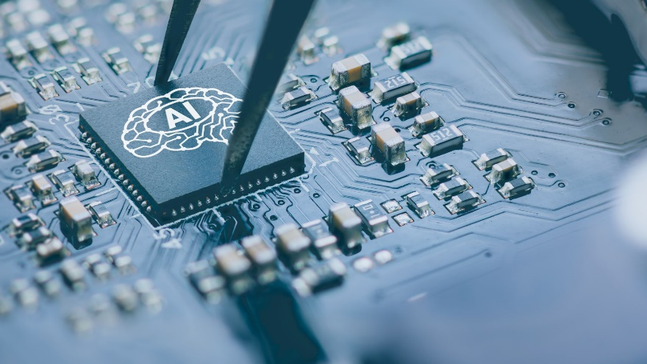

A class of microprocessor or computer system designed as hardware acceleration for artificial intelligence applications, especially artificial neural networks, machine vision, and machine learning.

AI-complete

In the field of artificial intelligence, the most difficult problems are informally known as AI-complete or AI-hard, implying that the difficulty of these computational problems is equivalent to that of solving the central artificial intelligence problem—making computers as intelligent as people, or strong AI. To call a problem AI-complete reflects an attitude that it would not be solved by a simple specific algorithm.

algorithm

An unambiguous specification of how to solve a class of problems. Algorithms can perform calculation, data processing, and automated reasoning tasks.

algorithmic efficiency

A property of an algorithm which relates to the number of computational resources used by the algorithm. An algorithm must be analyzed to determine its resource usage, and the efficiency of an algorithm can be measured based on usage of different resources. Algorithmic efficiency can be thought of as analogous to engineering productivity for a repeating or continuous process.

algorithmic probability



In algorithmic information theory, algorithmic probability, also known as Solomonoff probability, is a mathematical method of assigning a prior probability to a given observation. It was invented by Ray Solomonoff in the 1960s.

AlphaGo

A computer program that plays the board game Go. It was developed by Alphabet Inc.'s Google DeepMind in London. AlphaGo has several versions including AlphaGo Zero, AlphaGo Master, AlphaGo Lee, etc. In October 2015, AlphaGo became the first computer Go program to beat a human professional Go player without handicaps on a full-sized 19×19 board.

ambient intelligence (AmI)

Electronic environments that are sensitive and responsive to the presence of people.

analysis of algorithms

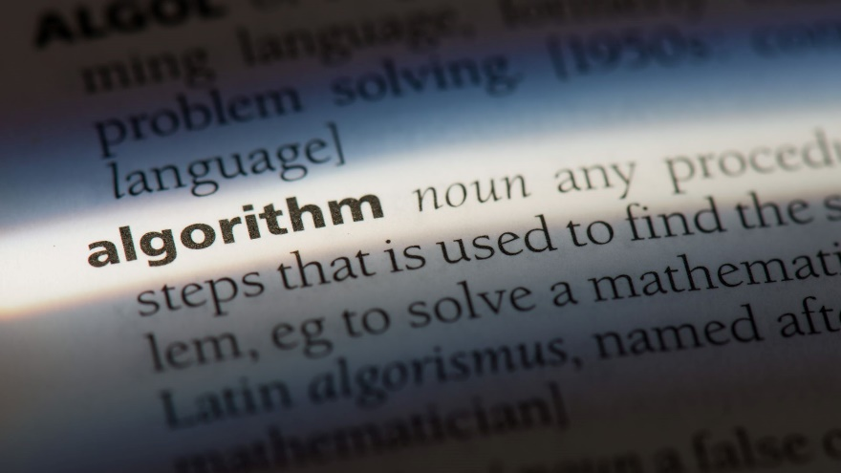

The determination of the computational complexity of algorithms, that is the amount of time, storage and/or other resources necessary to execute them. Usually, this involves determining a function that relates the length of an algorithm's input to the number of steps it takes (its time complexity) or the number of storage locations it uses (its space complexity).

analytics

The discovery, interpretation, and communication of meaningful patterns in data.

answer set programming (ASP)

A form of declarative programming oriented towards difficult (primarily NP-hard) search problems. It is based on the stable model (answer set) semantics of logic programming. In ASP, search problems are reduced to computing stable models, and answer set solvers—programs for generating stable models—are used to perform search.

anytime algorithm

An algorithm that can return a valid solution to a problem even if it is interrupted before it ends.

application programming interface (API)

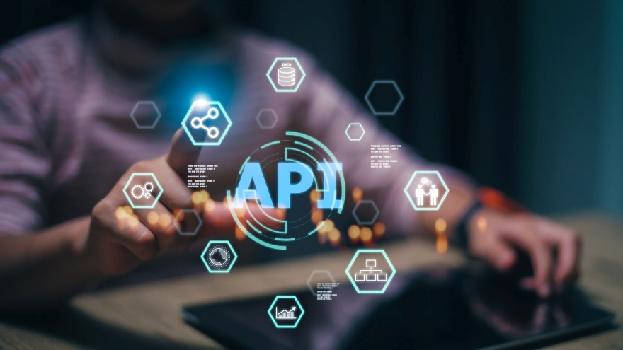

A set of subroutine definitions, communication protocols, and tools for building software. In general terms, it is a set of clearly defined methods of communication among various components. A good API makes it easier to develop a computer program by providing all the building blocks, which are then put together by the programmer. An API may be for a web-based system, operating system, database system, computer hardware, or software library.

approximate string matching, also fuzzy string searching.

The technique of finding strings that match a pattern approximately (rather than exactly). The problem of approximate string matching is typically divided into two sub-problems: finding approximate substring matches inside a given string and finding dictionary strings that match the pattern approximately.

approximation error

The discrepancy between an exact value and some approximation to it.

argumentation framework, also argumentation system.

A way to deal with contentious information and draw conclusions from it. In an abstract argumentation framework, entry-level information is a set of abstract arguments that, for instance, represent data or a proposition. Conflicts between arguments are represented by a binary relation on the set of arguments. In concrete terms, you represent an argumentation framework with a directed graph such that the nodes are the arguments, and the arrows represent the attack relation. There exist some extensions of the Dung's framework, like the logic-based argumentation frameworks or the value-based argumentation frameworks.

artificial general intelligence (AGI), artificial immune system (AIS)

A class of computationally intelligent, rule-based machine learning systems inspired by the principles and processes of the vertebrate immune system. The algorithms are typically modelled after the immune system's characteristics of learning and memory for use in problem-solving.

artificial intelligence (AI), also machine intelligence.

Any intelligence demonstrated by machines, in contrast to the natural intelligence displayed by humans and other animals. In computer science, AI research is defined as the study of "intelligent agents": any device that perceives its environment and takes actions that maximize its chance of successfully achieving its goals. Colloquially, the term "artificial intelligence" is applied when a machine mimics "cognitive" functions that humans associate with other human minds, such as "learning" and "problem solving".

Artificial Intelligence Markup Language

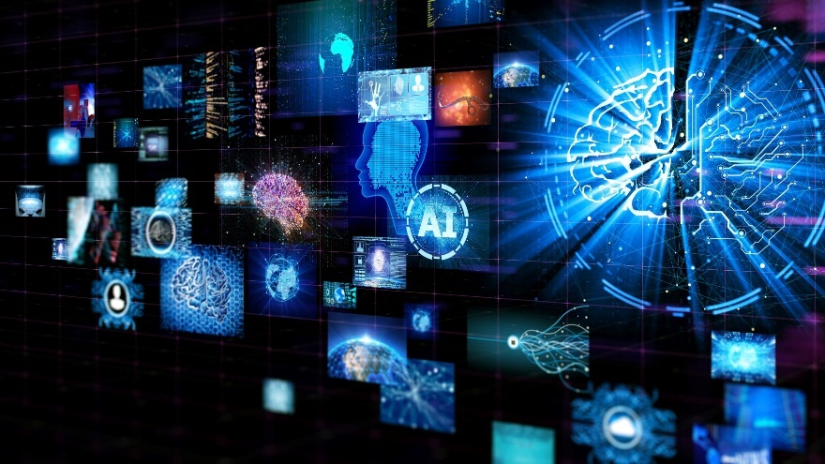

An XML dialect for creating natural language software agents.

artificial neural network (ANN), also connectionist system.

Artificial neural network (ANNs), also shortened to neural networks (NNs) or neural nets) are a branch of machine learning models that are built using principles of neuronal organization discovered by connectionism in the biological neural networks constituting animal brains.

Association for the Advancement of Artificial Intelligence (AAAI)

An international, nonprofit, scientific society devoted to promote research in, and responsible use of, artificial intelligence. AAAI also aims to increase public understanding of artificial intelligence (AI), improve the teaching and training of AI practitioners, and provide guidance for research planners and funders concerning the importance and potential of current AI developments and future directions.

asymptotic computational complexity

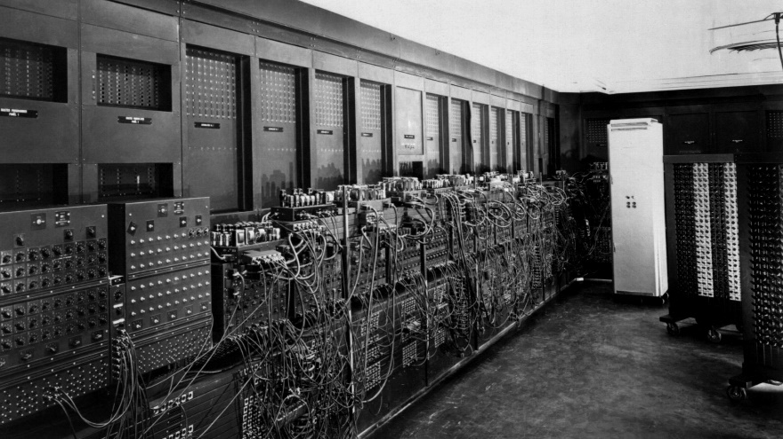

In computational complexity theory, asymptotic computational complexity is the usage of asymptotic analysis for the estimation of computational complexity of algorithms and computational problems, commonly associated with the usage of the big O notation.

attention mechanism

Machine learning-based attention is a mechanism mimicking cognitive attention. It calculates "soft" weights for each word, more precisely for its embedding, in the context window. It can do it either in parallel (such as in transformers) or sequentially (such as recursive neural networks). "Soft" weights can change during each runtime, in contrast to "hard" weights, which are (pre-)trained and fine-tuned and remain frozen afterwards. Multiple attention heads are used in transformer-based large language models.

attributional calculus

A logic and representation system defined by Ryszard S. Michalski. It combines elements of predicate logic, propositional calculus, and multi-valued logic. Attributional calculus provides a formal language for natural induction, an inductive learning process whose results are in forms natural to people.

augmented reality (AR)



Main article: Augmented reality

An interactive experience of a real-world environment where the objects that reside in the real-world are "augmented" by computer-generated perceptual information, sometimes across multiple sensory modalities, including visual, auditory, haptic, somatosensory, and olfactory.

automata theory

The study of abstract machines and automata, as well as the computational problems that can be solved using them. It is a theory in theoretical computer science and discrete mathematics (a subject of study in both mathematics and computer science).

automated machine learning (AutoML)

A field of machine learning which aims to automatically configure a machine learning system to maximize its performance (e.g, classification accuracy).

automated planning and scheduling, also simply AI planning.

A branch of artificial intelligence that concerns the realization of strategies or action sequences, typically for execution by intelligent agents, autonomous robots and unmanned vehicles. Unlike classical control and classification problems, the solutions are complex and must be discovered and optimized in multidimensional space. Planning is also related to decision theory.

automated reasoning

An area of computer science and mathematical logic dedicated to understanding different aspects of reasoning. The study of automated reasoning helps produce computer programs that allow computers to reason completely, or nearly completely, automatically. Although automated reasoning is considered a sub-field of artificial intelligence, it also has connections with theoretical computer science, and even philosophy.

autonomic computing (AC)



The self-managing characteristics of distributed computing resources, adapting to unpredictable changes while hiding intrinsic complexity to operators and users. Initiated by IBM in 2001, this initiative ultimately aimed to develop computer systems capable of self-management, to overcome the rapidly growing complexity of computing systems management, and to reduce the barrier that complexity poses to further growth.

autonomous car, also self-driving car, robot car, and driverless car.

A vehicle that is capable of sensing its environment and moving with little or no human input.

autonomous robot



A robot that performs behaviours or tasks with a high degree of autonomy. Autonomous robotics is usually considered to be a subfield of artificial intelligence, robotics, and information engineering.

B

Backpropagation

A method used in artificial neural networks to calculate a gradient that is needed in the calculation of the weights to be used in the network. Backpropagation is shorthand for "the backward propagation of errors", since an error is computed at the output and distributed backwards throughout the network's layers. It is commonly used to train deep neural networks, a term referring to neural networks with more than one hidden layer.

backpropagation through time (BPTT)

A gradient-based technique for training certain types of recurrent neural networks. It can be used to train Elman networks. The algorithm was independently derived by numerous researchers

backward chaining, also backward reasoning.

An inference method described colloquially as working backward from the goal. It is used in automated theorem provers, inference engines, proof assistants, and other artificial intelligence applications.

bag-of-words model

A simplifying representation used in natural language processing and information retrieval (IR). In this model, a text (such as a sentence or a document) is represented as the bag (multiset) of its words, disregarding grammar and even word order but keeping multiplicity. The bag-of-words model has also been used for computer vision. The bag-of-words model is commonly used in methods of document classification where the (frequency of) occurrence of each word is used as a feature for training a classifier.

bag-of-words model in computer vision

In computer vision, the bag-of-words model (BoW model) can be applied to image classification, by treating image features as words. In document classification, a bag of words is a sparse vector of occurrence counts of words; that is, a sparse histogram over the vocabulary. In computer vision, a bag of visual words is a vector of occurrence counts of a vocabulary of local image features.

batch normalization

A technique for improving the performance and stability of artificial neural networks. It is a technique to provide any layer in a neural network with inputs that are zero mean/unit variance. Batch normalization was introduced in a 2015 paper. It is used to normalize the input layer by adjusting and scaling the activations.

Bayesian programming

A formalism and a methodology for having a technique to specify probabilistic models and solve problems when less than the necessary information is available.

bees algorithm

A population-based search algorithm which was developed by Pham, Ghanbarzadeh and et al. in 2005. It mimics the food foraging behaviour of honey bee colonies. In its basic version the algorithm performs a kind of neighbourhood search combined with global search, and can be used for both combinatorial optimization and continuous optimization. The only condition for the application of the bees algorithm is that some measure of distance between the solutions is defined. The effectiveness and specific abilities of the bees algorithm have been proven in a number of studies.

behaviour informatics (BI)

The informatics of behaviours so as to obtain behaviour intelligence and behaviour insights.

behaviour tree (BT)

A mathematical model of plan execution used in computer science, robotics, control systems and video games. They describe switchings between a finite set of tasks in a modular fashion. Their strength comes from their ability to create very complex tasks composed of simple tasks, without worrying how the simple tasks are implemented. BTs present some similarities to hierarchical state machines with the key difference that the main building block of a behaviour is a task rather than a state. Its ease of human understanding make BTs less error-prone and very popular in the game developer community. BTs have shown to generalize several other control architectures.

belief-desire-intention software model (BDI)

A software model developed for programming intelligent agents. Superficially characterized by the implementation of an agent's beliefs, desires and intentions, it actually uses these concepts to solve a particular problem in agent programming. In essence, it provides a mechanism for separating the activity of selecting a plan (from a plan library or an external planner application) from the execution of currently active plans. Consequently, BDI agents are able to balance the time spent on deliberating about plans (choosing what to do) and executing those plans (doing it). A third activity, creating the plans in the first place (planning), is not within the scope of the model, and is left to the system designer and programmer.

bias–variance tradeoff

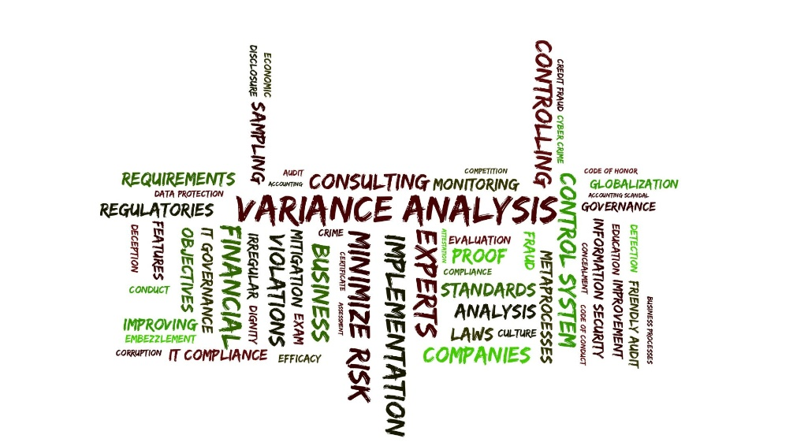In statistics and machine learning, the bias–variance tradeoff is the property of a set of predictive models whereby models with a lower bias in parameter estimation have a higher variance of the parameter estimates across samples, and vice versa.

big data

A term used to refer to data sets that are too large or complex for traditional data-processing application software to adequately deal with. Data with many cases (rows) offer greater statistical power, while data with higher complexity (more attributes or columns) may lead to a higher false discovery rate.

Big O notation

A mathematical notation that describes the limiting behaviour of a function when the argument tends towards a particular value or infinity. It is a member of a family of notations invented by Paul Bachmann, Edmund Landau, and others, collectively called Bachmann–Landau notation or asymptotic notation.

binary tree

A tree data structure in which each node has at most two children, which are referred to as the left child and the right child. A recursive definition using just set theory notions is that a (non-empty) binary tree is a tuple (L, S, R), where L and R are binary trees or the empty set and S is a singleton set. Some authors allow the binary tree to be the empty set as well.

blackboard system

An artificial intelligence approach based on the blackboard architectural model, where a common knowledge base, the "blackboard", is iteratively updated by a diverse group of specialist knowledge sources, starting with a problem specification and ending with a solution. Each knowledge source updates the blackboard with a partial solution when its internal constraints match the blackboard state. In this way, the specialists work together to solve the problem.

Boltzmann machine, also stochastic Hopfield network with hidden units.

A type of stochastic recurrent neural network and Markov random field. Boltzmann machines can be seen as the stochastic, generative counterpart of Hopfield networks.

Boolean satisfiability problem

Also propositional satisfiability problem; abbreviated SATISFIABILITY or SAT.

The problem of determining if there exists an interpretation that satisfies a given Boolean formula. In other words, it asks whether the variables of a given Boolean formula can be consistently replaced by the values TRUE or FALSE in such a way that the formula evaluates to TRUE. If this is the case, the formula is called satisfiable. On the other hand, if no such assignment exists, the function expressed by the formula is FALSE for all possible variable assignments and the formula is unsatisfiable. For example, the formula "a AND NOT b" is satisfiable because one can find the values a = TRUE and b = FALSE, which make (a AND NOT b) = TRUE. In contrast, "a AND NOT a" is unsatisfiable.

brain technology, also self-learning know-how system.

A technology that employs the latest findings in neuroscience. The term was first introduced by the Artificial Intelligence Laboratory in Zurich, Switzerland, in the context of the ROBOY project. Brain Technology can be employed in robots, know-how management systems and any other application with self-learning capabilities. In particular, Brain Technology applications allow the visualization of the underlying learning architecture often coined as "know-how maps".

branching factor

In computing, tree data structures, and game theory, the number of children at each node, the outdegree. If this value is not uniform, an average branching factor can be calculated.

brute-force search, also exhaustive search or generate and test.

A very general problem-solving technique and algorithmic paradigm that consists of systematically enumerating all possible candidates for the solution and checking whether each candidate satisfies the problem's statement.

C

capsule neural network (CapsNet)

A machine learning system that is a type of artificial neural network (ANN) that can be used to better model hierarchical relationships. The approach is an attempt to more closely mimic biological neural organization.

case-based reasoning (CBR)

Broadly construed, the process of solving new problems based on the solutions of similar past problems.

Chatbot, also smartbot, talkbot, chatterbot, bot, IM bot, interactive agent, conversational interface, or artificial conversational entity.

A computer program or an artificial intelligence which conducts a conversation via auditory or textual methods.

cloud robotics

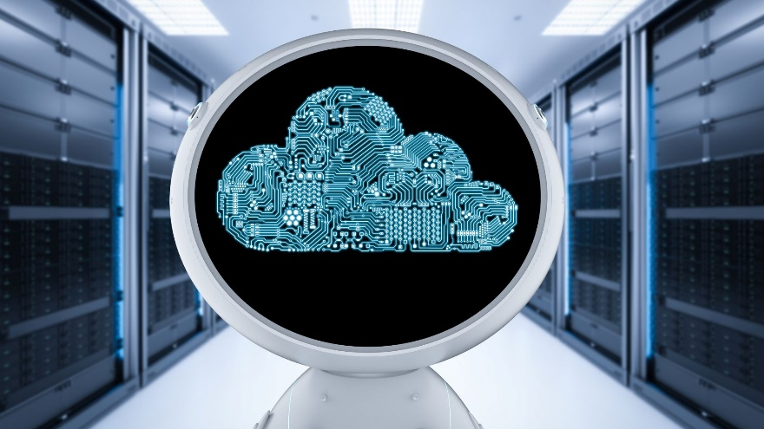

A field of robotics that attempts to invoke cloud technologies such as cloud computing, cloud storage, and other Internet technologies centred on the benefits of converged infrastructure and shared services for robotics. When connected to the cloud, robots can benefit from the powerful computation, storage, and communication resources of modern data center in the cloud, which can process and share information from various robots or agent (other machines, smart objects, humans, etc.). Humans can also delegate tasks to robots remotely through networks. Cloud computing technologies enable robot systems to be endowed with powerful capability whilst reducing costs through cloud technologies. Thus, it is possible to build lightweight, low cost, smarter robots have intelligent "brain" in the cloud. The "brain" consists of data center, knowledge base, task planners, deep learning, information processing, environment models, communication support, etc.

cluster analysis, also clustering.

The task of grouping a set of objects in such a way that objects in the same group (called a cluster) are more similar (in some sense) to each other than to those in other groups (clusters). It is a main task of exploratory data mining, and a common technique for statistical data analysis, used in many fields, including machine learning, pattern recognition, image analysis, information retrieval, bioinformatics, data compression, and computer graphics.

Cobweb

An incremental system for hierarchical conceptual clustering. COBWEB was invented by Professor Douglas H. Fisher, currently at Vanderbilt University. COBWEB incrementally organizes observations into a classification tree. Each node in a classification tree represents a class (concept) and is labelled by a probabilistic concept that summarizes the attribute-value distributions of objects classified under the node. This classification tree can be used to predict missing attributes or the class of a new object.

cognitive architecture

The Institute of Creative Technologies defines cognitive architecture as: "hypothesis about the fixed structures that provide a mind, whether in natural or artificial systems, and how they work together – in conjunction with knowledge and skills embodied within the architecture – to yield intelligent behaviour in a diversity of complex environments."

cognitive computing



In general, the term cognitive computing has been used to refer to new hardware and/or software that mimics the functioning of the human brain and helps to improve human decision-making. In this sense, CC is a new type of computing with the goal of more accurate models of how the human brain/mind senses, reasons, and responds to stimulus.

cognitive science

The interdisciplinary scientific study of the mind and its processes.

combinatorial optimization

In Operations Research, applied mathematics and theoretical computer science, combinatorial optimization is a topic that consists of finding an optimal object from a finite set of objects.

committee machine

A type of artificial neural network using a divide and conquer strategy in which the responses of multiple neural networks (experts) are combined into a single response. The combined response of the committee machine is supposed to be superior to those of its constituent experts. Compare ensembles of classifiers.

commonsense knowledge

In artificial intelligence research, commonsense knowledge consists of facts about the everyday world, such as "Lemons are sour", that all humans are expected to know. The first AI program to address common sense knowledge was Advice Taker in 1959 by John McCarthy.

commonsense reasoning

A branch of artificial intelligence concerned with simulating the human ability to make presumptions about the type and essence of ordinary situations they encounter every day.

computational chemistry

A branch of chemistry that uses computer simulation to assist in solving chemical problems.

computational complexity theory

Focuses on classifying computational problems according to their inherent difficulty, and relating these classes to each other. A computational problem is a task solved by a computer. A computation problem is solvable by mechanical application of mathematical steps, such as an algorithm.

computational creativity, also artificial creativity, mechanical creativity, creative computing, or creative computation.

A multidisciplinary endeavour that includes the fields of artificial intelligence, cognitive psychology, philosophy, and the arts.

computational cybernetics

The integration of cybernetics and computational intelligence techniques.

computational humor

A branch of computational linguistics and artificial intelligence which uses computers in humor research.

computational intelligence (CI)

Usually refers to the ability of a computer to learn a specific task from data or experimental observation.

computational learning theory

In computer science, computational learning theory (or just learning theory) is a subfield of artificial intelligence devoted to studying the design and analysis of machine learning algorithms.

computational linguistics

An interdisciplinary field concerned with the statistical or rule-based modelling of natural language from a computational perspective, as well as the study of appropriate computational approaches to linguistic questions.

computational mathematics

The mathematical research in areas of science where computing plays an essential role.

computational neuroscience, also theoretical neuroscience or mathematical neuroscience.

A branch of neuroscience which employs mathematical models, theoretical analysis and abstractions of the brain to understand the principles that govern the development, structure, physiology, and cognitive abilities of the nervous system.

computational number theory, also algorithmic number theory.

The study of algorithms for performing number theoretic computations.

computational problem



In theoretical computer science, a computational problem is a mathematical object representing a collection of questions that computers might be able to solve.

computational statistics, also statistical computing.

The interface between statistics and computer science.

computer-automated design (CAutoD)

Design automation usually refers to electronic design automation, or Design Automation which is a Product Configurator. Extending Computer-Aided Design (CAD), automated design and computer-automated design are concerned with a broader range of applications, such as automotive engineering, civil engineering, composite material design, control engineering, dynamic system identification and optimization, financial systems, industrial equipment, mechatronic systems, steel construction, structural optimisation, and the invention of novel systems. More recently, traditional CAD simulation is seen to be transformed to CAutoD by biologically inspired machine learning, including heuristic search techniques such as evolutionary computation, and swarm intelligence algorithms.

computer audition (CA)

See machine listening.

computer science



The theory, experimentation, and engineering that form the basis for the design and use of computers. It involves the study of algorithms that process, store, and communicate digital information. A computer scientist specializes in the theory of computation and the design of computational systems.

computer vision

An interdisciplinary scientific field that deals with how computers can be made to gain high-level understanding from digital images or videos. From the perspective of engineering, it seeks to automate tasks that the human visual system can do.

concept drift

In predictive analytics and machine learning, the concept drift means that the statistical properties of the target variable, which the model is trying to predict, change over time in unforeseen ways. This causes problems because the predictions become less accurate as time passes.

connectionism

An approach in the fields of cognitive science, that hopes to explain mental phenomena using artificial neural networks.

consistent heuristic

In the study of path-finding problems in artificial intelligence, a heuristic function is said to be consistent, or monotone, if its estimate is always less than or equal to the estimated distance from any neighbouring vertex to the goal, plus the cost of reaching that neighbour.

constrained conditional model (CCM)

A machine learning and inference framework that augments the learning of conditional (probabilistic or discriminative) models with declarative constraints.

constraint logic programming

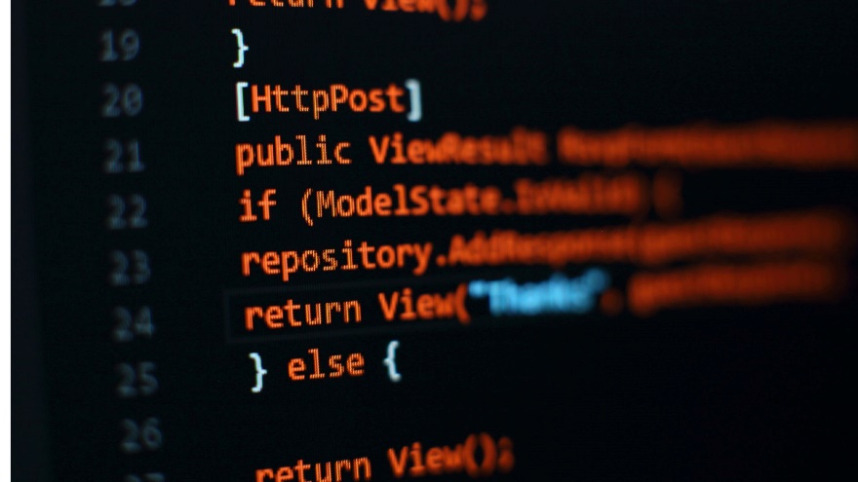

A form of constraint programming, in which logic programming is extended to include concepts from constraint satisfaction. A constraint logic program is a logic program that contains constraints in the body of clauses. An example of a clause including a constraint is A(X,Y) :- X+Y>0, B(X), C(Y). In this clause, X+Y>0 is a constraint; A(X,Y), B(X), and C(Y) are literals as in regular logic programming. This clause states one condition under which the statement A(X,Y) holds: X+Y is greater than zero and both B(X) and C(Y) are true.

constraint programming

A programming paradigm wherein relations between variables are stated in the form of constraints. Constraints differ from the common primitives of imperative programming languages in that they do not specify a step or sequence of steps to execute, but rather the properties of a solution to be found.

constructed language, also conlang.

A language whose phonology, grammar, and vocabulary are consciously devised, instead of having developed naturally. Constructed languages may also be referred to as artificial, planned, or invented languages.

control theory

In control systems engineering is a subfield of mathematics that deals with the control of continuously operating dynamical systems in engineered processes and machines. The objective is to develop a control model for controlling such systems using a control action in an optimum manner without delay or overshoot and ensuring control stability.

convolutional neural network

In deep learning, a convolutional neural network (CNN, or ConvNet) is a class of deep neural networks, most commonly applied to analyzing visual imagery. CNNs use a variation of multilayer perceptrons designed to require minimal preprocessing. They are also known as shift invariant or space invariant artificial neural networks (SIANN), based on their shared-weights architecture and translation invariance characteristics.

Crossover, also recombination.

In genetic algorithms and evolutionary computation, a genetic operator used to combine the genetic information of two parents to generate new offspring. It is one way to stochastically generate new solutions from an existing population, and analogous to the crossover that happens during sexual reproduction in biological organisms. Solutions can also be generated by cloning an existing solution, which is analogous to asexual reproduction. Newly generated solutions are typically mutated before being added to the population.

D

Darkforest

A computer go program developed by Facebook, based on deep learning techniques using a convolutional neural network. Its updated version Darkfores2 combines the techniques of its predecessor with Monte Carlo tree search. The MCTS effectively takes tree search methods commonly seen in computer chess programs and randomizes them. With the update, the system is known as Darkfmcts3.

Dartmouth workshop

The Dartmouth Summer Research Project on Artificial Intelligence was the name of a 1956 summer workshop now considered by many (though not all) to be the seminal event for artificial intelligence as a field.

data augmentation

Data augmentation in data analysis are techniques used to increase the amount of data. It helps reduce overfitting when training a machine learning.

data fusion

The process of integrating multiple data sources to produce more consistent, accurate, and useful information than that provided by any individual data source.

data integration

The process of combining data residing in different sources and providing users with a unified view of them. This process becomes significant in a variety of situations, which include both commercial (such as when two similar companies need to merge their databases) and scientific (combining research results from different bioinformatics repositories, for example) domains. Data integration appears with increasing frequency as the volume (that is, big data) and the need to share existing data explodes. It has become the focus of extensive theoretical work, and numerous open problems remain unsolved.

data mining



The process of discovering patterns in large data sets involving methods at the intersection of machine learning, statistics, and database systems.

data science

An interdisciplinary field that uses scientific methods, processes, algorithms and systems to extract knowledge and insights from data in various forms, both structured and unstructured, similar to data mining. Data science is a "concept to unify statistics, data analysis, machine learning and their related methods" in order to "understand and analyze actual phenomena" with data. It employs techniques and theories drawn from many fields within the context of mathematics, statistics, information science, and computer science.

data set, also dataset.



A collection of data. Most commonly a data set corresponds to the contents of a single database table, or a single statistical data matrix, where every column of the table represents a particular variable, and each row corresponds to a given member of the data set in question. The data set lists values for each of the variables, such as height and weight of an object, for each member of the data set. Each value is known as a datum. The data set may comprise data for one or more members, corresponding to the number of rows.

data warehouse (DW or DWH), also enterprise data warehouse (EDW).

A system used for reporting and data analysis. DWs are central repositories of integrated data from one or more disparate sources. They store current and historical data in one single place.

Datalog

A declarative logic programming language that syntactically is a subset of Prolog. It is often used as a query language for deductive databases. In recent years, Datalog has found new application in data integration, information extraction, networking, program analysis, security, and cloud computing.

decision boundary



In the case of backpropagation-based artificial neural networks or perceptrons, the type of decision boundary that the network can learn is determined by the number of hidden layers the network has. If it has no hidden layers, then it can only learn linear problems. If it has one hidden layer, then it can learn any continuous function on compact subsets of Rn as shown by the Universal approximation theorem, thus it can have an arbitrary decision boundary.

decision support system (DSS)



Aan information system that supports business or organizational decision-making activities. DSSs serve the management, operations and planning levels of an organization (usually mid and higher management) and help people make decisions about problems that may be rapidly changing and not easily specified in advance—i.e. unstructured and semi-structured decision problems. Decision support systems can be either fully computerized or human-powered, or a combination of both.

decision theory, also theory of choice.

The study of the reasoning underlying an agent's choices. Decision theory can be broken into two branches: normative decision theory, which gives advice on how to make the best decisions given a set of uncertain beliefs and a set of values, and descriptive decision theory which analyzes how existing, possibly irrational agents actually make decisions.

decision tree learning

Uses a decision tree (as a predictive model) to go from observations about an item (represented in the branches) to conclusions about the item's target value (represented in the leaves). It is one of the predictive modelling approaches used in statistics, data mining and machine learning.

declarative programming

A programming paradigm—a style of building the structure and elements of computer programs—that expresses the logic of a computation without describing its control flow.

deductive classifier

A type of artificial intelligence inference engine. It takes as input a set of declarations in a frame language about a domain such as medical research or molecular biology. For example, the names of classes, sub-classes, properties, and restrictions on allowable values.

Deep Blue

was a chess-playing computer developed by IBM. It is known for being the first computer chess-playing system to win both a chess game and a chess match against a reigning world champion under regular time controls.

deep learning

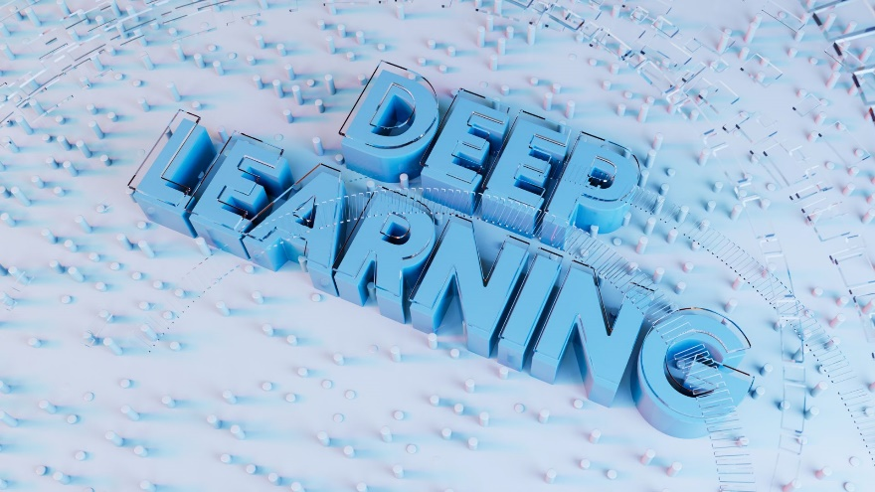

Also deep structured learning or hierarchical learning.

Part of a broader family of machine learning methods based on learning data representations, as opposed to task-specific algorithms. Learning can be supervised, semi-supervised, or unsupervised.

DeepMind Technologies

A British artificial intelligence company founded in September 2010, currently owned by Alphabet Inc. The company is based in London, with research centres in Canada, France, and the United States. Acquired by Google in 2014, the company has created a neural network that learns how to play video games in a fashion similar to that of humans, as well as a neural Turing machine, or a neural network that may be able to access an external memory like a conventional Turing machine, resulting in a computer that mimics the short-term memory of the human brain. The company made headlines in 2016 after its AlphaGo program beat human professional Go player Lee Sedol, the world champion, in a five-game match, which was the subject of a documentary film. A more general program, AlphaZero, beat the most powerful programs playing Go, chess, and shogi (Japanese chess) after a few days of play against itself using reinforcement learning.

default logic

A non-monotonic logic proposed by Raymond Reiter to formalize reasoning with default assumptions.

description logic (DL)

A family of formal knowledge representation languages. Many DLs are more expressive than propositional logic but less expressive than first-order logic. In contrast to the latter, the core reasoning problems for DLs are (usually) decidable, and efficient decision procedures have been designed and implemented for these problems. There are general, spatial, temporal, spatiotemporal, and fuzzy descriptions logics, and each description logic features a different balance between DL expressivity and reasoning complexity by supporting different sets of mathematical constructors.

developmental robotics (DevRob)

Also epigenetic robotics.

A scientific field which aims at studying the developmental mechanisms, architectures, and constraints that allow lifelong and open-ended learning of new skills and new knowledge in embodied machines.

Diagnosis



Concerned with the development of algorithms and techniques that are able to determine whether the behaviour of a system is correct. If the system is not functioning correctly, the algorithm should be able to determine, as accurately as possible, which part of the system is failing, and which kind of fault it is facing. The computation is based on observations, which provide information on the current behaviour.

dialogue system, also conversational agent (CA).

A computer system intended to converse with a human with a coherent structure. Dialogue systems have employed text, speech, graphics, haptics, gestures, and other modes for communication on both the input and output channel.

diffusion model

In machine learning, diffusion models, also known as diffusion probabilistic models or score-based generative models are a class of latent variable models. They are Markov chains trained using variation inference. The goal of diffusion models is to learn the latent structure of a dataset by modelling the way in which data points diffuse through the latent space. In computer vision, this means that a neural network is trained to denoise images blurred with Gaussian noise by learning to reverse the diffusion process. It mainly consists of three major components: the forward process, the reverse process, and the sampling procedure. Three examples of generic diffusion modelling frameworks used in computer vision are denoising diffusion probabilistic models, noise conditioned score networks, and stochastic differential equations.

dimensionality reduction

Also dimension reduction.

The process of reducing the number of random variables under consideration by obtaining a set of principal variables. It can be divided into feature selection and feature extraction.

discrete system

Any system with a countable number of states. Discrete systems may be contrasted with continuous systems, which may also be called analog systems. A final discrete system is often modeled with a directed graph and is analyzed for correctness and complexity according to computational theory. Because discrete systems have a countable number of states, they may be described in precise mathematical models. A computer is a finite state machine that may be viewed as a discrete system. Because computers are often used to model not only other discrete systems but continuous systems as well, methods have been developed to represent real-world continuous systems as discrete systems. One such method involves sampling a continuous signal at discrete time intervals.

distributed artificial intelligence (DAI), also decentralized artificial intelligence.

A subfield of artificial intelligence research dedicated to the development of distributed solutions for problems. DAI is closely related to and a predecessor of the field of multi-agent systems.

dynamic epistemic logic (DEL)

A logical framework dealing with knowledge and information change. Typically, DEL focuses on situations involving multiple agents and studies how their knowledge changes when events occur.

E

eager learning



A learning method in which the system tries to construct a general, input-independent target function during training of the system, as opposed to lazy learning, where generalization beyond the training data is delayed until a query is made to the system.

Ebert test

A test which gauges whether a computer-based synthesized voice can tell a joke with sufficient skill to cause people to laugh. It was proposed by film critic Roger Ebert at the 2011 TED conference as a challenge to software developers to have a computerized voice master the inflections, delivery, timing, and intonations of a speaking human. The test is similar to the Turing test proposed by Alan Turing in 1950 as a way to gauge a computer's ability to exhibit intelligent behaviour by generating performance indistinguishable from a human being.

echo state network (ESN)

A recurrent neural network with a sparsely connected hidden layer (with typically 1% connectivity). The connectivity and weights of hidden neurons are fixed and randomly assigned. The weights of output neurons can be learned so that the network can (re)produce specific temporal patterns. The main interest of this network is that although its behaviour is non-linear, the only weights that are modified during training are for the synapses that connect the hidden neurons to output neurons. Thus, the error function is quadratic with respect to the parameter vector and can be differentiated easily to a linear system.

embodied agent, also interface agent.

An intelligent agent that interacts with the environment through a physical body within that environment. Agents that are represented graphically with a body, for example a human or a cartoon animal, are also called embodied agents, although they have only virtual, not physical, embodiment.

embodied cognitive science

An interdisciplinary field of research, the aim of which is to explain the mechanisms underlying intelligent behaviour. It comprises three main methodologies: 1) the modelling of psychological and biological systems in a holistic manner that considers the mind and body as a single entity, 2) the formation of a common set of general principles of intelligent behaviour, and 3) the experimental use of robotic agents in controlled environments.

error-driven learning

A sub-area of machine learning concerned with how an agent ought to take actions in an environment so as to minimize some error feedback. It is a type of reinforcement learning.

ensemble averaging

In machine learning, particularly in the creation of artificial neural networks, ensemble averaging is the process of creating multiple models and combining them to produce a desired output, as opposed to creating just one model.

epoch (machine learning)

In machine learning, particularly in the creation of artificial neural networks, an epoch is training the model for one cycle through the full training dataset. Small models are typically trained for as many epochs as it takes to reach the best performance on the validation dataset. The largest models may train for only one epoch.

ethics of artificial intelligence

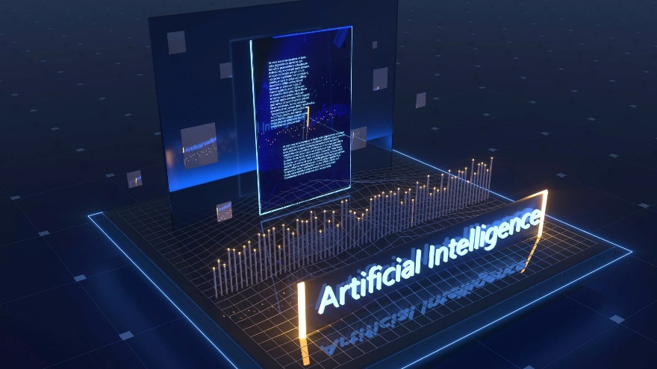

The part of the ethics of technology specific to artificial intelligence.

evolutionary algorithm (EA)

A subset of evolutionary computation, a generic population-based metaheuristic optimization algorithm. An EA uses mechanisms inspired by biological evolution, such as reproduction, mutation, recombination, and selection. Candidate solutions to the optimization problem play the role of individuals in a population, and the fitness function determines the quality of the solutions (see also loss function). Evolution of the population then takes place after the repeated application of the above operators.

evolutionary computation

A family of algorithms for global optimization inspired by biological evolution, and the subfield of artificial intelligence and soft computing studying these algorithms. In technical terms, they are a family of population-based trial and error problem solvers with a metaheuristic or stochastic optimization character.

evolving classification function (ECF)

Evolving classifier functions or evolving classifiers are used for classifying and clustering in the field of machine learning and artificial intelligence, typically employed for data stream mining tasks in dynamic and changing environments.

existential risk

The hypothesis that substantial progress in artificial general intelligence (AGI) could someday result in human extinction or some other unrecoverable global catastrophe.

expert system

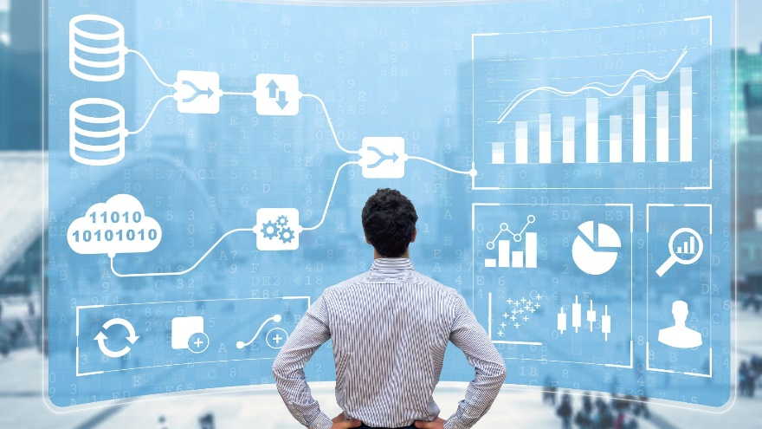

A computer system that emulates the decision-making ability of a human expert. Expert systems are designed to solve complex problems by reasoning through bodies of knowledge, represented mainly as if–then rules rather than through conventional procedural code.

F

fast-and-frugal trees

A type of classification tree. Fast-and-frugal trees can be used as decision-making tools which operate as lexicographic classifiers, and, if required, associate an action (decision) to each class or category.

feature extraction

In machine learning, pattern recognition, and image processing, feature extraction starts from an initial set of measured data and builds derived values (features) intended to be informative and non-redundant, facilitating the subsequent learning and generalization steps, and in some cases leading to better human interpretations.

feature learning

In machine learning, feature learning or representation learning is a set of techniques that allows a system to automatically discover the representations needed for feature detection or classification from raw data. This replaces manual feature engineering and allows a machine to both learn the features and use them to perform a specific task.

feature selection



In machine learning and statistics, feature selection, also known as variable selection, attribute selection or variable subset selection, is the process of selecting a subset of relevant features (variables, predictors) for use in model construction.

federated learning

A type of machine learning that allows for training on multiple devices with decentralized data, thus helping preserve the privacy of individual users and their data.

first-order logic

Also known as first-order predicate calculus and predicate logic.

A collection of formal systems used in mathematics, philosophy, linguistics, and computer science. First-order logic uses quantified variables over non-logical objects and allows the use of sentences that contain variables, so that rather than propositions such as Socrates is a man one can have expressions in the form "there exists X such that X is Socrates and X is a man" and there exists is a quantifier while X is a variable. This distinguishes it from propositional logic, which does not use quantifiers or relations.

fluent

A condition that can change over time. In logical approaches to reasoning about actions, fluents can be represented in first-order logic by predicates having an argument that depends on time.

formal language

A set of words whose letters are taken from an alphabet and are well-formed according to a specific set of rules.

forward chaining, also forward reasoning.

One of the two main methods of reasoning when using an inference engine and can be described logically as repeated application of modus ponens. Forward chaining is a popular implementation strategy for expert systems, businesses and production rule systems. The opposite of forward chaining is backward chaining. Forward chaining starts with the available data and uses inference rules to extract more data (from an end user, for example) until a goal is reached. An inference engine using forward chaining searches the inference rules until it finds one where the antecedent (If clause) is known to be true. When such a rule is found, the engine can conclude, or infer, the consequent (Then clause), resulting in the addition of new information to its data.

frame

An artificial intelligence data structure used to divide knowledge into substructures by representing "stereotyped situations". Frames are the primary data structure used in artificial intelligence frame language.

frame language

A technology used for knowledge representation in artificial intelligence. Frames are stored as ontologies of sets and subsets of the frame concepts. They are similar to class hierarchies in object-oriented languages although their fundamental design goals are different. Frames are focused on explicit and intuitive representation of knowledge whereas objects focus on encapsulation and information hiding. Frames originated in AI research and objects primarily in software engineering. However, in practice the techniques and capabilities of frame and object-oriented languages overlap significantly.

frame problem

The problem of finding adequate collections of axioms for a viable description of a robot environment.

friendly artificial intelligence, also friendly AI or FAI.

A hypothetical artificial general intelligence (AGI) that would have a positive effect on humanity. It is a part of the ethics of artificial intelligence and is closely related to machine ethics. While machine ethics is concerned with how an artificially intelligent agent should behave, friendly artificial intelligence research is focused on how to practically bring about this behaviour and ensuring it is adequately constrained.

futures studies



The study of postulating possible, probable, and preferable futures and the worldviews and myths that underlie them.

fuzzy control system

A control system based on fuzzy logic—a mathematical system that analyzes analog input values in terms of logical variables that take on continuous values between 0 and 1, in contrast to classical or digital logic, which operates on discrete values of either 1 or 0 (true or false, respectively).

fuzzy logic



A simple form for the many-valued logic, in which the truth values of variables may have any degree of "Truthfulness" that can be represented by any real number in the range between 0 (as in Completely False) and 1 (as in Completely True) inclusive. Consequently, It is employed to handle the concept of partial truth, where the truth value may range between completely true and completely false. In contrast to Boolean logic, where the truth values of variables may have the integer values 0 or 1 only.

fuzzy rule

A rule used within fuzzy logic systems to infer an output based on input variables.

fuzzy set

In classical set theory, the membership of elements in a set is assessed in binary terms according to a bivalent condition — an element either belongs or does not belong to the set. By contrast, fuzzy set theory permits the gradual assessment of the membership of elements in a set; this is described with the aid of a membership function valued in the real unit interval [0, 1]. Fuzzy sets generalize classical sets, since the indicator functions (aka characteristic functions) of classical sets are special cases of the membership functions of fuzzy sets, if the latter only take values 0 or 1. In fuzzy set theory, classical bivalent sets are usually called crisp sets. The fuzzy set theory can be used in a wide range of domains in which information is incomplete or imprecise, such as bioinformatics.

G

game theory

The study of mathematical models of strategic interaction between rational decision-makers.

general game playing (GGP)

General game playing is the design of artificial intelligence programs to be able to run and play more than one game successfully.

generative adversarial network (GAN)

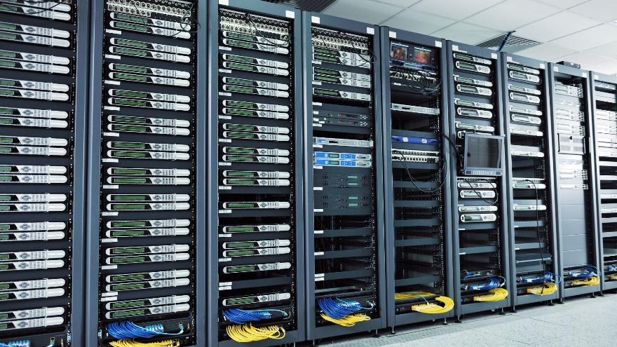

A class of machine learning systems. Two neural networks contest with each other in a zero-sum game framework.

generative artificial intelligence

Generative artificial intelligence is artificial intelligence capable of generating text, images, or other media in response to prompts. Generative AI models learn the patterns and structure of their input training data and then generate new data that has similar characteristics, typically using Transformer-based deep neural networks.

genetic algorithm (GA)



A metaheuristic inspired by the process of natural selection that belongs to the larger class of evolutionary algorithms (EA). Genetic algorithms are commonly used to generate high-quality solutions to optimization and search problems by relying on bio-inspired operators such as mutation, crossover and selection.

genetic operator

An operator used in genetic algorithms to guide the algorithm towards a solution to a given problem. There are three main types of operators (mutation, crossover and selection), which must work in conjunction with one another in order for the algorithm to be successful.

glowworm swarm optimization

A swarm intelligence optimization algorithm based on the behaviour of glowworms (also known as fireflies or lightning bugs).

graph (abstract data type)

In computer science, a graph is an abstract data type that is meant to implement the undirected graph and directed graph concepts from mathematics; specifically, the field of graph theory.

graph (discrete mathematics)

In mathematics, and more specifically in graph theory, a graph is a structure amounting to a set of objects in which some pairs of the objects are in some sense "related". The objects correspond to mathematical abstractions called vertices (also called nodes or points) and each of the related pairs of vertices is called an edge (also called an arc or line).

graph database (GDB)

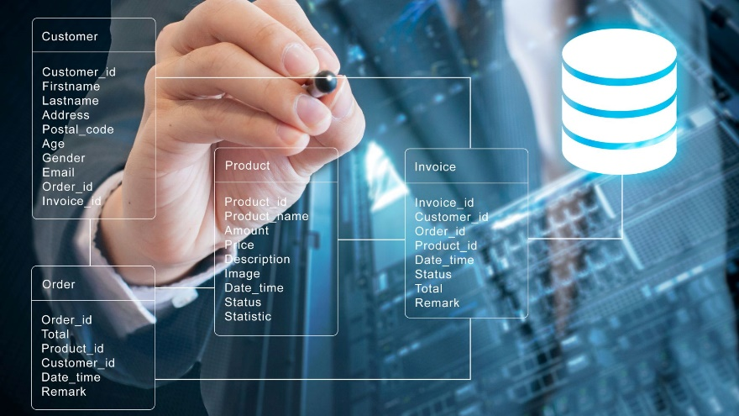

A database that uses graph structures for semantic queries with nodes, edges, and properties to represent and store data. A key concept of the system is the graph (or edge or relationship), which directly relates data items in the store a collection of nodes of data and edges representing the relationships between the nodes. The relationships allow data in the store to be linked together directly, and in many cases retrieved with one operation. Graph databases hold the relationships between data as a priority. Querying relationships within a graph database is fast because they are perpetually stored within the database itself. Relationships can be intuitively visualized using graph databases, making it useful for heavily inter-connected data.

graph theory



The study of graphs, which are mathematical structures used to model pairwise relations between objects.

graph traversal, also graph search.

The process of visiting (checking and/or updating) each vertex in a graph. Such traversals are classified by the order in which the vertices are visited. Tree traversal is a special case of graph traversal.

H

halting problem

heuristic

A technique designed for solving a problem more quickly when classic methods are too slow, or for finding an approximate solution when classic methods fail to find any exact solution. This is achieved by trading optimality, completeness, accuracy, or precision for speed. In a way, it can be considered a shortcut. A heuristic function, also called simply a heuristic, is a function that ranks alternatives in search algorithms at each branching step based on available information to decide which branch to follow. For example, it may approximate the exact solution.

hidden layer

An internal layer of neurons in an artificial neural network, not dedicated to input or output.

hidden unit

A neuron in a hidden layer in an artificial neural network.

hyper-heuristic

A heuristic search method that seeks to automate the process of selecting, combining, generating, or adapting several simpler heuristics (or components of such heuristics) to efficiently solve computational search problems, often by the incorporation of machine learning techniques. One of the motivations for studying hyper-heuristics is to build systems which can handle classes of problems rather than solving just one problem.

I

IEEE Computational Intelligence Society

A professional society of the Institute of Electrical and Electronics Engineers (IEEE) focussing on "the theory, design, application, and development of biologically and linguistically motivated computational paradigms emphasizing neural networks, connectionist systems, genetic algorithms, evolutionary programming, fuzzy systems, and hybrid intelligent systems in which these paradigms are contained".

incremental learning

A method of machine learning, in which input data is continuously used to extend the existing model's knowledge i.e. to further train the model. It represents a dynamic technique of supervised learning and unsupervised learning that can be applied when training data becomes available gradually over time or its size is out of system memory limits. Algorithms that can facilitate incremental learning are known as incremental machine learning algorithms.

inference engine

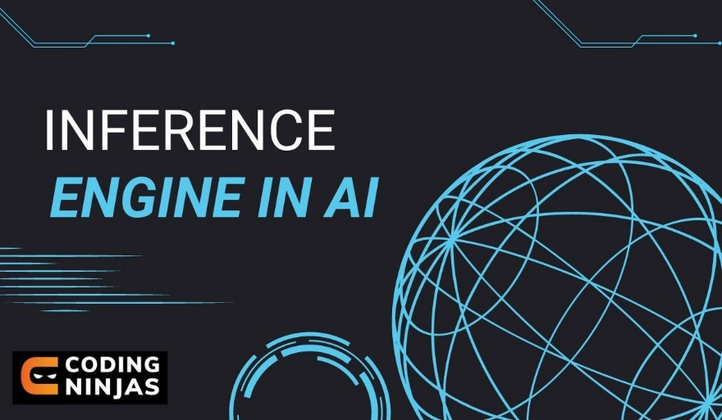

A component of the system that applies logical rules to the knowledge base to deduce new information.

information integration (II)

The merging of information from heterogeneous sources with differing conceptual, contextual and typographical representations. It is used in data mining and consolidation of data from unstructured or semi-structured resources. Typically, information integration refers to textual representations of knowledge but is sometimes applied to rich-media content. Information fusion, which is a related term, involves the combination of information into a new set of information towards reducing redundancy and uncertainty.

Information Processing Language (IPL)

A programming language that includes features intended to help with programs that perform simple problem solving actions such as lists, dynamic memory allocation, data types, recursion, functions as arguments, generators, and cooperative multitasking. IPL invented the concept of list processing, albeit in an assembly-language style.

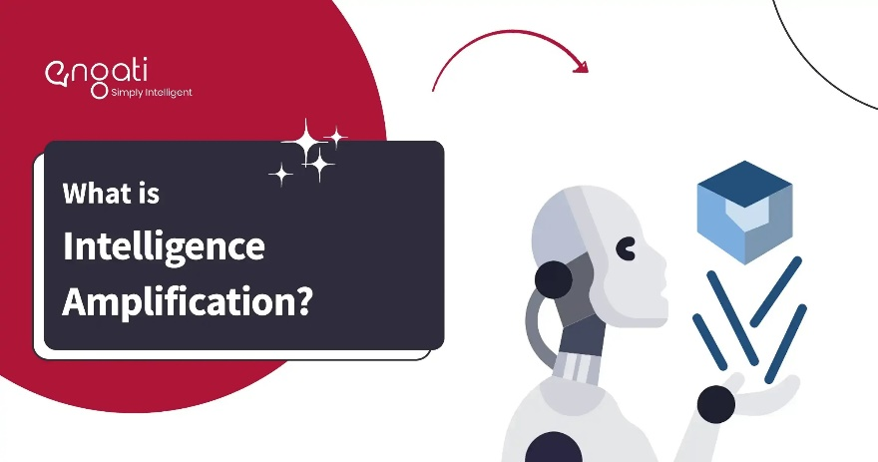intelligence amplification (IA)

Also cognitive augmentation, machine augmented intelligence, and enhanced intelligence.

The effective use of information technology in augmenting human intelligence.

intelligence explosion

A possible outcome of humanity building artificial general intelligence (AGI). AGI would be capable of recursive self-improvement leading to rapid emergence of ASI (artificial superintelligence), the limits of which are unknown, at the time of the technological singularity.

intelligent agent (IA)

An autonomous entity which acts, directing its activity towards achieving goals (i.e. it is an agent), upon an environment using observation through sensors and consequent actuators (i.e. it is intelligent). Intelligent agents may also learn or use knowledge to achieve their goals. They may be very simple or very complex.

intelligent control

A class of control techniques that use various artificial intelligence computing approaches like neural networks, Bayesian probability, fuzzy logic, machine learning, reinforcement learning, evolutionary computation and genetic algorithms.

intelligent personal assistant, also virtual assistant or personal digital assistant.

A software agent that can perform tasks or services for an individual based on verbal commands. Sometimes the term "chatbot" is used to refer to virtual assistants generally or specifically accessed by online chat (or in some cases online chat programs that are exclusively for entertainment purposes). Some virtual assistants are able to interpret human speech and respond via synthesized voices. Users can ask their assistants questions, control home automation devices and media playback via voice, and manage other basic tasks such as email, to-do lists, and calendars with verbal commands.

Interpretation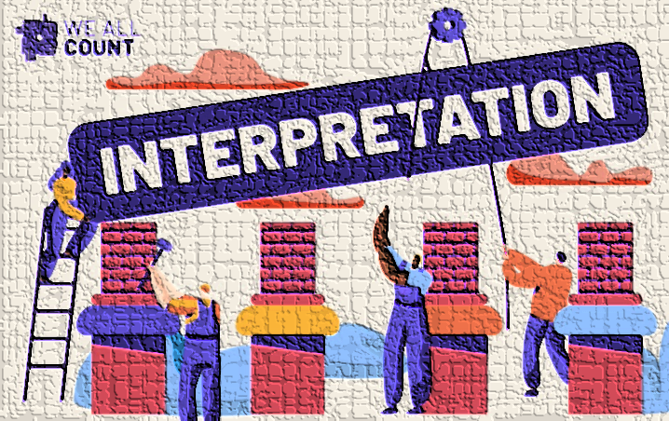

An assignment of meaning to the symbols of a formal language. Many formal languages used in mathematics, logic, and theoretical computer science are defined in solely syntactic terms, and as such do not have any meaning until they are given some interpretation. The general study of interpretations of formal languages is called formal semantics.

intrinsic motivation

An intelligent agent is intrinsically motivated to act if the information content alone, of the experience resulting from the action, is the motivating factor. Information content in this context is measured in the information theory sense as quantifying uncertainty. A typical intrinsic motivation is to search for unusual (surprising) situations, in contrast to a typical extrinsic motivation such as the search for food. Intrinsically motivated artificial agents display behaviours akin to exploration and curiosity.

issue tree, also logic tree.

A graphical breakdown of a question that dissects it into its different components vertically and that progresses into details as it reads to the right. Issue trees are useful in problem solving to identify the root causes of a problem as well as to identify its potential solutions. They also provide a reference point to see how each piece fits into the whole picture of a problem.

J

junction tree algorithm

Also Clique Tree.

A method used in machine learning to extract marginalization in general graphs. In essence, it entails performing belief propagation on a modified graph called a junction tree. The graph is called a tree because it branches into different sections of data; nodes of variables are the branches.

K

kernel method

In machine learning, kernel methods are a class of algorithms for pattern analysis, whose best known member is the support vector machine (SVM). The general task of pattern analysis is to find and study general types of relations (for example clusters, rankings, principal components, correlations, classifications) in datasets.

KL-ONE

A well-known knowledge representation system in the tradition of semantic networks and frames; that is, it is a frame language. The system is an attempt to overcome semantic indistinctness in semantic network representations and to explicitly represent conceptual information as a structured inheritance network.

knowledge acquisition



The process used to define the rules and ontologies required for a knowledge-based system. The phrase was first used in conjunction with expert systems to describe the initial tasks associated with developing an expert system, namely finding and interviewing domain experts and capturing their knowledge via rules, objects, and frame-based ontologies.

knowledge-based system (KBS)

A computer program that reasons and uses a knowledge base to solve complex problems. The term is broad and refers to many different kinds of systems. The one common theme that unites all knowledge based systems is an attempt to represent knowledge explicitly and a reasoning system that allows it to derive new knowledge. Thus, a knowledge-based system has two distinguishing features: a knowledge base and an inference engine.

knowledge engineering (KE)

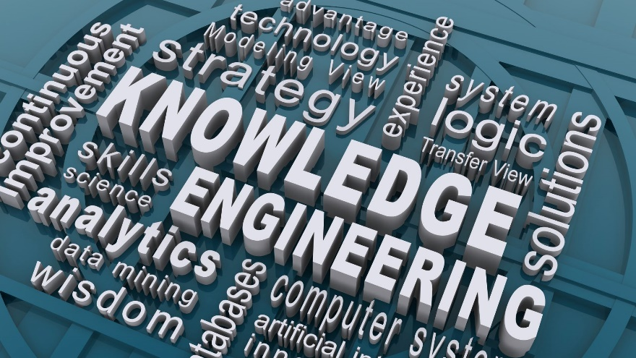

All technical, scientific, and social aspects involved in building, maintaining, and using knowledge-based systems.

knowledge extraction

The creation of knowledge from structured (relational databases, XML) and unstructured (text, documents, images) sources. The 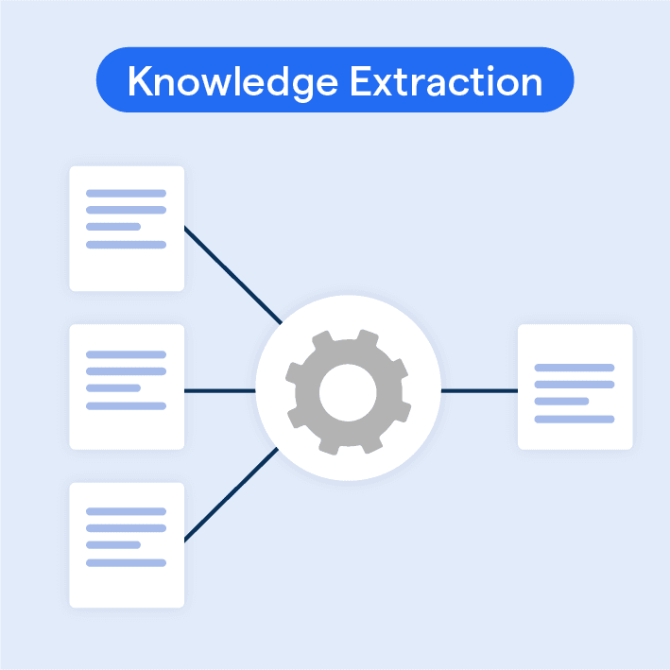resulting knowledge needs to be in a machine-readable and machine-interpretable format and must represent knowledge in a manner that facilitates inferencing. Although it is methodically similar to information extraction (NLP) and ETL (data warehouse), the main criterion is that the extraction result goes beyond the creation of structured information or the transformation into a relational schema. It requires either the reuse of existing formal knowledge (reusing identifiers or ontologies) or the generation of a schema based on the source data.

knowledge Interchange Format (KIF)

A computer language designed to enable systems to share and re-use information from knowledge-based systems. KIF is similar to frame languages such as KL-ONE and LOOM but unlike such language its primary role is not intended as a framework for the expression or use of knowledge but rather for the interchange of knowledge between systems. The designers of KIF likened it to PostScript. PostScript was not designed primarily as a language to store and manipulate documents but rather as an interchange format for systems and devices to share documents. In the same way KIF is meant to facilitate sharing of knowledge across different systems that use different languages, formalisms, platforms, etc.

knowledge representation and reasoning (KR² or KR&R)

The field of artificial intelligence dedicated to representing information about the world in a form that a computer system can utilize to solve complex tasks such as diagnosing a medical condition or having a dialog in a natural language. Knowledge representation incorporates findings from psychology about how humans solve problems and represent knowledge in order to design formalisms that will make complex systems easier to design and build. Knowledge representation and reasoning also incorporates findings from logic to automate various kinds of reasoning, such as the application of rules or the relations of sets and subsets. Examples of knowledge representation formalisms include semantic nets, systems architecture, frames, rules, and ontologies. Examples of automated reasoning engines include inference engines, theorem provers, and classifiers.

L

lazy learning

In machine learning, lazy learning is a learning method in which generalization of the training data is, in theory, delayed until a query is made to the system, as opposed to in eager learning, where the system tries to generalize the training data before receiving queries.

Lisp (programming language) (LISP)

A family of programming languages with a long history and a distinctive, fully parenthesized prefix notation.

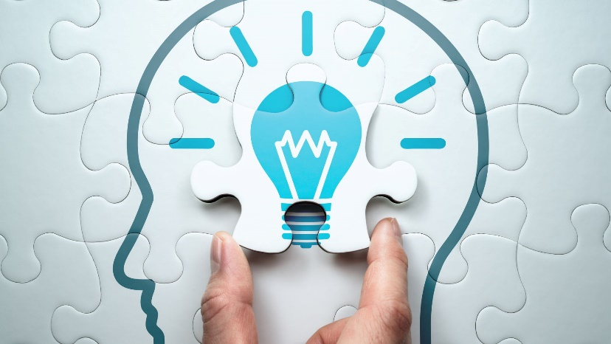logic programming

A type of programming paradigm which is largely based on formal logic. Any program written in a logic programming language is a set of sentences in logical form, expressing facts and rules about some problem domain. Major logic programming language families include Prolog, answer set programming (ASP), and Datalog.

long short-term memory (LSTM)

An artificial recurrent neural network architecture used in the field of deep learning. Unlike standard feedforward neural networks, LSTM has feedback connections that make it a "general purpose computer" (that is, it can compute anything that a Turing machine can). It can not only process single data points (such as images), but also entire sequences of data (such as speech or video).

M

machine vision (MV)

The technology and methods used to provide imaging-based automatic inspection and analysis for such applications as automatic inspection, process control, and robot guidance, usually in industry. Machine vision is a term encompassing a large number of technologies, software and hardware products, integrated systems, actions, methods and expertise. Machine vision as a systems engineering discipline can be considered distinct from computer vision, a form of computer science. It attempts to integrate existing technologies in new ways and apply them to solve real world problems. The term is the prevalent one for these functions in industrial automation environments but is also used for these functions in other environments such as security and vehicle guidance.

Markov chain

A stochastic model describing a sequence of possible events in which the probability of each event depends only on the state attained in the previous event.

Markov decision process (MDP)

A discrete time stochastic control process. It provides a mathematical framework for modelling decision making in situations where outcomes are partly random and partly under the control of a decision maker. MDPs are useful for studying optimization problems solved via dynamic programming and reinforcement learning.

mathematical optimization

Also mathematical programming.

In mathematics, computer science, and operations research, the selection of a best element (with regard to some criterion) from some set of available alternatives.

machine learning (ML)

The scientific study of algorithms and statistical models that computer systems use in order to perform a specific task effectively without using explicit instructions, relying on patterns and inference instead.

machine listening

Also computer audition (CA).

A general field of study of algorithms and systems for audio understanding by machine.

machine perception

The capability of a computer system to interpret data in a manner that is similar to the way humans use their senses to relate to the world around them.

mechanism design



A field in economics and game theory that takes an engineering approach to designing economic mechanisms or incentives, toward desired objectives, in strategic settings, where players act rationally. Because it starts at the end of the game, then goes backwards, it is also called reverse game theory. It has broad applications, from economics and politics (markets, auctions, voting procedures) to networked-systems (internet interdomain routing, sponsored search auctions).

Mechatronics, also mechatronic engineering.

A multidisciplinary branch of engineering that focuses on the engineering of both electrical and mechanical systems, and also includes a combination of robotics, electronics, computer, telecommunications, systems, control, and product engineering.

metabolic network reconstruction and simulation

Allows for an in-depth insight into the molecular mechanisms of a particular organism. In particular, these models correlate the genome with molecular physiology.

metaheuristic

In computer science and mathematical optimization, a metaheuristic is a higher-level procedure or heuristic designed to find, generate, or select a heuristic (partial search algorithm) that may provide a sufficiently good solution to an optimization problem, especially with incomplete or imperfect information or limited computation capacity. Metaheuristics sample a set of solutions which is too large to be completely sampled.

model checking

In computer science, model checking or property checking is, for a given model of a system, exhaustively and automatically checking whether this model meets a given specification. Typically, one has hardware or software systems in mind, whereas the specification contains safety requirements such as the absence of deadlocks and similar critical states that can cause the system to crash. Model checking is a technique for automatically verifying correctness properties of finite-state systems.

modus ponens

In propositional logic, modus ponens is a rule of inference. It can be summarized as "P implies Q and P is asserted to be true, therefore Q must be true."

modus tollens

In propositional logic, modus tollens is a valid argument form and a rule of inference. It is an application of the general truth that if a statement is true, then so is its contrapositive. The inference rule modus tollens asserts that the inference from P implies Q to the negation of Q implies the negation of P is valid.

Monte Carlo tree search

In computer science, Monte Carlo tree search (MCTS) is a heuristic search algorithm for some kinds of decision processes.

multi-agent system (MAS)

Also self-organized system. A computerized system composed of multiple interacting intelligent agents. Multi-agent systems can solve problems that are difficult or impossible for an individual agent or a monolithic system to solve. Intelligence may include methodic, functional, procedural approaches, algorithmic search or reinforcement learning.

multi-swarm optimization



A variant of particle swarm optimization (PSO) based on the use of multiple sub-swarms instead of one (standard) swarm. The general approach in multi-swarm optimization is that each sub-swarm focuses on a specific region while a specific diversification method decides where and when to launch the sub-swarms. The multi-swarm framework is especially fitted for the optimization on multi-modal problems, where multiple (local) optima exist.

mutation

A genetic operator used to maintain genetic diversity from one generation of a population of genetic algorithm chromosomes to the next. It is analogous to biological mutation. Mutation alters one or more gene values in a chromosome from its initial state. In mutation, the solution may change entirely from the previous solution. Hence GA can come to a better solution by using mutation. Mutation occurs during evolution according to a user-definable mutation probability. This probability should be set low. If it is set too high, the search will turn into a primitive random search.

Mycin

An early backward chaining expert system that used artificial intelligence to identify bacteria causing severe infections, such as bacteremia and meningitis, and to recommend antibiotics, with the dosage adjusted for patient's body weight – the name derived from the antibiotics themselves, as many antibiotics have the suffix "-mycin". The MYCIN system was also used for the diagnosis of blood clotting diseases.

N

naive Bayes classifier

In machine learning, naive Bayes classifiers are a family of simple probabilistic classifiers based on applying Bayes' theorem with strong (naive) independence assumptions between the features.

naive semantics

An approach used in computer science for representing basic knowledge about a specific domain, and has been used in applications such as the representation of the meaning of natural language sentences in artificial intelligence applications. In a general setting the term has been used to refer to the use of a limited store of generally understood knowledge about a specific domain in the world, and has been applied to fields such as the knowledge based design of data schemas.

name binding

In programming languages, name binding is the association of entities (data and/or code) with identifiers. An identifier bound to an object is said to reference that object. Machine languages have no built-in notion of identifiers, but name-object bindings as a service and notation for the programmer is implemented by programming languages. Binding is intimately connected with scoping, as scope determines which names bind to which objects – at which locations in the program code (lexically) and in which one of the possible execution paths (temporally). Use of an identifier id in a context that establishes a binding for id is called a binding (or defining) occurrence. In all other occurrences (e.g., in expressions, assignments, and subprogram calls), an identifier stands for what it is bound to; such occurrences are called applied occurrences.

named-entity recognition (NER), also entity identification, entity chunking, and entity extraction.

A subtask of information extraction that seeks to locate and classify named entity mentions in unstructured text into pre-defined categories such as the person names, organizations, locations, medical codes, time expressions, quantities, monetary values, percentages, etc.

named graph

A key concept of Semantic Web architecture in which a set of Resource Description Framework statements (a graph) are identified using a URI, allowing descriptions to be made of that set of statements such as context, provenance information or other such metadata. Named graphs are a simple extension of the RDF data model through which graphs can be created but the model lacks an effective means of distinguishing between them once published on the Web at large.

natural language generation (NLG)

A software process that transforms structured data into plain-English content. It can be used to produce long-form content for organizations to automate custom reports, as well as produce custom content for a web or mobile application. It can also be used to generate short blurbs of text in interactive conversations (a chatbot) which might even be read out loud by a text-to-speech system.

natural language processing (NLP)

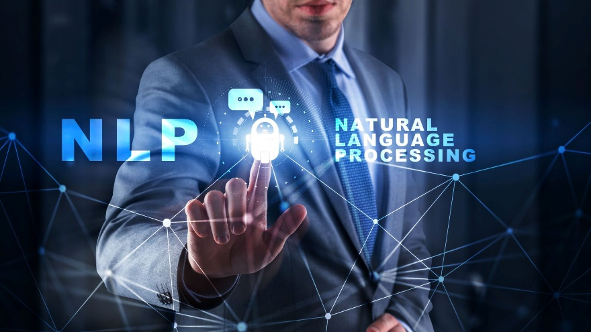

A subfield of computer science, information engineering, and artificial intelligence concerned with the interactions between computers and human (natural) languages, in particular how to program computers to process and analyze large amounts of natural language data.

natural language programming

An ontology-assisted way of programming in terms of natural-language sentences, e.g. English.

network motif

All networks, including biological networks, social networks, technological networks (e.g., computer networks and electrical circuits) and more, can be represented as graphs, which include a wide variety of subgraphs. One important local property of networks are so-called network motifs, which are defined as recurrent and statistically significant sub-graphs or patterns.

neural machine translation (NMT)

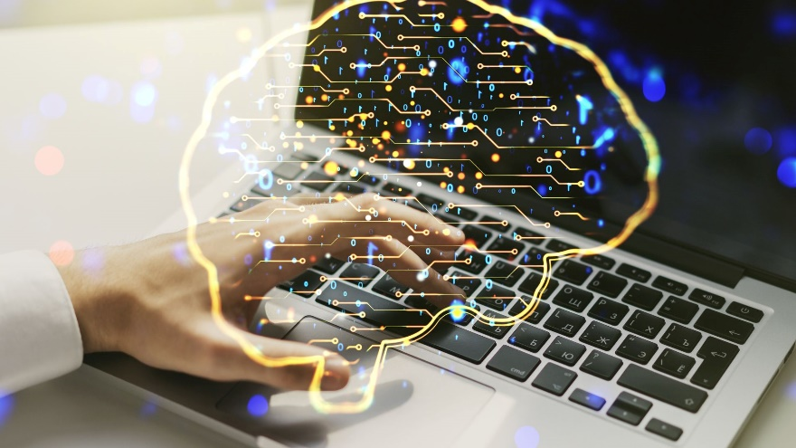

An approach to machine translation that uses a large artificial neural network to predict the likelihood of a sequence of words, typically modelling entire sentences in a single integrated model.

neural network, also artificial neural network.

A neural network can refer to either a neural circuit of biological neurons (sometimes also called a biological neural network), or a network of artificial neurons or nodes in the case of an artificial neural network. Artificial neural networks are used for solving artificial intelligence (AI) problems; they model connections of biological neurons as weights between nodes. A positive weight reflects an excitatory connection, while negative values mean inhibitory connections. All inputs are modified by a weight and summed. This activity is referred to as a linear combination. Finally, an activation function controls the amplitude of the output. For example, an acceptable range of output is usually between 0 and 1, or it could be −1 and 1.

neural Turing machine (NTM)

A recurrent neural network model. NTMs combine the fuzzy pattern matching capabilities of neural networks with the algorithmic power of programmable computers. An NTM has a neural network controller coupled to external memory resources, which it interacts with through attentional mechanisms. The memory interactions are differentiable end-to-end, making it possible to optimize them using gradient descent. An NTM with a long short-term memory (LSTM) network controller can infer simple algorithms such as copying, sorting, and associative recall from examples alone.

neuro-fuzzy

Combinations of artificial neural networks and fuzzy logic.

Neurocybernetics, also brain–computer interface (BCI), neural-control interface (NCI), mind-machine interface (MMI), direct neural interface (DNI), or brain–machine interface (BMI).

A direct communication pathway between an enhanced or wired brain and an external device. BCI differs from neuromodulation in that it allows for bidirectional information flow. BCIs are often directed at researching, mapping, assisting, augmenting, or repairing human cognitive or sensory-motor functions.

neuromorphic engineering, also neuromorphic computing.

A concept describing the use of very-large-scale integration (VLSI) systems containing electronic analog circuits to mimic neuro-biological architectures present in the nervous system. In recent times, the term neuromorphic has been used to describe analog, digital, mixed-mode analog/digital VLSI, and software systems that implement models of neural systems (for perception, motor control, or multisensory integration). The implementation of neuromorphic computing on the hardware level can be realized by oxide-based memristors, spintronic memories, threshold switches, and transistors.

node

A basic unit of a data structure, such as a linked list or tree data structure. Nodes contain data and also may link to other nodes. Links between nodes are often implemented by pointers.

nondeterministic algorithm



An algorithm that, even for the same input, can exhibit different behaviours on different runs, as opposed to a deterministic algorithm.

nouvelle AI

Nouvelle AI differs from classical AI by aiming to produce robots with intelligence levels similar to insects. Researchers believe that intelligence can emerge organically from simple behaviours as these intelligences interacted with the "real world", instead of using the constructed worlds which symbolic AIs typically needed to have programmed into them.

NP

In computational complexity theory, NP (nondeterministic polynomial time) is a complexity class used to classify decision problems. NP is the set of decision problems for which the problem instances, where the answer is "yes", have proofs verifiable in polynomial time.

NP-completeness

In computational complexity theory, a problem is NP-complete when it can be solved by a restricted class of brute force search algorithms and it can be used to simulate any other problem with a similar algorithm. More precisely, each input to the problem should be associated with a set of solutions of polynomial length, whose validity can be tested quickly (in polynomial time), such that the output for any input is "yes" if the solution set is non-empty and "no" if it is empty.

NP-hardness, also non-deterministic polynomial-time hardness.

In computational complexity theory, the defining property of a class of problems that are, informally, "at least as hard as the hardest problems in NP". A simple example of an NP-hard problem is the subset sum problem.

O

Occam's razor, also Ockham's razor or Ocham's razor.

The problem-solving principle that states that when presented with competing hypotheses that make the same predictions, one should select the solution with the fewest assumptions; the principle is not meant to filter out hypotheses that make different predictions. The idea is attributed to the English Franciscan friar William of Ockham (c. 1287–1347), a scholastic philosopher and theologian.

offline learning

online machine learning

A method of machine learning in which data becomes available in a sequential order and is used to update the best predictor for future data at each step, as opposed to batch learning techniques which generate the best predictor by learning on the entire training data set at once. Online learning is a common technique used in areas of machine learning where it is computationally infeasible to train over the entire dataset, requiring the need of out-of-core algorithms. It is also used in situations where it is necessary for the algorithm to dynamically adapt to new patterns in the data, or when the data itself is generated as a function of time.

ontology learning, also ontology extraction, ontology generation, or ontology acquisition.

The automatic or semi-automatic creation of ontologies, including extracting the corresponding domain's terms and the relationships between the concepts that these terms represent from a corpus of natural language text, and encoding them with an ontology language for easy retrieval.

OpenAI



The for-profit corporation OpenAI LP, whose parent organization is the non-profit organization OpenAI Inc that conducts research in the field of artificial intelligence (AI) with the stated aim to promote and develop friendly AI in such a way as to benefit humanity as a whole.

OpenCog

A project that aims to build an open-source artificial intelligence framework. OpenCog Prime is an architecture for robot and virtual embodied cognition that defines a set of interacting components designed to give rise to human-equivalent artificial general intelligence (AGI) as an emergent phenomenon of the whole system.

Open Mind Common Sense

An artificial intelligence project based at the Massachusetts Institute of Technology (MIT) Media Lab whose goal is to build and utilize a large commonsense knowledge base from the contributions of many thousands of people across the Web.

open-source software (OSS)

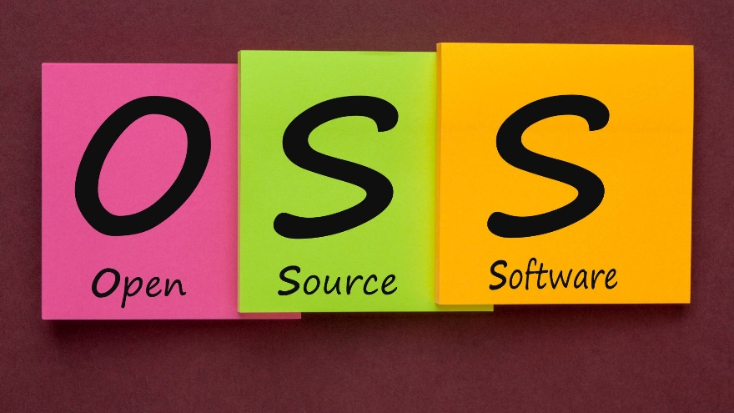

A type of computer software in which source code is released under a license in which the copyright holder grants users the rights to study, change, and distribute the software to anyone and for any purpose. Open-source software may be developed in a collaborative public manner. Open-source software is a prominent example of open collaboration.

P

partial order reduction

A technique for reducing the size of the state-space to be searched by a model checking or automated planning and scheduling algorithm. It exploits the commutativity of concurrently executed transitions, which result in the same state when executed in different orders.

partially observable Markov decision process (POMDP)

A generalization of a Markov decision process (MDP). A POMDP models an agent decision process in which it is assumed that the system dynamics are determined by an MDP, but the agent cannot directly observe the underlying state. Instead, it must maintain a probability distribution over the set of possible states, based on a set of observations and observation probabilities, and the underlying MDP.

particle swarm optimization (PSO)

A computational method that optimizes a problem by iteratively trying to improve a candidate solution with regard to a given measure of quality. It solves a problem by having a population of candidate solutions, here dubbed particles, and moving these particles around in the search-space according to simple mathematical formulae over the particle's position and velocity. Each particle's movement is influenced by its local best known position, but is also guided toward the best known positions in the search-space, which are updated as better positions are found by other particles. This is expected to move the swarm toward the best solutions.

Pathfinding, also pathing.

The plotting, by a computer application, of the shortest route between two points. It is a more practical variant on solving mazes. This field of research is based heavily on Dijkstra's algorithm for finding a shortest path on a weighted graph.

pattern recognition

Concerned with the automatic discovery of regularities in data through the use of computer algorithms and with the use of these regularities to take actions such as classifying the data into different categories.

predicate logic, also first-order logic, predicate logic, and first-order predicate calculus.

A collection of formal systems used in mathematics, philosophy, linguistics, and computer science. First-order logic uses quantified variables over non-logical objects and allows the use of sentences that contain variables, so that rather than propositions such as Socrates is a man one can have expressions in the form "there exists x such that x is Socrates and x is a man" and there exists is a quantifier while x is a variable. This distinguishes it from propositional logic, which does not use quantifiers or relations; in this sense, propositional logic is the foundation of first-order logic.

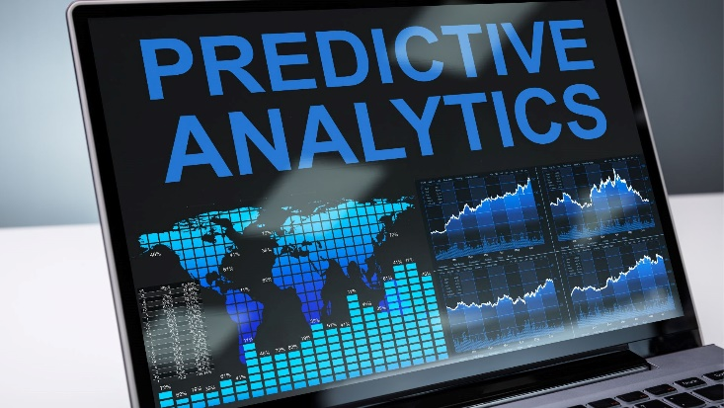predictive analytics

A variety of statistical techniques from data mining, predictive modelling, and machine learning, that analyze current and historical facts to make predictions about future or otherwise unknown events.

principal component analysis (PCA)

A statistical procedure that uses an orthogonal transformation to convert a set of observations of possibly correlated variables (entities each of which takes on various numerical values) into a set of values of linearly uncorrelated variables called principal components. This transformation is defined in such a way that the first principal component has the largest possible variance (that is, accounts for as much of the variability in the data as possible), and each succeeding component, in turn, has the highest variance possible under the constraint that it is orthogonal to the preceding components. The resulting vectors (each being a linear combination of the variables and containing n observations) are an uncorrelated orthogonal basis set. PCA is sensitive to the relative scaling of the original variables.

principle of rationality, also rationality principle.

A principle coined by Karl R. Popper in his Harvard Lecture of 1963, and published in his book Myth of Framework. It is related to what he called the 'logic of the situation' in an Economica article of 1944/1945, published later in his book The Poverty of Historicism. According to Popper's rationality principle, agents act in the most adequate way according to the objective situation. It is an idealized conception of human behaviour which he used to drive his model of situational analysis.

probabilistic programming (PP)

A programming paradigm in which probabilistic models are specified and inference for these models is performed automatically. It represents an attempt to unify probabilistic modelling and traditional general-purpose programming in order to make the former easier and more widely applicable. It can be used to create systems that help make decisions in the face of uncertainty. Programming languages used for probabilistic programming are referred to as "Probabilistic programming languages" (PPLs).

programming language



A formal language, which comprises a set of instructions that produce various kinds of output. Programming languages are used in computer programming to implement algorithms.

Prolog

A logic programming language associated with artificial intelligence and computational linguistics. Prolog has its roots in first-order logic, a formal logic, and unlike many other programming languages, Prolog is intended primarily as a declarative programming language: the program logic is expressed in terms of relations, represented as facts and rules. A computation is initiated by running a query over these relations.

propositional calculus, also propositional logic, statement logic, sentential calculus, sentential logic, and zeroth-order logic.

A branch of logic which deals with propositions (which can be true or false) and argument flow. Compound propositions are formed by connecting propositions by logical connectives. The propositions without logical connectives are called atomic propositions. Unlike first-order logic, propositional logic does not deal with non-logical objects, predicates about them, or quantifiers. However, all the machinery of propositional logic is included in first-order logic and higher-order logics. In this sense, propositional logic is the foundation of first-order logic and higher-order logic.

Python

An interpreted, high-level, general-purpose programming language created by Guido van Rossum and first released in 1991. Python's design philosophy emphasizes code readability with its notable use of significant whitespace. Its language constructs and object-oriented approach aim to help programmers write clear, logical code for small and large-scale projects.

Q

qualification problem

In philosophy and artificial intelligence (especially knowledge-based systems), the qualification problem is concerned with the impossibility of listing all of the preconditions required for a real-world action to have its intended effect. It might be posed as how to deal with the things that prevent me from achieving my intended result. It is strongly connected to, and opposite the ramification side of, the frame problem.

quantifier

In logic, quantification specifies the quantity of specimens in the domain of discourse that satisfy an open formula. The two most common quantifiers mean "for all" and "there exists". For example, in arithmetic, quantifiers allow one to say that the natural numbers go on forever, by writing that for all n (where n is a natural number), there is another number (say, the successor of n) which is one bigger than n.

quantum computing



The use of quantum-mechanical phenomena such as superposition and entanglement to perform computation. A quantum computer is used to perform such computation, which can be implemented theoretically or physically.

query language

Query languages or data query languages (DQLs) are computer languages used to make queries in databases and information systems. Broadly, query languages can be classified according to whether they are database query languages or information retrieval query languages. The difference is that a database query language attempts to give factual answers to factual questions, while an information retrieval query language attempts to find documents containing information that is relevant to an area of inquiry.

R

R programming language

A programming language and free software environment for statistical computing and graphics supported by the R Foundation for Statistical Computing. The R language is widely used among statisticians and data miners for developing statistical software and data analysis.

radial basis function network

In the field of mathematical modelling, a radial basis function network is an artificial neural network that uses radial basis functions as activation functions. The output of the network is a linear combination of radial basis functions of the inputs and neuron parameters. Radial basis function networks have many uses, including function approximation, time series prediction, classification, and system control. They were first formulated in a 1988 paper by Broomhead and Lowe, both researchers at the Royal Signals and Radar Establishment.

random forest, also random decision forest.

An ensemble learning method for classification, regression and other tasks that operates by constructing a multitude of decision trees at training time and outputting the class that is the mode of the classes (classification) or mean prediction (regression) of the individual trees. Random decision forests correct for decision trees' habit of overfitting to their training set.

reasoning system



In information technology a reasoning system is a software system that generates conclusions from available knowledge using logical techniques such as deduction and induction. Reasoning systems play an important role in the implementation of artificial intelligence and knowledge-based systems.

recurrent neural network (RNN)

A class of artificial neural networks where connections between nodes form a directed graph along a temporal sequence. This allows it to exhibit temporal dynamic behaviour. Unlike feedforward neural networks, RNNs can use their internal state (memory) to process sequences of inputs. This makes them applicable to tasks such as unsegmented, connected handwriting recognition or speech recognition.

region connection calculus

reinforcement learning (RL)

An area of machine learning concerned with how software agents ought to take actions in an environment so as to maximize some notion of cumulative reward. Reinforcement learning is one of three basic machine learning paradigms, alongside supervised learning and unsupervised learning. It differs from supervised learning in that labelled input/output pairs need not be presented, and sub-optimal actions need not be explicitly corrected. Instead the focus is finding a balance between exploration (of uncharted territory) and exploitation (of current knowledge).

reservoir computing

A framework for computation that may be viewed as an extension of neural networks. Typically an input signal is fed into a fixed (random) dynamical system called a reservoir and the dynamics of the reservoir map the input to a higher dimension. Then a simple readout mechanism is trained to read the state of the reservoir and map it to the desired output. The main benefit is that training is performed only at the readout stage and the reservoir is fixed. Liquid-state machines and echo state networks are two major types of reservoir computing.

Resource Description Framework (RDF)

A family of World Wide Web Consortium (W3C) specifications originally designed as a metadata data model. It has come to be used as a general method for conceptual description or modelling of information that is implemented in web resources, using a variety of syntax notations and data serialization formats. It is also used in knowledge management applications.

restricted Boltzmann machine (RBM)

A generative stochastic artificial neural network that can learn a probability distribution over its set of inputs.

Rete algorithm

A pattern matching algorithm for implementing rule-based systems. The algorithm was developed to efficiently apply many rules or patterns to many objects, or facts, in a knowledge base. It is used to determine which of the system's rules should fire based on its data store, its facts.

Robotics

An interdisciplinary branch of science and engineering that includes mechanical engineering, electronic engineering, information engineering, computer science, and others. Robotics deals with the design, construction, operation, and use of robots, as well as computer systems for their control, sensory feedback, and information processing.

rule-based system

In computer science, a rule-based system is used to store and manipulate knowledge to interpret information in a useful way. It is often used in artificial intelligence applications and research. Normally, the term rule-based system is applied to systems involving human-crafted or curated rule sets. Rule-based systems constructed using automatic rule inference, such as rule-based machine learning, are normally excluded from this system type.

S

satisfiability

In mathematical logic, satisfiability and validity are elementary concepts of semantics. A formula is satisfiable if it is possible to find an interpretation (model) that makes the formula true. A formula is valid if all interpretations make the formula true. The opposites of these concepts are unsatisfiability and invalidity, that is, a formula is unsatisfiable if none of the interpretations make the formula true, and invalid if some such interpretation makes the formula false. These four concepts are related to each other in a manner exactly analogous to Aristotle's square of opposition.

search algorithm

Any algorithm which solves the search problem, namely, to retrieve information stored within some data structure, or calculated in the search space of a problem domain, either with discrete or continuous values.

Selection



The stage of a genetic algorithm in which individual genomes are chosen from a population for later breeding (using the crossover operator).

self-management

The process by which computer systems manage their own operation without human intervention.

semantic network, also frame network.

A knowledge base that represents semantic relations between concepts in a network. This is often used as a form of knowledge representation. It is a directed or undirected graph consisting of vertices, which represent concepts, and edges, which represent semantic relations between concepts, mapping or connecting semantic fields.

semantic reasoner, also reasoning engine, rules engine, or simply reasoner.

A piece of software able to infer logical consequences from a set of asserted facts or axioms. The notion of a semantic reasoner generalizes that of an inference engine, by providing a richer set of mechanisms to work with. The inference rules are commonly specified by means of an ontology language, and often a description logic language. Many reasoners use first-order predicate logic to perform reasoning; inference commonly proceeds by forward chaining and backward chaining.

semantic query

Allows for queries and analytics of associative and contextual nature. Semantic queries enable the retrieval of both explicitly and implicitly derived information based on syntactic, semantic and structural information contained in data. They are designed to deliver precise results (possibly the distinctive selection of one single piece of information) or to answer more fuzzy and wide-open questions through pattern matching and digital reasoning.

semantics

In programming language theory, semantics is the field concerned with the rigorous mathematical study of the meaning of programming languages. It does so by evaluating the meaning of syntactically valid strings defined by a specific programming language, showing the computation involved. In such a case that the evaluation would be of syntactically invalid strings, the result would be non-computation. Semantics describes the processes a computer follows when executing a program in that specific language. This can be shown by describing the relationship between the input and output of a program, or an explanation of how the program will be executed on a certain platform, hence creating a model of computation.

sensor fusion



The combining of sensory data or data derived from disparate sources such that the resulting information has less uncertainty than would be possible when these sources were used individually.

separation logic

An extension of Hoare logic, a way of reasoning about programs. The assertion language of separation logic is a special case of the logic of bunched implications (BI).

similarity learning

An area of supervised machine learning in artificial intelligence. It is closely related to regression and classification, but the goal is to learn from a similarity function that measures how similar or related two objects are. It has applications in ranking, in recommendation systems, visual identity tracking, face verification, and speaker verification.

simulated annealing (SA)

A probabilistic technique for approximating the global optimum of a given function. Specifically, it is a metaheuristic to approximate global optimization in a large search space for an optimization problem.

situated approach

In artificial intelligence research, the situated approach builds agents that are designed to behave effectively successfully in their environment. This requires designing AI "from the bottom-up" by focussing on the basic perceptual and motor skills required to survive. The situated approach gives a much lower priority to abstract reasoning or problem-solving skills.

situation calculus

A logic formalism designed for representing and reasoning about dynamical domains.

Selective Linear Definite clause resolution, also simply SLD resolution.

The basic inference rule used in logic programming. It is a refinement of resolution, which is both sound and refutation complete for Horn clauses.

software

A collection of data or computer instructions that tell the computer how to work. This is in contrast to physical hardware, from which the system is built and actually performs the work. In computer science and software engineering, computer software is all information processed by computer systems, programs and data. Computer software includes computer programs, libraries and related non-executable data, such as online documentation or digital media.

software engineering



The application of engineering to the development of software in a systematic method.

spatial-temporal reasoning

An area of artificial intelligence which draws from the fields of computer science, cognitive science, and cognitive psychology. The theoretic goal—on the cognitive side—involves representing and reasoning spatial-temporal knowledge in mind. The applied goal—on the computing side—involves developing high-level control systems of automata for navigating and understanding time and space.

SPARQL

An RDF query language—that is, a semantic query language for databases—able to retrieve and manipulate data stored in Resource Description Framework (RDF) format.

speech recognition



An interdisciplinary subfield of computational linguistics that develops methodologies and technologies that enables the recognition and translation of spoken language into text by computers. It is also known as automatic speech recognition (ASR), computer speech recognition or speech to text (STT). It incorporates knowledge and research in the linguistics, computer science, and electrical engineering fields.

spiking neural network (SNN)

An artificial neural network that more closely mimics a natural neural network. In addition to neuronal and synaptic state, SNNs incorporate the concept of time into their Operating Model.

state

In information technology and computer science, a program is described as stateful if it is designed to remember preceding events or user interactions; the remembered information is called the state of the system.

statistical classification

In machine learning and statistics, classification is the problem of identifying to which of a set of categories (sub-populations) a new observation belongs, on the basis of a training set of data containing observations (or instances) whose category membership is known. Examples are assigning a given email to the "spam" or "non-spam" class, and assigning a diagnosis to a given patient based on observed characteristics of the patient (sex, blood pressure, presence or absence of certain symptoms, etc.). Classification is an example of pattern recognition.

statistical relational learning (SRL)

A subdiscipline of artificial intelligence and machine learning that is concerned with domain models that exhibit both uncertainty (which can be dealt with using statistical methods) and complex, relational structure. Note that SRL is sometimes called Relational Machine Learning (RML) in the literature. Typically, the knowledge representation formalisms developed in SRL use (a subset of) first-order logic to describe relational properties of a domain in a general manner (universal quantification) and draw upon probabilistic graphical models (such as Bayesian networks or Markov networks) to model the uncertainty; some also build upon the methods of inductive logic programming.

stochastic optimization (SO)

Any optimization method that generates and uses random variables. For stochastic problems, the random variables appear in the formulation of the optimization problem itself, which involves random objective functions or random constraints. Stochastic optimization methods also include methods with random iterates. Some stochastic optimization methods use random iterates to solve stochastic problems, combining both meanings of stochastic optimization. Stochastic optimization methods generalize deterministic methods for deterministic problems.

stochastic semantic analysis

An approach used in computer science as a semantic component of natural language understanding. Stochastic models generally use the definition of segments of words as basic semantic units for the semantic models, and in some cases involve a two layered approach.

Stanford Research Institute Problem Solver (STRIPS)

subject-matter expert

superintelligence

A hypothetical agent that possesses intelligence far surpassing that of the brightest and most gifted human minds. Superintelligence may also refer to a property of problem-solving systems (e.g., superintelligent language translators or engineering assistants) whether or not these high-level intellectual competencies are embodied in agents that act within the physical world. A superintelligence may or may not be created by an intelligence explosion and be associated with a technological singularity.

supervised learning

The machine learning task of learning a function that maps an input to an output based on example input-output pairs. It infers a function from labelled training data consisting of a set of training examples. In supervised learning, each example is a pair consisting of an input object (typically a vector) and a desired output value (also called the supervisory signal). A supervised learning algorithm analyzes the training data and produces an inferred function, which can be used for mapping new examples. An optimal scenario will allow for the algorithm to correctly determine the class labels for unseen instances. This requires the learning algorithm to generalize from the training data to unseen situations in a "reasonable" way (see inductive bias).

support-vector machines

In machine learning, support-vector machines (SVMs, also support-vector networks) are supervised learning models with associated learning algorithms that analyze data used for classification and regression analysis.

swarm intelligence (SI)

The collective behaviour of decentralized, self-organized systems, either natural or artificial. The expression was introduced in the context of cellular robotic systems.

symbolic artificial intelligence

The term for the collection of all methods in artificial intelligence research that are based on high-level "symbolic" (human-readable) representations of problems, logic, and search.

synthetic intelligence (SI)

An alternative term for artificial intelligence which emphasizes that the intelligence of machines need not be an imitation or in any way artificial; it can be a genuine form of intelligence.

systems neuroscience

A subdiscipline of neuroscience and systems biology that studies the structure and function of neural circuits and systems. It is an umbrella term, encompassing a number of areas of study concerned with how nerve cells behave when connected together to form neural pathways, neural circuits, and larger brain networks.

T

technological singularity, also simply the singularity.

A hypothetical point in the future when technological growth becomes uncontrollable and irreversible, resulting in unfathomable changes to human civilization.

temporal difference learning

A class of model-free reinforcement learning methods which learn by bootstrapping from the current estimate of the value function. These methods sample from the environment, like Monte Carlo methods, and perform updates based on current estimates, like dynamic programming methods.

tensor network theory

A theory of brain function (particularly that of the cerebellum) that provides a mathematical model of the transformation of sensory space-time coordinates into motor coordinates and vice versa by cerebellar neuronal networks. The theory was developed as a geometrization of brain function (especially of the central nervous system) using tensors.

TensorFlow



A free and open-source software library for dataflow and differentiable programming across a range of tasks. It is a symbolic math library, and is also used for machine learning applications such as neural networks.

theoretical computer science (TCS)

A subset of general computer science and mathematics that focuses on more mathematical topics of computing and includes the theory of computation.

theory of computation

In theoretical computer science and mathematics, the theory of computation is the branch that deals with how efficiently problems can be solved on a model of computation, using an algorithm. The field is divided into three major branches: automata theory and languages, computability theory, and computational complexity theory, which are linked by the question: "What are the fundamental capabilities and limitations of computers?".

Thompson sampling

A heuristic for choosing actions that addresses the exploration-exploitation dilemma in the multi-armed bandit problem. It consists in choosing the action that maximizes the expected reward with respect to a randomly drawn belief.

time complexity

The computational complexity that describes the amount of time it takes to run an algorithm. Time complexity is commonly estimated by counting the number of elementary operations performed by the algorithm, supposing that each elementary operation takes a fixed amount of time to perform. Thus, the amount of time taken and the number of elementary operations performed by the algorithm are taken to differ by at most a constant factor.

Transhumanism, abbreviated H+ or h+.

An international philosophical movement that advocates for the transformation of the human condition by developing and making widely available sophisticated technologies to greatly enhance human intellect and physiology.

transition system

In theoretical computer science, a transition system is a concept used in the study of computation. It is used to describe the potential behaviour of discrete systems. It consists of states and transitions between states, which may be labelled with labels chosen from a set; the same label may appear on more than one transition. If the label set is a singleton, the system is essentially unlabelled, and a simpler definition that omits the labels is possible.

tree traversal, also tree search.

A form of graph traversal and refers to the process of visiting (checking and/or updating) each node in a tree data structure, exactly once. Such traversals are classified by the order in which the nodes are visited.

true quantified Boolean formula

In computational complexity theory, the language TQBF is a formal language consisting of the true quantified Boolean formulas. A (fully) quantified Boolean formula is a formula in quantified propositional logic where every variable is quantified (or bound), using either existential or universal quantifiers, at the beginning of the sentence. Such a formula is equivalent to either true or false (since there are no free variables). If such a formula evaluates to true, then that formula is in the language TQBF. It is also known as QSAT (Quantified SAT).

Turing machine

Turing test

A test of a machine's ability to exhibit intelligent behaviour equivalent to, or indistinguishable from, that of a human, developed by Alan Turing in 1950. Turing proposed that a human evaluator would judge natural language conversations between a human and a machine designed to generate human-like responses. The evaluator would be aware that one of the two partners in conversation is a machine, and all participants would be separated from one another. The conversation would be limited to a text-only channel such as a computer keyboard and screen so the result would not depend on the machine's ability to render words as speech. If the evaluator cannot reliably tell the machine from the human, the machine is said to have passed the test. The test results do not depend on the machine's ability to give correct answers to questions, only how closely its answers resemble those a human would give.

type system

In programming languages, a set of rules that assigns a property called type to the various constructs of a computer program, such as variables, expressions, functions, or modules. These types formalize and enforce the otherwise implicit categories the programmer uses for algebraic data types, data structures, or other components (e.g. "string", "array of float", "function returning boolean"). The main purpose of a type system is to reduce possibilities for bugs in computer programs by defining interfaces between different parts of a computer program, and then checking that the parts have been connected in a consistent way. This checking can happen statically (at compile time), dynamically (at run time), or as a combination of static and dynamic checking. Type systems have other purposes as well, such as expressing business rules, enabling certain compiler optimizations, allowing for multiple dispatch, providing a form of documentation, etc.

U

unsupervised learning

A type of self-organized Hebbian learning that helps find previously unknown patterns in data set without pre-existing labels. It is also known as self-organization and allows modelling probability densities of given inputs. It is one of the main three categories of machine learning, along with supervised and reinforcement learning. Semi-supervised learning has also been described and is a hybridization of supervised and unsupervised techniques.

V

vision processing unit (VPU)

A type of microprocessor designed to accelerate machine vision tasks. Value-alignment complete – Analogous to an AI-complete problem, a value-alignment complete problem is a problem where the AI control problem needs to be fully solved to solve it.

W

Watson

A question-answering computer system capable of answering questions posed in natural language, developed in IBM's DeepQA project by a research team led by principal investigator David Ferrucci. Watson was named after IBM's first CEO, industrialist Thomas J. Watson.

weak AI, also narrow AI.

Artificial intelligence that is focused on one narrow task.

World Wide Web Consortium (W3C)

The main international standards organization for the World Wide Web (abbreviated WWW or W3).

# BIBLIOGRAPHY

1. Abe, Masaya, and Hideki Nakayama. 2018. “Deep Learning for Forecasting Stock Returns in the Cross-Section.” In Advances in Knowledge Discovery and Data Mining, Part 1, edited by Dinh Phung, Vincent S. Tseng, Geoffrey.
2. Webb, Bao Ho, Mohadeseh Ganji, and Lida Rashidi, 273–84. Cham, Switzerland: Springer International Publishing.
3. Aggarwal, Charu C. 2018. Neural Networks and Deep Learning. Cham, Switzerland: Springer. https://doi.org/10.1007/978-3-319-94463-0.
4. Aggarwal, Charu C., and Chandan K. Reddy, eds. 2014. Data Clustering: Algorithms and Applications. Boca Raton, FL: CRC Press.
5. Ahmed, Nesreen K., Amir F. Atiya, Neamat El Gayar, and Hisham El-Shishiny. 2010. “An Empirical Comparison of Machine Learning Models for Time Series Forecasting.” Econometric Reviews 29 (5–6): 594–621. https:// doi.org/10.1080/07474938.2010.481556.
6. Ahn, Jae Joon, Kyong Joo Oh, Tae Yoon Kim, and Dong Ha Kim. 2011. “Usefulness of Support Vector Machine to Develop an Early Warning System for Financial Crisis.” Expert Systems with Applications 38 (4): 2966–73. https:// doi.org/10.1016/j.eswa.2010.08.085.
7. Alberg, John, and Zachary C. Lipton. 2017. “Improving Factor-Based Quantitative Investing by Forecasting Company Fundamentals,” version 2. arXiv.org/abs/1711.04837v2.
8. Allen, Franklin, and Risto Karjalainen. 1999. “Using Genetic Algorithms to Find Technical Trading Rules.” Journal of Financial Economics 51 (2): 245–71. https://doi.org/:10.1016/S0304-405X(98)00052-X.
9. Alpaydin, Ethem. 2010. Introduction to Machine Learning, 2nd ed. Cambridge, MA: MIT Press.
10. Arrieta-ibarra, Imanol, and Ignacio N. Lobato. 2015. “Testing for Predictability in Financial Returns Using Statistical Learning Procedures.” Journal of Time Series Analysis 36 (5): 672–86. https://doi.org/10.1111/ jtsa.12120.
11. Atsalakis, George S., and Kimon P. Valavanis. 2009. “Surveying Stock Market Forecasting Techniques – Part II: Soft Computing Methods.” Expert Systems with Applications 36 (3): 5932–41. http://doi.org/10.1016/j. eswa.2008.07.006.
12. Auria, Laura, and Rouslan A. Moro. 2008. “Support Vector Machines (SVM) as a Technique for Solvency Analysis.” DIW Berlin Discussion Paper No. 811 (August). https://ssrn.com/abstract=1424949.
13. Avramov, Doron, Si Cheng, and Lior Metzker. 2019. “Machine Learning versus Economic Restrictions: Evidence from Stock Return Predictability.” https://ssrn.com/abstract=3450322.
14. Azimi, Mehran, and Anup Agrawal. 2019. “Is Positive Sentiment in Corporate Annual Reports Informative? Evidence from Deep Learning.” https://ssrn.com/abstract=3258821.
15. Aziz, Saqib, and Michael Dowling. 2019. “Machine Learning and AI for Risk Management.” In Disrupting Finance: FinTech and Strategy in the 21st Century, edited by Theo Lynn, John G. Mooney, Pierangelo Rosati, and Mark Cummins, 33–50. Cham, Switzerland: Palgrave Pivot. https://doi. org/10.1007/978-3-030-02330-0_3.
16. Ballings, Michel, Dirk Van den Poel, Nathalie Hespeels, and Ruben Gryp. 2015. “Evaluating Multiple Classifiers for Stock Price Direction Prediction.” Expert Systems with Applications 42 (20): 7046–56. https://doi.org/10.1016/j. eswa.2015.05.013.
17. Bao, Yang, and Anindya Datta. 2014. “Simultaneously Discovering and Quantifying Risk Types from Textual Risk Disclosures.” Management Science 60 (6): 1371–91. https://doi.org/10.1287/mnsc.2014.1930.
18. Becker, Sebastian, Patrick Cheridito, and Arnulf Jentzen. 2019a. “Deep Optimal Stopping.” Journal of Machine Learning Research 20: 1–25.
19. Becker, Sebastian, Patrick Cheridito, and Arnulf Jentzen. 2019b. “Pricing and Hedging American-Style Options with Deep Learning.” https://arxiv. org/abs/1912.11060.
20. Beketov, Mikhail, Kevin Lehmann, and Manuel Wittke. 2018. “Robo Advisors: Quantitative Methods Inside the Robots.” Journal of Asset Management 19: 363–70. http://doi.org/10.1057/s41260-018-0092-9.
21. Bellovary, Jodi L., Don E. Giacomino, and Michael D. Akers. 2007. “A Review of Bankruptcy Prediction Studies: 1930 to Present.” Journal of Financial Education 33: 1–42.
22. Bertsimas, Dimitris, and Andrew W. Lo. 1998. “Optimal Control of Execution Costs.” Journal of Financial Markets 1 (1): 1–50. https://doi. org/10.1016/S1386-4181(97)00012-8.
23. Berutich, José Manuel, Francisco López, Francisco Luna, and David Quintana. 2016. “Robust Technical Trading Strategies Using GP for Algorithmic Portfolio Selection.” Expert Systems with Applications 46 (15): 307–15. https://doi.org/10.1016/j.eswa.2015.10.040.
24. Bew, David, Campbell R. Harvey, Anthony Ledford, Sam Radnor, and Andrew Sinclair. 2019. “Modelling Analysts’ Recommendations via Bayesian Machine Learning.” Journal of Financial Data Science 1 (1): 75–98.
25. Bholat, David M., Stephen Hansen, Pedro Santos, and Cheryl Schonhardt- Bailey. 2015. “Text Mining for Central Banks.” http://dx.doi.org/10.2139/ ssrn.2624811.
26. Bianchi, Daniele, Matthias Büchner, and Andrea Tamoni. 2019. “Bond Risk Premia with Machine Learning.” https://doi.org/10.2139/ssrn.3400941.
27. Black, Fischer, and Robert Litterman. 1992. “Global Portfolio Optimization.”
28. Financial Analysts Journal 48 (5): 28–43. https://doi.org/10.2469/faj.v48.n5.28.
29. Board of Governors of the Federal Reserve System. 2011. “Supervisory Guidance on Model Risk Management.” Office of the Comptroller of the Currency (April 4). https://www.occ.treas.gov/news-issuances/bulletins/2011/ bulletin-2011-12a.pdf.
30. Booth, Ash, Enrico Gerding, and Frank McGroarty. 2014. “Automated Trading with Performance Weighted Random Forests and Seasonality.” Expert Systems with Applications 41 (8): 3651–61. https://doi.org/10.1016/j. eswa.2013.12.009.
31. Booth, Ash, Enrico Gerding, and Frank McGroarty. 2015. “Performance- Weighted Ensembles of Random Forests for Predicting Price Impact.” Quantitative Finance 15 (11): 1823–35. https://doi.org/10.1080/14697688.2014.983539.
32. Borghi, Riccardo, and Giuliano De Rossi. Forthcoming. “The Artificial Intelligence Approach to Picking Stocks.” In Machine Learning and Asset Management. Cham, Switzerland: Springer.
33. Branke, Juergen, Benedikt Scheckenbach, Michael Stein, Kalyanmoy Deb, and Hartmut Schmeck. 2009. “Portfolio Optimization with an Envelope-Based Multi-Objective Evolutionary Algorithm.” European Journal of Operational Research 199 (3): 684–93. https://doi.org/10.1016/j. ejor.2008.01.054.
34. Breiman, Leo. 2001. “Random Forests.” Machine Learning 45 (1): 5–32. https://doi.org/10.1023/A:1010933404324.
35. Brenner, Lukas, and Tobias Meyll. 2019. “Robo-Advisors: A Substitute for Human Financial Advice?” https://ssrn.com/abstract=3414200.
36. Briere, Marie, Charles-Albert Lehalle, Tamara Nefedova, and Amine Raboun. 2019. “Modelling Transaction Costs When Trades May Be Crowded: A Bayesian Network Using Partially Observable Orders Imbalance.” https:// ssrn.com/abstract=3420665.
37. Bryzgalova, Svetlana, Markus Pelger, and Jason Zhu. 2019. “Forest Through the Trees: Building Cross-Sections of Stock Returns.” https://ssrn.com/ abstract=3493458.
38. Buchanan, Bonnie G. 2019. “Artificial Intelligence in Finance.” http://doi. org/10.5281/zenodo.2612537.
39. Celik, Arzum Erken, and Yalcin Karatepe. 2007. “Evaluating and Forecasting Banking Crises Through Neural Network Models: An Application for Turkish Banking Sector.” Expert Systems with Applications 33 (4): 809–15. https://doi.org/10.1016/j.eswa.2006.07.005.
40. Chapados, Nicolas, and Yoshua Bengio. 2001. “Cost Functions and Model Combination for VaR-Based Asset Allocation Using Neural Networks.” IEEE Transactions on Neural Networks 12 (4): 890–906. https://doi. org/10.1109/72.935098.
41. Chen, Luyang, Markus Pelger, and Jason Zhu. 2020. “Deep Learning in Asset Pricing.” https://ssrn.com/abstract=3350138.
42. Chen, Shiyi, Wolfgang K. Hardle, and Kiho Jeong. 2009. “Forecasting Volatility with Support Vector Machine-Based GARCH Model.” Journal of Forecasting 29 (4): 406–33.
43. Chen, Wun-Hua, Jen-Ying Shih, and Soushan Wu. 2006. “Comparison of Support-Vector Machines and Back Propagation Neural Networks in Forecasting the Six Major Asian Stock Markets.” International Journal of Electronic Finance 1 (1): 49–67. https://doi.org/10.1504/IJEF.2006.008837.
44. Cheng, Ching-Hsue, Tai-Liang Chen, and Liang-Ying Wei. 2010. “A Hybrid Model Based on Rough Sets Theory and Genetic Algorithms for Stock Price Forecasting.” Information Sciences 180 (9): 1610–29. https://doi.org/10.1016/j. ins.2010.01.014.
45. Chinco, Alexander M., Adam D. Clark-Joseph, and Mao Ye. 2019. “Sparse Signals in the Cross-Section of Returns.” Journal of Finance 74 (1): 449–92. https://doi.org/10.1111/jofi.12733.
46. Choudhry, Taufiq, Frank McGroarty, Ke Peng, and Shiyun Wang. 2012. “High-Frequency Exchange-Rate Prediction with an Artificial Neural Network.” Intelligent Systems in Accounting, Finance & Management 19 (3): 170–78. https://doi.org/10.1002/isaf.1329.
47. Cong, Lin, Tengyuan Liang, and Xiao Zhang. 2019. “Textual Factors: A Scalable, Interpretable, and Data-Driven Approach to Analyzing Unstructured Information.” https://ssrn.com/abstract=3307057.
48. Coqueret, Guillaume, and Tony Guida. 2018. “Stock Returns and the Cross-Section of Characteristics: A Tree-Based Approach.” https://ssrn.com/ abstract=3169773.
49. Cortes, Corinna, and Vladimir Vapnik. 1995. “Support-Vector Networks.” Machine Learning 20 (3): 273–97. https://doi.org/10.1007/BF00994018.
50. D’Acunto, Francesco, Nagpurnanand Prabhala, and Alberto Rossi. 2017. “The Promises and Pitfalls of Robo-Advising.” https://ssrn.com/abstract=3122577.
51. Das, Sanjiv Ranjan. 2014. “Text and Context: Language Analytics in Finance.” Foundations and Trends in Finance 8 (3): 145–261. https://doi. org/10.1561/0500000045.
52. DeMiguel, Victor, Lorenzo Garlappi, and Raman Uppal. 2009. “Optimal versus Naive Diversification: How Inefficient Is the 1/N Portfolio Strategy?” Review of Financial Studies 22 (5): 1915–53. https://doi.org/10.1093/rfs/ hhm075.
53. Dhar, Vasant, and Roger Stein. 2017. “FinTech Platforms and Strategy.” MIT Sloan Research Paper No. 5183-16. https://ssrn.com/abstract=2892098.
54. Dixon, Matthew, Diego Klabjan, and Jin Hoon Bang. 2017. “Classification- Based Financial Markets Prediction Using Deep Neural Networks.” Algorithmic Finance 6 (3–4): 67–77.
55. DNNs have been successfully applied to speech transcription and image detection. In this study, the authors describe the application of DNNs to the classification of direction of movement in financial data.
56. Dixon, Matthew, and Nicholas G. Polson. 2019. “Deep Fundamental Factor Models.” https://arxiv.org/abs/1903.07677.
57. Donaldson, R. Glen, and Mark Kamstra. 1997. “An Artificial Neural Network-GARCH Model for International Stock Return Volatility.” Journal of Empirical Finance 4 (1): 17–46. https://doi.org/10.1016/S0927-5398(96) 00011-4.
58. Dunis, Christian L., Jason Laws, and Georgios Sermpinis. 2010. “Modelling and Trading the EUR/USD Exchange Rate at the ECB Fixing.” European Journal of Finance 16 (6): 541–60. https://doi.org/10.1080/13518470903037771.
59. Eiben, Agoston E., and Jim E. Smith. 2015. Introduction to Evolutionary Computing, 2nd ed. New York: Springer. https://doi.org/10.1007/978-3-662- 44874-8.
60. Elliott, Graham, and Allan Timmermann. 2008. “Economic Forecasting.” Journal of Economic Literature 46 (1): 3–56. https://doi.org/10.1257/jel.46.1.3.
61. Fan, Alan, and Marimuthu Palaniswami. 2001. “Stock Selection Using Support Vector Machines.” In International Joint Conference on Neural Networks. Proceedings (Cat. No. 01CH37222), vol. 3, 1793–98. Washington, DC: IEEE.
62. Farmer, J. Doyne, Austin Gerig, Fabrizio Lillo, and Szabolcs Mike. 2006. “Market Efficiency and the Long-Memory of Supply and Demand: Is Price Impact Variable and Permanent or Fixed and Temporary?” Quantitative Finance 6 (2): 107–12. https://doi.org/10.1080/14697680600668048.
63. Feng, Guanhao, Stefano Giglio, and Dacheng Xiu. 2017. “Taming the Factor Zoo: A Test of New Factors.” Fama-Miller Working Paper; Chicago Booth Research Paper No. 17-04. https://ssrn.com/abstract=2934020.
64. Feng, Guanhao, Nick Polson, and Jianeng Xu. 2020. “Deep Learning in Characteristics-Sorted Factor Models.” https://ssrn.com/abstract=3243683.
65. Fernandes, Marcelo, Marcelo C. Medeiros, and Marcel Scharth. 2014. “Modelling and Predicting the CBOE Market Volatility Index.” Journal of Banking & Finance 40: 1–10. https://doi.org/10.1016/j.jbankfin.2013.11.004.
66. The Chicago Board Options Exchange (CBOE) reports the volatility index (VIX) based on the 30-calendar day S&P 500 index option.
67. Financial Stability Board. 2017. “Artificial Intelligence and Machine Learning in Financial Services.” http://www.fsb.org/2017/11/artificial-intelligence-and- machine-learning-in-financial-service.
68. Fischer, Thomas, and Christopher Krauss. 2018. “Deep Learning with Long Short-Term Memory Networks for Financial Market Predictions.” European Journal of Operational Research 270 (2): 654–69. https://doi.org/10.1016/j. ejor.2017.11.054.
69. Fisher, Ingrid E., Margaret R. Garnsey, and Mark E. Hughes. 2016. “Natural Language Processing in Accounting, Auditing and Finance: A Synthesis of the Literature with a Roadmap for Future Research.” Intelligent Systems in Accounting, Finance & Management 23 (3): 157–214. https://doi.org/10.1002/ isaf.1386.
70. Fletcher, Tristan, and John Shawe-Taylor. 2013. “Multiple Kernel Learning with Fisher Kernels for High Frequency Currency Prediction.” Computational Economics 42: 217–40. https://doi.org/10.1007/s10614-012-9317-z.
71. Freyberger, Joachim, Andreas Neuhierl, and Michael Weber. 2018. “Dissecting Characteristics Nonparametrically.” University of Chicago, Becker Friedman Institute for Economics Working Paper No. 2018-50. https://ssrn.com/abstract=3223630.
72. Geva, Tomer, and Jacob Zahavi. 2014. “Empirical Evaluation of an Automated Intraday Stock Recommendation System Incorporating Both Market Data and Textual News.” Decision Support Systems 57: 212–23. https:// doi.org/10.1016/j.dss.2013.09.013.
73. Giamouridis, Daniel. 2017. “Systematic Investment Strategies.” Financial Analysts Journal 73 (4): 10–14. https://doi.org/10.2469/faj.v73.n4.10.
74. Giamouridis, Daniel, and Sandra Paterlini. 2010. “Regular(ized) Hedge Fund Clones.” Journal of Financial Research 33 (3): 223–47. https://doi.org/ 10.1111/j.1475-6803.2010.01269.x.
75. Gogas, Periklis, Theophilos Papadimitriou, Maria Matthaiou, and Efthymia Chrysanthidou. 2015. “Yield Curve and Recession Forecasting in a Machine Learning Framework.” Computational Economics 45: 635–45. https://doi. org/10.1007/s10614-014-9432-0.
76. Gradojevic, Nikola, and Jing Yang. 2006. “Non-Linear, Non-Parametric, Non-Fundamental Exchange Rate Forecasting.” Journal of Forecasting 25 (4): 227–45. https://doi.org/10.1002/for.986.
77. Groth, Sven S., and Jan Muntermann. 2011. “An Intraday Market Risk Management Approach Based on Textual Analysis.” Decision Support Systems 50 (4): 680–91. https://doi.org/10.1016/j.dss.2010.08.019.
78. Gu, Shihao, Bryan T. Kelly, and Dacheng Xiu. 2020. “Empirical Asset Pricing via Machine Learning.” Review of Financial Studies 33 (5): 2223–73.
79. Gu, Shihao, Bryan T. Kelly, and Dacheng Xiu. 2019. “Autoencoder Asset Pricing Models.” Yale ICF Working Paper No. 2019-04; Chicago Booth Research Paper No. 19-24. https://ssrn.com/abstract=3335536.
80. Hagenau, Michael, Michael Liebmann, and Dirk Neumann. 2013. “Automated News Reading: Stock Price Prediction Based on Financial News Using Context-Capturing Features.” Decision Support Systems 55 (3): 685–97. https://doi.org/10.1016/j.dss.2013.02.006.
81. Hamid, Shaikh A., and Zahid Iqbal. 2004. “Using Neural Networks for Forecasting Volatility of S&P 500 Index Futures Prices.” Journal of Business Research 57 (10): 1116–25. https://doi.org/10.1016/S0148-2963(03)00043-2.
82. Han, Shuo, and Rung-Ching Chen. 2007. “Using SVM with Financial Statement Analysis for Prediction of Stocks.” Communications of the IIMA 7 (4): article 8.
83. Haykin, Simon. 2009. Neural Networks and Learning Machines, 3rd ed. New York: Pearson.
84. Heaton, James B., Nick G. Polson, and Jan H. Witte. 2017. “Deep Learning for Finance: Deep Portfolios.” Applied Stochastic Models in Business and Industry 33 (1): 3–12. https://doi.org/10.1002/asmb.2209.
85. Hendricks, Dieter, and Diane Wilcox. 2014. “A Reinforcement Learning Extension to the Almgren–Chriss Framework for Optimal Trade Execution.” In 2014 IEEE Conference on Computational Intelligence for Financial Engineering & Economics (CIFEr), 457–64. London: IEEE.
86. Hong, Taeho, and Ingoo Han. 2002. “Knowledge-Based Data Mining of News Information on the Internet Using Cognitive Maps and Neural Networks.” Expert Systems with Applications 23 (1): 1–8. https://doi. org/10.1016/S0957-4174(02)00022-2.
87. Hu, Yong, Kang Liu, Xiangzhou Zhang, Lijun Su, E.W.T. Ngai, and Mei Liu. 2015. “Application of Evolutionary Computation for Rule Discovery in Stock Algorithmic Trading: A Literature Review.” Applied Soft Computing 36: 534–51. https://doi.org/10.1016/j.asoc.2015.07.008.
88. The authors explore the literature on the application of evolutionary computation in stock algorithmic trading. They observe that most of the trading techniques considered in the surveyed studies do well in the downtrend but poorly in the uptrend, which is likely because of the problems associated with the selection of factors and the transaction costs.
89. Huang, Chien-Feng. 2012. “A Hybrid Stock Selection Model Using Genetic Algorithms and Support Vector Regression.” Applied Soft Computing 12 (2): 807–18. https://doi.org/10.1016/j.asoc.2011.10.009.
90. Huang, Wei, Yoshiteru Nakamori, and Shou-Yang Wang. 2005. “Forecasting Stock Market Movement Direction with Support Vector Machine.” Computers & Operations Research 32 (10): 2513–22. https://doi.org/10.1016/j. asoc.2011.10.009.
91. Huang, Zan, Hsinchun Chen, Chia-Jung Hsu, Wun-Hwa Chen, and Soushan Wu. 2004. “Credit Rating Analysis with Support Vector Machines and Neural Networks: A Market Comparative Study.” Decision Support Systems 37 (4): 543–58. https://doi.org/10.1016/S0167-9236(03)00086-1.
92. Hutchinson, James M., Andrew W. Lo, and Tomaso Poggio. 1994. “A Nonparametric Approach to Pricing and Hedging Derivative Securities via Learning Networks.” Journal of Finance 49 (3): 851–89. https://doi. org/10.1111/j.1540-6261.1994.tb00081.x.
93. James, Gareth, Daniela Witten, Trevor Hastie, and Robert Tibshirani. 2017. An Introduction to Statistical Learning with Applications in R. New York: Springer.
94. Kaashoek, Johan F., and Herman K. van Dijk. 2002. “Neural Network Pruning Applied to Real Exchange Rate Analysis.” Journal of Forecasting 21 (8): 559–77. https://doi.org/10.1002/for.835.
95. Katona, Zsolt, Marcus Painter, Panos N. Patatoukas, and Jean Zeng. 2018. “On the Capital Market Consequences of Alternative Data: Evidence from Outer Space.” 9th Miami Behavioural Finance Conference 2018. https://ssrn. com/abstract=3222741.
96. The authors examine the use of satellite images of parking lot traffic to predict the earnings of major US retailers before public disclosure.
97. Ke, Zheng Tracy, Bryan T. Kelly, and Dacheng Xiu. 2019. “Predicting Returns with Text Data.” https://ssrn.com/abstract=3389884.
98. Kearney, Colm, and Sha Liu. 2014. “Textual Sentiment in Finance: A Survey of Methods and Models.” International Review of Financial Analysis 33: 171–85. https://doi.org/10.1016/j.irfa.2014.02.006.
99. Kearns, Michael, and Yuriy Nevmyvaka. 2013. “Machine Learning for Market Microstructure and High Frequency Trading.” In High Frequency Trading: New Realities for Traders, Markets, and Regulators, edited by Maureen O’Hara, Marcos Lopez de Prado, and David Easley, 91–124. London: Risk Books.
100. Kercheval, Alec N., and Yuan Zhang. 2015. “Modelling High-Frequency Limit Order Book Dynamics with Support Vector Machines.” Quantitative Finance 15 (8): 1315–29. https://doi.org/10.1080/14697688.2015.1032546.
101. Kim, Steven H., and Hyun Ju Noh. 1997. “Predictability of Interest Rates Using Data Mining Tools: A Comparative Analysis of Korea and the US.” Expert Systems with Applications 13 (2): 85–95. https://doi.org/10.1016/ S0957-4174(97)00010-9.
102. Kirilenko, Andrei, Albert S. Kyle, Mehrdad Samadi, and Tugkan Tuzun. 2017. “The Flash Crash: High-Frequency Trading in an Electronic Market.” Journal of Finance 72 (3): 967–98. https://doi.org/10.1111/jofi.12498.
103. Kirilenko, Andrei A., and Andrew W. Lo. 2013. “Moore’s Law versus Murphy’s Law: Algorithmic Trading and Its Discontents.” Journal of Economic Perspectives 27 (2): 51–72. https://doi.org/10.1257/jep.27.2.51.
104. Kofman, Paul, and Ian G. Sharpe. 2003. “Using Multiple Imputation in the Analysis of Incomplete Observations in Finance.” Journal of Financial Econometrics 1 (2): 216–49. https://doi.org/10.1093/jjfinec/nbg013.
105. Kolm, Petter N., and Gordon Ritter. Forthcoming. “Modern Perspectives on Reinforcement Learning in Finance.” Journal of Machine Learning in Finance 1 (1). https://ssrn.com/abstract=3449401.
106. Kolm, Petter N., Reha Tütüncü, and Frank J. Fabozzi. 2014. “60 Years of Portfolio Optimization: Practical Challenges and Current Trends.” European Journal of Operational Research 234 (2): 356–71. https://doi.org/10.1016/j. ejor.2013.10.060.
107. Kumar, P. Ravi, and Vadlamani Ravi. 2007. “Bankruptcy Prediction in Banks and Firms via Statistical and Intelligent Techniques – A Review.” European Journal of Operational Research 180 (1): 1–28. https://doi.org/10.1016/j. ejor.2006.08.043.
108. Lam, Monica. 2004. “Neural Network Techniques for Financial Performance Prediction: Integrating Fundamental and Technical Analysis.” Decision Support Systems 37 (4): 567–81. https://doi.org/10.1016/S0167-9236(03)00088-5.
109. Leshik, Edward, and Jane Cralle. 2011. An Introduction to Algorithmic Trading: Basic to Advanced Strategies. Chichester, UK: John Wiley and Sons.
110. Leung, Henry, and Thai Ton. 2015. “The Impact of Internet Stock Message Boards on Cross-Sectional Returns of Small-Capitalization Stocks.” Journal of Banking & Finance 55: 37–55. https://doi.org/10.1016/j.jbankfin.2015.01.009.
111. Li, Xiaodong, Xiaodi Huang, Xiaotie Deng, and Shanfeng Zhu. 2014. “Enhancing Quantitative Intra-Day Stock Return Prediction by Integrating
112. Both Market News and Stock Prices Information.” Neurocomputing 142: 228–38. https://doi.org/10.1016/j.neucom.2014.04.043.
113. Liao, Shu-Hsien, and Shan-Yuan Chou. 2013. “Data Mining Investigation of Co-Movements on the Taiwan and China Stock Markets for Future Investment Portfolio.” Expert Systems with Applications 40 (5): 1542–54. https://doi.org/10.1016/j.eswa.2012.08.075.
114. Taiwan and China signed an Economic Cooperation Framework Agreement in 2010.
115. Lin, Chin-Shien, Haider A. Khan, Ruei-Yuan Chang, and Ying-Chieh Wang. 2008. “A New Approach to Modelling Early Warning Systems for Currency Crises: Can a Machine-Learning Fuzzy Expert System Predict Currency Crises Effectively?” Journal of International Money and Finance 27 (7): 1098–121. https://doi.org/10.1016/j.jimonfin.2008.05.006.
116. Lopez de Prado, Marcos. 2016. “Building Diversified Portfolios that Outperform Out of Sample.” Journal of Portfolio Management 42 (4): 59–69. https://doi.org/10.3905/jpm.2016.42.4.059.
117. Loterman, Gert, Iain Brown, David Martens, Christophe Mues, and Bart Baesens. 2012. “Benchmarking Regression Algorithms for Loss Given Default Modelling.” International Journal of Forecasting 28 (1): 161–70. https:// doi.org/10.1016/j.ijforecast.2011.01.006.
118. Lowe, David. 1994. “Novel Exploitation of Neural Network Methods in Financial Markets.” In Proceedings of 1994 IEEE International Conference on Neural Networks, vol. 6, 3623–28. Orlando, FL: IEEE.
119. Majhi, Ritanjali, Ganapati Panda, and Gadhadhar Sahoo. 2009. “Efficient Prediction of Exchange Rates with Low Complexity Artificial Neural Network Models.” Expert Systems with Applications 36 (1): 181–89. https://doi. org/10.1016/j.eswa.2007.09.005.
120. Manahov, Viktor, Robert Hudson, and Bartosz Gebka. 2014. “Does High Frequency Trading Affect Technical Analysis and Market Efficiency? And If So, How?” Journal of International Financial Markets, Institutions and Money 28: 131–57. https://doi.org/10.1016/j.intfin.2013.11.002.
121. Manela, Asaf, and Alan Moreira. 2017. “News Implied Volatility and Disaster Concerns.” Journal of Financial Economics 123 (1): 137–62. https:// doi.org/10.1016/j.jfineco.2016.01.032.
122. Manning, Christopher D., and Hinrich Schütze. 1999. Foundations of Statistical Natural Language Processing. Cambridge, MA: MIT Press.
123. Markowitz, Harry. 1952. “Portfolio Selection.” Journal of Finance 7 (1): 77–91.
124. McCarthy, John, Marvin L. Minsky, Nathaniel Rochester, and Claude E. Shannon. 2006. “A Proposal for the Dartmouth Summer Research Project on Artificial Intelligence, August 31, 1955.” AI Magazine 27 (4): 12–14.
125. Michaud, Richard O., and Robert O. Michaud. 2008. Efficient Asset Management: A Practical Guide to Stock Portfolio Optimization and Asset Allocation, 2nd ed. Oxford, UK: Oxford University Press.
126. Mitkov, Ruslan, ed. 2014. The Oxford Handbook of Computational Linguistics, 2nd ed. New York: Oxford University Press. https://doi.org/10.1093/oxfor dhb/9780199573691.001.0001.
127. Molnar, Christoph. 2020. Interpretable Machine Learning: A Guide for Making Black Box Models Explainable. https://christophm.github.io/ interpretable-ml-book/.
128. Murphy, Kevin P. 2012. Machine Learning: A Probabilistic Perspective. Cambridge, MA: MIT Press.
129. Nevmyvaka, Yuriy, Yi Feng, and Michael Kearns. 2006. “Reinforcement Learning for Optimized Trade Execution.” In Proceedings of the 23rd International Conference on Machine Learning, 673–80.
130. Nuij, Wijnand, Viorel Milea, Frederik Hogenboom, Flavius Frasincar, and Uzay Kaymak. 2014. “An Automated Framework for Incorporating News into Stock Trading Strategies.” IEEE Transactions on Knowledge and Data Engineering 26 (4): 823–35. https://doi.org/10.1109/TKDE.2013.133.
131. Nuti, Giuseppe, Mahnoosh Mirghaemi, Philip Treleaven, and Chaiyakorn Yingsaeree. 2011. “Algorithmic Trading.” Computer 44 (11): 61–69. https:// doi.org/10.1109/MC.2011.31.
132. Oh, Kyong Jo, and Ingoo Han. 2000. “Using Change-Point Detection to Support Artificial Neural Networks for Interest Rates Forecasting.” Expert Systems with Applications 19 (2): 105–15. https://doi.org/10.1016/ S0957-4174(00)00025-7.
133. Papaioannou, Georgios V., and Daniel Giamouridis. Forthcoming. Enhancing Alpha Signals from Trade Ideas Data Using Supervised Learning, in Machine Learning and Asset Management. Springer.
134. Park, Saerom, Jaewook Lee, and Youngdoo Son. 2016. “Predicting Market Impact Costs Using Nonparametric Machine Learning Models.” PLoS One 11 (2): 1–13. https://doi.org/10.1371/journal.pone.0150243.
135. Patel, Keyur, and Marshall Lincoln. 2019. It’s Not Magic: Weighing the Risks of AI in Financial Services. London: Centre for the Study of Financial Innovation. http://www.csfi.org/s/Magic_10-19_v12_Proof.pdf.
136. Peña, Tonatiuh, Serafin Martinez, and Bolanle Abudu. 2011. “Bankruptcy Prediction: A Comparison of Some Statistical and Machine Learning Techniques.” In Computational Methods in Economic Dynamics, Dynamic Modelling and Econometrics in Economics and Finance, Vol. 13, edited by Herbert Dawid and Willi Semmler, 109–31. London: Springer. https://doi. org/10.1007/978-3-642-16943-4_6.
137. Rasekhschaffe, Keywan Christian, and Robert C. Jones. 2019. “Machine Learning for Stock Selection.” Financial Analysts Journal 75 (3): 70–88. https://doi.org/10.1080/0015198X.2019.1596678.
138. Rapach, David E., Jack K. Strauss, Jun Tu, and Guofu Zhou. 2019. “Industry Return Predictability: A Machine Learning Approach.” Journal of Financial Data Science 1 (3): 9–28.
139. Rapach, David E., Jack K. Strauss, and Guofu Zhou. 2013. “International Stock Return Predictability: What Is the Role of the United States?” Journal of Finance 68 (4): 1633–62. https://doi.org/10.1111/jofi.12041.
140. Renault, Thomas. 2017. “Intraday Online Investor Sentiment and Return Patterns in the U.S. Stock Market.” Journal of Banking & Finance 84: 25–40. https://doi.org/10.1016/j.jbankfin.2017.07.002.
141. Ribeiro, Bernardete, Catarina Silva, Ning Chen, Armando Vieira, and João Carvalho das Neves. 2012. “Enhanced Default Risk Models with SVM+.” Expert Systems with Applications 39 (11): 10140–52. https://doi.org/10.1016/j. eswa.2012.02.142.
142. Ristolainen, Kim. 2018. “Predicting Banking Crises with Artificial Neural Networks: The Role of Nonlinearity and Heterogeneity.” Scandinavian Journal of Economics 120 (1): 31–62. https://doi.org/10.1111/sjoe.12216.
143. Russell, Stuart, and Peter Norvig. 2010. Artificial Intelligence: A Modern Approach, 3rd ed. Upper Saddle River, NJ: Pearson.
144. Sabharwal, Chaman L. 2018. “The Rise of Machine Learning and RoboAdvisors in Banking.” Journal of Banking Technology 2: 28–43. https://www. idrbt.ac.in/assets/publications/Journals/Volume_02/No_02/Chapter_02.pdf.
145. Schumaker, Robert P., and Hsinchun Chen. 2006. “Textual Analysis of Stock Market Prediction Using Financial News Articles.” AMCIS 2006 Proceedings, 185: 1431–40. https://pdfs.semanticscholar.org/db74/80f28a68b95ed35701b8 4a282d6ebd8eb366.pdf.
146. Sevim, Cuneyt, Asil Oztekin, Ozkan Bali, Serkan Gumus, and Erkam Guresen. 2014. “Developing an Early Warning System to Predict Currency Crises.” European Journal of Operational Research 237 (3): 1095–104. https:// doi.org/10.1016/j.ejor.2014.02.047.
147. Simon, Dan. 2013. Evolutionary Optimization Algorithms. Hoboken, NJ: John Wiley & Sons, Inc.
148. Skolpadungket, Prisadarng, Keshav Dahal, and Napat Harnpornchai. 2016. “Handling Model Risk in Portfolio Selection Using Multi-Objective Genetic Algorithm.” In Artificial Intelligence in Financial Markets: New Developments in Quantitative Trading and Investment, edited by Christian Dunice, Peter Middleton, Andreas Karathanasopolous, and Konstantinos Theofilatos, 285–310. London: Palgrave Macmillan. https://doi.org/10.1057/ 978-1-137-48880-0_10.
149. Sprenger, Timm O., Philipp G. Sandner, Andranik Tumasjan, and Isabell
150. M. Welpe. 2014. “News or Noise? Using Twitter to Identify and Understand Company-Specific News Flow.” Journal of Business Finance & Accounting 41 (7–8): 791–830. https://doi.org/10.1111/jbfa.12086.
151. Tam, Kar Yan. 1991. “Neural Network Models and the Prediction of Bank Bankruptcy.” Omega 19 (5): 429–45. https://doi.org/10.1016/0305-0483(91)90060-7.
152. Tan, Pang-Ning, Michael Steinbach, Anuj Karpatne, and Vipin Kumar. 2018. “Data Mining Cluster Analysis: Basic Concepts and Algorithms.” In Introduction to Data Mining, 2nd ed., 525–603. New York: Pearson.
153. Tan, Zhiyong, Chai Quek, and Philip Y.K. Cheng. 2011. “Stock Trading with Cycles: A Financial Application of ANFIS and Reinforcement Learning.” Expert Systems with Applications 38 (5): 4741–55. https://doi.org/10.1016/j. eswa.2010.09.001.
154. Teräsvirta, Timo, Dickvan Dijk, and Marcelo C. Medeiros. 2005.“Linear Models, Smooth Transition Autoregressions, and Neural Networks for Forecasting Macroeconomic Time Series: A Re-Examination.” International Journal of Forecasting 21 (4): 755–74. https://doi.org/10.1016/j.ijforecast.2005.04.010.
155. Tibshirani, Robert. 1996. “Regression Shrinkage and Selection via the Lasso.” Journal of the Royal Statistical Society. Series B. Methodological 58 (1): 267–88. https://doi.org/10.1111/j.2517-6161.1996.tb02080.x.
156. Tsai, Chih-Fong, Yuah-Chiao Lin, David C. Yen, and Yan-Min Chen. 2011. “Predicting Stock Returns by Classifier Ensembles.” Applied Soft Computing 11 (2): 2452–59. https://doi.org/10.1016/j.asoc.2010.10.001.
157. Tsai, Chih-Fong, and Jhen-Wei Wu. 2008. “Using Neural Network Ensembles for Bankruptcy Prediction and Credit Scoring.” Expert Systems with Applications 34 (4): 2639–49. https://doi.org/10.1016/j.eswa.2007.05.019.
158. Vapnik, Vladimir N. 2000. The Nature of Statistical Learning Theory, 2nd ed. New York: Springer. https://doi.org/10.1007/978-1-4757-3264-1.
159. Varetto, Franco. 1998. “Genetic Algorithms Applications in the Analysis of Insolvency Risk.” Journal of Banking & Finance 22 (10–11): 1421–39. https:// doi.org/10.1016/S0378-4266(98)00059-4.
160. Verikas, Antanas, Zivile Kalsyte, Marija Bacauskiene, and Adas Gelzinis. 2010. “Hybrid and Ensemble-Based Soft Computing Techniques in Bankruptcy Prediction: A Survey.” Soft Computing 14: 995–1010. https://doi. org/10.1007/s00500-009-0490-5.
161. Vui, Chang Sim, Gan Kim Soon, Chin Kim On, Rayner Alfred, and Patricia Anthony. 2013. “A Review of Stock Market Prediction with Artificial Neural Network.” In 2013 IEEE International Conference on Control System, Computing and Engineering (ICCSCE), 477–82.
162. Xing, Frank Z., Erik Cambria, and Roy E. Welsch. 2018. “Natural Language Based Financial Forecasting: A Survey.” Artificial Intelligence Review 50: 49–73. https://doi.org/10.1007/s10462-017-9588-9.
163. Xue, Jingming, Qiang Liu, Miaomiao Li, Xinwang Liu, Yongkai Ye, Siqi Wang, and Jianping Yin. 2018. “Incremental Multiple Kernel Extreme Learning Machine and Its Application in Robo-Advisors.” Soft Computing 22: 3507–17. https://doi.org/10.1007/s00500-018-3031-2.
164. Yao, Jingtao, Yili Li, and Chew Lim Tan. 2000. “Option Price Forecasting Using Neural Networks.” Omega 28 (4): 455–66. https://doi.org/10.1016/ S0305-0483(99)00066-3.
165. Yu, Lean, Shouyang Wang, and Kin Keung Lai. 2008. “Neural Network- Based Mean–Variance-Skewness Model for Portfolio Selection.” Computers & Operations Research 35 (1): 34–46. https://doi.org/10.1016/j.cor.2006.02.012.
166. Yu, Lean, Shouyang Wang, Kin Keung Lai, and Fenghua Wen. 2010. “A Multiscale Neural Network Learning Paradigm for Financial Crisis Forecasting.” Neurocomputing 73 (4–6): 716–25. https://doi.org/10.1016/j. neucom.2008.11.035.
167. Zetzsche, Dirk A., Douglas W. Arner, Ross P. Buckley, and Brian W. Tang. 2020. “Artificial Intelligence in Finance: Putting the Human in the Loop.” CFTE Academic Paper Series: Centre for Finance, Technology and Entrepreneurship, no. 1; University of Hong Kong Faculty of Law Research Paper No. 2020/006. https://ssrn.com/abstract=3531711.
168. Zhang, Gioqinang, and Michael Y. Hu. 1998. “Neural Network Forecasting of the British Pound/US Dollar Exchange Rate.” Omega 26 (4): 495–506. https://doi.org/10.1016/S0305-0483(98)00003-6.
169. Zhang, Guoqiang, Michael Y. Hu, B. Eddy Patuwo, and Daniel C. Indro. 1999. “Artificial Neural Networks in Bankruptcy Prediction: General Framework and Cross-Validation Analysis.” European Journal of Operational Research 116 (1): 16–32. https://doi.org/10.1016/S0377-2217(98)00051-4.
170. Zheng, Ban, Eric Moulines, and Frederic Abergel. 2013. “Price Jump Prediction in a Limit Order Book.” Journal of Mathematical Finance 3 (2): 242–55. https://doi.org/10.4236/jmf.2013.32024.